**DIS-PAC-Poly-Hi-Hina-Final**

**Hina** is a form of the Proto-Austronesian word for "Matriarch" and its cognates are found in Taiwan, throughout South East Asia and in Polynesia in the forms Ina, Sina, Tina and Hina. In Polynesian mythology Hina is the name of several different goddesses. Many stories about the goddess Hina, especially in connection with the moon (See Martha Beckwith, *Hawaiian Mythology* (New Haven: Yale UP, 1940) ch. 15.Hina is mostly described as a very attractive, smart, beautiful, determined young woman pursued by men and other creatures. Hina becomes tired of living in the crowd, flees to the moon, and eventually becomes goddess of it.

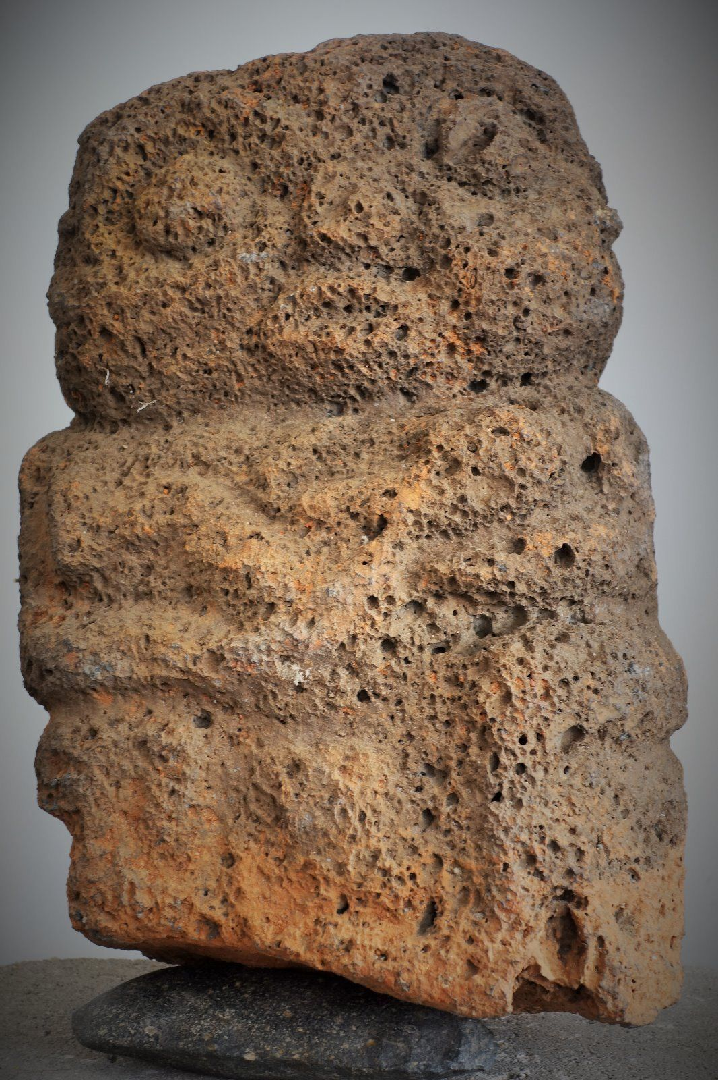

Hina cradling a baby in red scoria lava from Necker Island of Hawai'i. 0 AD to 700 AD, the oldest settlement. 15 inches high. There is a small head of vesicular lava in the Metropolitan Museum of New York of a similar period from Necker Island.

