DIS-Nukuoro- 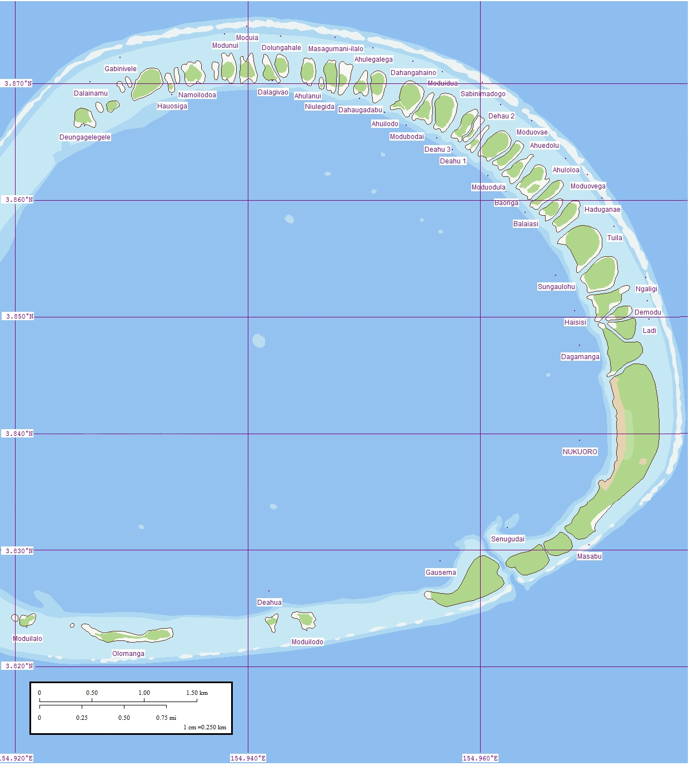

Fig. 1. Nukuoro Atoll, Caroline Islands, Micronesia. Map of eastern rim that contains islands. Western rim has no islands. . The lagoon averages 6 km (3.7 mi) in diameter. The image shows islets where the land surface is higher above sea level because the prevailing winds build up sand dunes. Coral in the lagoon appears as light blue patches. (This file was derived from: [Nukuoro North map.jpg](https://commons.wikimedia.org/wiki/File:Nukuoro_North_map.jpg):  [Nukuoro South map.jpg](https://commons.wikimedia.org/wiki/File:Nukuoro_South_map.jpg): )

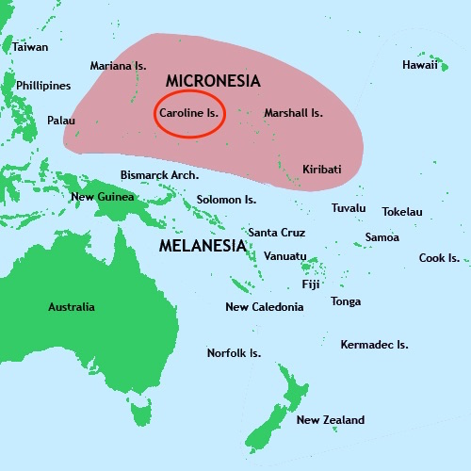

Location of Nukuoro in the Caroline Islands

Nukuoro Atoll (Ponape District, Trust Territory of the Pacific Islands) is a nearly circular atoll with a deep central lagoon and a fringing reef with forty-six small islets or *modu* (cf. Hawai’ian *motu*) that extend from the northwest clockwise to the southwest, which at low tide are interconnected.

Nukuoro atoll was settled in the eighth centuryAD/CE, by Samoan migrants who voyaged in two canoes under chief Wawe, landed at Nukufetau in Tuvalu and then set sail for the uninhabited *modu* of Nukuoro atoll in Micronesia. This settlement of a Micronesian atoll by these Polynesians created a “Polynesian outlier”. The eighth century is important climatologically and socially, since favorable weather conditions during the seventh century had induced increasing populations on many Pacific islands making the incentive to migrate attractive to many as internecine strife ensued with the stresses of increasing populations.

Nukuoro immigrants brought their Polynesian Samoan language, Polynesian concepts of social hierarchy (*ali’i*) and genealogy, and their Polynesian aesthetic acumen that would inform the basis of a unique style of human figuration in bananafruit wood.

However, these Polynesians also incorporated Micronesian principles from Tuvalu such as small outrigger construction that was useful in an isolated atoll and banana-fiber loom-weaving which proved suitable for canoe sails as well as clothing for themselves and their deities.

## Nukuoro wooden *te tino aitu* figures.

## Nukuoro deities or ancestors were thought to inhere in animals, stones, pieces of wood or wooden figurines (*te* tino aitu) only for the period of the first fruit rituals, that took place towards the month of Mataariki, when the Pleiades are visible in the west at dusk. The rituals marked the beginning of the harvesting of two kinds of taro, breadfruit, arrowroot, banana, sugar cane, pandanus and coconuts. During the first fruit festivals the harvested fruits and food offerings were brought to the object in which the deities inhered, male and female dances were performed in honor of the bounty being offered and women were ceremoniously tattooed in expectation of successful childbirths. Those deified objects that now were in need of repair were renewed or replaced during these ceremonies.

Nukuoro was first contacted by a western European, the Spanish Captain Juan Bautista Monteverde of the frigate Pala, on 18 February 1806 when en route from Manila to Lima, Peru. They named Nukuoro "Dunkin Is." Bautista Monteverde noted that the natives came out to trade and that the "Inhabitants are of the most pacific disposition" (Hezel 1979, Sharp 1960: 189, ).

In 1830 Captain Morrell [2] on the *Antarctic* encountered the inhabitants of Nukuoro who were at first friendly but then became aggressive and attacked the landing party (Eilers 1934: 163). Morrell had brought iron tools and these made the carving of wooden *te tino aitu* figures more expeditious since up to that time shell had been the source of woodworking implements. On 15 September 1852 the Reverends Doane and Sturges visited Ponape to found the first Protestant mission, in early February 1855 they returned to begin their missionary work and towards the end of the year, on 24 December, they both left for Kosrae for a mission meeting, returning to Ponape on 11 January 1856 [3]. In October of 1857 the king of Mac Askill, one of the islands surrounding Ponape to the north of Nukuoro, said to the Rev. Doane that "he wanted a missionary to come and live on his island" [4].

A trading post was established in 1870. Visiting Nukuoro, but not landing, in June 1874, the missionary Rev. Doane reported that “Idols carved from wood are common here, a very large one being in their temple.” (Doane 1874:205). Kubary (1900:53) also described how: “The wood idols [*te*] *tino aitu* must from time to time be renewed, since many, especially those made from breadfruit, become decayed and collapse. Such old idols are called *wai soni* and are kept in the temples.” Each clan had its particular deity images in multiple sculptures in their *amalau* or places of worship. For instance, Sope’s various forms were imaged in six wooden sculptures.

The introduction of iron woodworking tools encouraged a spirit of competition among the artists to produce the best and largest figures, which were sought by westerners such as Kubary, Cozens, American missionaries and James Lyle Young. In 1877, Kubary on his second visit purchased eleven figures that are now in German collections (De Grunne 1994). By 1885 most of the wooden sculptures had been either sold to collectors or destroyed by American protestant missionaries from the American Board of Commissioners for Foreign Missions (ABCFM) from Andover Newton Theological School and Harvard Divinity School. The missionaries had been in Hawai’i where they had earlier destroyed many images of the local deities. These new missionaries who had been assigned to the Marshall, Lukunor, Pohnpei, and Kosrae Islands had also managed to dispel the evil influences of the devil. The scene was similar on the nodu of Nukuoro. When the American missionary Thomas Gray arrived in Nukuoro in 1902 to baptize a female chief, he discovered that a large part of the population had been acquainted with Christianity through a Nukuoran woman who had lived on Pohnpei.

When Gray returned in 1905, the sacred Nukuoro marae and its large temple had been replaced with a church. By 1913, many of the Nukuoro traditions including religious ceremonies, dances, songs, and stories had been lost or destroyed.

## Earliest sources

In 1874, the missionary Edward T. Doane made the first mention of carved wooden figures. It is unclear, however, where this experienced missionary got his information from as he never left his ship, the Morning Star, to go ashore. Two German men, Johann Stanislaus Kubary, who visited the island in 1873 and in 1877 while working for the Godeffroy trading company and its museum, and Carl Jeschke, a ship’s captain who first visited the atoll in 1904 and then regularly between 1910 and 1913, give the Soon thereafter things must have changed for already on   
The above data supply important indications of the population's changing attitude as their religions were abandoned, and this has a direct bearing on the sculpting of their tino [5].  
  
Kubary, a special envoy sent by the Godeffroy Museum in Hamburg to collect specimens, made a first short visit in 1873 and stopped again in 1877 for a longer stay to study the Caroline Islands, mainly Nukuoro. By this time their religious practices were very considerably modified and since 1874 a trader lived there.   
  
He reports, but without specifying on which trip, that he had someone buy two images on his behalf, one of these was the goddess Ko Kawe [6] , venerated as a large idol in the Amalau [7]. She was the spouse of the god Te ariki and patron goddess and protectress of the Sekawe, one of the five clans. The author believes that all the deities brought back by Kubary to Hamburg were probably collected on his second visit in 1877, but that in any case they were surely made [8] for the purpose of barter and trade as are almost all the surviving examples.   
  
The coral island of Nukuoro had been ruled by two chiefs, one religious and one secular, for the latter the function being handed down from parent to child, or a family member, regardless of sex. 

As early as 1830 Nukuoro’s approximately 400 inhabitants began engaging in trade and exchange with European visitors, when most detailed information on the Nukuoron figures.

## Wooden sculptures

The first Europeans to collect the Nukuoro sculptures found them coarse and clumsy. It is not known whether the breadfruit tree (Artocarpus altilis) images were carved with local adzes equipped with Tridacna shell blades or with western metal blade tools (Tridacna is a genus of large saltwater clams). The surfaces were smoothed with pumice which was abundantly available on the beach. All the sculptures, ranging in size from 30 cm to 217 cm, have similar proportions: an ovoid head tapering slightly at the chin and a columnar neck. The eyes and nose are either discretely shown as slits or not at all. The shoulders slope downwards and the chest is indicated by a simple line. Some female figures have rudimentary breasts. Some of the sculptures, be they male, female or of indeterminate sex, have a sketchy indication of hands and feet. The buttocks are always flattened and set on a flexed pair of legs.

## References

## De Grunne, B. 1994. “Beauty in Abstraction: the Barbier-Mueller Nukuoro Statue”. *Art Tribal*, Geneva: 25-40.

## Doane, E.T. 1874. The Caroline Islands (Cruise of the Star). The *Geographical Magazi*ne, 1:203-205.

## D’Urville , M.J. Dumont. 1843. *Voyage au Pole Sud et dans L’Oceanie sur les Corvettes L’Astrolabe et la Zelee*. Vol. V. Paris, Gide et Cie.

## Eilers, A. 1934. “Inseln um Ponape”. *Ergebnisse der Sudsee-Expedition 1908–1910*. IIB Vol. 8. Hamburg, Friederichsen de Gruyter.

## Hezel, Fr. Francis X. S.J. 1979. http://www.micsem.org/pubs/articles/historical/forships/pohnpei.htm .

Kaeppler, Adrienne L. 2008. The Pacific Arts of Polynesia & Micronesia .Oxford: Oxford University Press.

Kaufmann, Christian, Oliver Wick (eds.). 2013. Nukuoro. Sculptures from Micronesia. Basel: Fondation Beyeler, Hirmer.

## Kubary, J. 1900. “Beitrag sur Kenntnis der Nukuoro- oder Monteverde Inseln”. *Mitteilungen der Geographischen Gesellschaft in Hamburg*, XVI.

## Newton, D. nd. “Figure of a divinity (tino), Caroline Islands, State of Ponape, Nukuoro Atoll”. Unpublished signed typescript report.

Sharp, Andrew. 1960: The Discovery of the Pacific Islands. Oxford, Clarendon Press.

## Volprecht, K. 1968. “Nukuoro: Zur Sammlung Kapitan Jesche im Rautenstrauch-Joest-Museum”. *Ethnologica* (NF) Band 4: 532-542.

Ward 1967: V, 275;

Sydney Gazette, 6 Nov 1808