DIS-PAC-POLY-HI-Adze

ancient Hawaiian Solid Blue Rock, pahohoe lava, Adze which has been in my family for over two hundred years, from the time of King Kamehameha the Great.  This is approximately 4-1/4 inches long.

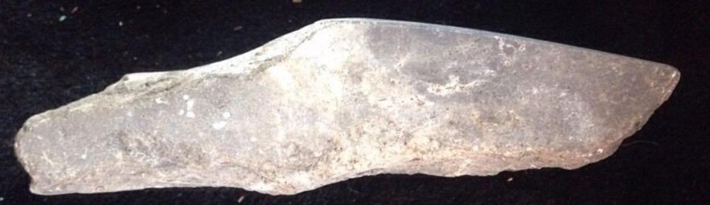

# Ancient Hawaiian Stone ADZE Black Lava Rock 2 hundred years same family

