DIS-PAC-POLY-Nukuoro-Canoe

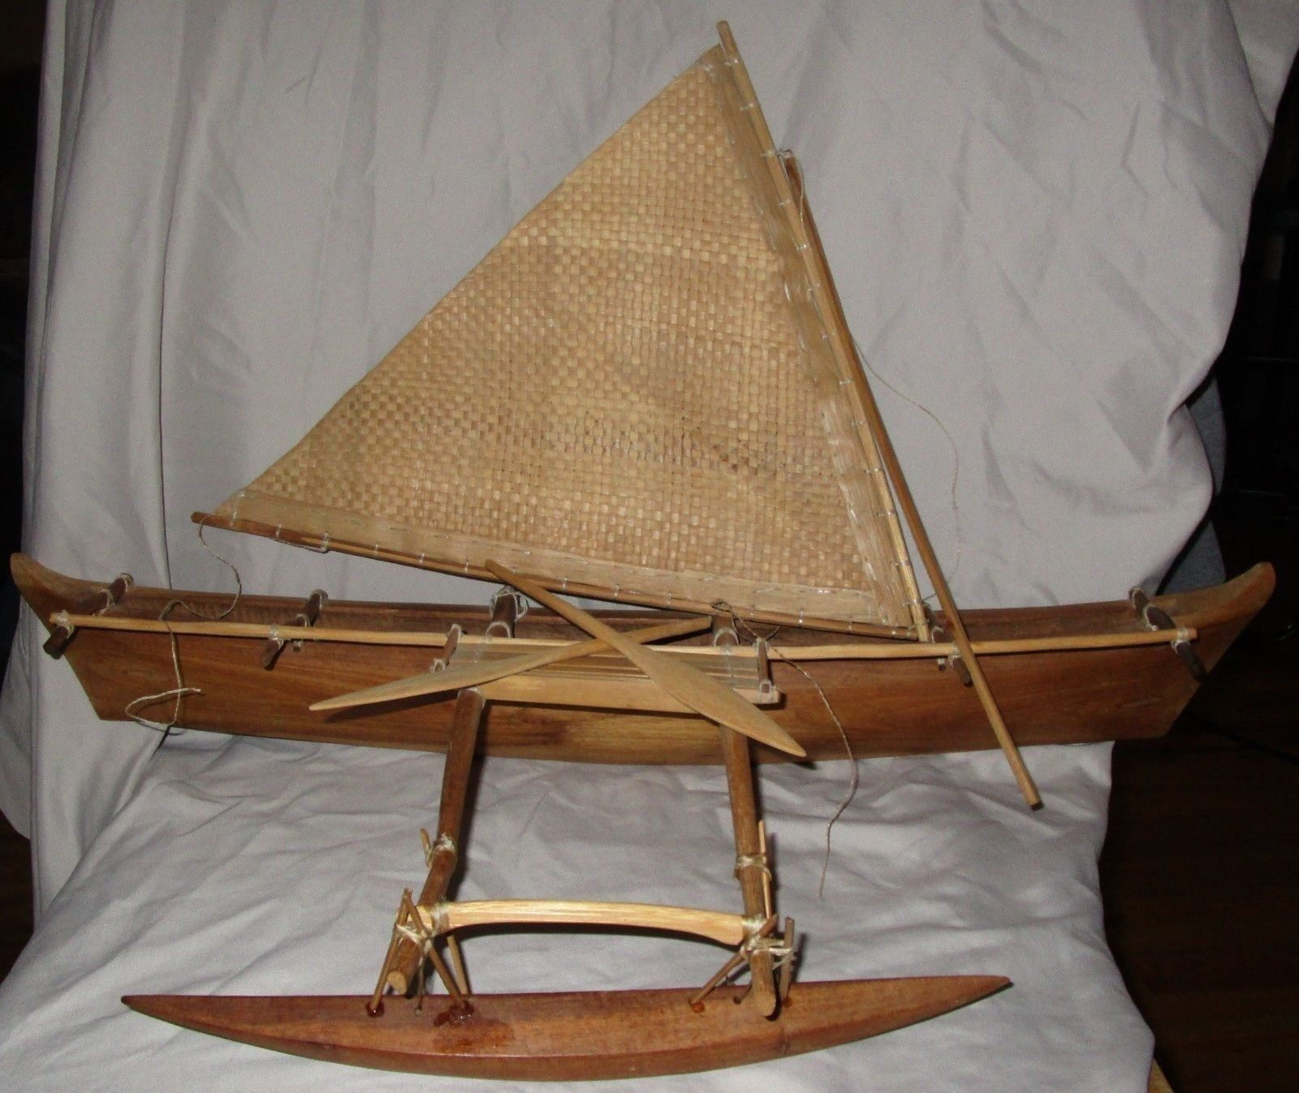

|  |  |
| --- | --- |
| **Title** | Model drua (sailing canoe) |
| **Production** | Kennedy, Alex, 2002, Fiji |
| **Materials** | wood, plant material, synthetic fibre, glue |
| **Classification** | models, sailing vessels, canoes |
| **Dimensions** | Overall: 330mm (Height) x 530mm (Length) x 210mm (Width/Depth) |
| **Credit line** | Commissioned 2002 |
| **Registration number** | FE011790 |

This type of canoe originated in Nukuoro, an atoll in what used to be called the Caroline Islands, which are now part of the state of Pohnpei in the modern Federated States of Micronesia. These single masted outrigger canoes skimmed across vast miles of ocean so efficiently, they were popularly called “flying proas” by European sailors and settlers in the early 20th century. Micronesia is a world of water, scattered with thousands of small islands, atolls and archipelagos, and it was the last place in the world where the traditional arts of sailing and navigating outrigger canoes survived. The sail is the typical Micronesian woven reed triangular lateen sail. The sail must always be windward of the single outrigger float , since the wind in the sail cannot easily lift the float out of the water. (If it was mounted to leeward, the wind could easily capsize the boat). This type of outrigger canoe is sometimes called a shunting canoe, since it sails equally well in either direction, but cannot come about like a modern yacht.

This model is 26" long. The canoe is made out of one piece of wood. It will be shipped with the mast down, and will include simple directions on how to attach the mast and put it back up.

This is a model of a Fijian drua (double hulled sailing canoe). The drua was the largest and finest sea-going vessel ever designed and built by natives of Oceania before contact with Europeans. Only chiefs able to command the services of highly skilled hereditary canoe builders, a class restricted in numbers and location, could effect its construction.

**Construction**The building of large vessels utilized the skills of many other specialists such as sail makers, rope makers and paddle makers and was probably a great strain on the resources of a village or district. The drua was a double hulled canoe made in Fiji. Its Samoan equivalent was the `alia, the Tongan equivalent was the kalia. These vessels were of the same design and could range up to 100 feet in length.

The drua was constructed of carefully fitted planks built up upon a keel and stitched together with coconut fibre cord. The joins were caulked with dry coconut husk and gum from the breadfruit tree.

They were very large with one account from 1847 saying that "the fleet of Thankombau [Cakobau] sailed out this morning with not less than 200 warriors on board each canoe." Another account from the 1880s describes a drua 72 feet long with a hold 5 feet deep. In a double canoe 100 feet long the beam would be 6 to 8 feet and a man could easily walk in the hold without touching the deck. " A pig could be roasted whole in the open cooking place, and the food and water were easily stowed away for long voyages. On one occasion a drua carried 12 head of cattle in her holds from Natewa Bay in Vanua Levu to Levuka, a trip of 120 miles, and another carried on deck from Tailevu to Suva a cargo of bagged maize sufficient to load the Alarm ketch of 30 tons, and the Xerifa at 20 tons burden."

The steering paddles were also impressive. One of the largest measured at 33 feet long with a blade 14 feet to the shoulder and 21 inches wide.