DIS-Nukuoro- 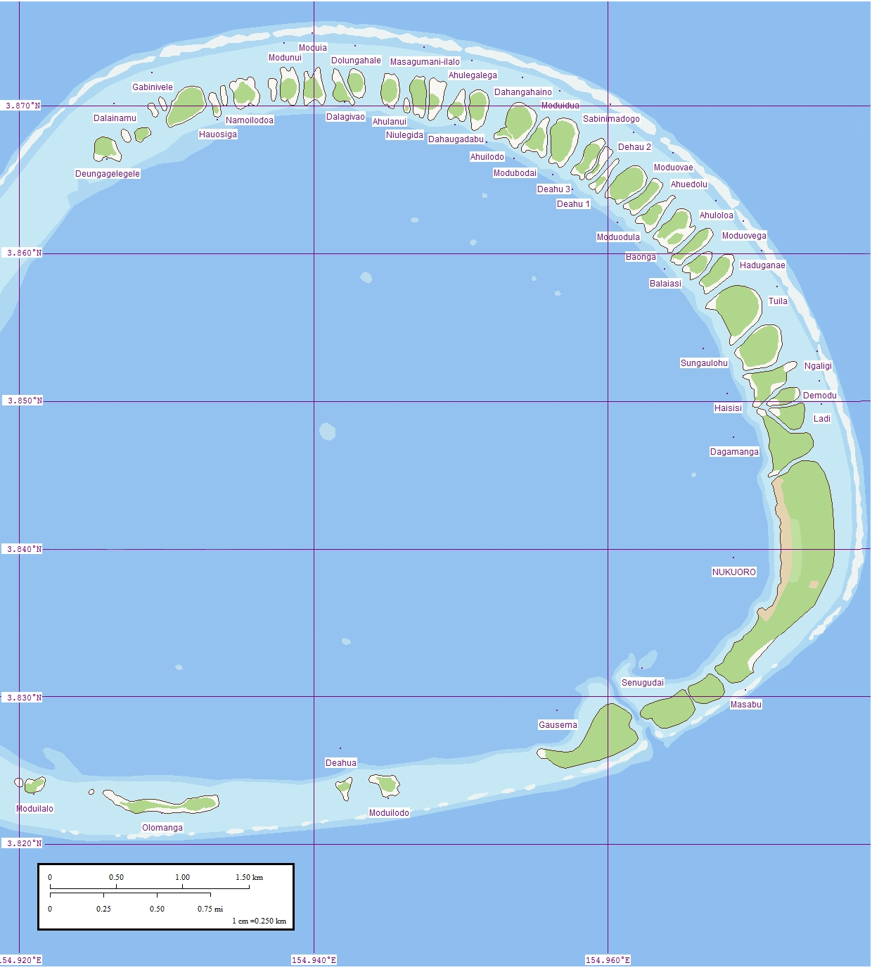

Fig. 1. Nukuoro Atoll, Caroline Islands, Micronesia. Map of eastern rim that contains forty-six small islets or *modu* (cf. Hawai’ian *motu*) . The western rim has no *modu*. The lagoon diameter averages 6 km (3.7 mi). The prevailing southwesterly winds build up sand duneson *Modu*. Coral in the lagoon appears as light blue patches. (This file was derived from: [Nukuoro North map.jpg](https://commons.wikimedia.org/wiki/File:Nukuoro_North_map.jpg): and  Nukuoro South map.jpg. )

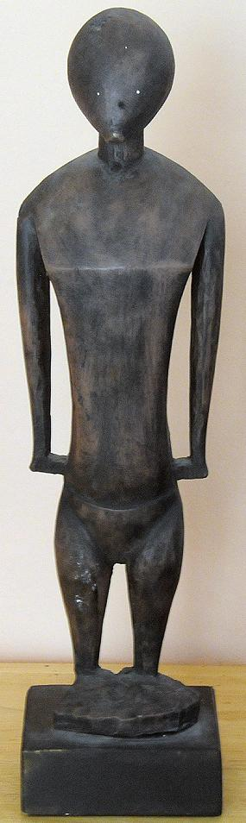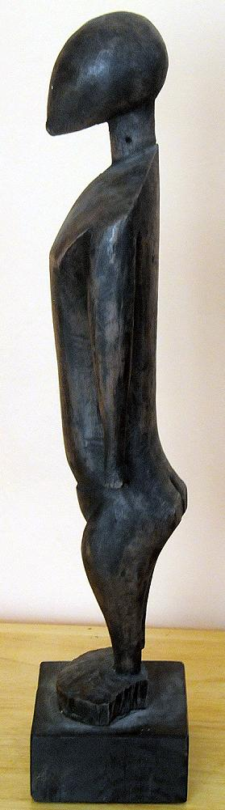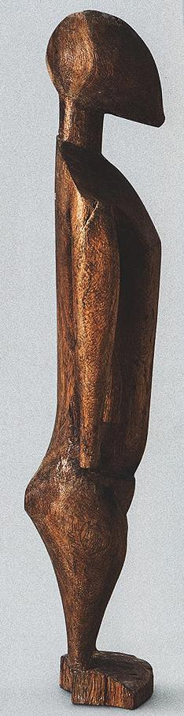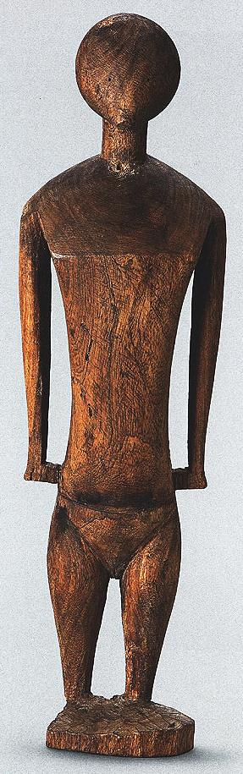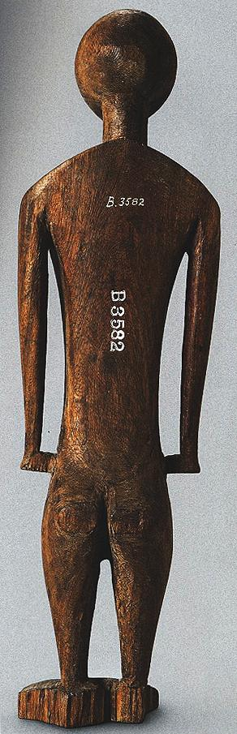

Fig. 3. Nukuoro figure, Bishop Museum, acc. No. 3582. The Atlantika figure is a resin cast on the left.

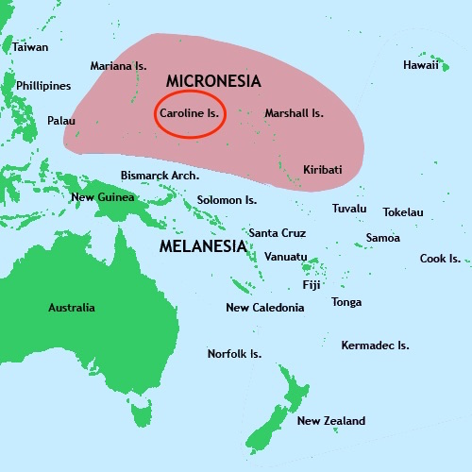

Location of Nukuoro in the Caroline Islands

# Background

Nukuoro Atoll (Ponape District, Trust Territory of the Pacific Islands) is a nearly circular atoll with a deep central lagoon and a fringing reef with forty-six small islets or *modu* (cf. Hawai’ian *motu*) that extend from the northwest clockwise to the southwest, which at low tide are interconnected.

Nukuoro atoll was settled in the eighth century AD/CE, by Samoan migrants who voyaged in two canoes under chief Wawe, landed at Nukufetau in Tuvalu and then set sail for the uninhabited *modu* of Nukuoro atoll in Micronesia. This settlement of a Micronesian atoll by these Polynesians created a “Polynesian outlier”. The eighth century is important climatologically and socially, since favorable weather conditions during the seventh century had induced increasing populations on many Pacific islands making the incentive to migrate attractive to many as internecine strife ensued with the stresses of increasing populations. These Nukuoro immigrants brought their Polynesian language, concepts of social hierarchy, genealogy, and an aesthetic acumen that would inform the basis of a totally unique style of human figuration in banana-fruit wood as in the current example. In addition, these Polynesians also incorporated Micronesian principles from Tuvalu such as outrigger canoe construction that was useful in an isolated atoll (as in the current outrigger canoe model) and banana-fiber loom weaving which proved suitable for canoe sails (as in the current outrigger canoe model) as well as clothing for themselves and for adorning figures of their deities.

## Nukuoro wooden *te tino aitu* figures.

## Nukuoro deities or ancestors were thought to inhere in animals, stones, pieces of wood or wooden figurines (*te* **tino aitu**) only for the period of the first fruit rituals, that took place towards the month of**Mataariki**, when the Pleiades are visible in the west at dusk. The rituals marked the beginning of the harvesting of two kinds of taro, breadfruit, arrowroot, banana, sugar cane, pandanus and coconuts. During the first fruit festivals the harvested fruits and food offerings were brought to the object in which the deities inhered, male and female dances were performed in honor of the bounty being offered and women were ceremoniously tattooed in expectation of successful childbirths. Those deified objects that now were in need of repair were renewed or replaced during these ceremonies.

Nukuoro was first contacted by western Europeans when the Spanish Captain Juan Bautista Monteverde of the frigate Pala on 18 February 1806 en route from Manila to Lima, Peru named Nukuoro "Dunkin Is." and noted that the natives who came out to trade "are of the most pacific disposition" (Hezel 1979, Sharp 1960: 189, Ward 1967).

However, it was not until 1830 that Nukuoro entered into European trade when Captain Morrell on the *Antarctic* landed on Nukuoro and brought iron tools. The inhabitants were at first friendly but then became aggressive and attacked the landing party (Eilers 1934: 163). The iron tools induced aggressive behavior for they made the carving of wooden *te tino aitu* figures and all other wooden implements easier since up to that time shell had been the source of woodworking implements.

A trading post was not established until 1870 and four years later the missionary Rev. Doane reported that “Idols carved from wood are common here, a very large one being in their temple.” (Doane 1874:205). Kubary (1900:53) a special envoy sent by the Godeffroy Museum in Hamburg to collect specimens also described how: “The wood idols [*te*] *tino aitu* must from time to time be renewed, since many, especially those made from breadfruit, become decayed and collapse. Such old idols are called *wai soni* and are kept in the temples.” Each clan had its particular deity images in multiple sculptures in their *amalau* or places of worship.

The introduction of iron woodworking tools encouraged a spirit of competition among the artists to produce the best and largest figures, which were sought by westerners such as Kubary, Cozens, American missionaries and James Lyle Young. In 1877, Kubary on his second visit purchased eleven figures that are now in German collections (De Grunne 1994). By 1885 most of the wooden sculptures had been either sold to collectors or destroyed by American protestant missionaries from the American Board of Commissioners for Foreign Missions (ABCFM) who had been assigned to the Marshall, Lukunor, Pohnpei, and Kosrae Islands’ The missionaries had earlier caused many religious images of Hawai’ian deities to be destroyed as a way of extirpating the devil.

By 1902 the advance of Christianity in Nukuoro was unexpected even to the missionaries. When the American Rev. Thomas Gray arrived to baptize a female chief he discovered that a large part of the population had already been partially Christianized by a Nukuoran woman who had lived on Pohnpei when the ABCFM missionaries were there. When Gray returned to the atoll in 1905, the sacred Nukuoro marae and its large temple had even been replaced by a church. By 1913, many Nukuoro traditions including religious figures, ceremonies, dances, songs, and stories had been either proscribed or destroyed. Today all of the existing Nukuoro wooden figures were made with iron tools as trade items. Not one has survived from the pre-contact era made with shell.

## Earliest sources

In 1874, the missionary Edward T. Doane made the first mention of carved wooden figures. It is unclear, however, where this experienced missionary got his information from as he never left his ship, the Morning Star, to go ashore. Two German men, Johann Stanislaus Kubary, who visited the island in 1873 and in 1877 while working for the Godeffroy trading company and its museum, and Carl Jeschke, a ship’s captain who first visited the atoll in 1904 and then regularly between 1910 and 1913, give the Soon thereafter things must have changed for already on   
The above data supply important indications of the population's changing attitude as their religions were abandoned, and this has a direct bearing on the sculpting of their tino [5].  
  
Kubary, a special envoy sent by the Godeffroy Museum in Hamburg to collect specimens, made a first short visit in 1873 and stopped again in 1877 for a longer stay to study the Caroline Islands, mainly Nukuoro. By this time their religious practices were very considerably modified and since 1874 a trader lived there.   
  
He reports, but without specifying on which trip, that he had someone buy two images on his behalf, one of these was the goddess Ko Kawe [6] , venerated as a large idol in the Amalau [7]. She was the spouse of the god Te ariki and patron goddess and protectress of the Sekawe, one of the five clans. The author believes that all the deities brought back by Kubary to Hamburg were probably collected on his second visit in 1877, but that in any case they were surely made [8] for the purpose of barter and trade as are almost all the surviving examples.   
  
The coral island of Nukuoro had been ruled by two chiefs, one religious and one secular, for the latter the function being handed down from parent to child, or a family member, regardless of sex. 

As early as 1830 Nukuoro’s approximately 400 inhabitants began engaging in trade and exchange with European visitors, when most detailed information on the Nukuoron figures.

## Wooden sculptures

The first Europeans to collect the Nukuoro sculptures found them coarse and clumsy. It is not known whether the breadfruit tree (Artocarpus altilis) images were carved with local adzes equipped with Tridacna shell blades or with western metal blade tools (Tridacna is a genus of large saltwater clams). The surfaces were smoothed with pumice which was abundantly available on the beach. All the sculptures, ranging in size from 30 cm to 217 cm, have similar proportions: an ovoid head tapering slightly at the chin and a columnar neck. The eyes and nose are either discretely shown as slits or not at all. The shoulders slope downwards and the chest is indicated by a simple line. Some female figures have rudimentary breasts. Some of the sculptures, be they male, female or of indeterminate sex, have a sketchy indication of hands and feet. The buttocks are always flattened and set on a flexed pair of legs.

## References

## De Grunne, B. 1994. “Beauty in Abstraction: the Barbier-Mueller Nukuoro Statue”. *Art Tribal*, Geneva: 25-40.

## Doane, E.T. 1874. The Caroline Islands (Cruise of the Star). The *Geographical Magazi*ne, 1:203-205.

## D’Urville , M.J. Dumont. 1843. *Voyage au Pole Sud et dans L’Oceanie sur les Corvettes L’Astrolabe et la Zelee*. Vol. V. Paris, Gide et Cie.

## Eilers, A. 1934. “Inseln um Ponape”. *Ergebnisse der Sudsee-Expedition 1908–1910*. IIB Vol. 8. Hamburg, Friederichsen de Gruyter.

## Hezel, Fr. Francis X. S.J. 1979. http://www.micsem.org/pubs/articles/historical/forships/pohnpei.htm .

Kaeppler, Adrienne L. 2008. The Pacific Arts of Polynesia & Micronesia .Oxford: Oxford University Press.

Kaufmann, Christian, Oliver Wick (eds.). 2013. Nukuoro. Sculptures from Micronesia. Basel: Fondation Beyeler, Hirmer.

## Kubary, J. 1900. “Beitrag sur Kenntnis der Nukuoro- oder Monteverde Inseln”. *Mitteilungen der Geographischen Gesellschaft in Hamburg*, XVI.

## Morrell, Benjamin. 1832. **A Narrative of Four Voyages to the South Sea, North and South Pacific " Ocean, Chinese Sea, Ethiopic and Southern At/antic Ocean, Indian and Antarctic Ocean, from the Year 1822 to 1831**. New York, J. & J. Harper.

Sharp, Andrew. 1960: The Discovery of the Pacific Islands. Oxford: Clarendon Press.

## Volprecht, K. 1968. “Nukuoro: Zur Sammlung Kapitan Jesche im Rautenstrauch-Joest-Museum.” *Ethnologica* (NF) Band 4: 532-542.

Ward, R. Gerard, ed. 1967. American Activities in the Central Pacific 1790-1870.8 Vols. Ridgewood, NJ, The Gregg Press.