DIS-PAC-POLY-Samoa-Tattoos

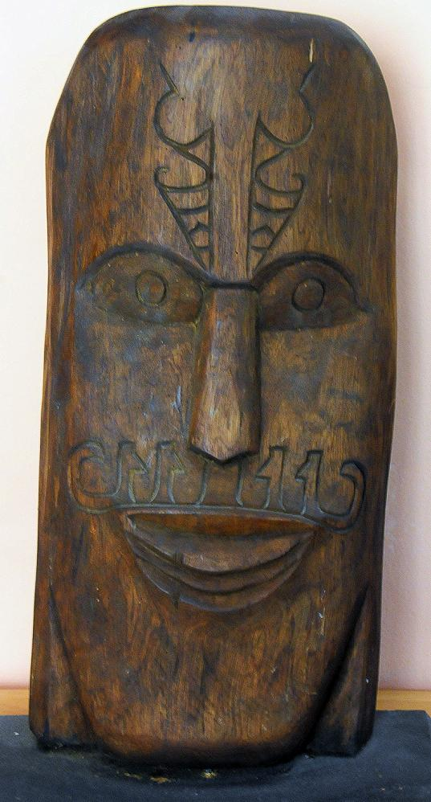

Fig. 1. Wooden bust (koa wood?) of a Samoan *ali’i* with extensive facial tattoos.

Samoan tattoos have their origin in the two-thousand year-old Polynesian culture. Both men’s (*pe’a*) and women’s tattoos (*malu*) are executed by "*taula-aitu*" or healers using teethed combs made of human bone attached to a turtle shell that protects the "*taula-aitu*" from the power of the human bone. The combs are dipped in ink, that was originally applied only to people of rank or *ali’i.* In 1899 almost all the Samoan men and 60-70 per-cent of the women are tattooed (Marquart 1899). These tattoos carry encoded invocations on behalf of the health of the individual involved. Explications of these encoded symbols were collected by a German anthropologist in Samoa, Carl Marquart (1899), and can be used to interpret the current tattoos on the wooden bust above.

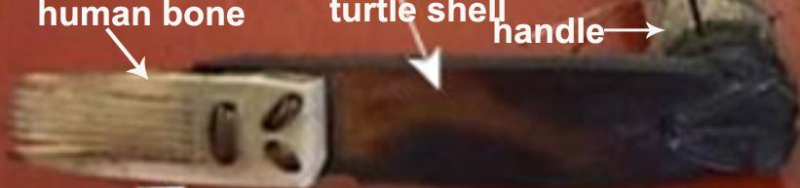

Fig. 2. Tattooing device used in Samoa.

Receiving a *pe'a* or *malu* is still considered a rite of passage, a symbol of reaching manhood or womanhood in Samoa, a process that can take days and even weeks to complete. Assistants sharpen the combs, prepare the ink, and apply the designs that have been received by the applicant in divine inspiration. In other words the tattoo symbols are an expression of the essence of the individual or his/her mission.

In the wooden bust under consideration Samoan symbols have been applied to the face.

The black tree fern (*Cyathea medullaris*), which reaches 20 m., and which is called In Samoa *’oli ’oli* (Milner 1993: 453) is distributed across the southwest Pacific from Fiji to Pitcairn and New Zealand. The salient feature of this plant is that it has spirally-unfolding emergent fronds suggestive of emergent life and protection from harm.

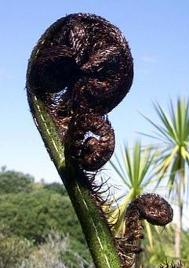

 Fiddlehead of a Black Tree Fern (*Cyathea medullaris*).

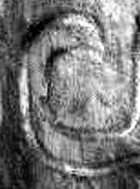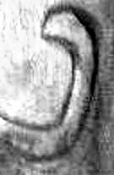

Spiral elements of the Samoan bust related to the shape of fronds of the black tree fern.

As worn by warriors it represents an apotropaic or protective symbol to avert harm. This symbol is used in conjunction with the symbol for shark teeth or sharp weapons.

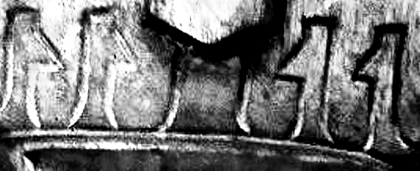

The combined symbolism suggests “protection from sharp weapons [of an enemy]”.

The symbolism on the forehead is consistent with this interpretation.

If this interpretation of the tattoos on the forehead of this Samoan *ali’i* is correct then the symbolism of the birthmark is defined as a protective sign, which is consistent with the interpretation of the apotropaic symbolism of the tree fern tattoos on his lips.

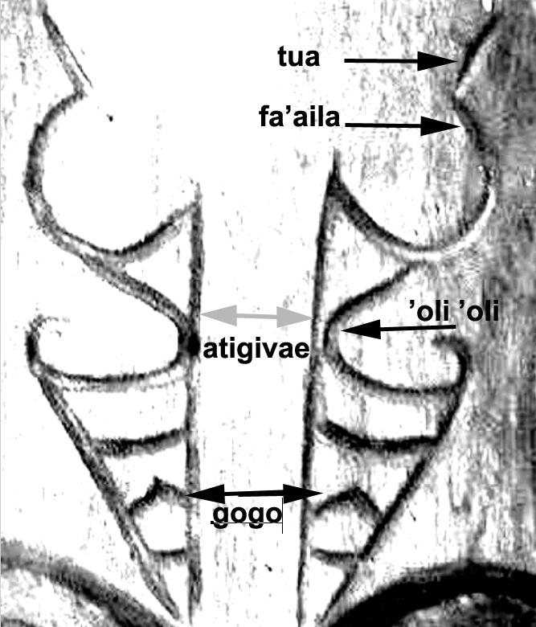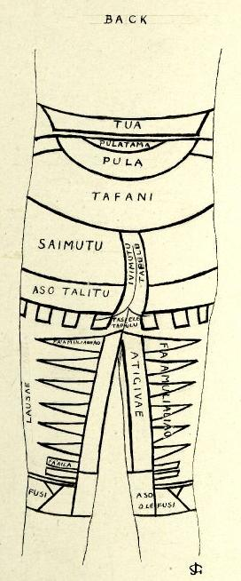

Fig.1: Frontal tattoos on carved face. Fig. 2: Drawing; rendering of a full body Samoan tattoo on the legs and the lower torso. 1940s-1950s Pigment ink. British Museum.. http://www.britishmuseum.org/collectionimages/AN00584/AN00584014_001_l.jpg

*Key to tattoo elements.*

*tua*  back

*fa’aila* birthmark

*atigivae* claw

*’oli ’oli* tree-fern frond = life, protection

*gogo* sea bird

The combined tattoo symbolism on the forehead suggests, “The birthmark on [my] back [is similar to the] protection provided by a sea bird’s claw”. It reinforces the twin values that lie at the heart of Polynesian culture: strength in the face of uncertianty and the ability to tolerate extreme amounts of pain. It also combines a feeling for the intimacy of birds in the life of individuals and their incorporation f this knowledge in prominent events of their lives, It further indicates that although the Hawai’ians did not have a written language they recorded complex thoughts by utilizing elements from tattoos (and petroglyphs) as they recorded thoughts in those two media.

References:

# Marquart, Carl. 1899. *Die Taetowirung beider Geschlechter in Samoa.* Berlin: D Reimer.

Milner, G. B. 1993. *Samoan Dictionary: Samoan-English, English –Samoan*. Auckland, Aotearoa-New Zealand: Polynesian Press.