Dis-Pac-Poly-HI-Adze-Marquesas Design-Trilateral

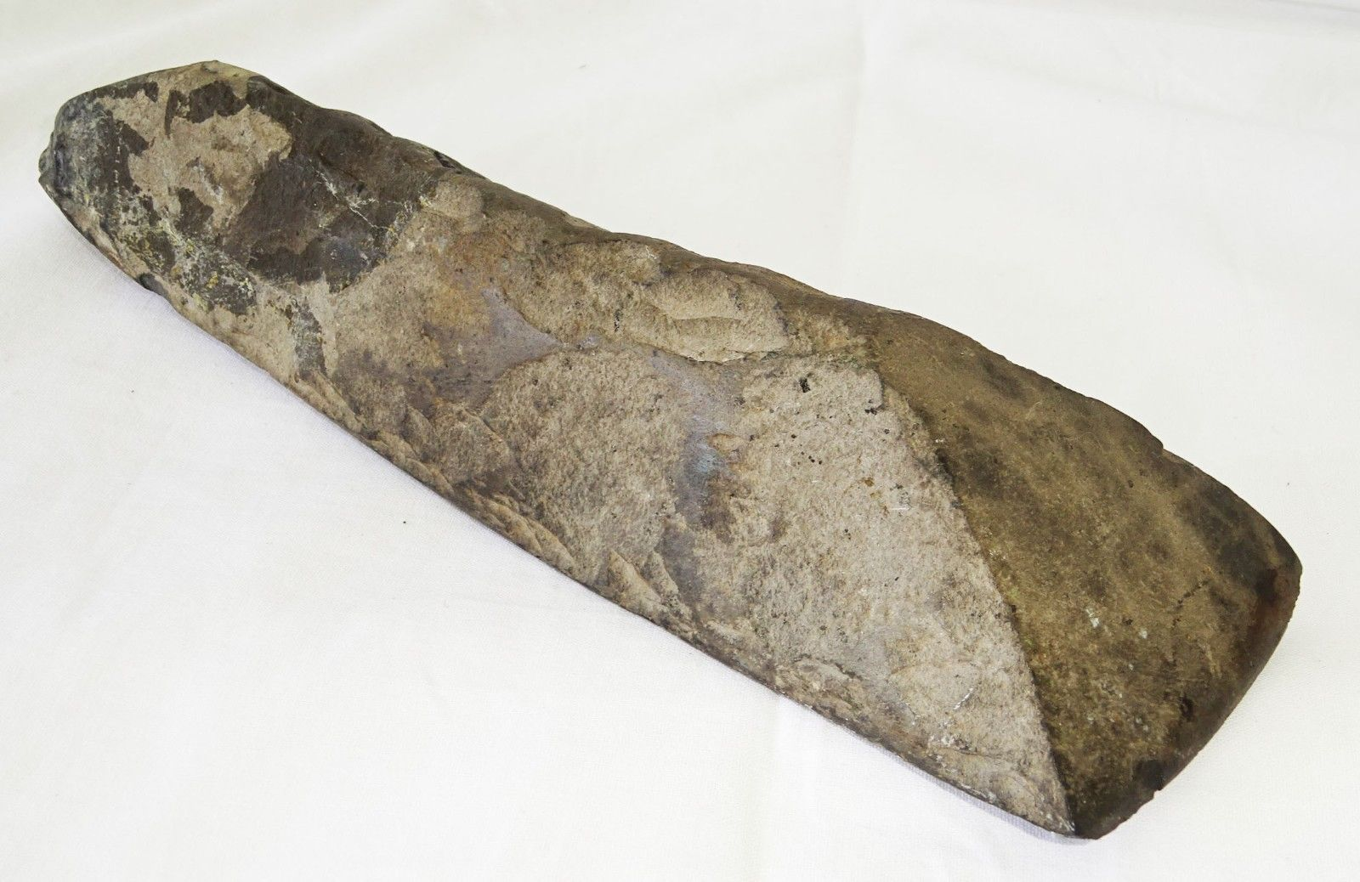

Example of a trilateral adze from the Marquesas, 19th century.

Case no.: Oceania

Accession Number:

Formal Label: Marquesas trilateral adze from Kohala, Hawai‘i.

**Display Description:** The trilateral adze is a Marquesas design. This was found in Kohala, Hawai’i. Extremely rare. Ca. 1200 AD/CE

**LC Classification:** [DU624.A1](https://uhmanoa.lib.hawaii.edu/vwebv/search?searchArg= DU624.A1 H35 no.71-1&searchCode=CALL+%2B&searchType=1)

Date or Time Horizon: ca 1200 AD/CE

Geographical Area: Kohala, Hawai‘i

**Map, GPS coordinates: 20.16769 -155.83228;** 40° 26' 46" N 79° 58' 56" W



Cultural Affiliation: Polynesian settlers from the Marquesas

Medium: basalt

Dimensions:

Weight:

Condition:

**Provenance:** Ex André Sharnisch Brokerage, Inc

**Discussion:**

**References:**