ARC-Fig-Goddess-Neolithic-Balkans

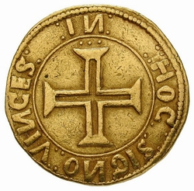

Ancient Neolithic clay idol, Balkan origin.

Provenance: Ex. UK collection.

Size:h.10,5 cm.(4.1")

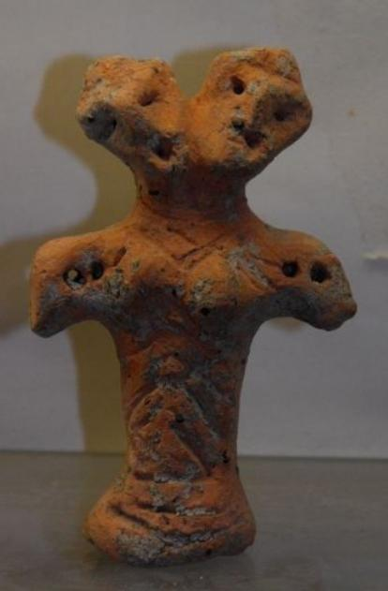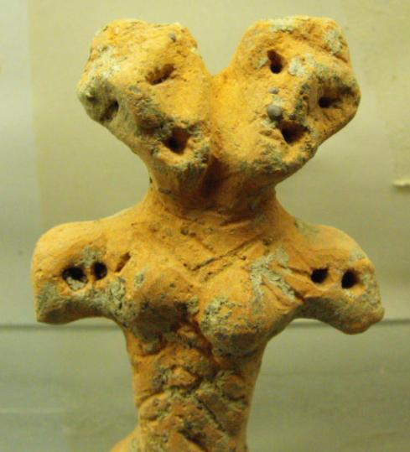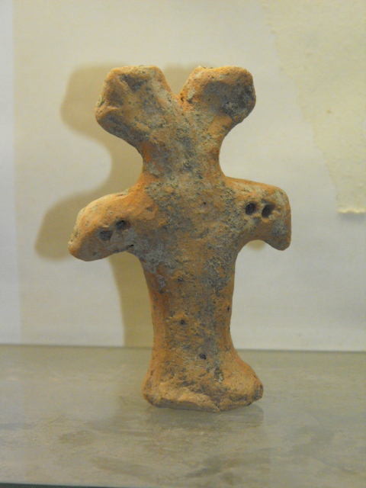

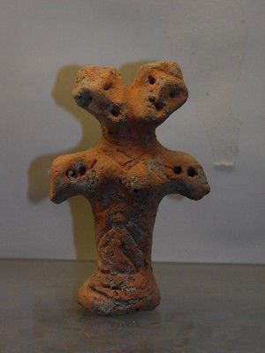

#### [ANCIENT NEOLITHIC CLAY IDOL](http://www.ebay.com/itm/231815202200)

|  |  |
| --- | --- |
| Item price | $222.50 |
| Quantity | 1 |
| Item number | 231815202200 |
| Shipping service | Standard Shipping from outside US |