Arc-Bannerstone--Circular

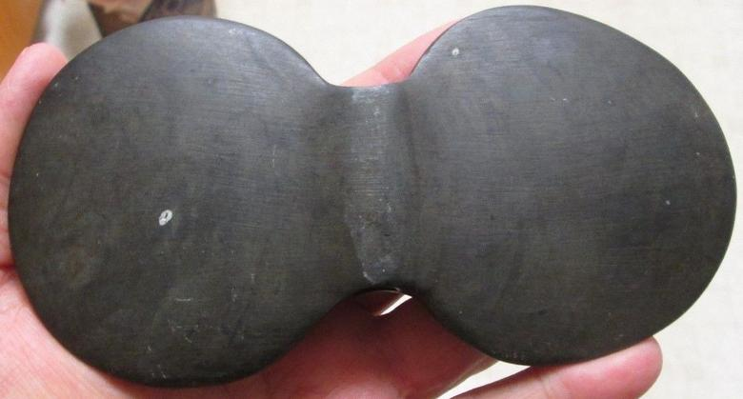Illinois 3 1/4 X 6 inches. slate.