Arc-Bannerstone-Slate

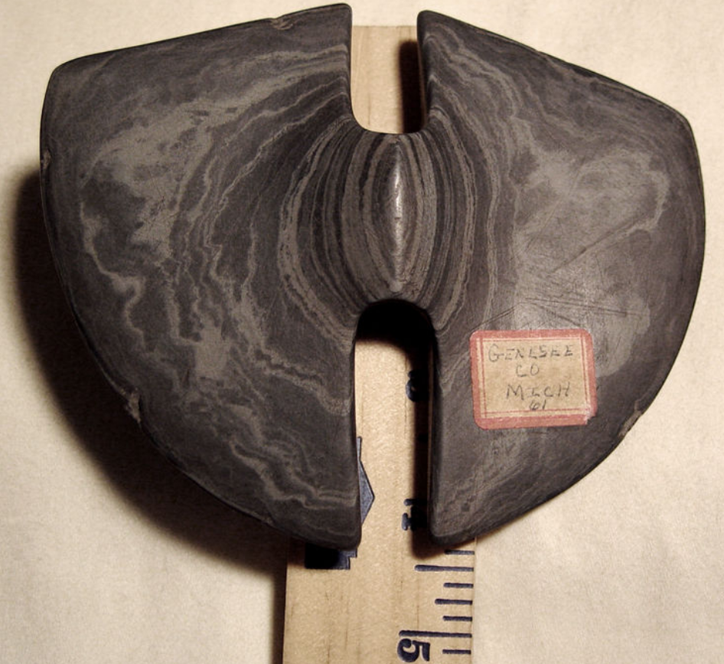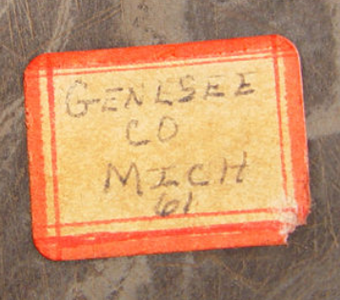

### [Native American Indian Slate Bannerstone - Guaranteed Authentic TN - AACA](http://www.ebay.com/itm/Native-American-Indian-Slate-Bannerstone-Guaranteed-Authentic-TN-AACA-/371193729032?hash=item566cded008:g:lNoAAOSwqu9VUMRl)

* $4,550.00

Was: $6,500.00

At offer is an extraordinarily beautiful museum quality Banded Slate Bannerstone.  It is 4 1/4" tall and 5 1/8" wide at the widest point.  This piece was found in Genesee County, MI in 1961

**BUTTERFLY BANNERSTONE WITH COA – OHIO**

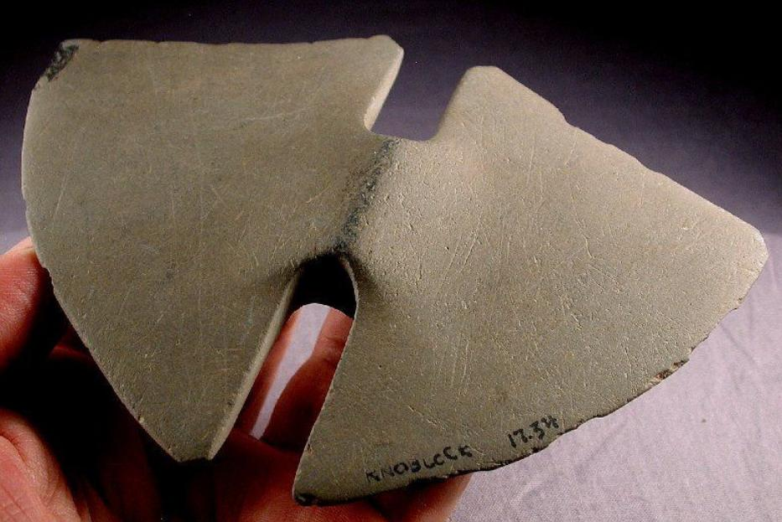

**MUSEUM GRADE – EX BYRON KNOBLOCK COLLECTION!**

**TYPE**: Double-notched, Butterfly Bannerstone

**SIZE**: 5-3/4” X 4-3/16”

**AGE**: Early to Late Archaic (10,000 to 3,000 B.P.)

**MATERIAL**: Heavily Patinated Dark Gray Slate

**FIND LOCATION**: Ohio

**GRADE**: Museum

**C.O.A.**: Butler *1

**NOTES:** EX Byron Knoblock Collection. Authentic Butterfly Bannerstones are very rarely found in whole condition making this a very special offering. The central notches lead to a fully drilled suspension hole which is correct in size and manufacture. Edge wear is minor.  Personally, I seen many fakes so if no wear is evident when comparing this genuine one to others, they probably aren't real.  This is the real deal and priced accordingly!  There are very few that have survived intact.

**Item - 263**