DIS-BASKET-PIMA-Geometric

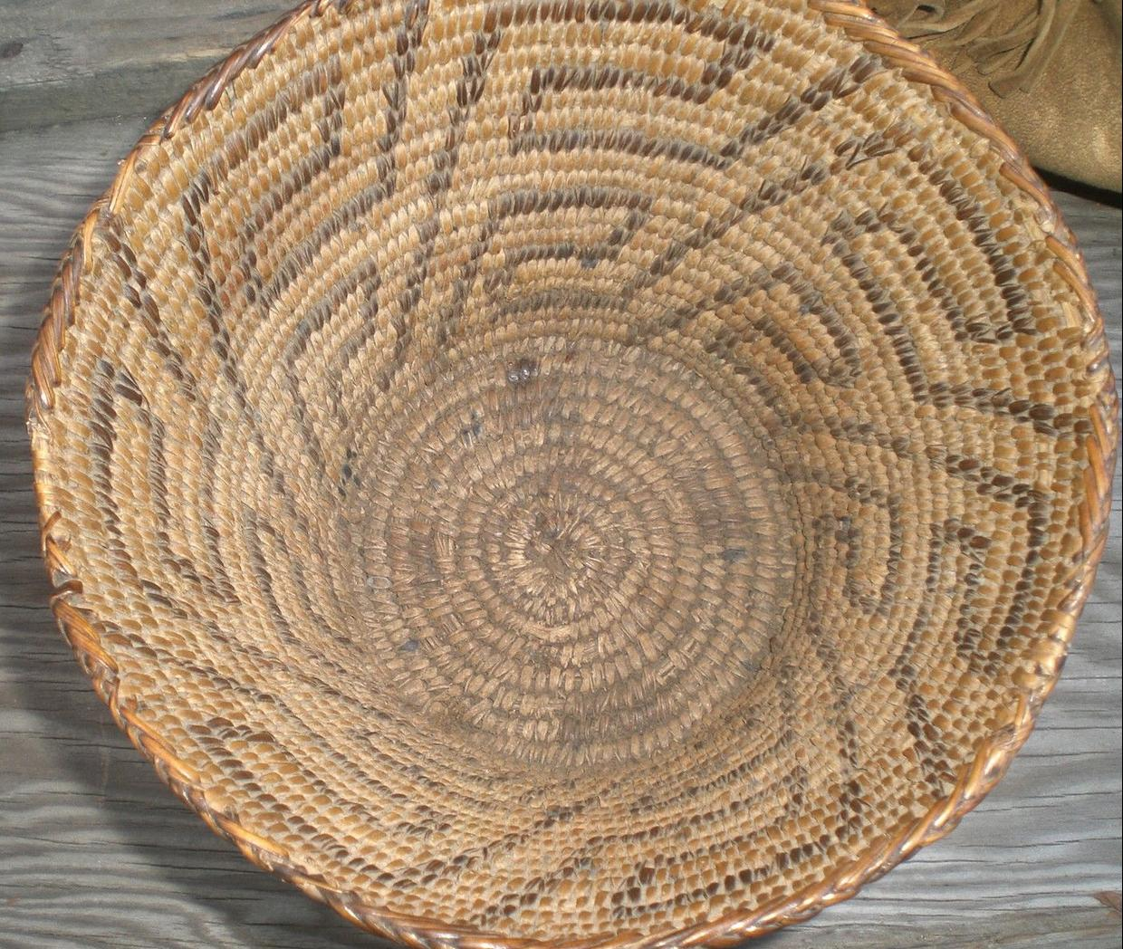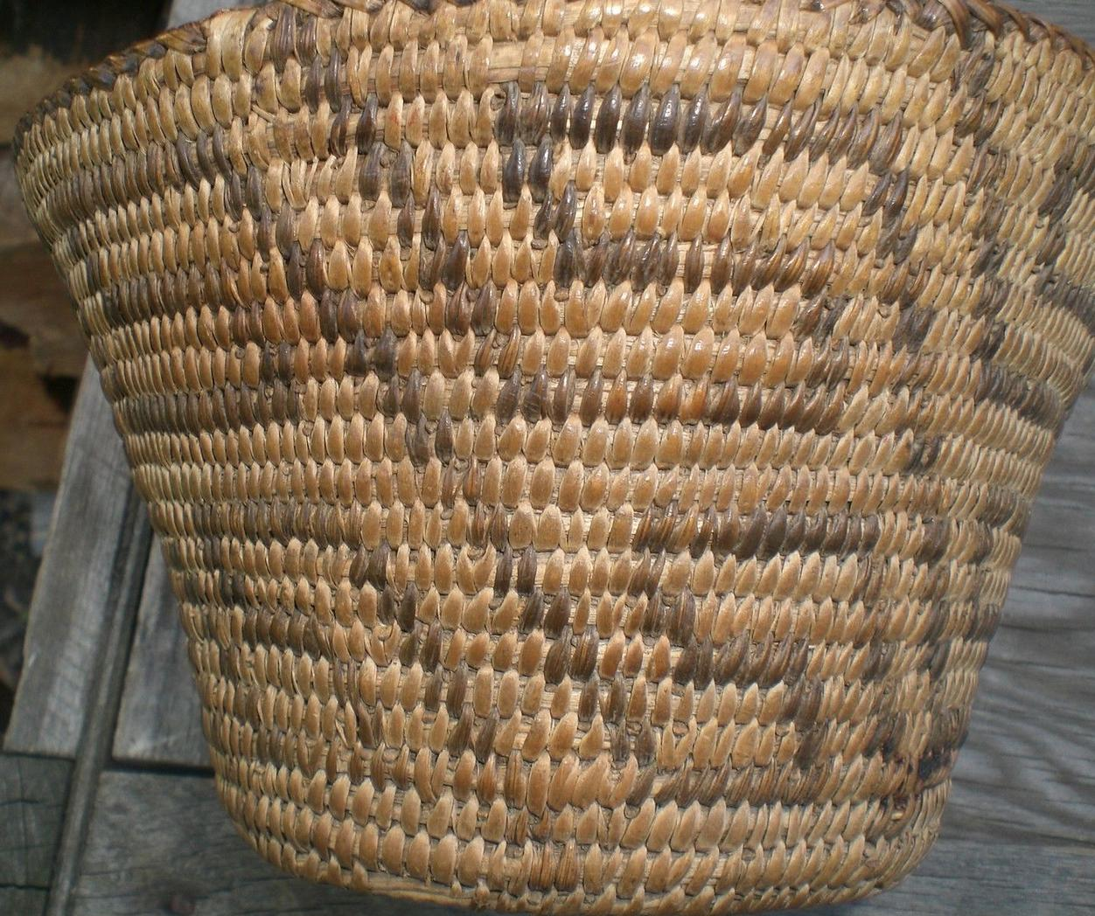

Sold by [bobbyhal](http://myworld.ebay.com/bobbyhal) ( [1466](http://feedback.ebay.com/ws/eBayISAPI.dll?ViewFeedback&userid=bobbyhal) )

### Delivery package 1 of 1

Estimated delivery Tuesday, Oct 13, 2015 - Friday, Oct 16, 2015

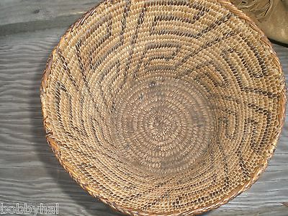

#### [2 BEAUTIFUL NATIVE AMERICAN INDIAN ITEMS BEADED PURSE ANTIQUE BERRY BASKET OLD](http://www.ebay.com/itm/371451629374)

|  |  |
| --- | --- |
| Item price | $153.50 |
| Quantity | 1 |
| Item number | 371451629374 |
| Shipping service | Expedited Shipping |