Fossil-Lepidodendron- Upper Carboniferous, Middle Pennsylvanian Period, 310 million years ago.

# Lepidodendron oculus-felis

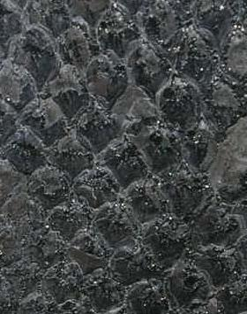

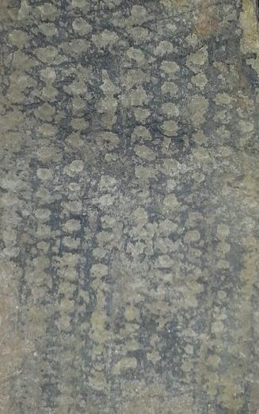

Pennsylvania in the Washington area

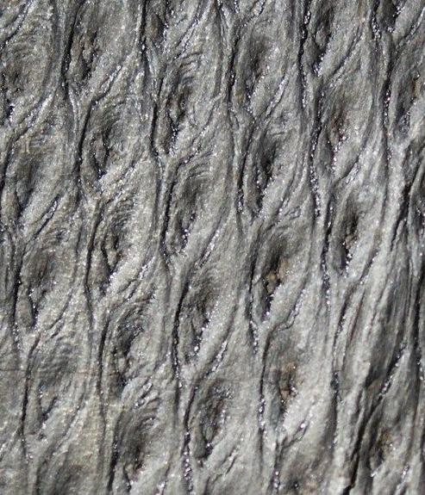

*Lepidodendron aculeatum* Sternberg 1820

Locality:           Poland, GZW Upper Silesia Coal Basin  
Stratigraphy:   Upper carboniferous –Pennsylvanian -  Westphalian B - Orzeskie Beds

Age:                 ca 305 Mya