DIS-POINTS-Clovis

Clovis Techno-Complex projectile points are lanceolate, concave-based and fluted with parallel or slightly convex mid sections and grinding of the base and midsections. The flutes are usually no longer than half of the length.

The following collection of 5 Clovis points is from locations now submerged due to the dam building practices that took place after World War II. The collection illustrates a range of flaking remanufacture of Clovis points in the Upper Missouri River Valley where these points were found.

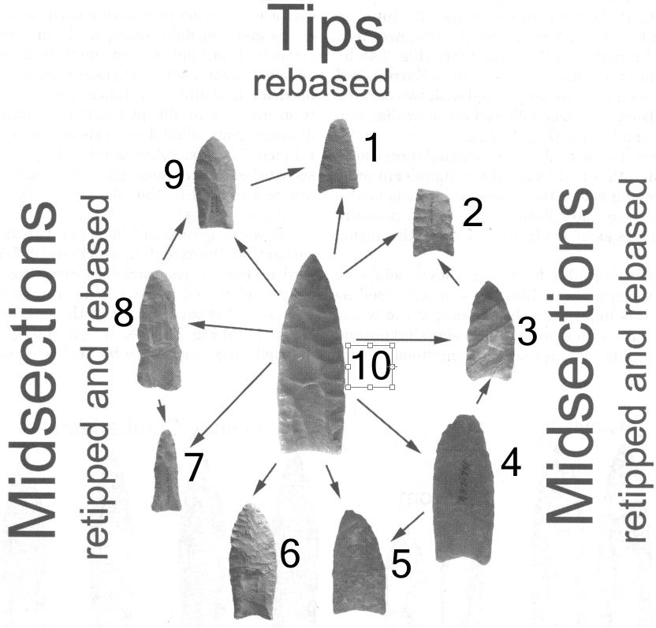



Fig. 1: Clovis retouch options after Huckell 2007.

Most Clovis projectile points exhibit some reworking due to their use in hunting. In the chart above (Fig. 1) various reworking strategies are organized on the basis of the finished shape that was employed in the remanufacture of projectile points that had suffered impact damage from hunting game.

Another peculiarity of the hunters of the Clovis Techno-Complex is that they depended on sources of raw materials that were exotic to the place of actual manufacture, indicating that long-distance trade and exchange was practiced in the Paleolithic period.

In the example of an exotic core illustrated below (Fig. 2) from the Rochester Creek area of Utah ([38°54′11″N 111°11′53″W](https://tools.wmflabs.org/geohack/geohack.php?pagename=Rochester_Rock_Art_Panel&params=38_54_11_N_111_11_53_W_type:landmark_region:US_)) the actual source was from Floy Wash in southeastern Utah. As can be seen in the map below, Floy wash also supplied the Fenn cache of Clovis points as well. In this instance, Rochester Creek may have been on the ancient trail to the Fenn cache.

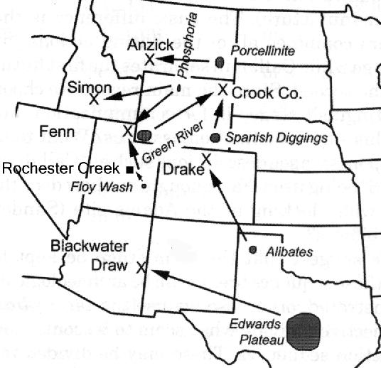

Fig. 2. Clovis chert sources and Clovis projectile point (**X**)and core () find sites in Midwestern United States. Note: Crook County =Fenn Cache.

This was the general area where the present Clovis points came from. Crook County, Wyoming was an important hunting ground of the Lakota. The first and the most spectacular of the Clovis caches was found in 1902 somewhere in the vicinity of southwestern Wyoming, southeastern Idaho, and northeastern Utah. Known today as the Fenn Cache, it includes fifty-six masterfully worked Clovis weapons and tools in virtually every stage of manufacture. The variety of the stone is another important dimension of the Fenn Cache artifacts, which were manufactured from obsidian, chert, jasper, quartz crystal, and agate, and often obtained hundreds of miles from the cache site. Most of the weapons and tools in the Fenn Cache have a thin coating of red ochre. In the fall of 1961, W.D. Simon found a second cache on the Big Camas Prairie of southern Idaho. Another possible cache from what is known as the Anzick site was discovered in 1968 near the town of Wilsall in southwestern Montana. Like the Fenn Cache, the Simon Cache consists of large Clovis points with beautifully colored, high-quality tool stone, quartz crystal bifaces, and red ochre staining.

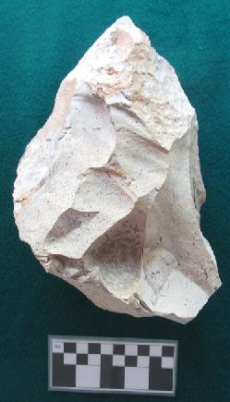Fig. 3. This Clovis Techno -Complex flint core is from the vicinity of the Rochester Creek, Molen Reef, San Rafael Swell, Emory County, Utah. Molen Reef is comprised of rusty sandstone, mixed with shale, siltstone, and limestone dating to the Cretaceous and Jurassic periods (See Bradley et al. 2010, Plates 2-3) but it does not contain any high quality chert.. Because this core is of a high quality flint which is not found in the Molen Reef area, it was probably imported by mobile Paleolithic hunter gatherers from a flint source similar if not identical to that of the Floy Wash, southeastern Utah.

SHAPE \* MERGEFORMAT 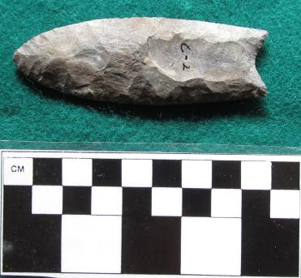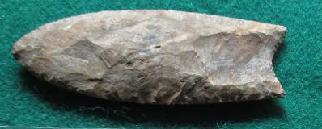

Point r-C-2: Clovis point showing some evidence of being reworked possibly in its midsection, and/or base and/or tip. See points 4, 6 and 9 in Fig. 1. In all three cases the midsection is wider than its base and the point is more curved than the Clovis point (no. 10).

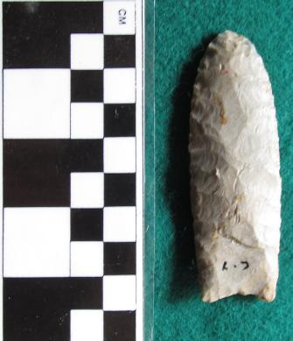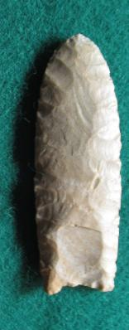

Point C-7: Clovis point showing some evidence of being reworked possibly in its midsection, and/or base and/or tip. See points 4, 6 and 9 in Fig. 1. In all three cases the midsection is wider than its base and the point is more curved than the Clovis point (no. 10).

SHAPE \* MERGEFORMAT 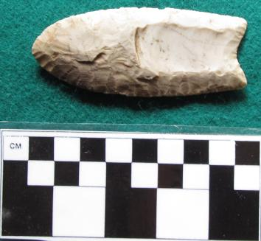 SHAPE \* MERGEFORMAT 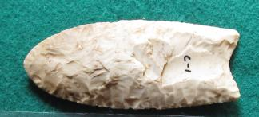

Point C-1: Clovis point showing some evidence of being reworked possibly in its midsection, and/or base and/or tip. the midsection is wider than its base the base is slightly less wide than the midsection and the point is more curved than the Clovis point (no. 10)..

SHAPE \* MERGEFORMAT 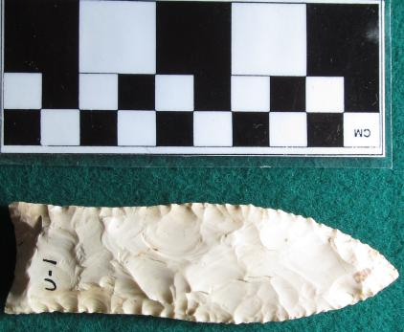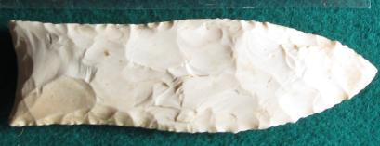

SHAPE \* MERGEFORMAT 