DIS-POINTS-Dalton-Alabama

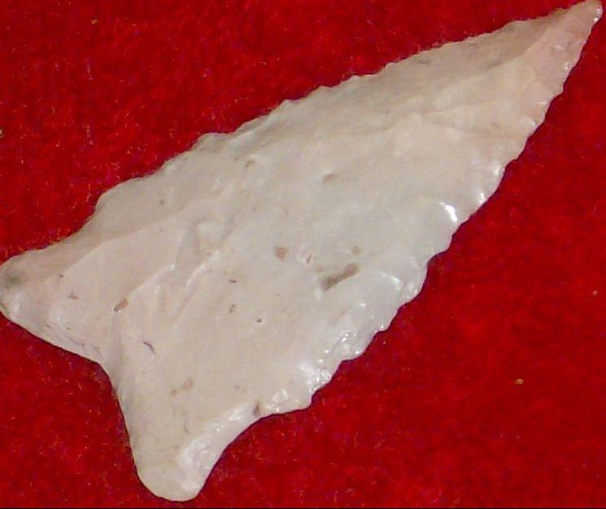

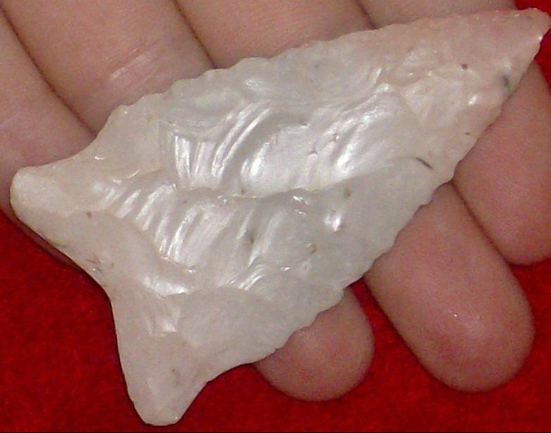

THIS ARROWHEAD  COMES FROM A COLLECTION OF 500  WE BOUGHT LAST YEAR AT A SHOW IN NORTH ALABAMA. MOST  FROM ALABAMA.. "" THIN""  THIS   ONE  IS "  2.  1/2.  INCHES LONG ".