POINTS-Dalton-Greenbrier

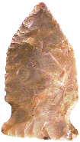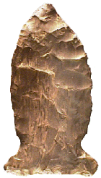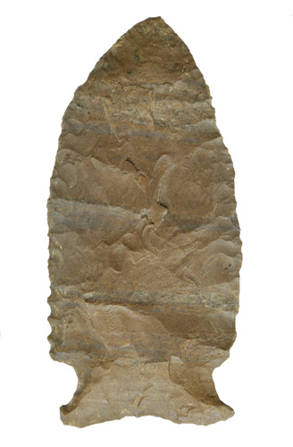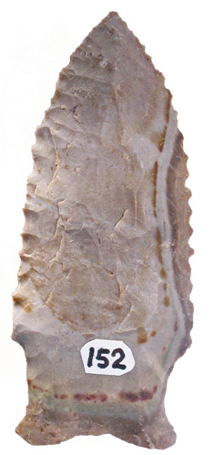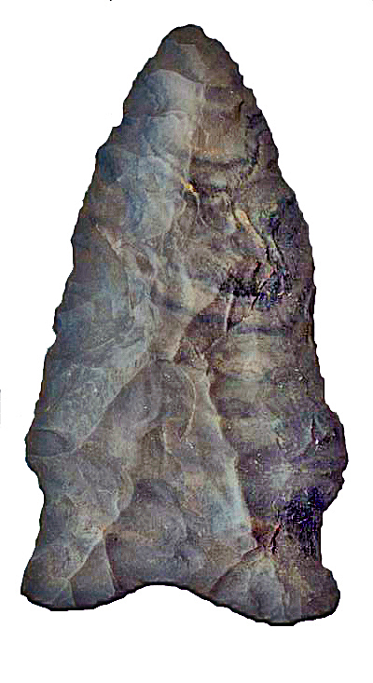

- More Points Shown Below -

Point Type: GREENBRIER  
*Also See:* Brunswick, [Dalton-Greenbrier](http://www.lithicsnet.com/daltgrnb.html), Hardaway, Osceola-Greenbrier, [Pine Tree](http://www.lithicsnet.com/pinetree.html)

Location: Southeastern United States

Associated Dates: 9500 - 6000 B.P.- [Transitional Paleo](http://www.lithicsnet.com/glossary.html" \l "Transitional Paleo) - [Early Archaic](http://www.lithicsnet.com/glossary.html" \l "Early Archaic)   
Morphology: [Side Notched](http://www.lithicsnet.com/glossary.html" \l "Notched, Side)

General Description: The Greenbrier is a medium to large, side notched, [auriculate](http://www.lithicsnet.com/glossary.html" \l "Auriculate) point with broad weak side notches. The prime identification aspects of the blade are heavy [grinding](http://www.lithicsnet.com/glossary.html" \l "Grinding) in the shoulders and [hafting area](http://www.lithicsnet.com/glossary.html" \l "Hafting Area) and fine [secondary edge flaking](http://www.lithicsnet.com/glossary.html" \l "Flaking, Secondary). The blade shape is basically triangular and varies from [recurvate](http://www.lithicsnet.com/glossary.html" \l "Recurvate) to straight due to resharpening of the blade edges. Resharpening was typically accomplished at a steep angle which resulted in [bifacially beveled](http://www.lithicsnet.com/glossary.html" \l "Bevel, Biface) blade edges. The blade edges usually include fine [serrations](http://www.lithicsnet.com/glossary.html" \l "Serrations).   
  
The Greenbrier, due to the following variants is a difficult point to type and identify. The ground base of the Greenbrier can take on a variety of outlines; it can be concave, lobbed, eared, straight or bifurcated. To further complicate identification matters, very early examples can be fluted. The hafting area displays broad [side notches](http://www.lithicsnet.com/glossary.html" \l "Notched, Side) which are created as the [shoulder](http://www.lithicsnet.com/glossary.html" \l "Shoulder) tapers into the expanded [stem](http://www.lithicsnet.com/glossary.html" \l "Stem). It is believed that this type developed from the [Dalton](http://www.lithicsnet.com/dalton.html) type as well as from the [Clovis](http://www.lithicsnet.com/clovis.html) type and then later evolved into the [Pine Tree](http://www.lithicsnet.com/pinetree.html) type.   
  
At the Hester site in Mississippi (Brookes 1975) a large number of Greenbrier points were recovered which revealed a wide range of manufacture and resharpening stages. Edge wear on these specimens indicated use as both knives and spear points.

The Greenbrier was named by T. M. N. Lewis in 1958 for examples which recovered from the Nuckolls' site in the Greenbrier area of Kentucky Lake, Tennessee. The size of the Greenbrier can range from 40 mm to 80 mm in length based upon a small sample size (6).

About The Point Above (Left): The point pictured above on the left side of the page, is a very small Greenbrier point made from a glossy brownish, greenish flint material with a few tan colored inclusions. The point measures 48 mm in length, 26 mm across the auricles, and is 9 mm thick. The stem is 20 mm wide at the notches and is 13 mm long. The blade is 25 mm wide. The base has been thinned and ground as have the notches. The edges have slight serrations and are quite sharp. This point was found in Jackson County, Alabama. Catalog Number 64-28-D

About The Point Above (Left Center): The point pictured above on the left center of the page, is a Greenbrier point made from a glossy dark brown or bark colored flint material with a few tan and cream colored inclusions. The point measures 64 mm in length, 38 mm across the auricles, and is a very thin 6 mm thick. The stem is 21 mm wide at the notches and is 14 mm long. The blade is 29 mm wide. The base is slightly concave and has been thinned and ground as have the notches. The basal ear on the left is more pointed than the rounded basal ear on the right. This point was found outside of the town of Childress Hill, Hardin County, Tennessee. Catalog Number 133-88-DAbout The Point Above (Center): The point pictured above on the center of the page, is a Greenbrier point made from a dull, dark brown Dover Chert material.   The point measures 65 mm in length, 31 mm wide at the shoulders, 29 mm across the auricles, and is 7.5 mm thick. The stem is 22 mm wide at the notches and is 12 mm long. The blade is bifacially beveled.  The blade edges are slightly serrated on the left hand side of the blade near the base. The base is  slightly concave and has been thinned and ground as have the notches.  This point was found in Tennessee. Catalog Number 157-45-V  
About The Point Above (Right Center): The point pictured above on the right center hand side of the page, is a Greenbrier point made from a semi glossy three toned gray-tan, dark brown and cream colored banded flint material with a few tan and cream colored inclusions.  The flint is banded with dark and light colors.   The point measures 61 mm in length, 27 mm wide at the shoulders, 24 mm across the auricles, and is 7.9 mm thick. The stem is 21 mm wide at the notches and is 15 mm long. The blade flat on one side and unifacially beveled resulting in a boat shaped profile.  The blade edges are serrated. The base is  concave and has been thinned and ground as have the notches.  This point was found by Tony Clinton in Livingston, KY. Catalog Number 152-119-D  
About The Point Above (Right): The point pictured above on the far right hand side of the page, is a Greenbrier point made from a dull dark brown and green or bark colored flint material with a few tan and cream colored inclusions.  The flint appears banded with dark and light colors.  When the flint is wet the colors really show well. The point measures 56 mm in length, 29 mm across the auricles, and is 8.4 mm thick. The stem is 25 mm wide at the notches and is 13 mm long. The blade is 29 mm wide. The base is  concave and has been thinned and ground as have the notches. The upper basal ear on the (left) is more pointed than the rounded basal ear on the right. This point was found outside of the town of Childress Hill in a creek bank wash, Hardin County, Tennessee. Catalog Number 188-40-CAbout The Point Below: The point pictured below (twice size) in the center of the page, is a Greenbrier point made from a dull chalky, white or tan Jeffersonville chert material with a few specks of tan and cream colored inclusions.  The point measures 46 mm in length, 26 mm across the auricles, and is 7 mm thick. The stem is 21 mm wide at the notches and is 10.8 mm long. The blade is 24 mm wide at the barbs. The base is  concave and has been thinned and ground as have the notches.  The point has very steep unifacial bevels which are on the left side of each face. This point was found in  Carroll County, Indiana.  Catalog Number 424-7-AC

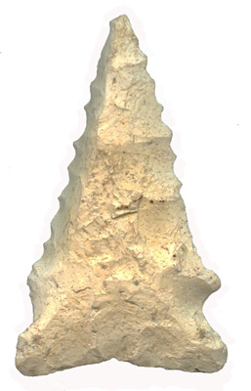

**References: Baker, Bell (2), Cambron & Hulse, Justice (1), Overstreet, Perino (1)**