# DIS-POINTS-PICKWICK

SHAPE \* MERGEFORMAT 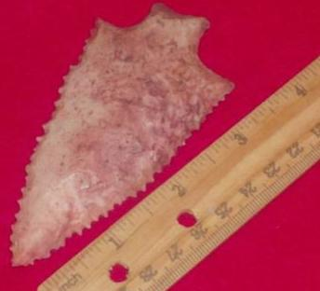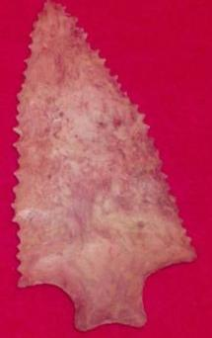

M