DIS-Points-Angostura-Final

# Angostura

Angostura is a Late Paleoindian point type named by R. P. Wheeler (1957) after examples found at the Ray Long site in the Angostura Reservoir near Hot Springs, South Dakota. The site is now under reservoir waters..  The points were renamed Angostura points for the reservoir where the site was located (Cambron and Hulse, 1964)  
Named By:  Jack Hughes  
Named For:  Type Site location  
Date Identified:  1949  
Type Site: Long Site, Angostura Reservoir, South Dakota

Hughes was a distinguished anthropologist who was considered a pioneer of Texas archaeology and a professor at West Texas University. This point was named in a professional publication and has many professional references. This is a valid type.

In Texas there are two variants of these points found.  One is this type (Texas Angostura) and the other is called the Zella Point (Turner and Hester, 1985).

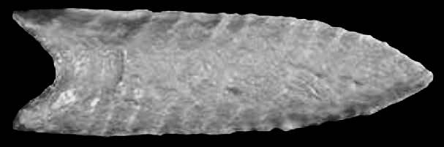  
Angostura - U of M Teaching Collection

Description: A medium- to large-sized, thin, leaf-shaped lanceolate point with a lenticular cross section. Blade edges tend to be almost parallel along the bottom half to two-thirds and to curve inward near the tip. Bases are generally concave but can be approximately straight; they are usually thinned by the removal of small vertical flakes and have ground edges. Distinctive ribbon flake scars run diagonally across the faces of classic specimens; flaking on blade surfaces is more random on other specimens in which soft hammer percussion served as the principal means of reduction. Morrow's (1984:17) Iowa sample ranges from 2.5 to 3.5 inches (6.4 to 9 cm) in length and are about 1 inch (2.5 cm) wide; some are heat-treated. Angostura points are made from a variety of raw stone material types.

Distribution: Angostura points are found most widely throughout the Great Plains, although examples have been reported from the western part of the Southeast northward to Alaska. Angostura-like points are widespread but fairly rare in Minnesota. The point type has been reported from Douglas, Fillmore, Freeborn, Itasca, Koochiching, Morrison, Nicollet, Otter Tail, and Roseau counties (SHPO archaeology database; Florin 1996: Figure 59).

Age and Associations: Radiocarbon dates suggest a date of 7000 B.C. or slightly earlier for Angostura points (Hannus 1998). Morrow also suggests an age of around 7000 B.C. Points of this type may extend well into the Archaic period in extreme northern Minnesota and adjacent parts of southern Canada.

Comments: Originally named "Long Points" for the Ray Long site, they were renamed to avoid confusion.

Similar and Identical Types: East of the Mississippi River valley, specimens lacking the classic western technological attributes tend to resemble Eastern Lanceolate points. In the Southern Plains, they are called "Texas Angostura" because of their frequency of occurrence in that state.

 Angostura  
AKA: Long Point  
*Cluster: Plano Lanceolate Cluster*

10,000 - 8,000 B.P.  
Late Paleo to Early Archaic   
Late Pleistocene to Early Holocene

*Outline is Representative of Common Size and Shape:*

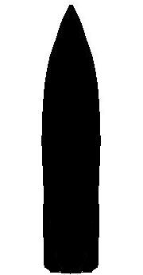

Description of Physical Characteristics and Flaking Pattern:

This is a medium to large (most average 3 inches in length) lanceolate point with an elliptical cross section. This point may range from the classic lanceolate shape to slightly articulated. The blade is most commonly an inward recurvate. The base ranges from straight to concave and may have basal thinning or grinding. The most common flaking pattern in oblique parallel with random flaking also being common. Less commonly seen is horizontal transverse.

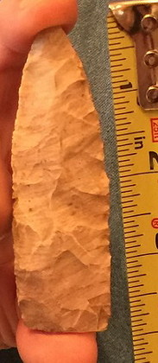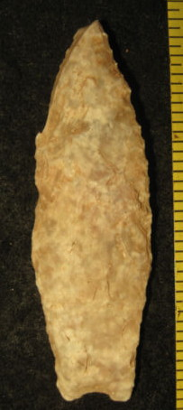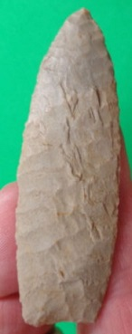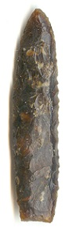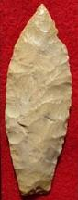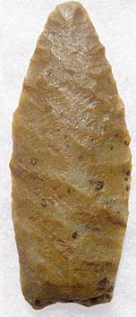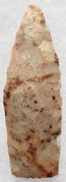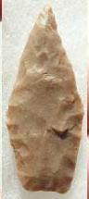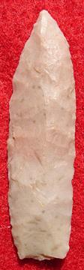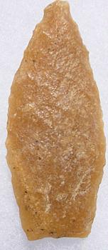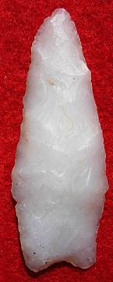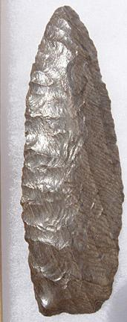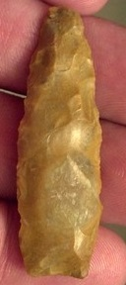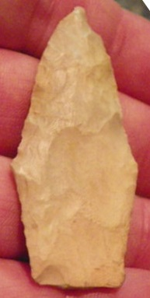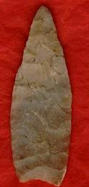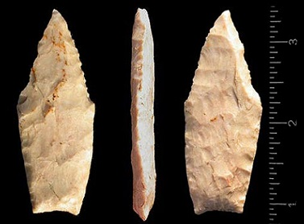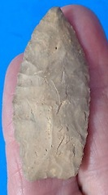

 References: (See Reference Page, Entry Number):  
  
8, 10, 12, 13, 17, 21, 23, 27, 30, 44, W2, W18

Zella  
AKA: Zella Angostura

Thomas Kelly (1983) did an analysis of Angostura point found in central to the Coastal Plains region of Texas (primarily McMullen County, Texas) and identified three variants of the Angostura points found in Texas.  He named identified these types as the Texas Angostura, Victoria Angostura, and the Zella Angostura.

