DIS-Points-Angostura

# Angostura

Angostura is a Late Paleoindian point type named by R. P. Wheeler (1957) after examples found at the Ray Long site in the Angostura Reservoir near Hot Springs, South Dakota. The site is now under reservoir waters.

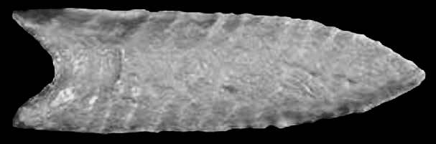  
Angostura - U of M Teaching Collection

Description: A medium- to large-sized, thin, leaf-shaped lanceolate point with a lenticular cross section. Blade edges tend to be almost parallel along the bottom half to two-thirds and to curve inward near the tip. Bases are generally concave but can be approximately straight; they are usually thinned by the removal of small vertical flakes and have ground edges. Distinctive ribbon flake scars run diagonally across the faces of classic specimens; flaking on blade surfaces is more random on other specimens in which soft hammer percussion served as the principal means of reduction. Morrow's (1984:17) Iowa sample ranges from 2.5 to 3.5 inches (6.4 to 9 cm) in length and are about 1 inch (2.5 cm) wide; some are heat-treated. Angostura points are made from a variety of raw stone material types.

Distribution: Angostura points are found most widely throughout the Great Plains, although examples have been reported from the western part of the Southeast northward to Alaska. Angostura-like points are widespread but fairly rare in Minnesota. The point type has been reported from Douglas, Fillmore, Freeborn, Itasca, Koochiching, Morrison, Nicollet, Otter Tail, and Roseau counties (SHPO archaeology database; Florin 1996: Figure 59).

Age and Associations: Radiocarbon dates suggest a date of 7000 B.C. or slightly earlier for Angostura points (Hannus 1998). Morrow also suggests an age of around 7000 B.C. Points of this type may extend well into the Archaic period in extreme northern Minnesota and adjacent parts of southern Canada.

Comments: Originally named "Long Points" for the Ray Long site, they were renamed to avoid confusion.

Similar and Identical Types: East of the Mississippi River valley, specimens lacking the classic western technological attributes tend to resemble Eastern Lanceolate points. In the Southern Plains, they are called "Texas Angostura" because of their frequency of occurrence in that state.