DIS-Points-Archaic-AL

THESE ARROWHEADS  COME FROM A COLLECTION OF 500  WE BOUGHT LAST YEAR AT A SHOW IN NORTH ALABAMA.. MOSTLY FIELD POINTS FROM ALABAMA.. "" THIN""  THE BIGGEST  ONE  IS "" 2. 1/4. INCHES LONG.""

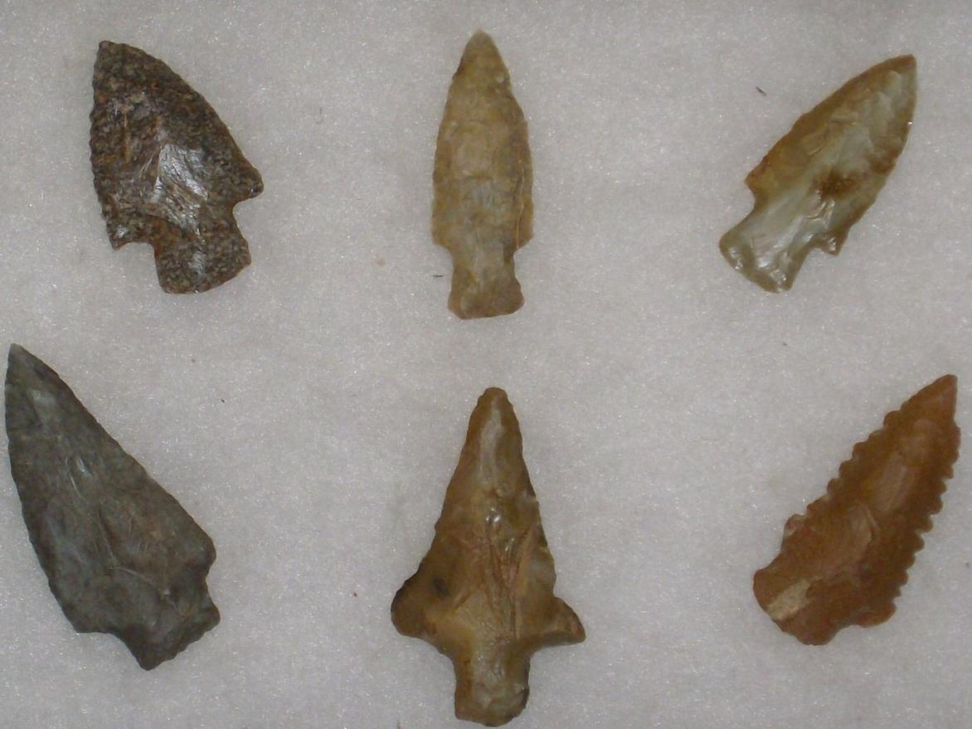

SHAPE \\* MERGEFORMAT 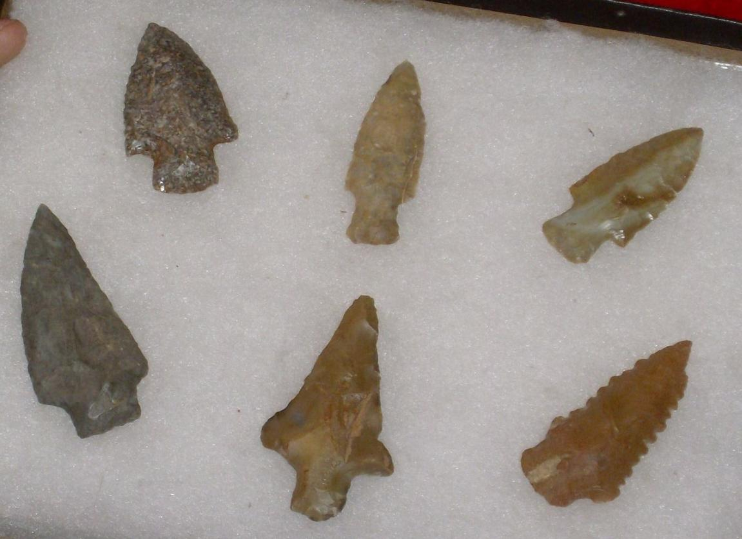 SHAPE \\* MERGEFORMAT 