DIS-Points-Hemphill-Illinois

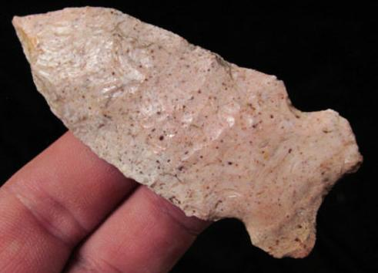 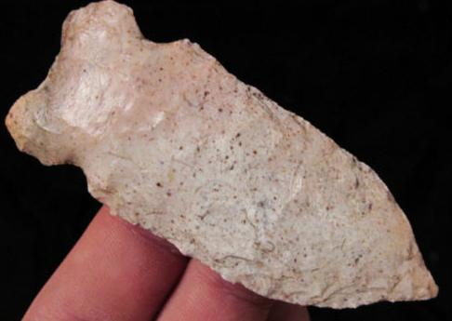

2 3/4" long Hemphill point

From: Madison Co., Illinois

Material: an attractive pinkish colored flint material

# ILLINOIS HEMPHILL POINT Arrowhead Authentic Artifact r

## Seller information

|  |  |
| --- | --- |
|  |  |

[mydirtyolboots](http://www.ebay.com/usr/mydirtyolboots?_trksid=p2047675.l2559) ([5310](http://feedback.ebay.com/ws/eBayISAPI.dll?ViewFeedback&userid=mydirtyolboots&iid=391260690399&ssPageName=VIP:feedback&ftab=FeedbackAsSeller&rt=nc&_trksid=p2047675.l2560) )

100% Positive feedback

[Follow this seller](http://www.ebay.com/itm/COLORFUL-ILLINOIS-HEMPHILL-POINT-Arrowhead-Authentic-Artifact-r-/391260690399?ssPageName=STRK%3AMEBIDX%3AIT&_trksid=p2047675.l2557&nma=true&si=NuSo68aY%252BzUT8d2z6M4JSvPsi48%253D&orig_cvip=true&rt=nc)

Visit store:

[The Relic Room](http://stores.ebay.com/The-Relic-Room?_trksid=p2047675.l2563)

[See other items](http://www.ebay.com/sch/mydirtyolboots/m.html?item=391260690399&nma=true&orig_cvip=true&rt=nc&ssPageName=STRK%3AMEBIDX%3AIT&si=NuSo68aY%252BzUT8d2z6M4JSvPsi48%253D&_trksid=p2047675.l2562)

## Item Information

Top of Form

Item condition:

--not specified

Ended:

Sep 19, 2015 , 8:10PM

Winning bid:

US $14.50

Bottom of Form