DIS-Points-Lafayette

**Lafayette Notched Point**

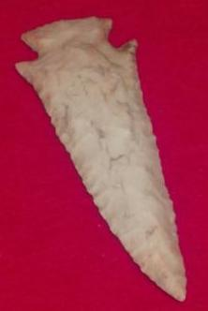 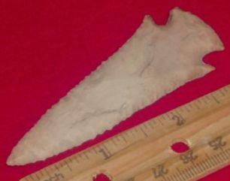

**Lafayette [Notched] Point, named by Ripley P. Bullen in 1968, is a medium-to-large point with corner notches which give it a dovetail look. Type dates 1000 BCE and is found in Florida. Bullen (1975) suggests: ... "corner notched point with a straight, sometimes excurvate base.**

**Major attribute: hanging barbs.**

**Type validity: traditional.**

**References:**

**Bullen, Ripley P. 1968. *A Guide to the Identification of Florida Projectile Points*. Florida State Museum, University of Florida, Gainesville, FL.**

**Elliot, Daniel T. and Kenneth Sassaman 1995. *Archaic Period Archaeology of the Georgia Coastal Plain and Coastal Zone*. University of Georgia, Laboratory Series, Report No.5, Georgia Archaeological Research Design Paper, No. 11. Athens: West Georgia College.**

**Ledbetter, J. Jerald 1995. *Archaeological Investigations at Mill Branch Sites 9WR4 and 9WR11, Warren County, Georgia*. Technical Reports NO.3,**

**Atlanta: Archaeological Services Division.**

**Milanich, Jerald T. 1994. *Archaeology of Pre-Columbian Florida*. Gainesville: University Press of Florida.**

**Milanich, Jerald T. and Charles H. Fairbanks 1980. *Florida Archaeology*. New York: Academic Press.**

**Perino, Gregory 1985. *Selected Preforms, Points and Knives of the North American Indians*, Vol. 1. Idabel, OK: Points and Barbs.**