DIS-TAINO-Pestle

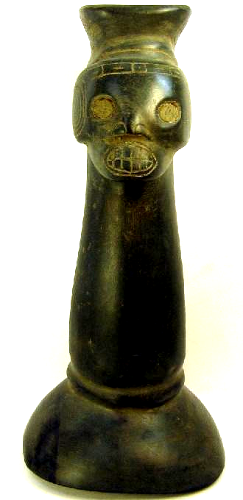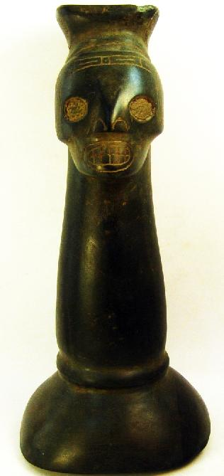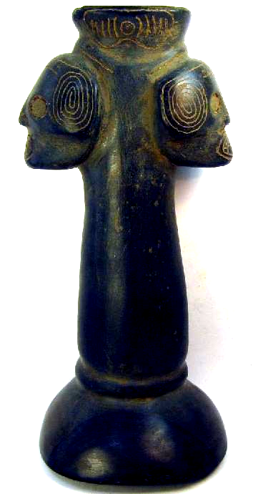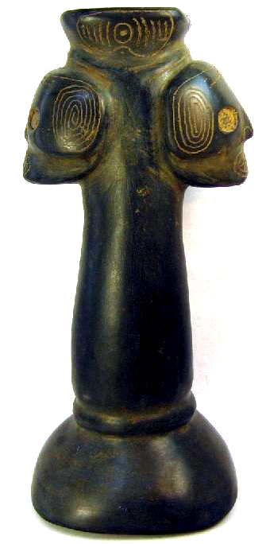

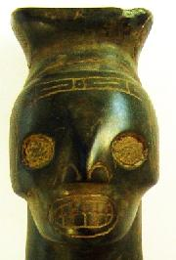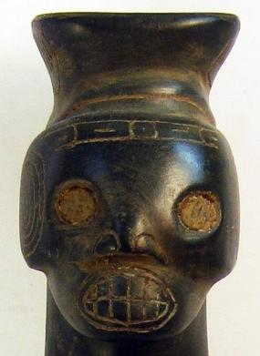

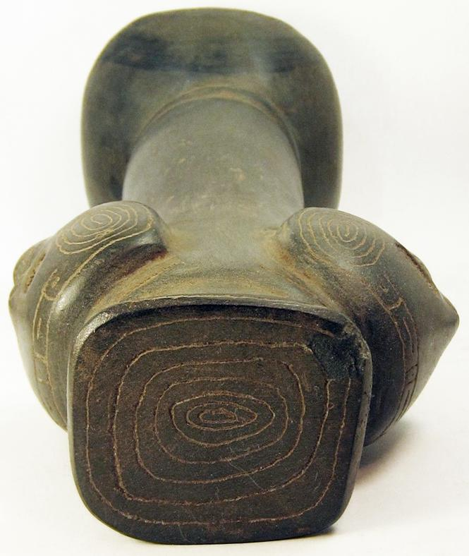 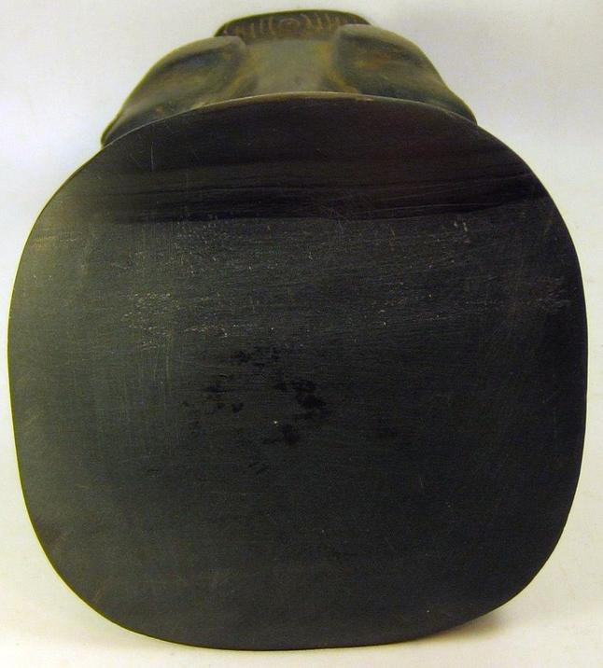

“There is a small chip on the top. This is also called a majador or pilon.”

### Delivery package 1 of 1

Estimated delivery Friday, Oct 16, 2015

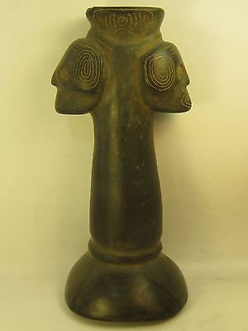

#### [Taino carved stone pestle statue sculpture Zemi Puerto Rico 10.5 in. majador](http://www.ebay.com/itm/151837243632)

|  |  |
| --- | --- |
| Item price | $450.00 |
| Quantity | 1 |
| Item number | 151837243632 |
| Shipping service | Standard Shipping |