DIS-Trees-Archaeopteris

DIS-Vermont-Kaolinite

**Archaeopteris Fossil Tree Trunk Fragment, Monkton, Vermont, abandoned quarry**

This Devonian Age (380-360 million years ago) fossil tree trunk fragment of Archaeopteris is a progymnosperm from which all seed plants evolved. It was found in August 2005 in an abandoned Monkton, Vermont, kaolinite quarry. The specimen of the Archaeopteris trunk presented here on the left with its approximately 17-inch-diameter trunk clearly shows vertical bark ridges that distinguishes it from its cousin the Gilboa tree-fern with its horizontal bark ridges (Stein et al. 2007).

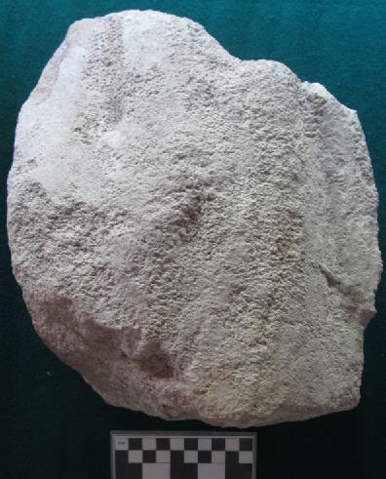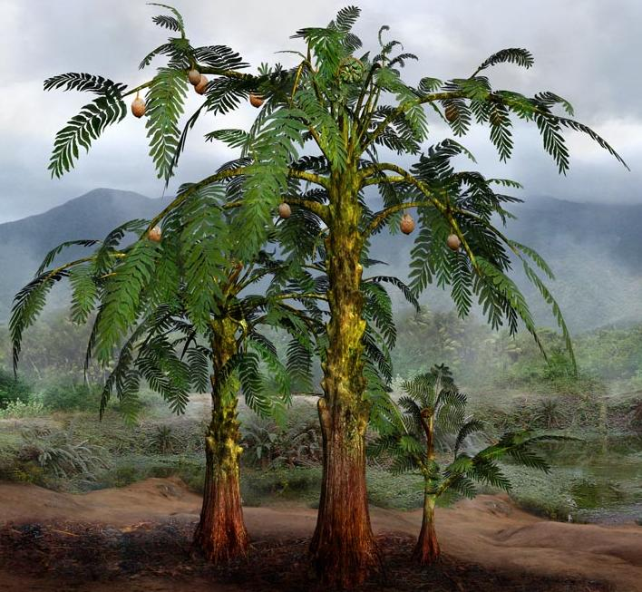

Left: Archaeopteris tree trunk fossil fragment, Monkton, Vermont. Right: Reconstruction of Archaeopteris trees from the Middle Devonian (397 million to 385 million years BP), after http://jfhdigital.com/wp-content/uploads/Alethopteris.jpg.

Archaeopteris trees proliferated in damp forests along the banks of sloughs that were oriented north-south along the Cheshire Formation that extends southward from Lake Champlain along a linear belt on the western side of the Vermont and the eastern side of New York, an area that was the shore of an ancient sea (Taylor and Taylor 1993). The clay mineral kaolinite that constitutes the material of this fossilized trunk is a hydrous aluminum silicate [Al2(Si2O5)(OH)4] and was quarried at Monkton, Vermont, from the early 1800's until the late 1960's to make white house paint and pottery. However, because Monkton kaolinite contained a high proportion of quartz grains it was not pure enough to use in its natural state so the quartz grains had to be removed by a separation process that by the 1960's became too costly and so the Monkton quarry was abandoned. Other quarries in Bennington and Shaftsbury, Vermont, also mined kaolinite, but they were able to extract the kaolin more cheaply probably because the quartz content was less and so they were able to remain in operation.

References:

## Stein, William E., Frank Mannolini, Linda Van Aller Hernick, Ed Landing & Christopher M. Berry. 2007. Giant cladoxylopsid trees resolve the enigma of the Earth's earliest forest stumps at Gilboa, *Nature* 446, 904-907 (19 April).

|  |  |
| --- | --- |
|  | Taylor; Thomas N, Edith L Taylor. 1993. *The biology and evolution of fossil plants*. Englewood Cliffs, N.J. : Prentice Hall. |

Archaeopteris trees proliferated in damp forests along the banks of sloughs that were oriented north-south along the ancient north-south kaolin belt along the western side of the State extending from Lake Champlain south to Hudson, New York.

The specimen of Archaeopteris presented here clearly shows the vertical bark ridges and extrapolated approximately 17 inch diameter of the trunk from which it came.

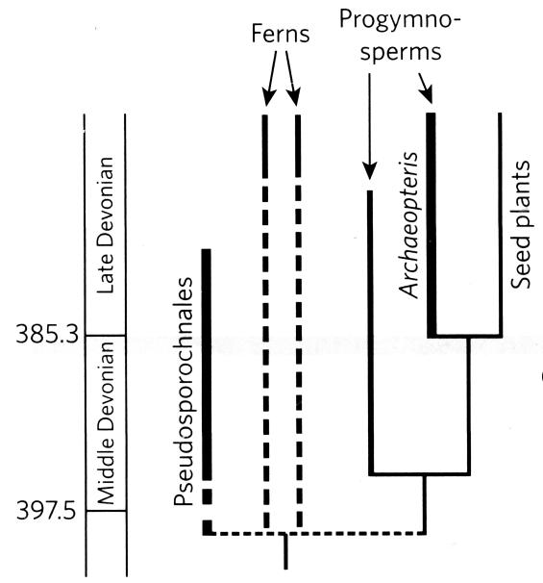

Initially, Kaolin was mined sporadically at Monkton, Vermont, during the late 1700's and the early 1800's but it remained a fledgling industry until a method of removing the quartzite impurities from the kaolin made the natural resource an economically feasible base for white paint, which was responsible for creating the "signature" Vermont countryside studded with pure white clapboard houses. Purified kaolin also made it possible to produce high quality pottery in fledgling industries in Bennington and Shaftsbury beginning in the late 1800's and continuing to the present.

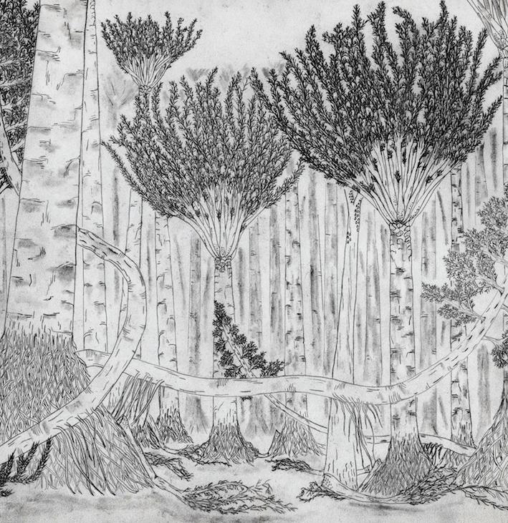

One of the earliest forests in the world was home to towering palmlike trees and woody plants that crept along the ground like vines, a new fossil find reveals.

The forest, which stood in what is now Gilboa, N.Y., was first unearthed in a quarry in the 1920s. But now, a new construction project has revealed for the first time the forest floor as it stood 380 million years ago in the Devonian period.

"For the first time, we actually have a map of about 1,200 square meters (12,900 square feet) of [a Devonian forest](http://www.livescience.com/18254-plants-extinction-climate-change-rivers.html)," said study researcher Chris Berry, a scientist at Cardiff University in the United Kingdom. "We know which plants were growing where in this forest, and how they were interacting."

The [fossilized forest](http://www.livescience.com/18569-ancient-forest-preserved-ash.html) floor contained three types of enormous plants. The first, known as the Gilboa tree or Eospermatopteris, was once thought to be the only type of tree in the forest; quarry workers have been carting specimens out of the area since the fossil plants were first discovered. This tree was tall and looked like today's palm trees, with a crown of branches at the very top.

But an even stranger specimen lurked in this ancient forest. Amid the towering Gilboa trees were woody creeping plants with branches about 6 inches (15 centimeters) in diameter. These giant plants, known as progymnosperms, seemed to lean against the Gilboa trees for support, perhaps even climbing into them occasionally, Berry said.

"Those trees were covered in little branches which sprung out in all directions and made a sort of thicket on the floor of the forest," Berry said. "That was a big surprise."

The researchers also found a fragment of a third type of tree, lycopsids, which would later dominate the Carboniferous period from about 360 million to about 300 million years ago. They reported their findings Wednesday (Feb. 29) in the journal Nature.

Understanding an ecosystem

The new view of the ancient forest is changing paleontologists' understanding of what [the landscape](http://landscaping-software-review.toptenreviews.com/mac-landscaping-software/green-landscaping-eco-friendly-ideas.html) looked like. The earliest researchers thought the forest was in a swamp, but Berry and his colleagues, including study leader William Stein of Binghamton University in New York, now believe the forest stood in a flat coastal plain near an ancient shoreline. It was probably buried and preserved when a river channel shifted, bringing in loads of sand to cover the forest floor.

Before the forest's death, it was probably chock full of [millipedes and insects](http://www.livescience.com/15337-creepy-crawlies-gallery-cutest-bugs.html), Berry said. As they grew, the Gilboa trees shed branches, which would have littered the forest floor and created a perfect habitat for creepy-crawlies.

"I've spent 20 years trying to imagine what these plants were like as individuals, and yet I really had no conception of them as an ecosystem," Berry said. "Going to Gilboa and sitting in the middle of the forest floor, you could almost see them growing out of the ground. … The fossil forest [came to life](http://www.livescience.com/29694-nasa-aqua-satellite-snaps-fall-foilage-images.html) in front of my eyes in a way that has never happened before."

More broadly, a deeper understanding of the forest helps paleontologists piece together the ecology of [the very earliest forests on Earth](http://www.livescience.com/18569-ancient-forest-preserved-ash.html). The Devonian period marks a time when plant life began to shift from small, scattered vegetation to large-scale forests, Berry said. Plants remove carbon dioxide from the atmosphere, and during the Devonian forest boom, carbon dioxide levels may have dropped from 15 times that of today to modern levels.

The arrival of forests changed the way the whole Earth system worked, Berry said. He and his colleagues are using the Gilboa site to understand how this ecosystem flourished.