COINS-Templar

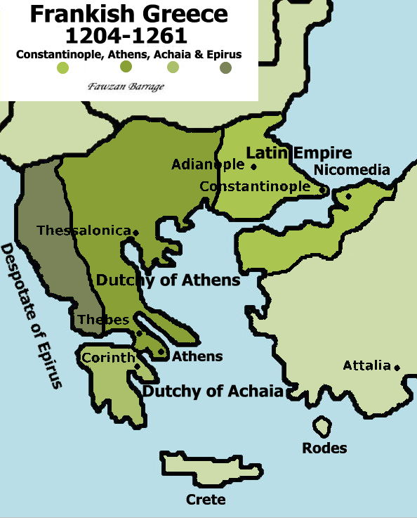

|  |  |  |  |  |  |  |  |
| --- | --- | --- | --- | --- | --- | --- | --- |
| **Ruler** | **Coins** | | | | | | |
| Clicking on the thumbnail image of the coins will bring up larger images. Clicking on the name will bring up the history. | | | | | | | |
| **Latin Empire of Constantinople** | | | | | | | |
| **Anonymous Trachea** | **[CruConstantinople_3.JPG (32004 bytes)](http://medievalcoins.ancients.info/crusaders/CruConstantinople_3.JPG)** | | Trachy Metcalf **824** |  | **[CruConstantinople_2.JPG (36126 bytes)](http://medievalcoins.ancients.info/crusaders/CruConstantinople_2.JPG)** | | Trachy Metcalf **828** |
|  | **Central Legend** | **Marginal Legend** |  |  | **Central Legend** | **Marginal Legend** |
| **Obv.** |  |  |  | **Obv.** |  |  |
| **Rev.** |  |  |  | **Rev.** |  |  |
|  | | | | | | |
| **[CruConstantinople_1.JPG (42969 bytes)](http://medievalcoins.ancients.info/crusaders/CruConstantinople_1.JPG)** | | Trachy Metcalf **830** |  |  | |  |
|  | **Central Legend** | **Marginal Legend** |  |  | **Central Legend** | **Marginal Legend** |
| **Obv.** |  |  |  | **Obv.** |  |  |
| **Rev.** |  |  |  | **Rev.** |  |  |
|  | | | | | | |
| **Baldwin I of Hainaut 1204-1205** |  | | | | | | |
| **Henry of Hainaut 1206-1216** |  | | | | | | |
| **Peter of Courtenay 1217** |  | | | | | | |
| **Yolande of Courtenay 1217-1219** |  | | | | | | |
| **Conor of Bethune Regent 1219-1220** |  | | | | | | |
| **John Colonna Regent 1220** |  | | | | | | |
| **Robert of Courtenay 1221-1228** |  | | | | | | |
| **Mary of Courtenay 1228** |  | | | | | | |
| **Narjot of Toucy Regent 1228-1231** |  | | | | | | |
| **John of Brienne, King of Jerusalem 1231-1237** |  | | | | | | |
| **Anseau of Cayeux 1237-1238** |  | | | | | | |
| **Narjot of Toucy Regent 1238-1240** |  | | | | | | |
| **Baldwin II of Courtenay 1240-1261** |  | | | | | | |
| **Latin Principality of Achaia** | | | | | | | |
| **William I of Champlitte 1205-1209** |  | | | | | | |
| **Geoffrey of Villehardouin 1209-1229** |  | | | | | | |
| **Geoffrey II of Villehardouin 1229-1246** |  | | | | | | |
| **William II de Villehardouin 1246-1278** |  | | | | | | |
| **Charles I 1278-1285** | **[AchaiaCharlesI.JPG (39683 bytes)](http://medievalcoins.ancients.info/crusaders/AchaiaCharlesI.JPG)** | | Denier Clarentza Could be attributed to either Charles I or II Metcalf 948 V.KH 202 |  |  | |  |
|  | **Central Legend** | **Marginal Legend** |  |  | **Central Legend** | **Marginal Legend** |
| **Obv.** | Châtel | DE CLARENTIA |  | **Obv.** |  |  |
| **Rev.** | Cross | K.R.PRINC'ACh |  | **Rev.** |  |  |
|  | | | | | | |
| **Charles II 1285-1289** | **[AchaiaCharlesI.JPG (39683 bytes)](http://medievalcoins.ancients.info/crusaders/AchaiaCharlesI.JPG)** | | Denier Clarentza Could be attributed to either Charles I or II Metcalf 948 V.KH 202 |  |  | |  |
|  | **Central Legend** | **Marginal Legend** |  |  | **Central Legend** | **Marginal Legend** |
| **Obv.** | Châtel | DE CLARENTIA |  | **Obv.** |  |  |
| **Rev.** | Cross | K.R.PRINC'ACh |  | **Rev.** |  |  |
|  | | | | | | |
| **Florent of Hainaut 1289-1297** | **[AchaiaFlorentdeH.JPG (41727 bytes)](http://medievalcoins.ancients.info/crusaders/AchaiaFlorentdeH.JPG)** | | Denier Clarentza Metcalf 958 V.F3 |  |  | |  |
|  | **Central Legend** | **Marginal Legend** |  |  | **Central Legend** | **Marginal Legend** |
| **Obv.** | Châtel | +D'CLARENCIA |  | **Obv.** |  |  |
| **Rev.** | Cross | +FLORENS P:ACh |  | **Rev.** |  |  |
|  | | | | | | |
| **Isabelle de Villehardouin 1297-1301** | **[AchaiaIsabelledeVillehardouin.JPG (45453 bytes)](http://medievalcoins.ancients.info/crusaders/AchaiaIsabelledeVillehardouin.JPG)** | | Denier Clarentza Metcalf 970 V.Y3 |  |  | |  |
|  | **Central Legend** | **Marginal Legend** |  |  | **Central Legend** | **Marginal Legend** |
| **Obv.** | Châtel | +DE CLARENCIA |  | **Obv.** |  |  |
| **Rev.** | Cross | +YSABELLA.P .ACh |  | **Rev.** |  |  |
|  | | | | | | |
| **Philip of Savoy 1301-1307** | **[AchaiaPhilippeofSavoy.JPG (39130 bytes)](http://medievalcoins.ancients.info/crusaders/AchaiaPhilippeofSavoy.JPG)** | | Denier Clarentza Metcalf 977 V.PS3 |  |  | |  |
|  | **Central Legend** | **Marginal Legend** |  |  | **Central Legend** | **Marginal Legend** |
| **Obv.** | Châtel | +DE CLARENCIA |  | **Obv.** |  |  |
| **Rev.** | Cross | +PhS.D'SAB. P.AChE |  | **Rev.** |  |  |
|  | | | | | | |
| **Philip of Taranto 1307-1313** | **[AchaiaPhilippedeTarente.JPG (43973 bytes)](http://medievalcoins.ancients.info/crusaders/AchaiaPhilippedeTarente.JPG)** | | Denier Clarentza Metcalf 979 V.PT1 |  |  | |  |
|  | **Central Legend** | **Marginal Legend** |  |  | **Central Legend** | **Marginal Legend** |
| **Obv.** | Châtel | +DE CLARENCIA |  | **Obv.** |  |  |
| **Rev.** | Cross | +PhS P.ACH. TAR. D.R |  | **Rev.** |  |  |
|  | | | | | | |
| **Loius of Burgundy 1313-1316** |  | | | | | | |
| **Maud of Hainaut 1316-1321** |  | | | | | | |
| **John III of Gravina 1322-1333** | [EpirusJohnII.JPG (37123 bytes)](http://medievalcoins.ancients.info/crusaders/EpirusJohnII.JPG) | | Denier Clarentza Metcalf 1019 V.B2 |  |  | |  |
|  | **Central Legend** | **Marginal Legend** |  |  | **Central Legend** | **Marginal Legend** |
| **Obv.** | Châtel | +DE CLARENCIA |  | **Obv.** |  |  |
| **Rev.** | Cross | +IOhSD.A ChE |  | **Rev.** |  |  |
| **Robert of Taranto 1333-1364** |  | | | | | | |
| **Latin Dutchy of Athens** | | | | | | | |
| **Otto of La Roche 1205-1225** |  | | | | | | |
| **Guy of La Roche 1225-1263** |  | | | | | | |
| **John of La Roche 1263-1280** |  | | | | | | |
| **William of La Roche 1280-1287** | [AthensWilliamI.JPG (41928 bytes)](http://medievalcoins.ancients.info/crusaders/AthensWilliamI.JPG) | | Denier Thebes Metcalf 1032 |  |  | |  |
|  | **Central Legend** | **Marginal Legend** |  |  | **Central Legend** | **Marginal Legend** |
| **Obv.** | Châtel | +G:DVX: ATENES: |  | **Obv.** |  |  |
| **Rev.** | Cross | +ThEBE:CIVIS |  | **Rev.** |  |  |
|  | | | | | | |
| **Guy II of La Roche 1287-1308** | [AthensGuyII.JPG (40872 bytes)](http://medievalcoins.ancients.info/crusaders/AthensGuyII.JPG) | | Denier Thebes Metcalf 1032 |  |  | |  |
|  | **Central Legend** | **Marginal Legend** |  |  | **Central Legend** | **Marginal Legend** |
| **Obv.** | Châtel | +G:DVX: ATENES: |  | **Obv.** |  |  |
| **Rev.** | Cross | +ThEBE:CIVIS |  | **Rev.** |  |  |
|  | | | | | | |
| **Walter of Brienne 1309-1311** |  | | | | | | |
| **Latin Kingdom of Thssalonica** | | | | | | | |
| **Boniface of Montferrat 1204-1207** |  | | | | | | |
| **Demetrius of Montferrat 1207-1224** |  | | | | | | |