DIS-COLLECTION-CHINA-NUMISMATICS

`DIS- Asia-China- Numismatics-Cast Coins

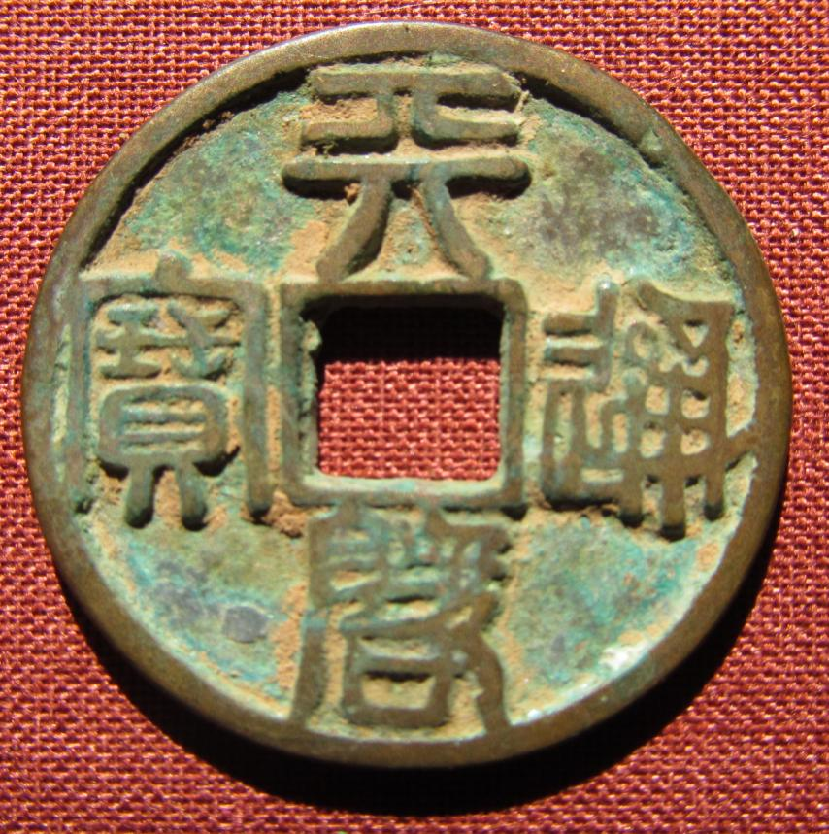 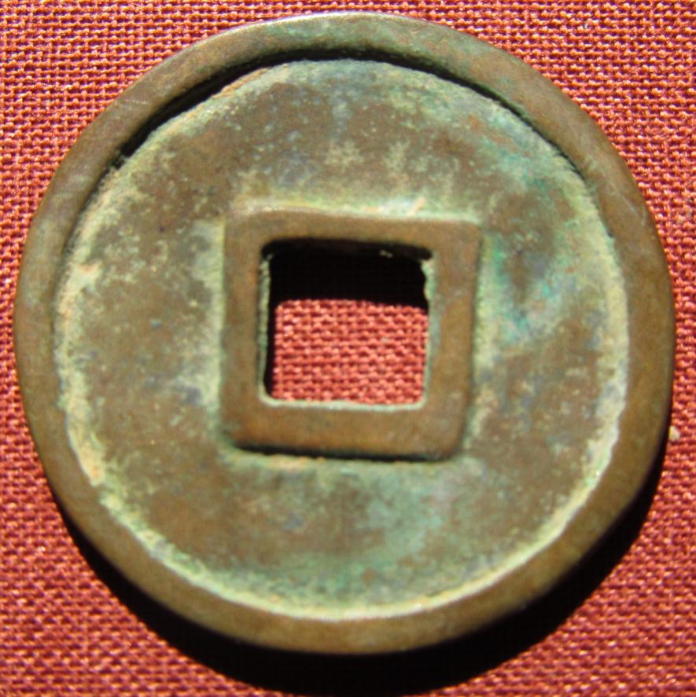

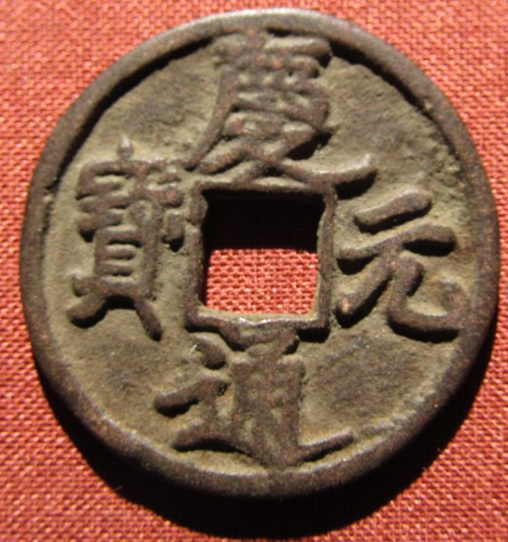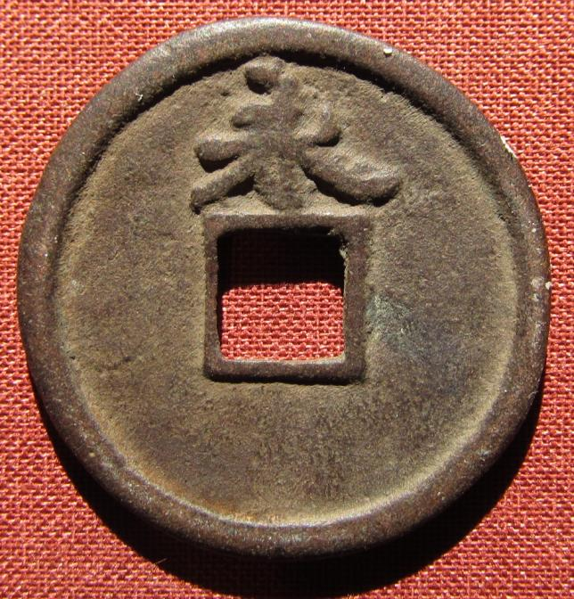

`DIS- Asia-China- Numismatics-Knives

The first monetary knives of antique China, called "sharp knives", *jianshou dao*, came from the knives of the hunters and shepherds of the North of China. Indispensable instrument for the agricultural and pastoral life, for the nomads and the breeders, the knife became an exchange object, general equivalent for all the populations of the North, Xiongnu, Ordos, Rong, Di and Oof. Gradually, by the 7-th century BC, the monetary knife lost any practical use, to become only a monetary sign. The monetary sharp knives are produced mainly in Yan's realm and in nomadic confederacies of Rong and Di located in the North and in the northeast of China.

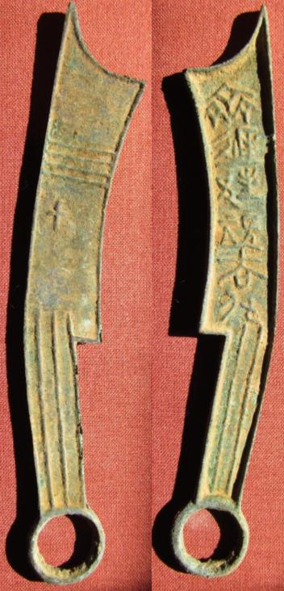

A sharp knife of Yan or the nomadic Rong or Di (6th-5th century BCE)

`DIS- Asia-China- Numismatics-spade coin-

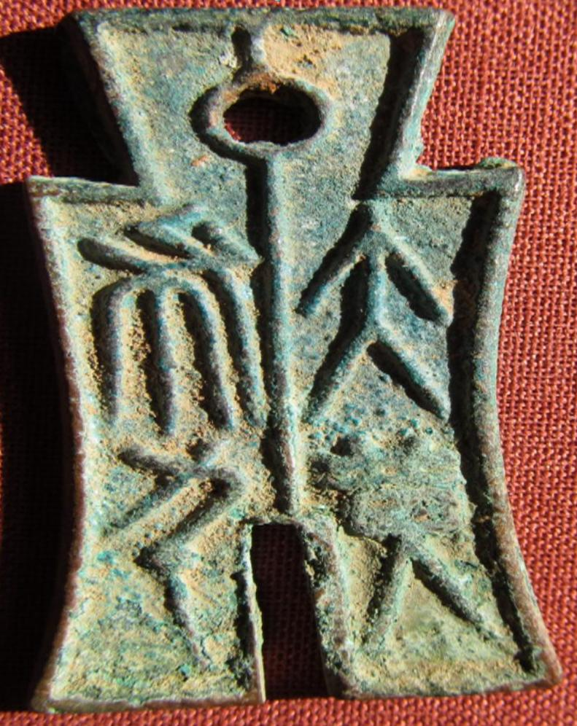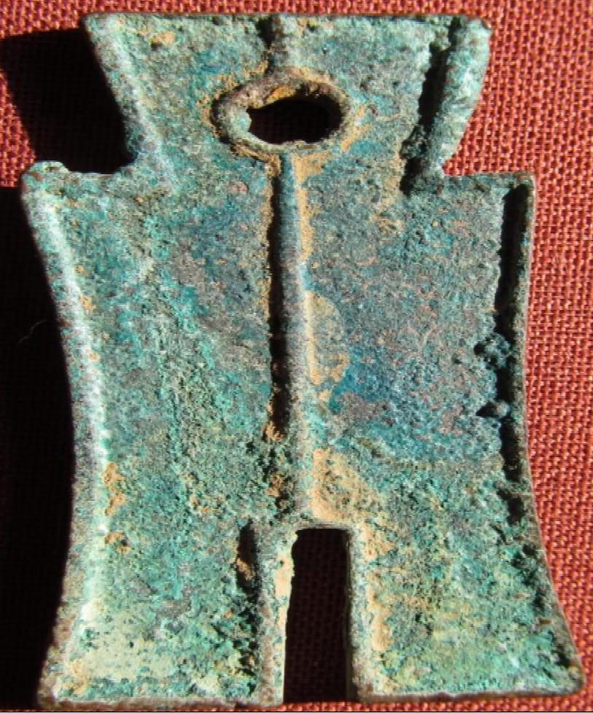  
Chinese characters divided with a vertical line Da Bu Heng Qian ("Large Spade, weight one thousand"), single inside and outside rim / Single inside and outside rim, long vertical line. Very nice green and brown patina with earthen highlights.

59mm long, 11.85 grams.

Schjoth 148; Hartill 9.30.

The inscription on this coin - "Money Spade", meant that this piece was equal to one older spade coin. These pieces were issued after the monetary reform of 14 AD. It was probably equal to 1000 Huo Quan round coins.

Wang Mang (45 BC 6 October 23 AD), was a Han Dynasty official who seized the throne from the Liu family and founded the Xin (or Hsin, meaning "new") Dynasty, ruling AD 923. The Han dynasty was restored after his overthrow and his rule marks the separation between the Western Han Dynasty (before Xin) and Eastern Han Dynasty (after Xin). Some historians have traditionally viewed Wang as a usurper, while others have portrayed him as a visionary and selfless social reformer. Though a learned Confucian scholar who sought to implement the harmonious society he saw in the classics, his efforts ended in chaos.

