Arc-Baetyl-Coins-Ebay

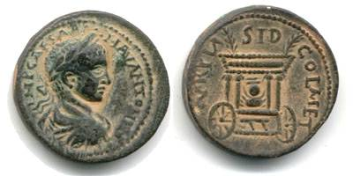

### Baetyl, the Sacred Stone

A baetyl was a meteorite or similar-looking rough stone thought to be of divine origin and worshipped, especially in the Middle East, but not only there, were as gods.  Perhaps the most famous baetyl is the stone which was venerated as the god Elagabal in [Emesa](http://www.forumancientcoins.com/numiswiki/view.asp?key=Emesa) and which his Highpriest [Bassianus](http://www.forumancientcoins.com/numiswiki/view.asp?key=Bassianus) (the later emperor [Elagabalus](http://www.forumancientcoins.com/numiswiki/view.asp?key=Elagabalus)) introduced to Rome. Below is a coin depicting the sacred stone of [Sidon](http://www.forumancientcoins.com/numiswiki/view.asp?key=Sidon).

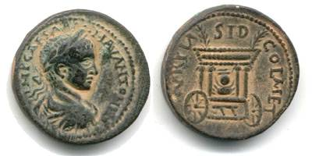

[Phoenicia](http://www.forumancientcoins.com/numiswiki/view.asp?key=phoenicia), [Sidon](http://www.forumancientcoins.com/numiswiki/view.asp?key=Sidon), Elagabal AD 218-222  
AE 30, 20.23g  
obv. IMP [CAESAR](http://www.forumancientcoins.com/numiswiki/view.asp?key=caesar) - M AV ANTONINVS, draped and [cuirassed](http://www.forumancientcoins.com/numiswiki/view.asp?key=cuirassed) [bust](http://www.forumancientcoins.com/numiswiki/view.asp?key=Bust) right  
rev. AVR PIA - SID - COL MET, two-wheeled cult cart of [Astarte](http://www.forumancientcoins.com/numiswiki/view.asp?key=Astarte), r., with roof on four columns, from which two palms emanate; on the cart the sacred stone (Baetyl) of [Sidon](http://www.forumancientcoins.com/numiswiki/view.asp?key=Sidon)  
[SNG Copenhagen](http://www.forumancientcoins.com/numiswiki/view.asp?key=SNG Copenhagen) 255  
about VF, nice sandpatina  
  
Baitylia, 'animated stones', are said to be invented by Uranos. This is a mythological circumscription of its celestial nature as meteorites which is confirmed by other references too: Baitylia come from the sky and move jumping through the air; they occur lonely or in swarms. Of various, sometimes changing, colour they hold in its spherical cover an extraterrestrial core. Some have magic power and the gift of prophecy, and are so the place of supranatural power; its annunciations based on the authority of mighty gods (Zeus, Kronos, [Helios](http://www.forumancientcoins.com/numiswiki/view.asp?key=Helios)). In this way they are related to the many aniconic stone idols.  
  
While the relicts of a stone cult in the whole mediterranean [area](http://www.forumancientcoins.com/numiswiki/view.asp?key=Area) are not [rare](http://www.forumancientcoins.com/numiswiki/view.asp?key=Rare), the evidence of a special worshipping of Baetyls is originated in the sphere of the Semitic [ethnic](http://www.forumancientcoins.com/numiswiki/view.asp?key=Ethnic): still the late time knows beside the pre-islamic cube idol of the Kaaba in Mekka  the black cube of Dusares in the Nabatean Petra and the omphalos-shaped stone of Elagabal-Ammudates in [Emesa](http://www.forumancientcoins.com/numiswiki/view.asp?key=Emesa).  
  
The rites of wrapping and clothing these cult objects constitutes the beginning of an antropomorphization, i.e. the attempt to humanize them. Mythologically this is performed in the figure of Xaabou, the virgin-mother of Dusares, but in Baitulos, the son of Kronos, too. In addition to it inscriptions from [Dura-Europos](http://www.forumancientcoins.com/numiswiki/view.asp?key=Dura-Europos) and Kafr-Neb for [Syria](http://www.forumancientcoins.com/numiswiki/view.asp?key=syria) testify the worshipping of a Zeus Betulos. The relation between Baitulos, the Baitylia and the jewish-aramaic god Bethel who is named in the Old Testament is problematic. They all to trace back to the aramaic bet'el 'the house of god' goes probably too far. But it seems to be a word of mediterranean origin.  
  
With it our view goes to [Asia Minor](http://www.forumancientcoins.com/numiswiki/view.asp?key=Asia Minor) and [Crete](http://www.forumancientcoins.com/numiswiki/view.asp?key=crete): there is the black meteorite of Ma-Kybele from Pessinus and the stone of the cretic Rhea, who was gorged by Kronos, then spewed out, in [Delphi](http://www.forumancientcoins.com/numiswiki/view.asp?key=Delphi) - where it came to earth - being salved and wrapped with bandages. It is named explicitly 'baitylos'. This reminds strong of the clothed syrean Baitylos. Behind this myth stands the cult of the aniconic Zeus Kretagenes. This is approved by Lykophron when he mentioned a Zeus Diskos.  
  
Source: Der kleine Pauly

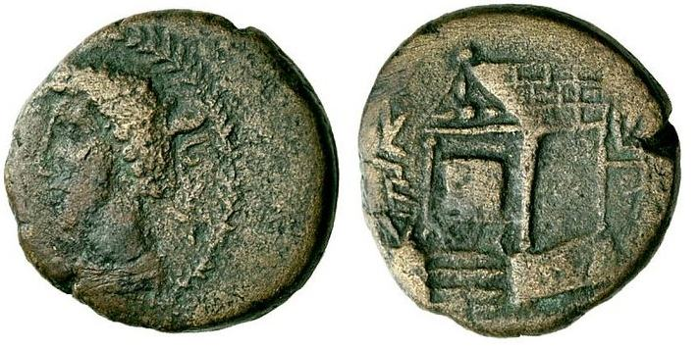

Wael, king of Edessa, Mesopotamia. 163-165 AD. AE, 8.13 g.

"Wael Malika" in local script, draped bust of Wael left, within wreath.

"Eloul The God" in local script, temple of Eloul (?) seen

in three-quarters perspective with star in pediment;

beneath the doorway a cube-shaped betyl on a pedestal.

BMC 2; Babelon 2; Lindgren II 1560.

Scarce.

With permission of Numismatik Lanz München, Auction 146, 2009, lot 269. Sold for 400 EUR (ca $560)

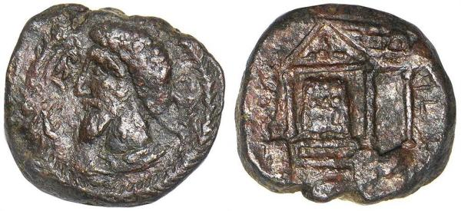

Stack's

Vermeule, Ward, and Mexico Maxico Collections

Auction date: 11 January 2010

Lot number: 175

Price realized: 220 USD + buyer's fees.

Mesopotamia. Edessa. Waël, son of Sahru, A.D. 163-165/6. AE 20 mm. 8.99 grams.

Obv: Draped bust of Waël left within wreathed border.

Rv. Square cultus object within distyle temple with triform star

in pediment, viewed in perspective from the left.

Lindgren III 1560. Hunterian III p. 304, 1. BMC p. 91, 2.

Very Good. (Est. $400-500)

Waël was the Parthian client-ruler who was installed on the

throne of Edessa by Vologases IV in 163, probably to counter

Roman influence in the city under the Roman-backed Ma'nu.

In 165/6, after a brief reign lasting a mere two years, Waël

was deposed by the Romans under Lucius Verus, who had laid siege

to and captured the city, and Ma'nu was reinstalled as the

Roman client-ruler of Edessa.

From the Estate of Cornelius C. Vermeule.

Courtesy of Stack's Auctions, March 2010.

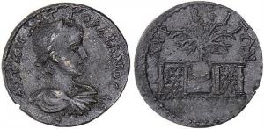

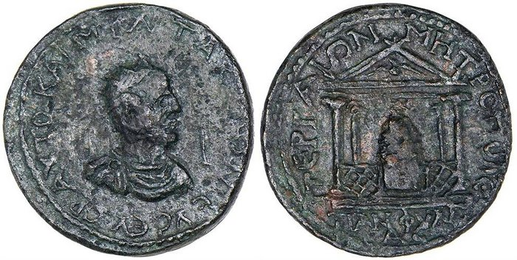

PAMPHYLIA. Perga. Tacitus, A.D. 275-276.  
  
Æ Decassarion. Radiate, draped and cuirassed bust of Tacitus right; in right field, denominational mark (I). Rv. Tetrastyle temple containing the cult image of Artemis Pergaia within latticed barrier; in pediment, eagle standing facing, head left, wings displayed. 20.89 grams. SNG BN 622. SNG von Aulock 4759. SNG Pfälzer 458. Price-Trell 594, fig. 344. Minor porosity and light roughness. Green patina. Very Fine. (600-800)  
  
Henceforth after this issue of Tacitus from Perga, all coinage struck for use in the Roman world was under central Imperial control, with the sole exception of the provincial series of Alexandria in Egypt which continued to be struck into Tetrarchic times. Thus, if one excludes Alexandrian coins, this type has the particular distinction of being the very last Roman Provincial coin ever issued.   
  
From the Estate of Cornelius C. Vermeule; ex Triton V, January 2002, Lot 1742.

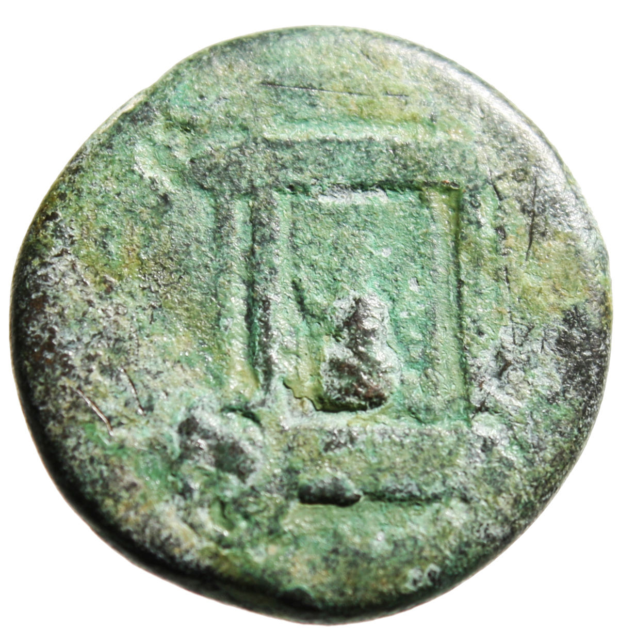 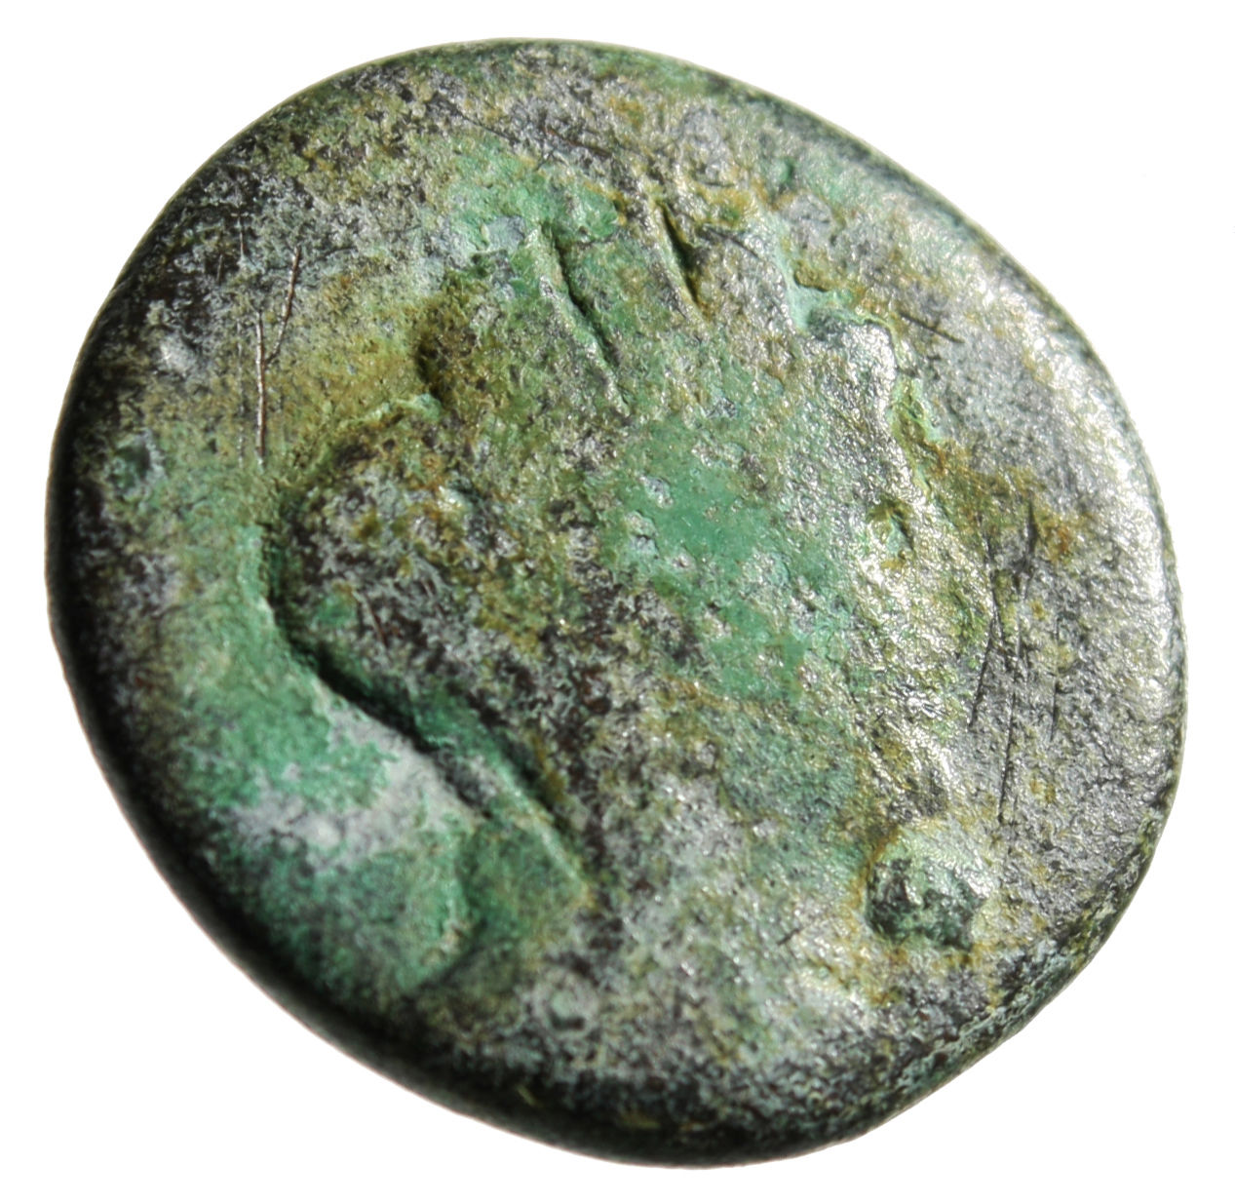

Time of Trajan: AE Civic Issue

Phoenicia, Sidon Mint 98-117 AD

Obverse: Turreted, draped bust of Tyche right

Reverse: SIDONWN QEAS to left and right, Cart of Astarte on wheels, containing sacred baetyl, conceivably a meteorite, date below

Rouvier: 1392 Rare

Size: 23mm, 8.82g

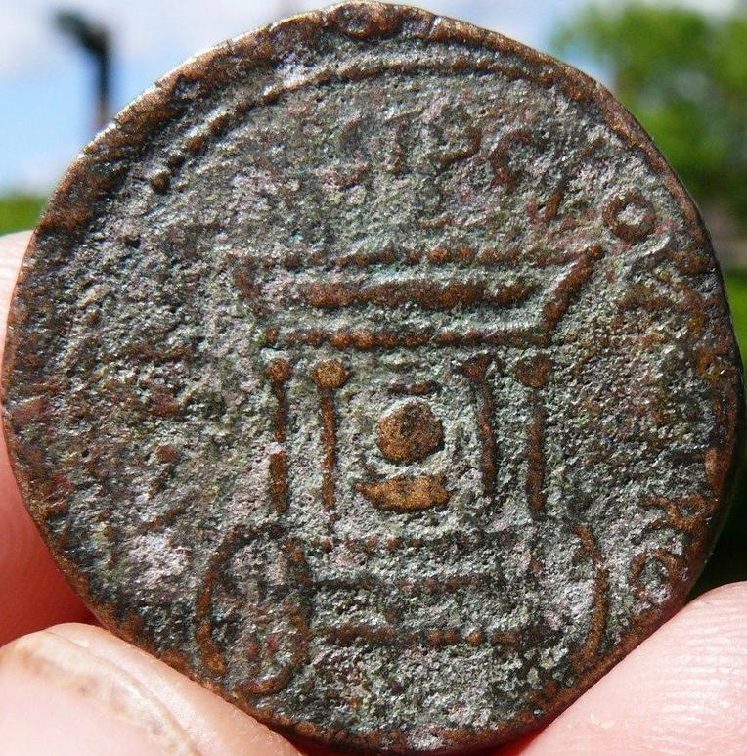 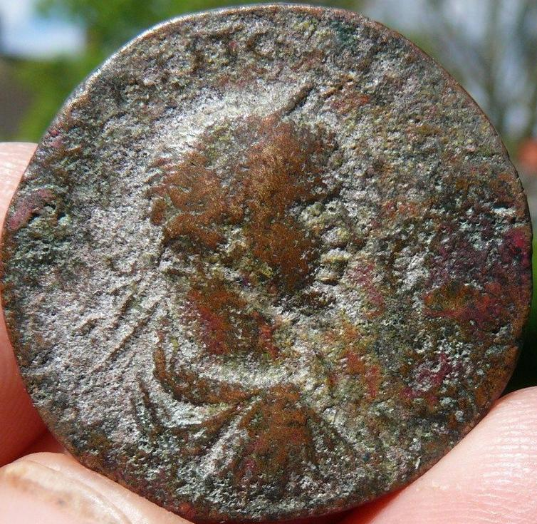

Sidon. Elagabalus. AD 218-222. Æ 29mm . Obv Laureate, draped, and cuirassed bust right; Rev Car of Astarte: cult xoanon within ornate tetrastyle canopy, set on two-wheeled base; two palms emerging from roof of structure. Ref  SNG Copenhagen 256; Howgego 396.

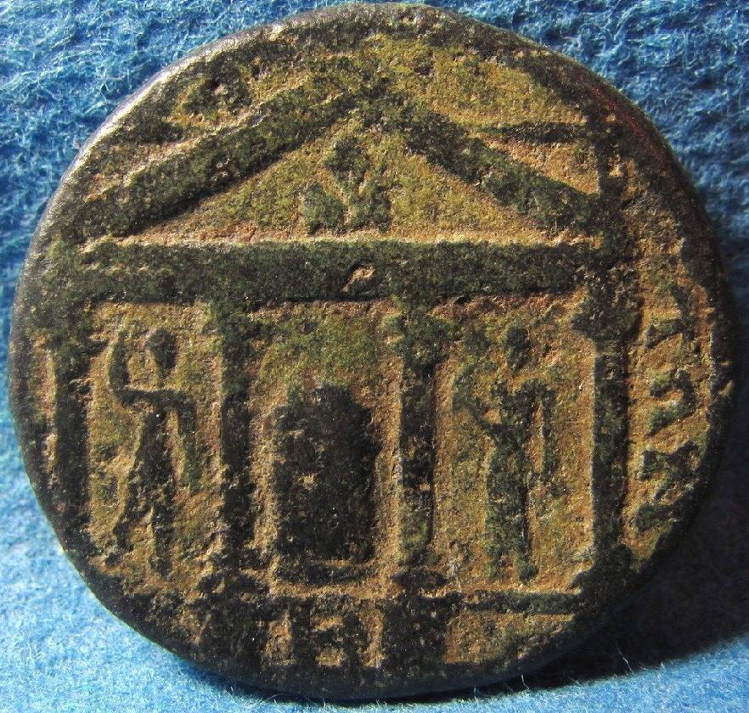

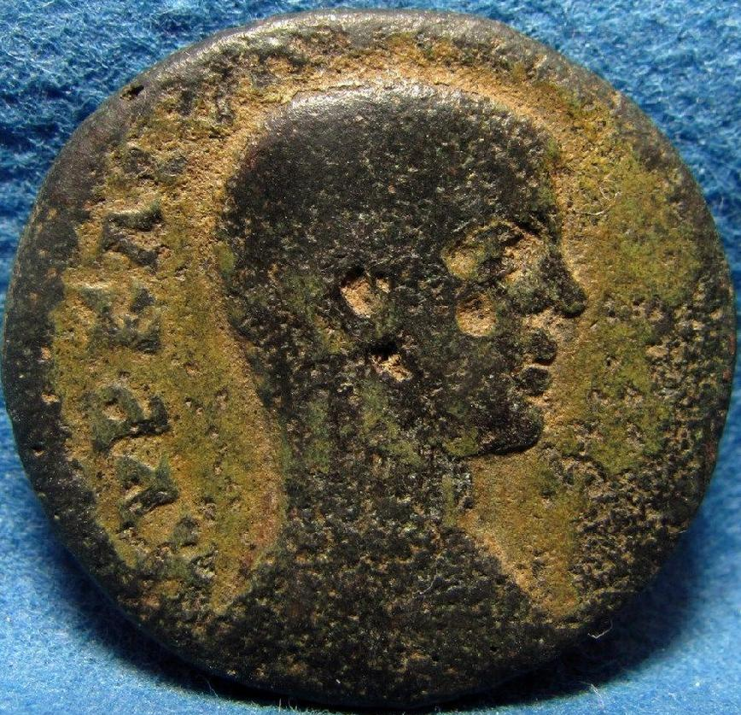

PHOENICIA, Tripolis. Elagabalus. AD 218-222. Æ. Ancient coin.

Laureate, draped, and cuirassed bust right, seen from behind /

Flaming altar of Zeus Hagios within tetrastyle temple; Helios and Selene flanking between columns

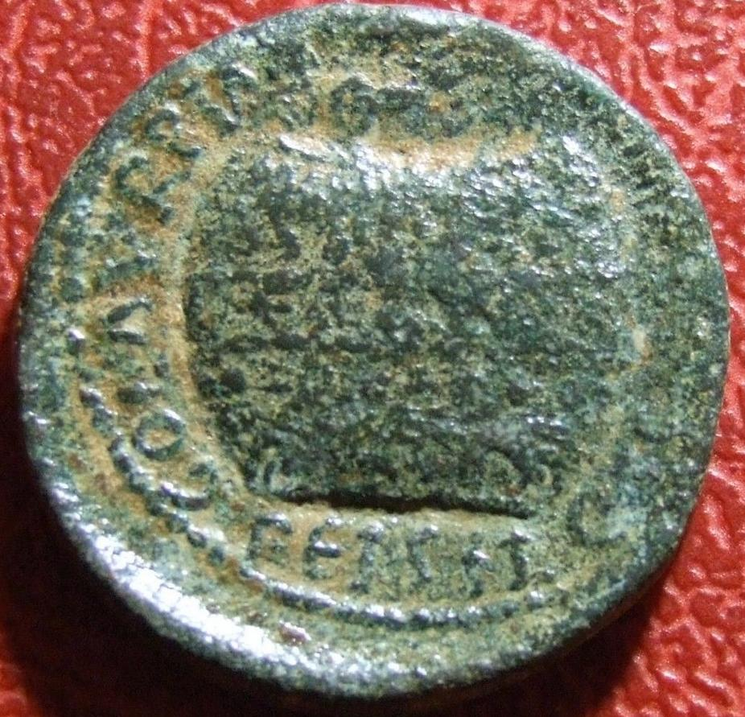

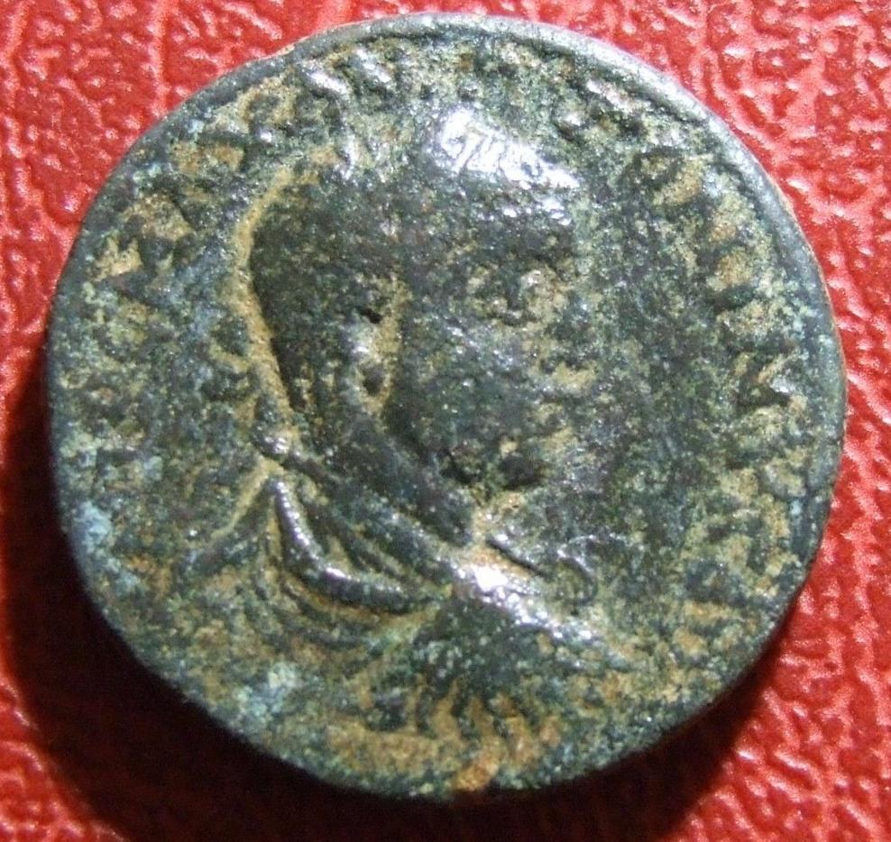 Elagabalus AE26 Agonistic urn Very Rare Roman coin to identify

Elagabalus, AE32. laureate, draped, cuirassed bust right.

Obv: Agonistic urn containing palm branch.

If you have any information about this coin please contact.

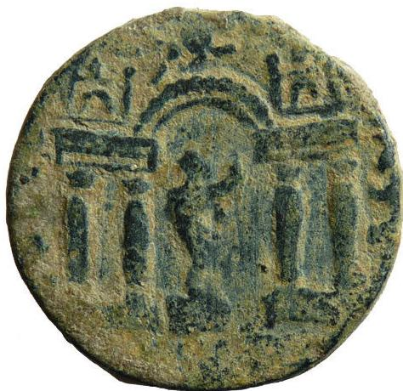 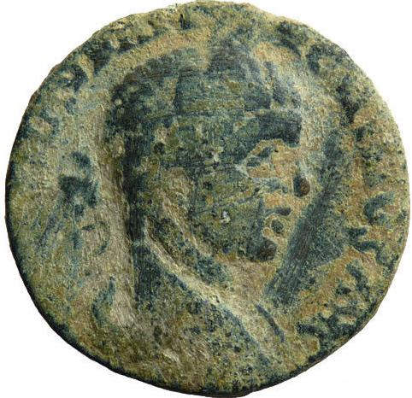

Phoenicia, Berytos. Elagabalus. Laureate, draped, and cuirassed bust right / Tetrastyle temple, the satyr Marsyas on pedestal playing pipes within. Lindgren 2269

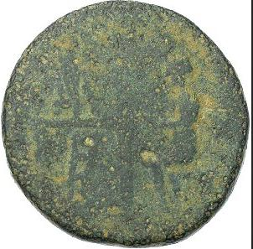 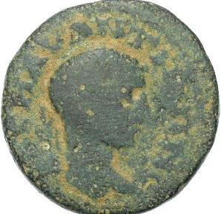

RP63100. Bronze AE 17, references: Meshorer City-Coins 275, Spijkerman 5, SNG ANS -, Rosenberger 2; condition: F/aF, mint: Charachmoba, weight: 5.235g, maximum diameter: 19.5mm, die axis: 180oobverse A K M AV ANTΩNINO, laureate head right; reverse XAPAXMΩBA, priest (on right) seated left facing a high platform altar with steps, on top of the platform: a column flanked by baetyls all on a low base and a wall or panel behind about half as high as the column; additional comments: green patina with desert earthen highlighting, interesting type; very rare, $311

|  |
| --- |
| The baetyl ultimately was the House of God - a Beth-El. These stones were venerated as having the god living or the god's soul residing within the sacred stone. They were believed to have supernatural powers as in giving the gift of prophecy. The word itself seems to be both Mediterranean and Semitic in origin. As a historical note the term baetyl for the first time was used by the author Pliny the Elder.  The stone's connection to birds: the omphalos has two - one on either side - and the Benben has the Bennu bird. The Benben does not seem to have been a geodetic marker on the order of the omphalos but rather a marker of where it all began. The Benben was the original primitive mound represented as a pyramid shaped stone and the dwelling place of the sun god with its association with the Bennu bird (also Benu bird). This is documented in the Egyptian Pyramid Texts. The Roman Baetyl also has bird associations. It was protected by an eagle which can be seen standing in front or on top of the stone on some Roman coins. |
| The omphalos stone below and to the far left is a Roman copy and covered in a design normally called a net. More likely it it a stylized pine cone of which other stones resemble. The gray stone is a replica of the Delphi stone and probably is what most of the stones looked like. The site of Delphi has been inhabited at least since the Neolithic between 5,000 and 3,000 BC. The next stone is wrapped with the serpent Python who guarded the omphalos at Pytho the name before the site was called Delphi. Omphalos meant "center of the Earth "and "navel" to the Greeks. The leaves ringing the bottom may be a reference to the Tree of Life. The last is an Egyptian illustration of the stone with two birds and two serpents. The birds show up in Greek renderings as well. The birds represent 'to lay out parallels and meridians' that is to say latitude and longitude. In Indian mythology Vishnu is found lying on the serpent Ananta inside the cosmic egg which when split half becomes the omphalos. This is part of the Indus Valley mythology. |
| The omphalos as the "navel of the earth" marks the terrestrial center from which all points are determined. Thus the parallels and meridians were measured from it - which in ancient Egypt the center was at the Temple of Amun. It marked the spot of the axis mundi which determined the cardinal points of the compass. This center ruled immense power both religious and political. In fact when the Babylonians ruled Mesopotamia they declared Marduk's temple as the axis mundi dethroning Enlil - a top pantheon god. That was quite a feat and they were successful. The Assyrians tried the same thing but were not able to accomplish what the Babylonians did. |
| In India the Shiva linga is considered an omphalos. Its shape can be conical to phallic and be made from a variety of materials. The Shiva linga has a complex symbolism including the axis mundi and as with other omphalos the serpent and fire are also other aspects of the linga. It has a direct connection to the Hindu god Shiva and is his sign as well as a fertility symbol. The Sanskrit word Shiva is an adjective meaning kind, friendly, gracious or auspicious. As a proper name it means "The Auspicious One". Shiva also has an association with serpents and the trident called the Trishula of Shiva. The trident is also a symbol of Poseidon the Greek water god who if you go back far enough to an earlier time is Enki. |
| To the far left is an omphalos stone from Ireland. It is called the Turoe Stone and dates from 150 BC to 250 BC. The shorter stone is the Castlestrange stone.  "Standing at around 3 feet high the granite boulder known as the Turoe stone is a beautifully decorated phallic stone, the top half is covered with a curvilinear design typical of the Celtic art style known as La Tene, this dates the stone to around the 1st to 3rd centuries B C, the middle is decorated with a form of Greek key. The patterns are carved in relief using a technique known as poking." (http://www.megalithicireland.com/Turoe%2520Stone.htm)  "Along the side of the farm drive in the grounds of Castlestrange Demense stands this beautifully inscribed Cult stone, decorated with curvilinear ornament and dating to around 200 BC. At 60 cm high and approx. 90 cm long, it sits on a round bed of radially placed river rocks which in turn is surrounded by a protective cattle grid. While the function of these cult stones is not clear, it is presumed that they had a ritual or religious purpose. (http://www.ancientireland.org/castlestrange/index.htm) |
| Baetyl Handles The omphalos is also known by its Latin name Baetyl and tends to look more like a tall pyramid. The images below are from Roman coins and show a winged angel on one side and on the reverse the baetyl stone. What is peculiar about these images is that the baetyl has handles on it. The first three have a handle on each side at the top. The fourth and fifth coin have a different rendering for these handles, more like knobs, and located at the top. If the baetyl does in fact come from the Egyptian Benben stone and thus the pyramidion, then it hearkens back to the winged disk and the "handles" that also appear at the top of the disk. It then would reinforce the concept that the "pointy object" could have been a container that opened and closed. Many of the images of the winged disk also had two handles.            What also raises questions is, why is this angel on the obverse of all the coins above? Same kneeling pose with the wreath and what is called a caduceus is another question. Why a caduceus? It may be a nod to the symbolism of the Tree of Life. Most Roman coins depict an emperor. Also on both sides of the baetyl are the two birds (but could be grapes) associated with Greek and Egyptian omphalos stones. The only thing missing is a serpent. Some coins without baetyl handles do have an emperor on the obverse side. |
| Tree of Life Here are three coins with associating the Tree of Life with the sacred stone. The first coin shows the classic fleur design for the leaves and fruit. The twin stones may depict a pair of oracle stones which was common at that time but these still are considered baetyls. Oracles were associated with the baetyl. The second shows the Tree growing from the baetyl itself much like the world tree growing from the primitive hill and the last is Greek with the typical Fleur-de-Lys symbol for the Tree of Life growing from the top of the omphalos. It is curious that the head of a bird is on the obverse side of this coin. |
| The Crease There appears on some coins a crease at the top of the baetyl. The three coins below have an indication of a crease. The first two coins have an obvious crease. The coin to the far right has a faint line on the same diagonal and at the same height as the other two coins. This  diagonal crease at the top of the baetyl with the same slant and location indicates it is intentional. To me it looks like a hatch but you can draw your own conclusion. Since it shows up on three of these coins there must be some unknown symbolism connected to it. Of all the coin pages I have visited not one makes any reference to it, the handles yes the crease no. The last is a mystery. It looks like three poles with an undefinable object inside. |
| Axis Mundi The coins below are even more curious in that they seem to show that the baetyl has an interior and that although this sacred stone is presumed to be solid yet there is something mysterious going on inside. It is as if the outside skin has been rendered open to reveal some sort of structure. Four of the five coins show a pole or strut. Notice at the top how the outside wraps itself over the internal object/structure of the second coin. The mundane answer to this pole could be and most likely is the axis mundi. These coins may be telling us something conneted with the baetyl in a mystical way that in reality does not belong there as these stones in real life were solid clear through. The baetyls did not have a pole inside them nor a skin that could be torn open. All of these coins also have the angel on them.          The Sphere These images are baetyls. Although the first two are fairly rough looking these two coins have what appears to be a sphere coming out of the apex of the baetyl. Even in the more worn coin the sphere is easily discernible. Once again it is located at the top along with the handles and crease. The kneeling angel is on the obverse side. The last image is of the baetyl in the Temple of Aphrodite near Paphos, Cyprus. At the very tip of the stone is a sphere. These coins are minted in different locations. These images are telling us something we do not know or even suspect. My question is does this sphere represent an abstract icon of the god or of the god's soul? This is not something I had expected to find. It's spooky.   The symbols on either side of the baetyls that have the axis mundi and crease are the mint marks delta and gamma. The axis mundi and perhaps the crease as well may represent themes of this particular mint. These coins were struck in southwestern Anatolia, now Turkey, around 400 AD in a city named Kaunos. The ancient ruins of this city are still there. Click: [Kaunos](http://firstlegend.info/3rivers/Kaunos.jpg) to see an image of it from Google Maps.  No story about the omphalos and baetyl would be complete without including the two symbols tied together at almost every turn and they would be the serpent and the bird which in this case is an eagle. Both of these creatures by the way are considered as protecting the sacred stone. In the case of the serpent, at Delphi at least, it was killed by Apollo with his silver bow thus becoming like the  dragon slayers of lore. The eagle is a strong Roman symbol. If you look closely at the serpent coin you can see the omphalos in its symbolism of the pine cone. |
| The first coin is from Syria 246-227 BC shows the god Apollo sitting on an omphalos stone which was a common scene found on many coins. But in this instance the omphalos is decorated as a pine cone. The next two coins also show the same scene with an even greater emphasis of omphalos as a pine cone. The pine cone as mentioned earlier represents the fruit from the Tree of Life. |

|  |
| --- |
| Ancient Coins Showing Sacred Stones |

|  |
| --- |
| You can click on any coin image to see the full coin. |

Sacred stones appeared on many ancient coins, Greek and Roman Provincial, and even Roman Imperial. Some of these were an interesting type, unusual to us, called a baetyl.

What was a baetyl?

The Greek word baetyl, or baetylos, probably originated from the Punic "betel" or the Semitic "bethel," both meaning the house of god. There were many of these stones across the ancient world, and it seems that they represented the spirit or essence of a deity. So, they were revered aniconic symbols of gods, indicating that they were present and accessible; they were not regarded as the gods themselves.

You might read elsewhere that these stones were meteorites. This is what Wikipedia says. But that is at best an oversimplification. Some might have been meteorites; some definitely were not. If the surface of a baetyl looked black and shiny, it was not because it had been melted in its passage through the atmosphere, but because it had been drenched in offerings of wine, oil, honey or milk for centuries.

Of course, not all sacred stones were baetyls.

The Omphalos at Delphi

Probably the most famous sacred stone was the Omphalos at Delphi. It was named "Navel" because it was supposed to be at the centre of the world. Other towns also had Omphalos stones, but these were copies or imitations of the revered original.

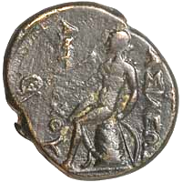A bronze coin of Antiochos I showing Apollo seated on the Omphalos of Delphi.

The site at Delphi was originally called Pytho, and was a centre of worship of the earth goddess Gê or Gaia. It seems that a sacred stone existed then, maybe as far back as Mycenaean times, 1400 to 1100 BCE. It is now thought that this original stone might have been where sacrifices were made to Gê, maybe an altar over which blood was poured, and was neither the embodiment of a deity nor a marker that indicated a god's accessible presence, so not a true baetyl.

Joseph E. Fontenrose, in an early edition of the Oxford Classical Dictionary, notes the existence of a stone block which might have been this original, sited in the adytum of Apollo's temple. It had the rough lettering ΓAΣ carved into it, meaning a dedication to the earth goddess Gê, though we don't know when these letters were carved or even, really, the shape of the block.

The site under Gê was said to have been protected by a dragon or serpent called the Python, and just a few days after [Apollo](http://www.forumancientcoins.com/moonmoth/reverse_apollo.html) was born on Delos, he came to fight it. He defeated it and took over the precincts, complete with its real prize, the most famous oracle of the ancient world, the source of Delphi's fame.

The whole site then became dedicated to Apollo. Many came to his temple, to consult the oracle. On the seventh day of the month, a priestess called the Pythia would sit on a tripod, inhale fumes from a crack in the earth, and make mysterious pronouncements said to come from the deity, which were then gracefully reworded by a college of interpreters. There are records of many famous prophecies.

The Omphalos became a symbol which represented the Delphic Apollo. So, symbols of Apollo would appear on coins which showed the Delphi Omphalos. There were many such coins and quite a few symbols.

The coin above on the right, of the Seleukid Antiochos I, shows one of the most common of such images: [Apollo](http://www.forumancientcoins.com/moonmoth/reverse_apollo.html) himself seated on the Omphalos, holding his bow and examining an arrow. Some similar coins show him grasping a laurel branch and with his [kithara](http://www.forumancientcoins.com/moonmoth/glossary.html" \l "KITHARA) standing nearby.

The coin of Neapolis below left, although not very beautiful, is here because it shows Apollo's [kithara](http://www.forumancientcoins.com/moonmoth/glossary.html" \l "KITHARA) leaning against the Omphalos. Apollo was a master musician, and was sometimes called the leader of the muses.

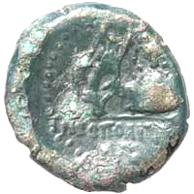A bronze coin of Neapolis showing a kithara leaning against the Omphalos of Delphi.

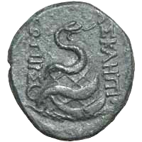A bronze coin of Pergamon showing a serpent winding around the Omphalos of Delphi.

The Omphalos was the centre of much ceremony. It was said to have been anointed every day with oil, and it was certainly wrapped with a netting of raw wool (carded, but not spun or dyed) called the [agrenon](http://www.forumancientcoins.com/moonmoth/glossary.html" \l "AGRENON). Coins, vase paintings and stone copies all show the Omphalos with this ceremonial netting, which was sometimes worn by soothsayers. Similar netting is shown on some sacrificial animals, and was also depicted as being worn by Apollo.

A stone which some take to be the original Omphalos can be seen at Delphi today, out in the open, adjacent to the Treasury of the Athenians. It is of limestone and has been carved into a half-ovoid shape. But this is unlikely to be the original, and in fact shows too little weathering to have been in the open for long.

There is a Roman copy of the stone in the Delphi museum. Like other copies, it has thick netting carved onto its surface. Beware of sources like Wikipedia which say that this is the original Omphalos. It is not.

The right-hand coin above shows a snake wound around the Omphalos, and here the netted surface is obvious. Among other things, Apollo was as a deity of medicine and healing, and this is what the [snake](http://www.forumancientcoins.com/moonmoth/snake_coins.html) represents on this coin from Pergamon, which was famous for its sanctuary of the minor healing deity [Asklepios](http://www.forumancientcoins.com/moonmoth/reverse_salus.html" \l "ASKLEPIOS).

The oracular sanctuary declined in importance during the period of the Roman Empire, and was closed in 395 CE on the orders of the Emperor Theodosius I.

Tyre's Ambrosial Rocks

Tyre was an ancient Phoenician city, which still exists on the coast of modern Lebanon. The main city was originally on an island just off the coast, a very good defensive position, but Alexander the Great built up a causeway to join it to the mainland, so as to conquer it, and so it remains today.

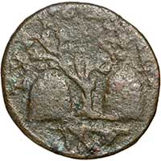A bronze coin of Elagabalus from Tyre showing the Ambrosial Rocks with an olive tree.

The name of the city means "Rock." In myth, Tyre was said to have been founded on a pair of floating rocks, the Ambrosial Rocks, upon which an olive tree grew. These rocks wandered around the sea until, with divine guidance from Melqart, they were halted and became the site of the city. And in fact there were originally two islands, which were joined by king Hiram I in the tenth century BCE.

The story of the Ambrosial Rocks was firmly fixed in the history of Tyre and they appear on several coins, like the one on the right, with the olive tree between them.

Those stones are often described as baetyls, but do not seem to have the right holy significance to truly deserve the name.

The shape in the exergue is unclear, but should show a hound, belonging to Melqart, finding a Murex shell. The Murex is a species of predatory sea-snail from which was made a fabulous and expensive dye, Tyrian Purple. This colour was reserved for royalty or aristocracy in several cultures.

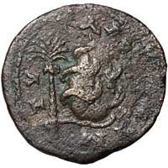A bronze coin of Elagabalus from Tyre showing a baetyl with a snake winding around it.

On the left is another coin from Tyre. It shows a date palm, the type called Phoenix, which was spread by the Phoenicians and which produces the kind of dates we still eat today. To the right of the stone, not at all clear in this example, is supposed to be another Murex shell. I'm still on the lookout for a coin with a clearly depicted Murex!

The stone in the centre is oddly shaped, as though the engraver started to make it fat at the base, and then changed his mind part way up and made it thinner to allow space for a murex shell on the right. Or perhaps this is evidence of a double strike when the coin was produced, which would explain the lack of clarity on the right.

The coin shows a baetyl with a snake winding around it. But which baetyl is this? Its shape, and the snake, are reminiscent of the Omphalos on the coin shown above. Perhaps this snake is the Python that Apollo defeated. But this is a coin of Elagabalus, and he is known for his worship of the baetyl of Emesa, shown below. So perhaps it is that stone, though this does not explain the snake.

And there is a third possibility. In the mythology of the Phoenicians, Ouranos (the sky) and Gê (the earth) gave birth to four sons, one of whom was named Baitylos. (Greek mythology has a different account.) So this stone might be a representation of a Phoenician deity, a true baetyl.

The Sacred Stone of Emesa

In the town of Emesa in Syria, now called Hims (or Homs), a sun god was worshipped. He was called Elah-Gabal, Heliogabalus or Elagabalus, or sometimes other variations of this name.

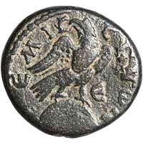A bronze coin of Antoninus Pius showing the baetyl of Emesa with an eagle.

It happened that an Emperor of Rome, Septimius Severus, had married a Syrian princess from Emesa before he became Emperor. Julia Domna was the youngest daughter of the local high priest Gaius Julius Bassianus, and through this heredity, her grand-nephew Varius Avitus Bassianus was also a priest of that sun god in his home town.

In due course, this young man, now renamed Marcus Aurelius Antoninus, became Emperor in his turn. We know him best by none of those names, but by the name of the god whose priest he was. Because [Elagabalus](http://www.forumancientcoins.com/moonmoth/coins/elagabalus_011.html), perhaps the weirdest of all the Roman Emperors, decided to bring his god to Rome and place it at the head of the Roman pantheon.

The baetyl of Emesa was the stone of the sun-god Elagabalus. It is shown on the coin on the right. It was black, and is sometimes said to have an eagle engraved on it. Certainly an eagle was often shown in front of it or standing upon it, as on this coin, but it is not clear what, if anything, was really engraved on it. Some examples of the coin on the right might show a crescent and stars, or something more complicated, or maybe only an irregular shape. An Imperial denarius shows an eagle clearly in front of the stone, and stars that might be on it.

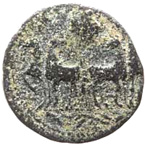A bronze coin of Elagabalus showing the baetyl of Emesa being drawn in a quadriga.

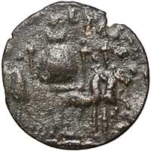A bronze coin of Elagabalus showing the baetyl of Emesa in a quadriga with parasols.

As part of the process of making his sun-god supreme in Rome, the emperor Elagabalus brought the baetyl to the capital and installed it in a new temple, the Elagabalium.

There are many coins, including Roman Imperial denarii and aurei, which show the stone in a ceremonial procession, set in a slow [quadriga](http://www.forumancientcoins.com/moonmoth/glossary.html" \l "QUADRIGA), shaded by parasols. It is said that Elagabalus the Emperor walked backwards in front of the quadriga in these processions, his eyes fixed on the stone, the object of his reverence.

The left-hand coin is so worn that you can only just see the stone in the background. This coin is from Aelia Capitolina, the name the Romans gave to Jerusalem.

To its right is a clearer coin from Laodikeia ad Mare in Syria. This coin shows the stone clearly, as well as the parasols surrounding the quadriga.

When Elagabalus the Emperor was finally killed, his successor, Severus Alexander, had the stone returned to Emesa. Some have conjectured that this is the same Black Stone that can now be found in the Grand Mosque in Mecca. If so, it is quite small compared to the depictions on these last two coins, maybe a foot in diameter; more consistent with the stone on the coin from Emesa itself, above right.

The Shrine of Astarte

Astarte was an ancient goddess from the Phoenician region, sometimes calles Ashtoreth. She was a goddess of sexuality, love and war. She was equivalent to the Mesopotamian Ishtar, a goddess associated with holy prostitution.

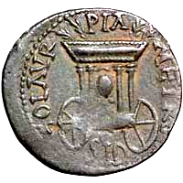A coin of Severus Alexander showing the baetyl of Astarte in a carriage.

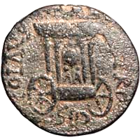A bronze coin of Elagabalus showing the baetyl of Astarte in a carriage.

The Greeks took her up under the name Aphrodite, and later, the Romans evoked her into the Empire from Sicily as [Venus Erycina](http://www.forumancientcoins.com/moonmoth/reverse_venus.html" \l "ERYCINA). This ancient deity had a long and complex history.

One of the Phoenician cities in which she was worshipped was Sidon. These coins comes from that city in the time of the emperor Elagabalus and his successor Severus Alexander, and show what is sometimes called the Cart of Astarte, a two-wheeled carriage containing a round or ovoid baetyl on two oddly-shaped supports, underneath a protective baldaquin.

This is one of the best known baetyl coins.

It is normally presumed that this is specifically a baetyl of Astarte, though I have also seen it conjectured that — as it appears on coins of Elagabalus — the baetyl is his personal holy stone of Emesa. However, the carriage is not the type that appears on coins from Rome or Emesa, where Elagabalus' stone had actually been taken in procession. For example, it lacks the decorative parasols and instead cas a cover with palm branches. You would have to assume that the Sidonites had heard of those processions, but not the fine details, and given the stone their own local appurtenances. And as the Phoenicians were quite familiar with baetyls, such assumptions do not appear to be necessary.

You would also have to explain why the same stone appears on coins of Severus Alexander, who became emperor after Elagabalus' violent overthrow and sent his stone back to Emesa. That would be carelessness by the Sidonites, at best.

The Stone of Zeus Kasios

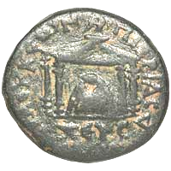A bronze coin of Trajan showing the baetyl of Zeus Kasios in a shrine.

In the north-west of Syria, by the seashore near the mouth of the river Orontes, is Jebel Aqra, Bald Mountain.

This mountain is particularly prone to thunderstorms, and had been the place of worship of more than one local thunder god before the arrival of the Euboean Greeks. When they settled on the north side of the mountain, they called the main peak Mount Kasios.

They adopted the local thunder deity into their own pantheon and called him Zeus Kasios, the Zeus of this particular mountain.

This coin comes from Seleukia Pieria, a nearby town which had been built by [Seleukos I Nikator](http://www.forumancientcoins.com/moonmoth/hellenic_names.html" \l "nikator) in 300 BCE. This town no longer exists; its ruins are near the town of Samandağ in Turkey. The coin was struck in the reign of the Emperor Trajan, at the beginning of the second century CE, and shows the baetyl of Zeus Kasios in his shrine.

The hollow near the top of this stone appears on nearly all coins that show it, so must have been there in reality. Perhaps it was used to place offerings, or to hold a statuette or other holy object.

Saturn's Stone

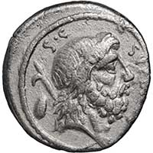A silver Roman Republican denarius of M. Nonius Sufenas showing a bust of Saturn with harpa and baetyl.

The Romans considered the era of Saturn to have been a golden age, when no-one needed to work because the earth's abundance was freely available to all. His festival, Saturnalia, was a very merry time. But not everything about Saturn was so lovely. He was also equated with the Greek god Kronos, son of the sky, Ouranos. Kronos overthrew his father by attacking him with a sickle or a [harpa](http://www.forumancientcoins.com/moonmoth/glossary.html/HARPA), castrating him.

Kronos had been given a prophecy that he would be overthrown by his own sons, so whenever Rhea gave birth, he devoured the child. But eventually, Rhea made a plan. When she gave birth to Zeus, she gave Kronos a stone wrapped in swaddling clothes, and he swallowed that. The eventual outcome when Zeus grew up included the forced disgorging of the stone and all the other children, who became part of the Greek pantheon.

So, when Saturn is shown on a rebuplican coin like this one with a [harpa](http://www.forumancientcoins.com/moonmoth/glossary.html/HARPA) over his shoulder and a stone behind him, it is a reference to the Roman version of the Kronos myth, with Saturn in the leading role and Ops as the mother of the unlucky children. There is a very alarming [painting by Goya depicting this](http://en.wikipedia.org/wiki/Saturn_Devouring_His_Son). Perhaps the coin is not so pretty when the full story is known!

But the harpa was not just a weapon. Saturn was supposed to have brought agriculture to the Romans, and he is sometimes shown with a long-handled harpa, an implement for cutting grain that symbolised fruitful cropping and the cycle of the years. There are some more Saturn and Harpa coins on my [Saturn page](http://www.forumancientcoins.com/moonmoth/reverse_saturn.html).

Artemis of Perge

The town or Perge (Perga to the Romans) had a temple to Artemis which was probably ancient, perhaps dating back to the 5th century CE. In it was an object which is usually referred to as a cult statue of Artemis of Perge, or Artemis Pergaia.

This object is shown on the coin on the left, which dates from the 2nd or 1st century BCE.

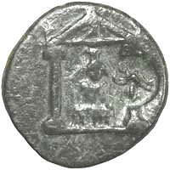A bronze coin of Perge in Pamphylia showing the cult statue of Artemis Pergaia.

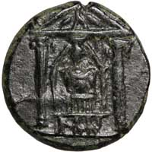A bronze coin of Perge in Pamphylia showing the cult statue of Artemis Pergaia.

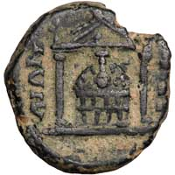A bronze coin of Marcus Aurelius from Perga showing a more detailed view of Artemis Pergaia.

It is vague enough that you might take it for a rather blocky seated figure wearing a cylindrical headdress. But if you look carefully, the detail is not quite right for that.

In the centre is another coin from the same period, much clearer without the countermark, which has a slightly different shape.

On this coin you can see a multistoried structure with a vase-shaped object prominently displayed at its top. This time there is an irregularly shaped object, perhaps with a carved surface, between the vase and the lower layers.

Later coins, like the bronze of Marcus Aurelius from the mid-second-century CE on the right of the row, also show a good deal of detail, but again, with differences. This object looks nothing at all like a cult statue. The two niched layers are not in tiers, but the same width as each other; and instead of that irregular object, there is a regular dome with a decorated surface. However, the vase-shaped object is still there, now even more prominently displayed.

Marvin Tameanko, in his book "[Monumental Coins"](http://www.forumancientcoins.com/moonmoth/references.html" \l "MONUMENTAL), reconstructs this structure and calls the whole thing a baetyl. But I think this is not quite the correct use of the word.

Perhaps the small object with the long neck was actually a baetyl. The rest of the structure is there to support and display that object, with niches in which to place offerings or perhaps cult objects.

The baetyl itself, if this is the correct interpretation, is an unusual shape, and is clearly not a found stone but something made with care.

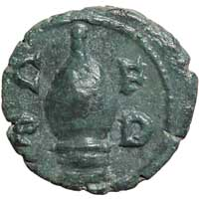A bronze coin of Maximinus I from Deultum in Thrace showing a baetyl-like object.

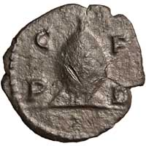A bronze coin of Philip I from Deultum in Thrace showing a baetyl-like object.

Deultum's "Beehive"

Coins of several emperors from Deultum in Thrace show an oddly-shaped object, which in the references is usually labelled a beehive. This follows Jurukova, who called it that because he thought the shape was similar.

A more likely conjecture was put forward by Michel Amandry, and followed by Dragonov. They call the object a civic fountain, like the Meta Sudans ("sweating cone") in Rome; a type in which water flows from outlets at the top and over the shaped stone, to be collected at the base.

A similarity in shape to the stone (if that is what is) of Artemis Pergaia, shown in the previous paragraph, is no doubt just a potentially confusing coincidence. But it has been conjectured that this might be a sacred stone.

It is often shown with a tiny structure below or in front of it; sometimes sketchy, as on the left-hand coin, sometimes in much clearer detail. If the object is a sacred stone, then the structure below might be the temple that contains the holy object, shown in small scale just to indicate its existence. But it could also be part of a fountain.

Beehive, fountain or baetyl? All these are only imaginative conjectures. But the beehive is certainly the least likely explanation of the three, and the fountain perhaps the most likely.

A Pyramidical Baetyl

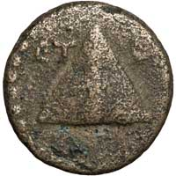A bronze coin of Caesarea in Cappadocia showing a pyramidical baetyl.

This coin, from Caesarea in Cappadocia, now called Kayseri, shows what appears to be a pyramidical baetyl. Another idea is that it might be a stylised representation of Mount Argaeus. That mountain was in plain view from Caesarea; it is a huge volcano, now called Erciyes Daği by the Turks.

Not surprisingly, the mountain appears on many coins of Caesarea, but usually in the form of a pile of rocks.

Baetyls in conical form are known on coins from Kaunos and elsewhere, so it is not unreasonable to accept that a pyramidical form could be a baetyl. Perhaps this one has to remain uncertain.

Other Baetyls and Sacred Stones

Also appearing on coins, but not represented here, are:

• A conical baetyl (sometimes with two handles) on coins of Kaunos in Caria which have winged Iris on the obverse;

• A conical baetyl of Aphrodite in a courtyard on coins from Byblos in Phoenicia;

• A baetyl between tables and under a tree on coins from Lyrbe in Cilicia;

• Three baetyls on an altar in a small scene inset into a founder's ploughing scene, on a coin of Severus Alexander from Bostra in Arabia Petraea (Gemini VI lot 691; Spijkerman 51; Meshorer 241);

• A dome-shaped baetyl of Dusares (the Arabian equivalent of Dionysus) on an altar on a coin of Marcus Aurelius from Adraa in Arabia Petraea (Gemini VI lot 674; Spijkerman 3, pl. 10; SNG ANS 1130; Hendin 809 var);

• A tall baetyl surmounted by a crescent, in a columned temple, on a coin of Septimius Severus from Carrhae in Mesopotamia.

• Two small baetyls on either side of a tall column surmounted by a globe in a phallic arrangement on a coin of Elagabalus from Charachmoba in Arabia Petraea. The globe on the column may be intended to represent a baetyl of Dusares. (Gemini VI lot 699; Spijkerman 5; Rosenberger 2; Hendin 302);

• The Black Stone of Paphos in Cyprus, a baetyl of Aphrodite, on coins of several Emperors. This stone still exists, in a museum near Kouklia. It is 130 by 90 cm, and is a smooth piece of andesite, a volcanic rock. It is definitely not a meteorite.

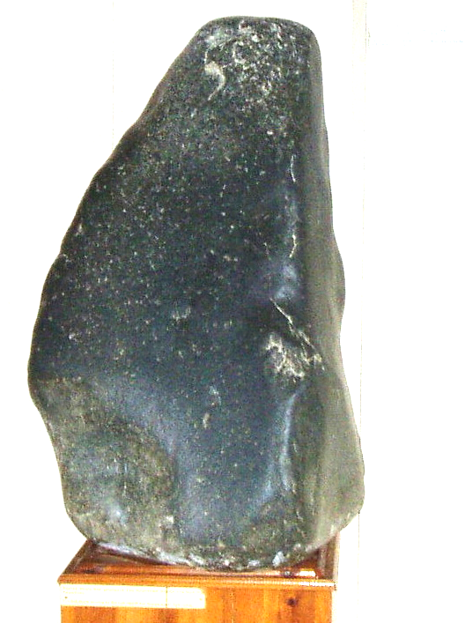 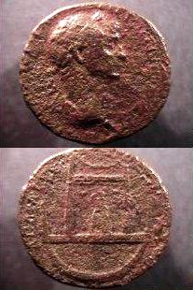

Left: The Black Stone of Paphos – the aniconic andesite baetyl of Aphrodite from the Sanctuary of Aphrodite at Palaipaphos” on display at the archaeological museum in Kouklia, formerly at the National museum of Nikosia.

Right: Historic coin showing Roman Emperor Trajan (front),  
and the sacred Black Stone of Paphos, Cyprus (back)

Other holy stones that have existed include:

• A stone of [Cybele](http://www.forumancientcoins.com/moonmoth/reverse_cybele.html), which was brought to Rome from Pergamon on 204 BCE, accompanied by Cybele and Attis' self-castrated priests which were probably rather alarming to the Romans, when Cybele's cult was evoked into the Republic as the Magna Mater.

• A cubical stone of Dusares, whose name could also be transliterated as Dushara, in the god's sanctuary at Petra. This is presumably not the same stone as the conical or globular ones mentioned above.

• A stone of the Ephesian [Artemis](http://www.forumancientcoins.com/moonmoth/reverse_diana.html), which was in the goddess' great temple at Ephesus, one of the seven wonders of the ancient world.

Just because I have not listed these last three as being on coins does not mean such coins don't exist; it means that I have not come across any. There are probably many other sacred stones too, which I will add to the list if I hear or read about them.

|  |
| --- |
| ————————  Some Relevant References  ———————— |

These books provided some, but not all, of the information on this page. Thanks also to the contributors to the [Forum](http://www.forumancientcoins.com/) [Classical Numismatics Discussion Board](http://www.forumancientcoins.com/board/index.php), a group of people who are both helpful and knowledgeable. In particular, Jochen and Pat Lawrence have been very helpful in clearing a view through the fog of just plain wrong material about the Omphalos which can be found on the web and elsewhere. Thanks also to Lloyd T. for his personal observation of the limestone half-ovoid now visible at Delphi. Any mistakes or misapprehensions that remain are mine alone.

Thanks are also due to participants in [Forum](http://www.forumancientcoins.com/) for the conjecture about Deultum's "beehive".

Collier's Encyclopaedia, 1995 edition.

[The Oxford Classical Dictionary](http://www.forumancientcoins.com/moonmoth/references.html" \l "OCD2) by various writers, edited by N.G.L. Hammond and H.H. Scullard. Second edition.

[A Dictionary of Roman Coins](http://www.forumancientcoins.com/moonmoth/references.html" \l "DICTCOINS) by Seth William Stevenson, F.S.A., C Roach Smith, F.S.A., and Frederic W. Madden, M.R.A.S. First published by George Bell and Sons, 1889. Reprinted by B A Seaby Ltd, London in 1964.

[Monumental Coins — Buildings & Structures on Ancient Coinage](http://www.forumancientcoins.com/moonmoth/references.html" \l "MONUMENTAL) by Marvin Tameanko. Published in 1999 by krause publications.

[Religions of Rome: Volume 1, A History](http://www.forumancientcoins.com/moonmoth/references.html" \l "RELROME) by Mary Beard, John North and Simon Price. Published by Cambridge University Press in 1998.

These books are covered in a bit more detail on my page on [coin reference books](http://www.forumancientcoins.com/moonmoth/references.html).