DIS-FOSSIL-Anomalocaris

Anomalocaris, in feldspathic quartz sandstone, Guanshan Biota, Cambrian; ca. 515~510 Ma , Yunnan Province, China. Phylum: Arthropoda; Class: †Dinocaridida; Family: †Anomalocarididae; Genus: †Anomalocaris ; Whiteaves 1892

11cm. (L) ×.6cm. (W) with concretion a pair of the matrix, fossil 3 cm. (L )x 2 cm. (W). This rare specimen shows the soft tissue parts that are usually un-mineralized, including evidence of a pair of flexible appendages with barbed spikes.

***Anomalocaris*** ("anomalous shrimp") is an extinct genus of Anomalocaridid, a family related to ancestral arthropods known from fossils found in Cambrian deposits in China, United States, Canada, Poland and Australia. The discovery of large Ordovician specimens has extended its time range (Van Roy 2011). The first fossils of *Anomalocaris* were discovered in the Burgess Shale by Joseph Frederick Whiteaves and Charles Doolittle Walcott (Conway 1998).

The Guanshan biota of Yunnan, South China (Series 2, Stage 4, Cambrian; ca. 515~510 Ma) serves as an evolutionary bridge closely linking the earlier Chengjiang (Series 2, Stage 3, Cambrian) and the later Kaili biota (Series 3, Stage 5, Cambrian; also the coeval Burgess Shale biota) and exemplifies the Cambrian radiation and its aftermath (Liu et al. 2010). It represents an unparalleled record of the fundamentally important rapid diversification of metazoan life in the early Cambrian, a geologically short interval during which almost all major groups of animals had their origins. It is an outstanding example of a major stage in the history of life. 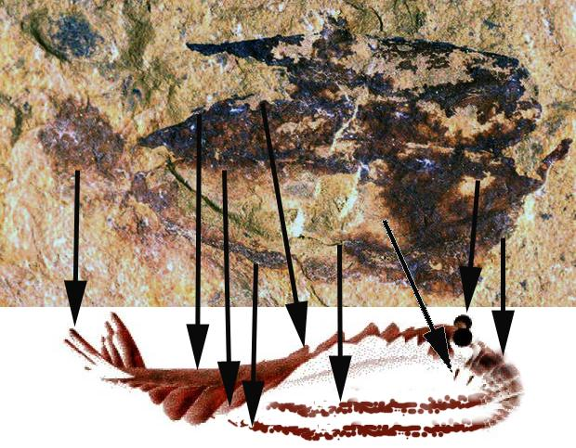

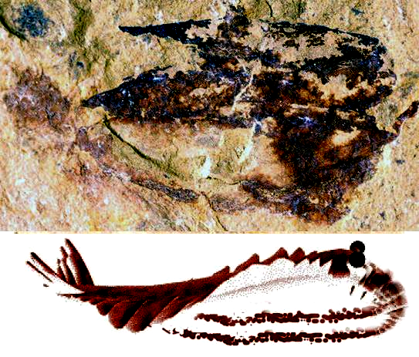

***Anomalocaris*** had a large head, a single pair of large, compound eyes on stalks comprising approximately 16,000 lenses, and an unusual disk-like mouth (Patterson et al. 2011). The mouth was composed of 32 overlapping plates, four large and 28 small, resembling a pineapple ring with the center of serrated prongs that continued down the gullet (Gould 1989; Morris 1998). The mouth could crush prey, but could never completely close so the prey was impaled by two appendages with barb-like spikes (Whittington and Briggs 1985). The mouthparts of *Anomalocaris* have three major axes and a small central opening; thus this species probably fed by sucking up small items rather than biting hard-bodied organisms (Daley and Bergström 2012). The fan-shaped tail assisted the undulating lobes in propulsion through water (Usami 2006). Each lobe overlapped with the one more posterior to it (Whittington and Briggs 1985), and this overlapping allowed the lobes on each side of the body to act as a single "fin", maximizing the swimming efficiency (Usami 2006). The construction of a remote-controlled model showed this mode of swimming to be intrinsically stable *(*Briggs 1994), implying that *Anomalocaris* would not have needed a complex brain to manage balance while swimming. The body was widest between the third and fifth lobe and narrowed towards the tail; it had at least 11 lobes in total. Stacked lamella of what were probably gills attached to the top of each lobe.

# References

Briggs, Derek E. G. (1994). "Giant Predators from the Cambrian of China". Science **264** (5163): 1283–4.

Conway Morris, S. (1998). The crucible of creation: the Burgess Shale and the rise of animals. Oxford [Oxfordshire]: Oxford University Press. pp. 56–9.

Gould, Stephen Jay (1989). Wonderful life: the Burgess Shale and the nature of history. New York: W.W. Norton. pp. 194–206.

Conway Morris, S. (1998). The crucible of creation: the Burgess Shale and the rise of animals. Oxford [Oxfordshire]: Oxford University Press. pp. 56–9.

Daley, A. C.; Bergström, J. (2012). "The oral cone of Anomalocaris is not a classic peytoia". Naturwissenschaften **99** (6): 501–504.

## LIU, Jianni, OU, Qiang, HAN, Jian, HE, Tongjiang, and SHU, Degan(2010). New sights on Lower Cambrian Guanshan Biota, Yunnan, South China. 2010 GSA Denver Annual Meeting (31 October- 3 November 2010). Paper No. 189-5

John R. Paterson, Diego C. García-Bellido, Michael S. Y. Lee, Glenn A. Brock, James B. Jago & Gregory D. Edgecombe (2011). "Acute vision in the giant Cambrian predator Anomalocaris and the origin of compound eyes". [*Nature*](https://en.wikipedia.org/wiki/Nature_(journal)) **480** (7376): 237–240.

Usami, Yoshiyuki (2006). "Theoretical study on the body form and swimming pattern of Anomalocaris based on hydrodynamic simulation". Journal of Theoretical Biology **238** (1): 11–7.

Van Roy, P.; Briggs, D. E. G. (2011). "A giant Ordovician anomalocaridid". Nature **473** (7348): 510–513.

Whittington, H.B.; Briggs, D.E.G. (1985). "The largest Cambrian animal, Anomalocaris, Burgess Shale, British Columbia". Philosophical Transactions of the Royal Society B **309** (1141): 569–609.

