DIS-Fossils-Crinoid-Georgia

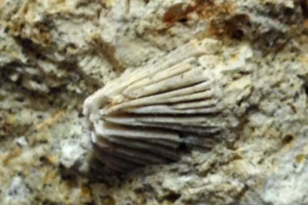

Tivola limestone, Houston County, Georgia, from the Eocene period.