DIS-MIN-US-NC-Lepidolite

# Lepidolite-Rubellite site, Wilton, Granville Co., North Carolina.

System:Monoclinic

Color: Pink, light purple, ...

Hardness:

2½ - 3½

Member of:

[Mica Group](http://www.mindat.org/min-6728.html)

Name:

Named in 1792 by Martin Klaproth from the Greek words Lepidos for "scale" and Lithos for "stone".

Series Formula:

KLi2Al(Si4O10)(F,OH)2 to K(Li1.5Al1.5)(AlSi3O10)(F,OH)2

A series between [Polylithionite](http://www.mindat.org/min-3260.html) and [Trilithionite](http://www.mindat.org/min-7341.html)  
  
A Li-rich mica in, or close to, the so-called [Polylithionite-Trilithionite series](http://www.mindat.org/min-28887.html).  
  
The original lepidolite came from Rožná pegmatite, Žďár nad Sázavou, Vysočina Region, Moravia (Mähren; Maehren), Czech Republic.  
  
The name is sometimes incorrectly applied to lithian muscovite.

## Physical Properties of Lepidolite

[Lustre:](http://www.mindat.org/glossary/lustre)

Sub-Vitreous, Resinous, Greasy, Pearly

Diaphaneity (Transparency):

Transparent, Translucent

Colour:

Pink, light purple, light rose red, other colors possible but are rare.

Comment:

Ideally colorless, but frequently occurs in manganese-bearing environments

Streak:

white

Hardness (Mohs):

2½ - 3½

Tenacity:

Elastic

Cleavage:

Perfect  
{001} perfect

Fracture:

Micaceous

Density:

2.8 - 2.9 g/cm3 (Measured)    2.83 g/cm3 (Calculated)

Comment:

Calculated densities for various polytypes to 3.11

## Crystallography of Lepidolite

Crystal System: Monoclinic

X-Ray Powder Diffraction:

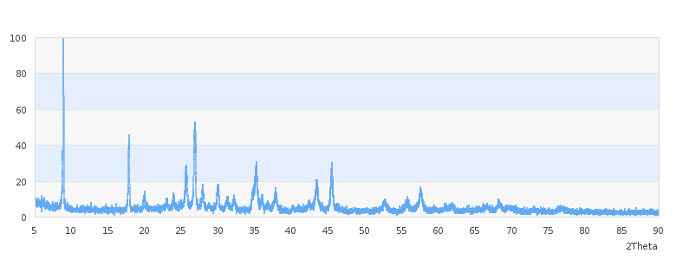

Ref.:   
Wilson,W.F and McKenzie,B.J, 1978, Mineral Collecting Sites in North Carolina, Information Circular 24.