PRINTS-Greece-Epidauros-Tholos-Patouillard-1905

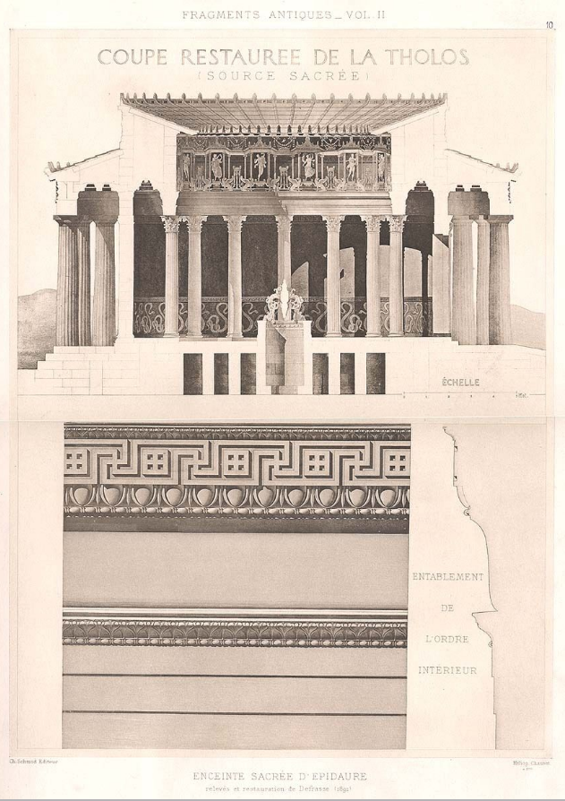

**DESCRIPTION OF PRINT SUBJECT:** Epidaurus was a maritime city situated on the eastern coast of Argolis, sometimes distinguished as Epidaurus the Holy. It stood on a small rocky peninsula with a natural harbour on the northern side and an open but serviceable bay on the southern; and from this position acquired the epithet of ôtarouos, or the two-mouthed. Its narrow but fertile territory consisted of a plain shut in on all sides except towards the sea by considerable elevations, among which the most remarkable were Mount Arachnaeon and Titthion. The conterminous states were Corinth, Argos, Troezen and Hermione. Its proximity to Athens and the islands of the Saronic gulf, the commercial advantages of its position, and the fame of its temple of Asclepius combined to make Epidaurus a place of no small importance. Its origin was ascribed to a Carian colony, whose memory was possibly preserved in Epicarus, the earlier name of the city; it was afterwards occupied by Ionians, and appears to have incorporated a body of Phlegyans from Thessaly. The lonians in turn succumbed to the Dorians of Argos, who, according to the legend, were led by Deiphontes; and from that time the city continued to preserve its Dorian character. It not only colonized the neighbouring islands, and founded the city of Aegina, by which it was ultimately outstripped in wealth and power, but also took part with the people of Argos and Troezen in their settlements in the south of Asia Minor. The monarchical government introduced by Deiphontes gave way to an oligarchy, and the oligarchy degenerated into a despotism. When Procles the tyrant was carried captive by Periander of Corinth, the oligarchy was restored, and the people of Epidaurus continued ever afterwards close allies of the Spartan power. The governing body consisted of 180 members, chosen from certain influential families, and the executive was entrusted to a select committee of artynae (from tipr~vav, to manage). The rural population, who had no share in the affairs of the city, were called eovi-iro&s (" dusty-feet "). Among the objects of interest described by Pausanias as extant in Epidaurus are the image of Athena Cissaea in the Acropolis, the temple of Dionysus and Artemis, a shrine of Aphrodite, statues of Asclepius and his wife Epione, and a temple of Hera. The site of the last is identified with the chapel of St Nicolas; a few portions of the outer walls of the city can be traced; and the name Epidaurus is still preserved by the little village of Nea-Epidavros, or Pidhavro.

The Hieron (sacred precinct) of Asclepius, which lies inland about 8 m. from the town of Epidaurus, has been thoroughly excavated by the Greek Archaeological Society since the year 1881, under the direction of M. Kavvadias. In addition to the sacred precinct, with its temples and other buildings, the theatre and stadium have been cleared; and several other extensive buildings, including baths, gymnasia, and a hospital for invalids, have also been found. The sacred road from Epidaurus, which is flanked by tombs, approaches the precinct through a gateway or propylaea. The chief buildings are grouped together, and include temples of Asciepius and Artemis, the Tholos, and the Abaton, or portico where the patients slept. In addition to remains of architecture and sculpture, some of them of high merit, there have been found many inscriptions, throwing light on the cures attributed to the god. The chief buildings outside the sacred precinct are the theatre and the stadium.

The temple of Asclepius, which contained the gold and ivory statue by Thrasymedes of Paros, had six columns at the ends and eleven at the sides; it was raised on stages and approached by a ramp at the eastern front. An inscription has been found recording the contracts for building this temple; it dates from about 460 B.C. The sculptor Timotheus-one of those who collaborated in the Mausoleum-is mentioned as undertaking to make the acroteria that stood on the ends of the pediments, and also models for the sculpture that filled one of them. Some of this sculpture has been found; the acroteria are Nereids mounted on sea-horses, and one pediment contained a battle of Greeks and Amazons. The great altar lay to the south of the temple, and a little to the east of it are what appear to be the remains of an earlier altar, built into the corner of a large square edifice of Roman date, perhaps a house of the priests. Just to the south of this are the foundations of a small temple of Artemis. The Tholos lay to the south-west of the temple of Asclepius; it must, when perfect, have been. one of the most beautiful buildings in Greece; the exquisite carving of its mouldings is only equalled by that of the Erechtheum at Athens. It consisted of a circular chamber, surrounded on. the outside by a Doric colonnade, and on the inside by a Corinthian one. The architect was Polyditus, probably to be identified with the younger sculptor of that name. In the inscription recording the contracts for its building it is called the Thymele; and this name may give the clue to its purpose; it was probably the idealized architectural representative of a primitive pit of sacrifice, such as may still be seen in the Asclepianum at Athens. The foundations now visible present a very curious appearance, consisting of a series of concentric walls. Those in the middle are thin, having only the pavement of the cella to support, and are provided with doors and partitions that make a sort of subterranean labyrinth. There is no evidence for the statement sometimes made that there was a well or spring below the Tholos. North of the Tholos is the long portico described in inscriptions as the Abaton; it is on two different levels, and the lower or western portion of it had two storeys, of which the upper one was on a level with the ground in the eastern portion. Here the invalids used to sleep when consulting the god, and the inscriptions found here record not only the method of consulting the god, but the manner of his cures. Some of the inscriptions are contemporary dedications; but those which give us most information are long lists of cases, evidently compiled by the priests from the dedications in the sanctuary, or from tradition. There is no reason to doubt that most of the records have at least a basis of fact, for the cases are in accord with well-attested phenomena of a similar nature at the present day; but there are others, such as the miraculous mending of a broken vase, which suggest either invention or trickeryIn early times, though there is considerable variety in the cases treated and the methods of cure, there are certain characteristics common to the majority of the cases. The patient consulting the god sleeps in the Abaton, sees certain visions, and, as a result, comes forth cured the next morning. Sometimes there seem to be surgical cases, like that of a man who had a spear-head extracted from his jaw, and found it laid in his hands when ne awoke in the, morning, and there are many examples resembling those known at the present day at Lourdes or Tenos, where hysterical or other similar affections are cured by the influence of imagination or sudden emotion. It is, however, difficult to make any scientific use of the records, owing to the indiscriminate manner in which genuine and apocryphal cases are mingled, and circumstantial details ara added. We learn the practice of later times from some dedicated inscriptions. Apparently the- old faith-healing had lost its efficacy, and the priests substituted for it elaborate prescriptions as to diet, baths and regimen which must have made Epidaurus and its visitors resemble their counterparts in a modern spa. At this time there were extensive buildings provided for the accommodation of invalids, some of which have been discovered and partially cleared; one was built by Antoninus Pius. They were in the form of great courtyards surrounded by colonnades and chambers.

Between the precinct and the theatre was a large gymnasium, which was in later times co9verted to other purposes, a small odeum being kiiilt in the middle of it. In a valley just to the south-west of the precinct is the stadium, of which the' seats and goal are well preserved. There is a gutter round the level space of the stadium, with basins at intervals for the use of spectators or competitors, and a post at every hundred feet of the course, thus dividing it into six portions. The goal, which is well preserved at the upper end, is similar to that at Olympia; it consists of a sill of stone sunk level with the ground, with parallel grooves for the feet of the runners at starting, and socketstoholdthe posts that separated the spacesassigned to the various competitors, and served as guides to them in running. For these were substituted later a set of stone columns resembling those in the proscenium of a theatre. There was doubtless a similar sill at the lower end for the start of the stadium, this upper one being intended for the start of the diaulos and longer races. The theatre still deserves the praise given it by Pausanias as the most beautiful in Greece. The auditorium is in remarkable preservation, almost every seat being still in situ, except a few where the supporting walls have given way on the wings. The whole plan is drawn from three centres, the outer portion of the curves being arcs of a larger circle than the one used for the central portion; the complete circle of the orchestra is marked by a sill of white limestone, and greatly enhances the effect' of the whole. There are benches with backs not only in the bottom row, but also above and below the diazoma. The acoustic properties of the theatre are extraordinarily good, a speaker in the orchestra being heard throughout the auditorium without raising his voice. The stage buildings are not preserved much above their foundations, and show signs of later repairs; but their general character can be clearly seen. They consist of a long rectangular building, with a proscenium or column front which almost forms a tangent to the circle of the orchestra; at the middle and at either end of this proscenium are doors leading into the orchestra, those at the end set in projecting wings; the top of the proscenium is approached by a ramp, of which the lower part is still preserved, running parallel to the parodi, but sloping up as they slope down. The proscenium was originally about 14 ft. high and 12 ft. broad; so corresponding approximately to the Greek stage as described by Vitruvius. M. Kavvadias, who excavated the theatre, believes that the proscenium is contemporary with the rest of the theatre, which, like the Tholos, was built by Polyclitus (the younger); btit Professor W. Dorpfeld maintains that it is a later addition. In any case, the theatre at Epidaurus ranks as the most typical of Greek theatres, both from the simplicity of its plan and the beauty of its proportions.

**BACKGROUND HISTORY ON PRINT :** Louis XIV, the King of France, was a generous patron of the arts. During his long reign (1643-1715), he sought to raise standards of taste and sophistication in the Arts and so a number of royal academies were founded, including the Academy of Painting and Sculpture (1648), the Academie de France in Rome (1663) and the foundation of the Academie royale d'Architecture (1671). This formalized a system for the training of French architects and by elevating artisans to academicians, the power of the medieval guilds was eroded and centered instead on the patronage of the king. Subsidized by the state, the Academy of Architecture was free to those, aged fifteen to thirty, who could pass the entrance examinations. By the nineteenth century, students were obliged to complete a number of increasingly demanding concours or competitions, the most prestigious of which was the Grand Prix de Rome, a rigorous annual examination (a first competition was in 1702, then 1720, then yearly) that provided the winner advanced study at the French Academy in Rome at the Villa Medici, where classical antiquities could be seen first hand. Although drawings of ancient classical ornament had been made for generations before the winners of the Grand Prix de Rome were sent to the Villa Medici, these young French students were the first to go about the work systematically. The drawings were limited to, and solidly based on, carefully studied remains. Further, their presentation in formal academic renderings offers more information than could possibly be supplied even by a large number of photographs. Each year, for the four or five years they were in Rome, the students, supported financially with pensions, (hence their name of pensionnaires) were required to produce two sets of drawings, or envois, of Rome's ancient and medieval monuments: the état actuel, which was an exacting representation of the extant state, documenting the site with the precision of an archaeologist, and the état restauré, a more imaginary and often idealized restoration including the rendering of shade and shadow, which was accompanied by a written description of the monument's antiquity and construction. The artists progress usually was from a study of architectural ornaments and fragments gradually moving towards study and design of whole architectural ruins or sites. The series of prints presented here are those of the artist's earlier years when they focused on the details of architectural ornament.

The drawings submitted for the annual Grand Prix de Rome were on themes chosen by the Academy. The subjects set are indeed grand in scale and often in reach: triumphal arches (1730, 1747, 1763), palaces (1752, 1772, 1791, 1804, 1806), city squares and markets (1733, 1792, 1801), town halls (1742, 1787, 1813), law courts (1782, 1821) museums (1779) and educational institutions including libraries (1775, 1786, 1789, 1800, 1807, 1811, 1814, 1815, 1820) - all schemes for the promotion of civilization as the ancients would have understood the term. Stylistically, the entries usually share common characteristics: a grand Roman manner, with columns and orders, vaults and polychromy; an insistent and regular geometry, usually the square or the circle but sometimes the triangle; a penchant for the hemicycle, the propylaea and the pyramid; and finally a desire to impress by symmetry and the contrast between plain and decorated surfaces. These drawings first were shown in Rome at the French Academy and then were forwarded to Paris to be shown to the members of the Academie des Beaux Arts, one of the constituent bodies of the Institut de France, which was responsible for the Rome Academy. They were also exhibited to the public in Paris. Hector D'Espouy (1854-1929) won the Grand Prix de Rome in 1884, and after four years as a student at the Villa Medici, followed by several years of travel in Italy and Greece, as well as commissions for murals, he returned to the school that educated him in 1895 as the Professor of Ornamental Design at the Ecole Des Beaux Arts. It was in this role for the next several years that he amassed a large collection of the work of the students in Rome and the prints here are the best examples of this work.

Appreciation of these drawings cannot be complete without some explanation of the technique of India Ink wash rendering. Extreme discipline is required to produce these finely studied works of art. Even the simplest drawings require painstaking care and preparation before any of the washes are applied. Great skill is required to do the necessary linework. All of the information must be recorded before tone is even thought about. The drawing is then meticulously transferred in ink to the watercolor paper and the paper mounted on a board. The rendering itself requires infinite care and patience. Each tone is built up through many faint layers of wash so that the ink seems to be in the paper rather than on it. Each surface is graded so that the final effect of the drawing is that of an object in light and space, with a sense of atmosphere surrounding it.

**PRINT DATE:** This print was printed circa 1905; it is not a modern reproduction in any way.

**PRINT SIZE:** Overall print size is 12 inches by 16 1/2 inches including white borders.

**PRINT CONDITION:** Condition is excellent as shown in this detailed scan. Blank on reverse. Paper is quality woven rag stock

**Narcisse Théophile Patouillard** (2 July 1854 – 30 March 1926) was a French [pharmacist](https://en.wikipedia.org/wiki/Pharmacist) and [mycologist](https://en.wikipedia.org/wiki/Mycologist).

He was born in [Macornay](https://en.wikipedia.org/wiki/Macornay" \o "Macornay), a town in the department of [Jura](https://en.wikipedia.org/wiki/Jura_(department)). He studied in [Besançon](https://en.wikipedia.org/wiki/Besan%C3%A7on" \o "Besançon), then furthered his education at the École Supérieure de Pharmacie in [Paris](https://en.wikipedia.org/wiki/Paris), where in 1884 he earned a diploma with a doctoral thesis involving the structure and classification of [Hymenomycetes](https://en.wikipedia.org/wiki/Hymenomycetes" \o "Hymenomycetes) called "*Des Hyménomycètes au point de vue de leur structure et de leur classification*".[[1]](https://en.wikipedia.org/wiki/Narcisse_Th%C3%A9ophile_Patouillard#cite_note-1)

Patouillard was a practicing pharmacist for more than forty years, first in [Poligny](https://en.wikipedia.org/wiki/Poligny,_Jura" \o "Poligny, Jura) (1881–84), and later in [Fontenay-sous-Bois](https://en.wikipedia.org/wiki/Fontenay-sous-Bois) (1884–85), Paris (1886–1898) and [Neuilly-sur-Seine](https://en.wikipedia.org/wiki/Neuilly-sur-Seine) (beginning in 1898). From 1893 to 1900, he was *préparateur* to the chair of [cryptogamy](https://en.wikipedia.org/wiki/Cryptogam" \o "Cryptogam) at the École Supérieure de Pharmacie in Paris. In 1884 he was one of the founders of the [Société mycologique de France](https://en.wikipedia.org/wiki/Soci%C3%A9t%C3%A9_mycologique_de_France" \o "Société mycologique de France) and served as its third president in 1891-92. In 1920 he became an honorary member of the [British Mycological Society](https://en.wikipedia.org/wiki/British_Mycological_Society). He died in [Paris](https://en.wikipedia.org/wiki/Paris), aged 71.

Patouillard is highly regarded for his taxonomical work in mycology, and during his career, he described numerous genera and species of [fungi](https://en.wikipedia.org/wiki/Fungi). The following are some of the genera that he is the [taxonomic authority](https://en.wikipedia.org/wiki/Binomial_authority) of: [*Guepiniopsis*](https://en.wikipedia.org/wiki/Guepiniopsis), [*Hirsutella*](https://en.wikipedia.org/wiki/Hirsutella), [*Lacrymaria*](https://en.wikipedia.org/wiki/Lacrymaria_(fungus)), [*Leucocoprinus*](https://en.wikipedia.org/wiki/Leucocoprinus), [*Melanoleuca*](https://en.wikipedia.org/wiki/Melanoleuca) and [*Spongipellis*](https://en.wikipedia.org/wiki/Spongipellis). A mycological species called *[Inocybe patouillardii](https://en.wikipedia.org/wiki/Inocybe_erubescens" \o "Inocybe erubescens)* (brick-red tear mushroom) is one of the species named after him.

He was the author of nearly 250 works, and was a leading authority on tropical mycology. Over 100 of his publications involved studies of fungi from diverse locales such as [Brazil](https://en.wikipedia.org/wiki/Brazil), [Java](https://en.wikipedia.org/wiki/Java), [Guadeloupe](https://en.wikipedia.org/wiki/Guadeloupe), [Mexico](https://en.wikipedia.org/wiki/Mexico), [New Caledonia](https://en.wikipedia.org/wiki/New_Caledonia), the [Gambier Islands](https://en.wikipedia.org/wiki/Gambier_Islands), [Philippines](https://en.wikipedia.org/wiki/Philippines), et al.

Selected writings[[edit](https://en.wikipedia.org/w/index.php?title=Narcisse_Th%C3%A9ophile_Patouillard&action=edit&section=1" \o "Edit section: Selected writings)]

* *Tabulae analyticae Fungorum* (Analytic tables of fungi), 1883–1889.
* *Les Hyménomycètes d'Europe. Anatomie générale et classification des champignons supérieurs* (The Hymenomycetes of Europe. General anatomy and classification of the higher fungi) 166 pp. 1887.
* *Fragments mycologiques: Notes sur quelques champignons de la Martinique*(Notes on certain mushrooms of [Martinique](https://en.wikipedia.org/wiki/Martinique)) in Journal of Botany 3 pp. 335 - 343, 1889.
* *Essai taxonomique sur les familles et les genres des Hyménomycètes*
* 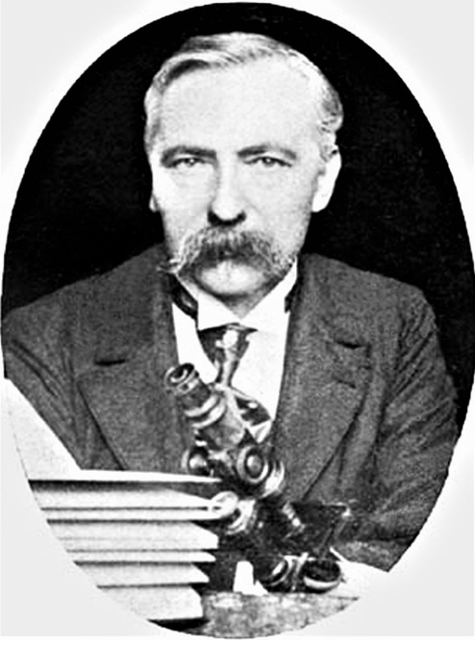
* Narcisse Theophile Patouillard (1854-1926) photographie prise par William Ashbrook Kellerman, publiée en 1906 dans *Ohio Mycological Bulletin*

The drawings submitted for the annual Grand Prix de Rome were on themes chosen by the Academy. The subjects set are indeed grand in scale and often in reach: triumphal arches (1730, 1747, 1763), palaces (1752, 1772, 1791, 1804, 1806), city squares and markets (1733, 1792, 1801), town halls (1742, 1787, 1813), law courts (1782, 1821) museums (1779) and educational institutions including libraries (1775, 1786, 1789, 1800, 1807, 1811, 1814, 1815, 1820) - all schemes for the promotion of civilization as the ancients would have understood the term. Stylistically, the entries usually share common characteristics: a grand Roman manner, with columns and orders, vaults and polychromy; an insistent and regular geometry, usually the square or the circle but sometimes the triangle; a penchant for the hemicycle, the propylaea and the pyramid; and finally a desire to impress by symmetry and the contrast between plain and decorated surfaces.

These ground plans (a drawing projected on a horizontal plane) and elevations (which was projected on a vertical plane) first were shown in Rome at the French Academy and then were forwarded to Paris to be shown to the members of the Academie des Beaux Arts, one of the constituent bodies of the Institut de France, which was responsible for the Rome Academy. They were also exhibited to the public in Paris. In the fourth year, after a thorough study of architectural detail, the student presented a complete restoration of a classical building. Although drawings of ancient classical ornament had been made for generations before the winners of the Grand Prix de Rome descended on the Villa Medici, the young Frenchmen were the first to go about the work systematically. The drawings were limited to, and solidly based on, the carefully studied remains. Further, their presentation in formal academic renderings offers more information than could possibly be supplied even by a large number of photographs.

Appreciation of these drawings cannot be complete without some explanation of the technique of India Ink was rendering. Extreme discipline is required to produce these finely studied works of art. Even the simplest drawings require painstaking care and preparation before any of the washes are applied. Great skill is required to do the neccesary linework. All of the information must be recorded before tone is even thought about. The drawing is then meticulously transferred in ink to the watercolor paper and the paper mounted on a board. The rendering itself requires infinite care and patience. Each tone is built up through many faint layers of wash so that the ink seems to be in the paper rather than on it. Each surface is graded so that the final effect of the drawing is that of an object in light and space, with a sense of atmosphere surrounding it.

|  |  |
| --- | --- |
| **Item price** | $50.00 |