Prints-A0000Eur-Greece-Epidauros-Defrasse-1891

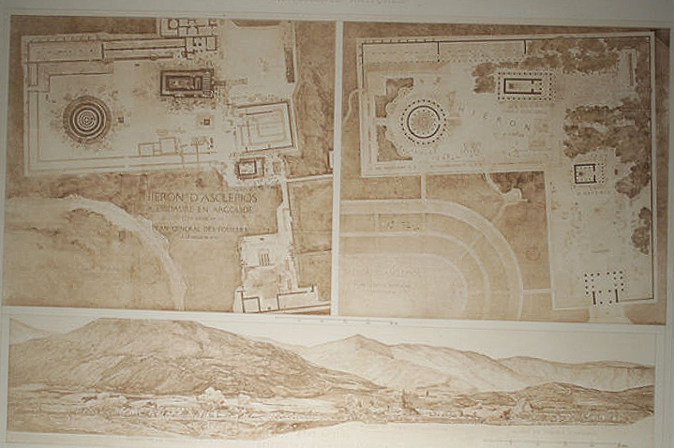

**The Temples of Epidaurus; the Hieron of Asclepius, Les Temples D'Epidaure**

An original antique heliogravure print of The Temples of Epidaurus, including the Hieron of Asclepius based on the work of Defrasse, 1891, with the site as it survived at the time and restoration.  Part of the Fragmens D'Architecture Antiques, printed by Chauvet and edited by Hector-Jean -Baptiste D'Espouy (1854-1929) and C. Massin.

Antique D'Espouy Heliogravure Print:

Printed in 1905.

Picture Dimension: 15 in wide by 11 high. (38 cm x 27.8 cm)

Framed Picture: 22 in. wide by 18 in. high (56 cm x 45.5 cm)

Hector-Jean -Baptiste D'Espouy was a painter and architect who as professor of the School of Beaux Arts in Paris from 1895 oversaw the publication of Fragmens D'Architecture Antiques, a massive study of the architectural remains of classical antiquity.  The prints contained therein were based upon the meticulous restorations, elevations, maps, and site plans compiled by the finest French academics of the time.

Confer:  Benezit, E. "Dictionnaire critique et Documentaire des Peintres, Sculteurs, Dessinateurs et Gravures," Librairie Grund, 1966, Vol. 3, p. 611.