RINGS-**EUR-Rome-Trajan-Legio secunda Traiana**

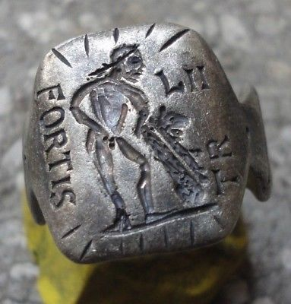

**Legio secunda Traiana, ("Trajan's Second Legion") was a legion of the Imperial Roman army founded by emperor Trajan in 105, along with XXX Ulpia Victrix, for the campaigns in Dacia. There are still records of the II Traiana Fortis in Egypt in the middle of the 5th century. The legion's emblem was the demi-god Hercules.**

ANCIENT ROMAN SILVER LEGIONARY SENATORIAL RING INSCRIBED ' HERCULES - FORTIS - L - II - TR '

Wearable <> 13.00 grams

**SOL INVICTUS **Ancient Silver Legionary Roman Ring**

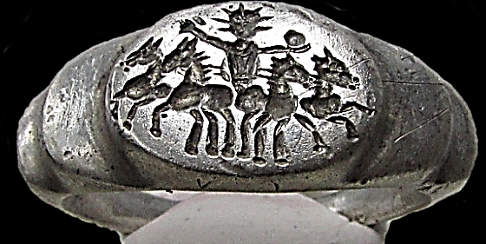

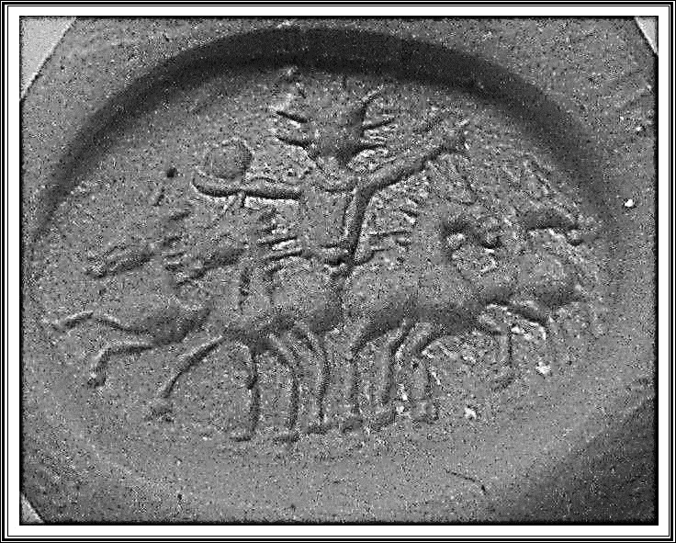

**SOL INVICTUS **Ancient Silver Legionary Roman Ring **AMAZING **  
                                                    **EXTREMELY RARE**PERFECT CONDITION**  
                                                             ** SOL IN QUADRIGA ENGRAVED **  
                                                              
INNER DIAMETER: 17,5-19mm  
WEIGHT : 8,82g  
Sol is the personification of the Sun and a god in ancient Roman religion. It was long thought that Rome actually had two different, consecutive sun gods. The first, Sol Indiges, was thought to have been unimportant, disappearing altogether at an early period. Only in the late Roman Empire, scholars argued, did solar cult re-appear with the arrival in Rome of the Syrian Sol Invictus, perhaps under the influence of the Mithraic mysteries.[1] Recent publications have challenged the notion of two different sun gods in Rome, pointing to the abundant evidence for the continuity of the cult of Sol, and the lack of any clear differentiation—either in name or depiction—between the "early" and "late" Roman sun god.According to Roman sources, the worship of Sol was introduced by Titus Tatius shortly after the foundation of Rome[7][8] In Virgil he is the grandfather of Latinus, the son of Sol's daughter Circe who lived not far from Rome at Monte Circeo.[9] A shrine to Sol stood on the banks of the Numicius, near many important shrines of early Latin religion.[10] In Rome Sol had an "old" temple in the Circus Maximus according to Tacitus (AD 56 – 117),[11] and this temple remained important in the first three centuries AD.[12] There was also an old shrine for Sol on the Quirinal, where an annual sacrifice was offered to Sol Indiges on August 9 to commemorate Caesar's victory at Pharsala (48 BC).[13] The Roman ritual calendars or fasti also mention a feast for Sol Indiges on December 11, and a sacrifice for Sol and Luna on August 28. Traditionally, scholars have considered Sol Indiges ("the native sun" or "the invoked sun"—the etymology and meaning of the word "indiges" is disputed) to represent an earlier, more agrarian form in which the Roman god Sol was worshipped, and considered him to be very different from the late Roman Sol Invictus, whom they believed was a predominantly Syrian deity. Neither the epithet "indiges" (which fell into disuse sometime after Caesar) nor the epithet "invictus" are used with any consistency however, making it impossible to differentiate between the two (see Sol Invictus, see also Di indigetes).  
Sol Invictus ("Unconquered Sun") was long thought to have been a foreign state-supported sun god introduced from either Emesa or Palmyra in Syria by the emperor Aurelian in 274 and overshadowing other Eastern cults in importance,[14] until the abolition of Classical Roman religion under Theodosius I. However the evidence for this is meager at best,[15] and the notion that Aurelian introduced a new cult of the sun ignores the abundant evidence on coins, in images, in inscriptions, and in other sources for a strong presence of the sun god in Rome throughout the imperial period.[16] Tertullian (died AD 220) writes that the Circus Maximus was dedicated primarily to Sol.[17] During the reign of Aurelian, a new college of pontiffs for Sol was established.[citation needed]  
  
There is some debate over the significance of the date December 21 for the cult of Sol. According to a single, late source, the Romans held a festival on December 21 of Dies Natalis Invicti, "the birthday of the unconquered one." Most scholars assume Sol Invictus was meant, although our source for this festival does not state so explicitly.[18] December 25 was commonly indicated as the date of the winter solstice,[19] with the first detectable lengthening of daylight hours. There were also festivals on other days in December, including the 11th (mentioned above), as well as August. Gordon points out that none of these other festivals are linked to astronomical events.[20] When the festival on December 25 was instituted is not clear, which makes it hard to assess what impact (if any) it had on the establishment of Christmas.  
  
The official status of the cult of Sol after Aurelian was significant, but there is no evidence that it was the supreme cult of the state. Hoey exaggerates the importance of an inscription from Salsovia that supposedly indicates an official empire-wide cult-prescription for Sol on December 19.[21] It actually simply states that at the command of the emperor Licinius the commanding officer of the detachment at Salsovia was to burn incense annually for a newly erected statue of Sol on November 18 (Hoey misread the date).[22] This simply means that Licinius accepted the erection of the statue in his honour.  
  
Throughout the 4th century the cult of Sol continued to be maintained by high-ranking pontiffs, including the renowned Vettius Agorius Praetextatus.[**

[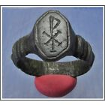](https://www.ebay.com/itm/CHI-RHO-Ancient-Legionary-Bronze-Roman-Ring-AMAZING/264003872849?ssPageName=STRK%3AMEBIDX%3AIT&_trksid=p2057872.m2749.l2648)

[**CHI-RHO **Ancient Legionary Bronze Roman Ring](https://www.ebay.com/itm/CHI-RHO-Ancient-Legionary-Bronze-Roman-Ring-AMAZING/264003872849?ssPageName=STRK%3AMEBIDX%3AIT&_trksid=p2057872.m2749.l2649)

**INNER DIAMETER:20-22mm  
WEIGHT:7.02g  
The Chi Rho (/'ka? 'ro?/; also known as chrismon or sigla[1]) is one of the earliest forms of christogram, formed by superimposing the first two (capital) letters—chi and rho (??)—of the Greek word ??????? (Christos) in such a way that the vertical stroke of the rho intersects the center of the chi.[2]  
  
The Chi-Rho symbol was used by the Roman emperor Constantine I (r. 306–337) as part of a military standard (vexillum). Constantine's standard was known as the Labarum. Early symbols similar to the Chi Rho were the Staurogram (Christliche Symbolik (Menzel) I 193 2.jpg) and the IX monogram (Christliche Symbolik (Menzel) I 193 4.jpg).  
  
In pre-Christian times, the Chi-Rho symbol was also to mark a particularly valuable or relevant passage in the margin of a page, abbreviating chreston (good).[3] Some coins of Ptolemy III Euergetes (r. 246–222 BC) were marked with a Chi-Rho.[4]  
  
Although formed of Greek characters, the device (or its separate parts) is frequently found serving as an abbreviation in Latin text, with endings added appropriate to a Latin noun, thus XPo, signifying Christo, "to Christ", the dative form of Christus.[5]  
  
The Chi Rho symbol has two Unicode codepoints: U+2627 ? Chi Rho in the Miscellaneous symbols block and U+2CE9 ? Coptic symbol Khi Ro in the Coptic block. According to Lactantius,[6] a Latin historian of North African origins saved from poverty by the Emperor Constantine I (r. 306–337), who made him tutor to his son Crispus, Constantine had dreamt of being ordered to put a "heavenly divine symbol" (Latin: coeleste signum dei) on the shields of his soldiers. The description of the actual symbol chosen by Emperor Constantine the next morning, as reported by Lactantius, is not very clear: it closely resembles a Chi-Rho or a staurogram (Christliche Symbolik (Menzel) I 193 2.jpg), a similar Christian symbol. That very day Constantine's army fought the forces of Maxentius and won the Battle of the Milvian Bridge (312), outside Rome.  
Emperor Constantine's labarum, a standard incorporating the wreathed Chi-Rho, from an antique silver medal.  
  
Eusebius of Caesarea (died in 339) gave two different accounts of the events. In his church history, written shortly after the battle, when Eusebius hadn't yet had contact with Constantine, he doesn't mention any dream or vision, but compares the defeat of Maxentius (drowned in the Tiber) to that of the biblical pharaoh and credits Constantine's victory to divine protection.  
  
In a memoir of the Roman emperor that Eusebius wrote after Constantine's death (On the Life of Constantine, circa 337–339), a miraculous appearance is said to have come in Gaul long before the Battle of the Milvian Bridge. In this later version, the Roman emperor had been pondering the misfortunes that befall commanders that invoke the help of many different gods, and decided to seek divine aid in the forthcoming battle from the One God. At noon, Constantine saw a cross of light imposed over the sun. Attached to it, in Greek characters, was the saying "????? ????!" (“In this sign you will conquer!”).[7] Not only Constantine, but the whole army saw the miracle. That night, Christ appeared to the Roman emperor in a dream and told him to make a replica of the sign he had seen in the sky, which would be a sure defence in battle.  
  
Eusebius wrote in the Vita that Constantine himself had told him this story "and confirmed it with oaths" late in life "when I was deemed worthy of his acquaintance and company." "Indeed", says Eusebius, "had anyone else told this story, it would not have been easy to accept it."  
  
Eusebius also left a description of the labarum, the military standard which incorporated the Chi-Rho sign, used by Emperor Constantine in his later wars against Licinius.Late antiquity  
  
An early visual representation of the connection between the Crucifixion of Jesus and his resurrection, seen in the 4th century sarcophagus of Domitilla in Rome, the use of a wreath around the Chi-Rho symbolizes the victory of the Resurrection over death.[11]  
  
After Constantine, the Chi-Rho became part of the official imperial insignia. Archaeologists have uncovered evidence demonstrating that the Chi-Rho was emblazoned on the helmets of some Late Roman soldiers. Coins and medallions minted during Emperor Constantine's reign also bore the Chi-Rho. By the year 350, the Chi-Rho began to be used on Christian sarcophagi and frescoes. The usurper Magnentius appears to have been the first to use the Chi-Rho monogram flanked by Alpha and Omega, on the reverse of some coins minted in 353.[12] In Roman Britannia, a tesselated mosaic pavement was uncovered at Hinton St. Mary, Dorset, in 1963. On stylistic grounds, it is dated to the 4th century; its central roundel represents a beardless male head and bust draped in a pallium in front of the Chi-Rho symbol, flanked by pomegranates, symbols of eternal life. Another Romano-British Chi-Rho, in fresco, was found at the site of a villa at Lullingstone (illustrated). The symbol was also found on Late Roman Christian signet rings in Britain.[13]  
Insular Gospel books  
In Insular Gospel books, the beginning of Matthew 1:18, at the end of his account of the genealogy of Christ and introducing his account of the life, so representing the moment of the Incarnation of Christ, was usually marked with a heavily decorated page, where the letters of the first word "Christi" are abbreviated and written in Greek as "XPI", and often almost submerged by decoration.[14] Though the letters are written one after the other and the "X" and "P" not combined in a monogram, these are known as Chi-Rho pages. Famous examples are in the Book of Kells and Book of Lindisfarne.[15] The "X" was regarded as the crux decussata, a symbol of the cross; this idea is found in the works of Isidore of Seville and other patristic and Early Medieval writers.[16] The Book of Kells has a second Chi-Rho abbreviation on folio 124 in the account of the Crucifixion of Christ,[17] and in some manuscripts the Chi-Rho occurs at the beginning of Matthew rather than mid-text at Matthew 1:18. In some other works like the Carolingian Godescalc Evangelistary, "XPS" in sequential letters, representing "Christus" is given a prominent place.[**

**Roman Senatorial Legionary Silver ring Leg II Adiutrix**

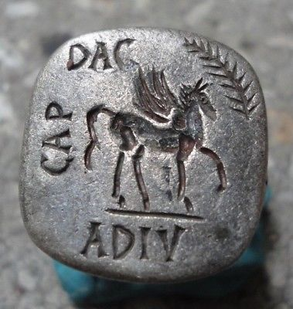

**Roman Senatorial Legionary Silver ring Leg II Adiutrix**



**Legio II Adiutrix**

**Legio secunda adiutrix ("Rescuer Second Legion"), was a legion of the Imperial Roman army founded in AD 70 by the emperor Vespasian (r. 69-79), originally composed of Roman navy marines of the classis Ravennatis. There are still records of II Adiutrix in the Rhine border in the beginning of the 4th century. The legion's symbols were a Capricorn and Pegasus.**

INSCRIBED - PEGASUS - Roman legionary combat symbol/emblem on the Legion " L - II - ADIV - DAC - CAP "

EXTREMELY RARE **Roman SENATORIAL LEGIONARY SILVERring.**

SOLID SILVER - Wearable <> 10.60 grams <>

**<> 22.00mm. = 0.88" Inner diameter <>**

Legio VI Hispana

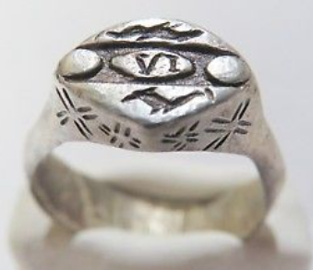

Ancient silver Roman Ring *VERY RARE*

**7,17 gr**

INNER DIAMETER  20 - 22

 mm

**Legio sexta Hispana** ("Sixth (*[Hispanian](https://en.wikipedia.org/wiki/Hispania" \o "Hispania)*) Legion") may have been a [legion](https://en.wikipedia.org/wiki/Roman_legion) of the [Imperial Roman army](https://en.wikipedia.org/wiki/Imperial_Roman_army). Only a few records attesting a "VI Hispana" were known in 2015. Seyrig (1923) argued that this unit was created in AD 68 and disappeared before 197.[[1]](https://en.wikipedia.org/wiki/Legio_VI_Hispana#cite_note-1) Another theory is that VI Hispana was created *after* 197 and was destroyed in the turmoil of the Empire's [Third Century Crisis](https://en.wikipedia.org/wiki/Third_Century_Crisis).

The scarcity and ambiguity of records of "VI Hispana" has led some scholars to doubt that this legion ever existed and that the inscriptions attesting it were erroneous references to the legions [VII Gemina](https://en.wikipedia.org/wiki/Legio_VII_Gemina) or [IX Hispana](https://en.wikipedia.org/wiki/Legio_IX_Hispana)[[2]](https://en.wikipedia.org/wiki/Legio_VI_Hispana#cite_note-2)

## Contents

# [1Sources](https://en.wikipedia.org/wiki/Legio_VI_Hispana#Sources)

# [2Legion lists](https://en.wikipedia.org/wiki/Legio_VI_Hispana#Legion_lists)

# [3Theories](https://en.wikipedia.org/wiki/Legio_VI_Hispana#Theories)

# [3.1Mistaken identity](https://en.wikipedia.org/wiki/Legio_VI_Hispana#Mistaken_identity)

# [3.2Early VI Hispana (1st/2nd centuries)](https://en.wikipedia.org/wiki/Legio_VI_Hispana#Early_VI_Hispana_(1st/2nd_centuries))

# [3.3Late VI Hispana (3rd century)](https://en.wikipedia.org/wiki/Legio_VI_Hispana#Late_VI_Hispana_(3rd_century))

# [3.4Conclusion](https://en.wikipedia.org/wiki/Legio_VI_Hispana#Conclusion)

# [4Citations](https://en.wikipedia.org/wiki/Legio_VI_Hispana#Citations)

# [5References](https://en.wikipedia.org/wiki/Legio_VI_Hispana#References)

# [5.1Ancient](https://en.wikipedia.org/wiki/Legio_VI_Hispana#Ancient)

# [5.2Modern](https://en.wikipedia.org/wiki/Legio_VI_Hispana#Modern)

# [6Sources](https://en.wikipedia.org/wiki/Legio_VI_Hispana#Sources_2)

## **Sources[**[**edit**](https://en.wikipedia.org/w/index.php?title=Legio_VI_Hispana&action=edit&section=1)**]**

The extant records attesting a "Legio VI Hispana" are as follows:

# AE (2003) 1014 and 7 other similar inscriptions from [Corinth](https://en.wikipedia.org/wiki/Corinth) honouring Tiberius Claudius Dinippus, who is described as a [military tribune](https://en.wikipedia.org/wiki/Military_tribune) of "VI Hispana" (also called "VI Hispanensis" in 3 of the inscr.). KEY TEXT: "LEG VI HISP". Date: reign of [Nero](https://en.wikipedia.org/wiki/Nero) (AD 54-68)[[3]](https://en.wikipedia.org/wiki/Legio_VI_Hispana#cite_note-3)

# [CIL](https://en.wikipedia.org/wiki/Corpus_Inscriptionum_Latinarum) III 8069: Tile-stamps from [Pannonia](https://en.wikipedia.org/wiki/Pannonia) (Szent Mihaly,Hungary). KEY TEXT: "LEG VI HIS". Date uncertain.[[4]](https://en.wikipedia.org/wiki/Legio_VI_Hispana#cite_note-4)[[5]](https://en.wikipedia.org/wiki/Legio_VI_Hispana#cite_note-5)

# CIL V 4381: (from Brescia, It.): KEY TEXT: "[LE]G HI/////". Date ca. AD 100[[6]](https://en.wikipedia.org/wiki/Legio_VI_Hispana#cite_note-6)[[7]](https://en.wikipedia.org/wiki/Legio_VI_Hispana#cite_note-7)

# *Inscriptiones Aquileiae* I.310. From [Aquileia](https://en.wikipedia.org/wiki/Aquileia) in northeastern Italy. Votive altar. The text reads: "[Dedicated] to the invincible god [Mithras](https://en.wikipedia.org/wiki/Mithras). Lucius Septimius Cassianus, [standard-bearer](https://en.wikipedia.org/wiki/Signifer) of the legion IIIIII Hispana, acting in the [*lustrum*](https://en.wikipedia.org/wiki/Lustrum) of [*chief centurion*](https://en.wikipedia.org/wiki/Primus_pilus) Publius Porcius Faustus, freely fulfilled his vow to the well-deserving [god]." Date: AD 244-8.[[8]](https://en.wikipedia.org/wiki/Legio_VI_Hispana#cite_note-8)

## **Legion lists[**[**edit**](https://en.wikipedia.org/w/index.php?title=Legio_VI_Hispana&action=edit&section=2)**]**

It appears certain that no "VI Hispana" existed during the reign of [Septimius Severus](https://en.wikipedia.org/wiki/Septimius_Severus" \o "Septimius Severus) (r. 193-211). Two lists of the legions in being survive from this era, one inscribed on a column found in Rome (CIL VI 3492) and the other a list of legions in existence "today" provided by the contemporary Greco-Roman historian [Dio Cassius](https://en.wikipedia.org/wiki/Dio_Cassius" \o "Dio Cassius), writing ca. 210-232 ("Roman History" LV.23-4). Both these lists date from after 197, as both include the 3 *Parthica* legions founded by Severus in that year. Both lists provide an identical list of 33 legions. Therefore, if a VI Hispana ever did exist, it must have been either before or after Severus' reign.

## **Theories[**[**edit**](https://en.wikipedia.org/w/index.php?title=Legio_VI_Hispana&action=edit&section=3)**]**

### Mistaken identity**[**[**edit**](https://en.wikipedia.org/w/index.php?title=Legio_VI_Hispana&action=edit&section=4)**]**

[Theodor Mommsen](https://en.wikipedia.org/wiki/Theodor_Mommsen), the 19th century German classicist, argued that the "IIIIII Hispana" of the Cassianus inscription was a misspelling of [IX Hispana](https://en.wikipedia.org/wiki/Legio_IX_Hispana). This legion was sometimes written "VIIII Hispana". The mason may have mistakenly engraved "II" instead of "V".[[9]](https://en.wikipedia.org/wiki/Legio_VI_Hispana#cite_note-9) But there was (in 2015) no other evidence of the existence of IX Hispana later than 120. Sauveur argued (in 1918) that the tile-stamps of VI Hispana were in reality a mistake for [VII Gemina](https://en.wikipedia.org/wiki/Legio_VII_Gemina), which from AD 70 till the 4th century was the sole imperial legion permanently based in Hispania.[[10]](https://en.wikipedia.org/wiki/Legio_VI_Hispana#cite_note-10) Sauveur also attributed the Brescia inscription to the [VI Victrix](https://en.wikipedia.org/wiki/Legio_VI_Victrix), which was in Hispania for about a century (29 BC - AD 70), and may have acquired the "Hispana" title from this time. But there is no supporting evidence that VI Victrix was ever known by this name.[[11]](https://en.wikipedia.org/wiki/Legio_VI_Hispana#cite_note-11)

### Early VI Hispana (1st/2nd centuries)**[**[**edit**](https://en.wikipedia.org/w/index.php?title=Legio_VI_Hispana&action=edit&section=5)**]**

According to Seyrig (1923), the evidence is sufficient to prove that VI Hispana existed. Seyrig argues that VI Hispana was levied in present-day Northern Spain by the general [Servius Sulpicius Galba](https://en.wikipedia.org/wiki/Galba" \o "Galba) in AD 68 to participate in his coup d'état against the emperor [Nero](https://en.wikipedia.org/wiki/Nero). Seyrig cites [Suetonius](https://en.wikipedia.org/wiki/Suetonius) that Galba "raised from the people of his province ([Hispania Tarraconensis](https://en.wikipedia.org/wiki/Hispania_Tarraconensis)) legions and [auxiliary regiments](https://en.wikipedia.org/wiki/Auxilia) additional to his existing forces of one legion [VI Victrix] and [5 auxiliary regiments]".[[12]](https://en.wikipedia.org/wiki/Legio_VI_Hispana#cite_note-12) But [Dio Cassius](https://en.wikipedia.org/wiki/Dio_Cassius" \o "Dio Cassius) records that Galba founded only VII Gemina and the [I Adiutrix](https://en.wikipedia.org/wiki/Legio_I_Adiutrix).[[13]](https://en.wikipedia.org/wiki/Legio_VI_Hispana#cite_note-13) Seyrig suggests that VI Hispana (or at least a detachment of it) was deployed in Dacia sometime in the period 70-150. Finally, Seyrig argues, VI Hispana disappeared during the 2nd century, before 197.[[14]](https://en.wikipedia.org/wiki/Legio_VI_Hispana#cite_note-14)

However, Seyrig's theory relied on dating of the source inscriptions which are not favoured today. Seyrig dates the Dinippus inscription to ca. 150, much later than the period 54-68 given in *Epigraphik Datenbank*. Also Seyrig considers the Cassianus inscription to date from before 197. This is unlikely, as Cassianus' first names, Lucius Septimius, show that he (or his forebears) acquired [Roman citizenship](https://en.wikipedia.org/wiki/Roman_citizen) under the emperor [Septimius Severus](https://en.wikipedia.org/wiki/Septimius_Severus" \o "Septimius Severus) (or one of his successors) i.e. in 193 at the earliest. Furthermore, the Cassianus inscription has been dated to the reign of [Philip the Arab](https://en.wikipedia.org/wiki/Philip_the_Arab) (r. 244-9) on stylistic and content grounds.[[15]](https://en.wikipedia.org/wiki/Legio_VI_Hispana#cite_note-15) The other main objection to Seyrig's thesis is that no further records of "VI Hispana" have been found since 1923, despite almost a century of intensive archaeological excavation of Roman military sites across Europe and the discovery of tens of thousands of Roman inscriptions. This seems implausible for an imperial legion active in the 1st and 2nd centuries.

### Late VI Hispana (3rd century)**[**[**edit**](https://en.wikipedia.org/w/index.php?title=Legio_VI_Hispana&action=edit&section=6)**]**

The dating of Cassianus to the reign of emperor [Philip the Arab](https://en.wikipedia.org/wiki/Philip_the_Arab) (244-9) has given rise to the theory that a legion VI Hispana was founded under the [Severan dynasty](https://en.wikipedia.org/wiki/Severan_dynasty" \o "Severan dynasty)(193-235), or even later, and was destroyed during the Empire's [Third Century Crisis](https://en.wikipedia.org/wiki/Third_Century_Crisis), possibly at the [Battle of Abrittus](https://en.wikipedia.org/wiki/Battle_of_Abrittus) (251), where an entire Roman army was annihilated. The epithet "Hispana" probably indicates that the legion's initial recruits were Spaniards.

The main difficulty with this theory is that Dio Cassius does not include a "VI Hispana" in his list of legions existing at his time of writing (210-235). If VI Hispana was founded after Dio completed his history (or after he died) the omission would be explained. In this case, VI Hispana may have been raised during the reigns of [Alexander Severus](https://en.wikipedia.org/wiki/Alexander_Severus) (r. 222-35), [Maximinus I](https://en.wikipedia.org/wiki/Maximinus_I" \o "Maximinus I) (r. 235-8) or even Philip himself.

The lack of other evidence is not necessarily fatal to its plausibility, as the 3rd century saw a huge diminution in the frequency of inscriptions compared to the two preceding centuries. Furthermore, if the legion was founded around in the period 230-44 and destroyed in 251, its existence lasted only a decade or two, explaining the lack of more evidence.

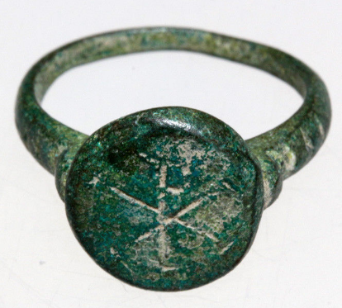

**BYZANTINE BRONZE RING WITH ENGRAVED CHRISTOGRAM CIRCA 700-1000 AD**

**Weight : 6.13gr**

**Size : 25 x 22 x 13mm , Inner : 18mm**