A000-AM,C-Taino-Petroglyph

This is a ROCK CARVING - Stone Sculpture from the DOMINICAN REPUBLIC. These very interesting and cultural pieces are rocks that were carved by using stone tools and decorated with symbols meaningful to their people. This particular rock is rather like a Trapezoid in shape and it lies face up or stand upright (although unevenly). It measures approximately 12 inches long by 5 1/2 inches high by about 3 inches thick. It weighs 8.7 pounds

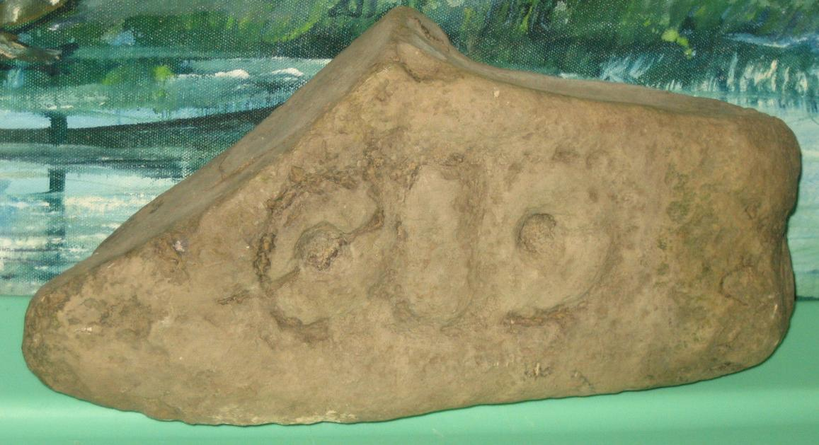

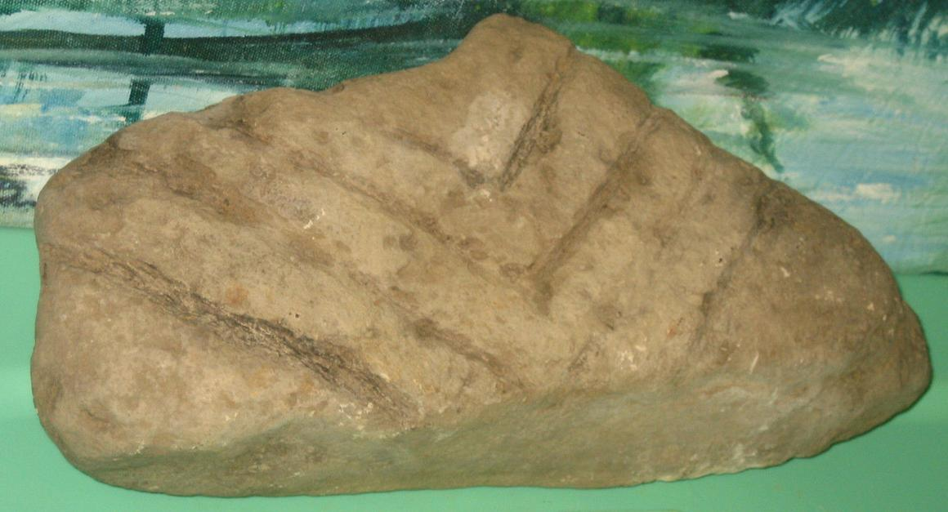

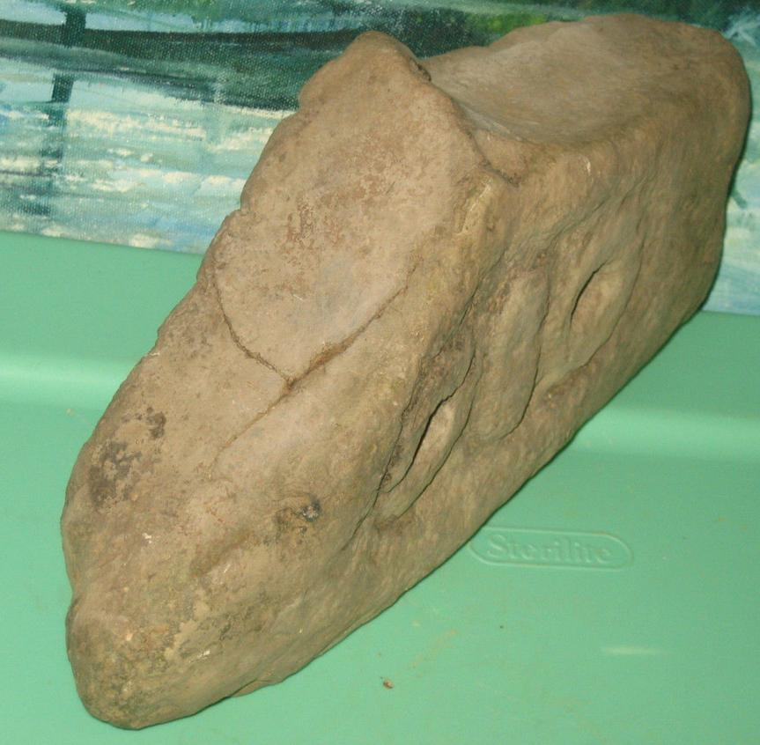

Sold by [alifeinthepastla...](http://myworld.ebay.com/alifeinthepastlane) ( [26214](http://feedback.ebay.com/ws/eBayISAPI.dll?ViewFeedback&userid=alifeinthepastlane) )

### Delivery package 1 of 1

Estimated delivery Friday, Jan 29, 2016

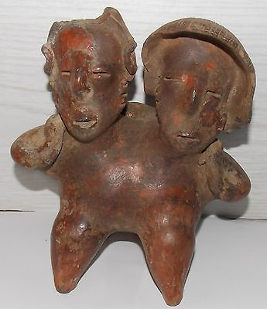

#### [ESTATE PRE-COLUMBIAN POLYCHROME HUGGING COUPLE FIGURES STATUE](http://www.ebay.com/itm/201504222075)

|  |  |
| --- | --- |
| Item price | $659.99 |
| Quantity | 1 |
| Item number | 201504222075 |
| Shipping service | Standard Shipping |

## Sales order

Sold by [tainorocksplus](http://myworld.ebay.com/tainorocksplus) ( [82](http://feedback.ebay.com/ws/eBayISAPI.dll?ViewFeedback&userid=tainorocksplus) )

### Delivery package 1 of 1

Estimated delivery Friday, Jan 29, 2016

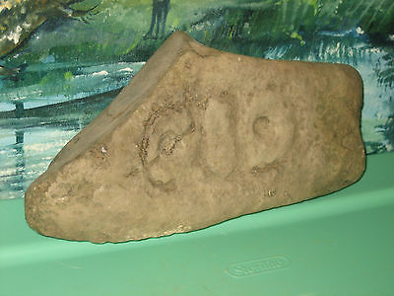

#### [TAINO - DOMINICAN REPUBLIC STONE CARVING ROCK SCULPTURE ARTIFACT FOSSIL # 19](http://www.ebay.com/itm/201491787395)

|  |  |
| --- | --- |
| Item price | $76.00 |
| Quantity | 1 |
| Item number | 201491787395 |
| Shipping service | Standard Shipping |

## Sales order

Sold by [l.orcino](http://myworld.ebay.com/l.orcino) ( [843](http://feedback.ebay.com/ws/eBayISAPI.dll?ViewFeedback&userid=l.orcino) )

### Delivery package 1 of 1

No estimate available

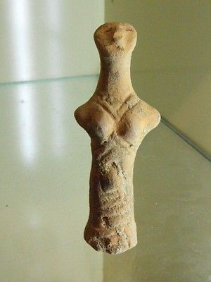

#### [RARE NEOLITHIC CLAY IDOL](http://www.ebay.com/itm/231815194921)

|  |  |
| --- | --- |
| Item price | $177.50 |
| Quantity | 1 |
| Item number | 231815194921 |
| Shipping service | Standard Shipping from outside US |

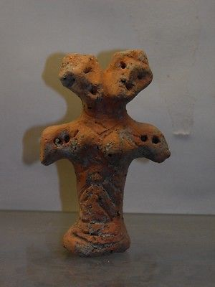

#### [ANCIENT NEOLITHIC CLAY IDOL](http://www.ebay.com/itm/231815202200)

|  |  |
| --- | --- |
| Item price | $222.50 |
| Quantity | 1 |
| Item number | 231815202200 |
| Shipping service | Standard Shipping from outside US |