A000-Asia-Afghanistan-Seals

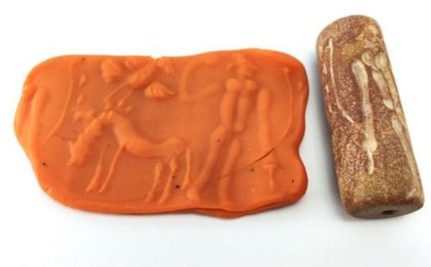 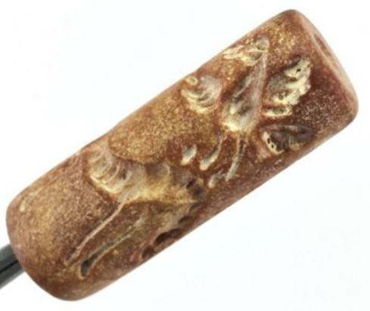 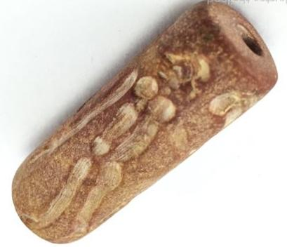

|  |  |
| --- | --- |
| ORDER DATEApr 05, 2016 | ORDER TOTAL  US $24.90  + US $6.00  shipping  **Order BIG Vintage Human Bird Horse Stamp Seal Old Afghanistan Carved Garnet Bead U78** [Leave feedback - ORDER DATE Apr 05, 2016](http://feedback.ebay.com/ws/eBayISAPI.dll?LeaveFeedbackShow&useridto=luckystar-thailand&transactID=0&item=152033225899&_trksid=p2057872.m2749.l2665)[View order details](http://payments.ebay.com/ws/eBayISAPI.dll?ViewPaymentStatus&transId=0&itemid=152033225899&_trksid=p2057872.m2749.l2673) - ORDER DATE Apr 05, 2016  [More actions - ORDER DATE Apr 05, 2016](http://www.ebay.com/myb/PurchaseHistory) |

1 item sold by [luckystar-thailand](http://www.ebay.com/usr/luckystar-thailand?_trksid=p2057872.m2749.l2754)

|  |  |  |  |  |
| --- | --- | --- | --- | --- |
| [BIG Vintage Human Bird Horse Stamp Seal Old Afghanistan Carved Garnet Bead U78](http://www.ebay.com/itm/152033225899?_trksid=p2057872.m2749.l2649&ssPageName=STRK%3AMEBIDX%3AIT)  ( 152033225899 )  Estimated delivery Fri, Apr 22 - Thu, May 05  Tracking number: [**Tracking number**RR076150504TH](javascript:;)  [Add note](javascript:;) | | | | ITEM PRICE:  US $24.90 |
|  | ORDER DATEApr 01, 2016 | ORDER TOTAL  US $177.00  Free shipping  **Order Stunning Beauty old Carved Agate Seal Stamp bead,Gloriouse Beauty Old Afghan greek king Ancient Black Stone seal stamp bead,Gloriouse Beauty Old Afghan seal stamp bead** [View order details - ORDER DATE Apr 01, 2016](http://payments.ebay.com/ws/eBayISAPI.dll?ViewPaymentStatus&transId=1388091279005&itemid=152002889039&_trksid=p2057872.m2749.l2673)[Contact seller](http://contact.ebay.com/ws/eBayISAPI.dll?ShowSellerFAQ&requested=kselleronline&iid=152002889039&redirect=0&_trksid=p2057872.m2749.l2652) - ORDER DATE Apr 01, 2016  [More actions - ORDER DATE Apr 01, 2016](http://www.ebay.com/myb/PurchaseHistory) |  | |

3 items sold by [kselleronline](http://www.ebay.com/usr/kselleronline?_trksid=p2057872.m2749.l2754)

|  |  |  |
| --- | --- | --- |
| [Stunning Beauty old Carved Agate Seal Stamp bead](http://www.ebay.com/itm/152002889039?_trksid=p2057872.m2749.l2649&ssPageName=STRK%3AMEBIDX%3AIT)  ( 152002889039 )  Estimated delivery Thu, Apr 21 - Wed, May 04  Tracking number: [**Tracking number**Rr174550263th](javascript:;)  [Add note](javascript:;) | ITEM PRICE:  US $17.00 | **Item Stunning Beauty old Carved Agate Seal Stamp bead Orders 152002889039-0-1388091279005**[Leave feedback](http://feedback.ebay.com/ws/eBayISAPI.dll?LeaveFeedbackShow&useridto=kselleronline&transactID=1388091279005&item=152002889039&_trksid=p2057872.m2749.l2665)[Return this item](http://postorder.ebay.com/Return/ReturnViewSelectedItem?transactionId=1388091279005&itemId=152002889039&_trksid=p2057872.m2749.l3185)  [More actions](http://www.ebay.com/myb/PurchaseHistory) |

|  |  |  |
| --- | --- | --- |
| [Gloriouse Beauty Old Afghan greek king Ancient Black Stone seal stamp bead](http://www.ebay.com/itm/152006081725?_trksid=p2057872.m2749.l2649&ssPageName=STRK%3AMEBIDX%3AIT)  ( 152006081725 )  Estimated delivery Thu, Apr 21 - Wed, May 04  Tracking number: [**Tracking number**Rr174550263th](javascript:;)  [Add note](javascript:;) | ITEM PRICE:  US $100.00 | **Item Gloriouse Beauty Old Afghan greek king Ancient Black Stone seal stamp bead Orders 152006081725-0-1388090821005**[Leave feedback](http://feedback.ebay.com/ws/eBayISAPI.dll?LeaveFeedbackShow&useridto=kselleronline&transactID=1388090821005&item=152006081725&_trksid=p2057872.m2749.l2665)[Return this item](http://postorder.ebay.com/Return/ReturnViewSelectedItem?transactionId=1388090821005&itemId=152006081725&_trksid=p2057872.m2749.l3185)  [More actions](http://www.ebay.com/myb/PurchaseHistory) |

|  |  |
| --- | --- |
| [Gloriouse Beauty Old Afghan seal stamp bead](http://www.ebay.com/itm/161999074682?_trksid=p2057872.m2749.l2649&ssPageName=STRK%3AMEBIDX%3AIT)  ( 161999074682 )  Estimated delivery Thu, Apr 21 - Wed, May 04  Tracking number: [**Tracking number**Rr174550263th](javascript:;)  [Add note](javascript:;) | ITEM PRICE:  US $60.00 |

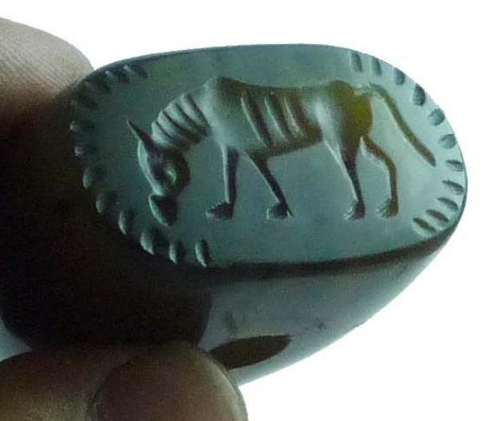 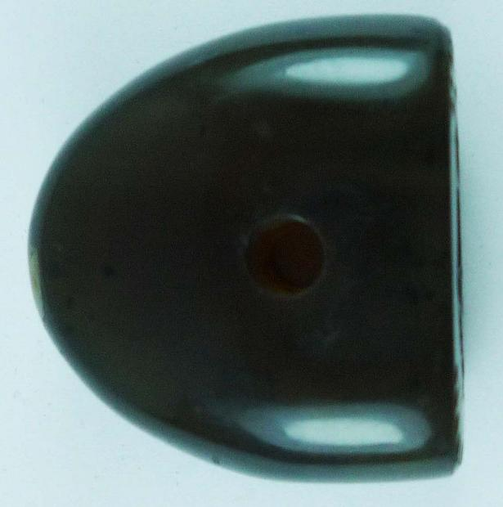 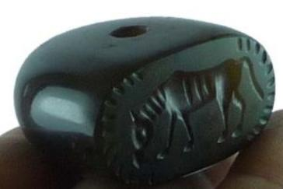

Very nice old carved agate seal stamp bead from north Afghanistan.these beads were used as seal stamp mostly people used az personal

stamp,these beads mostly found in balkh province of Afghanistan.

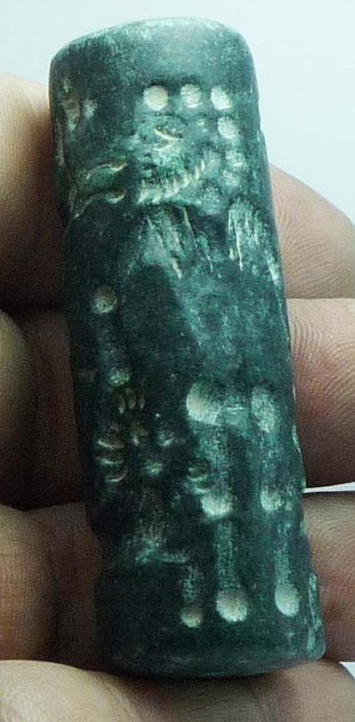 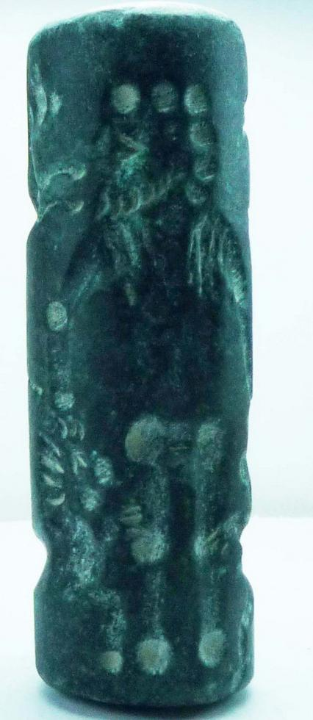 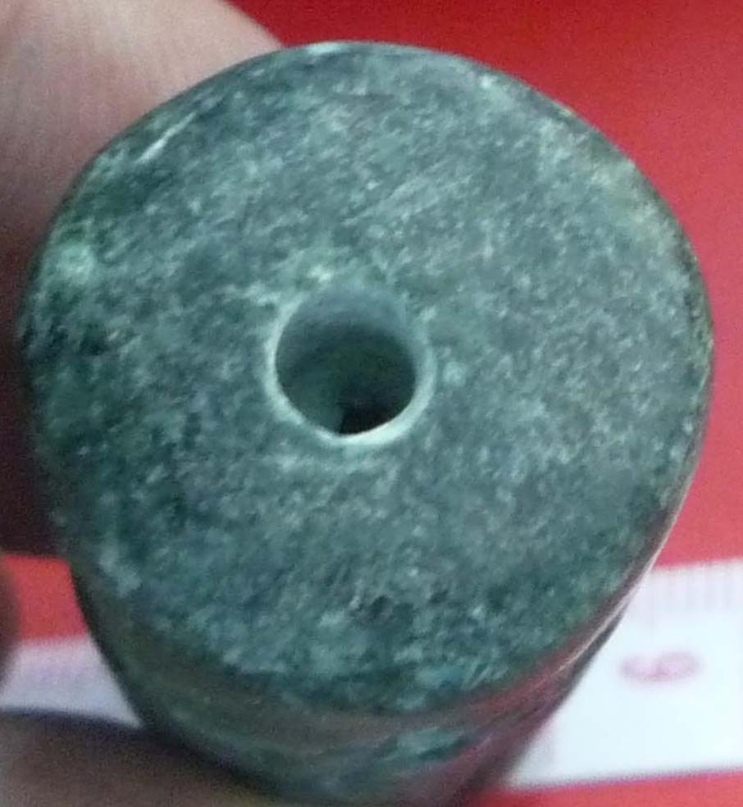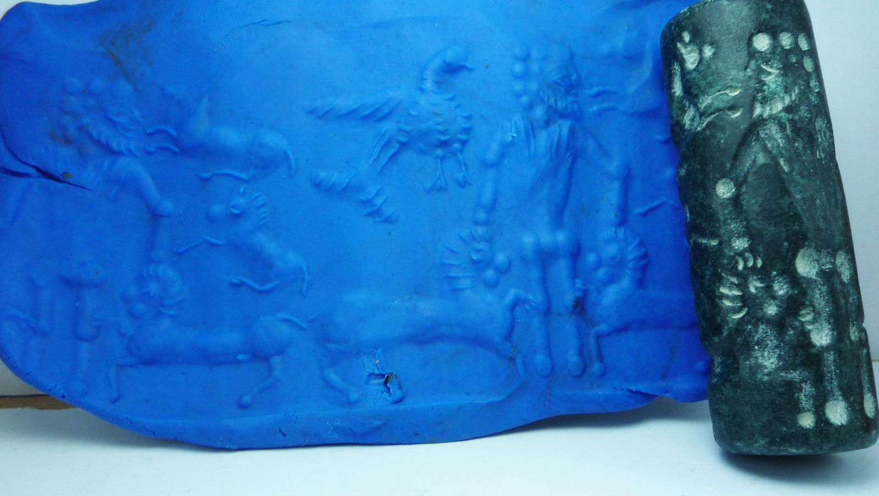

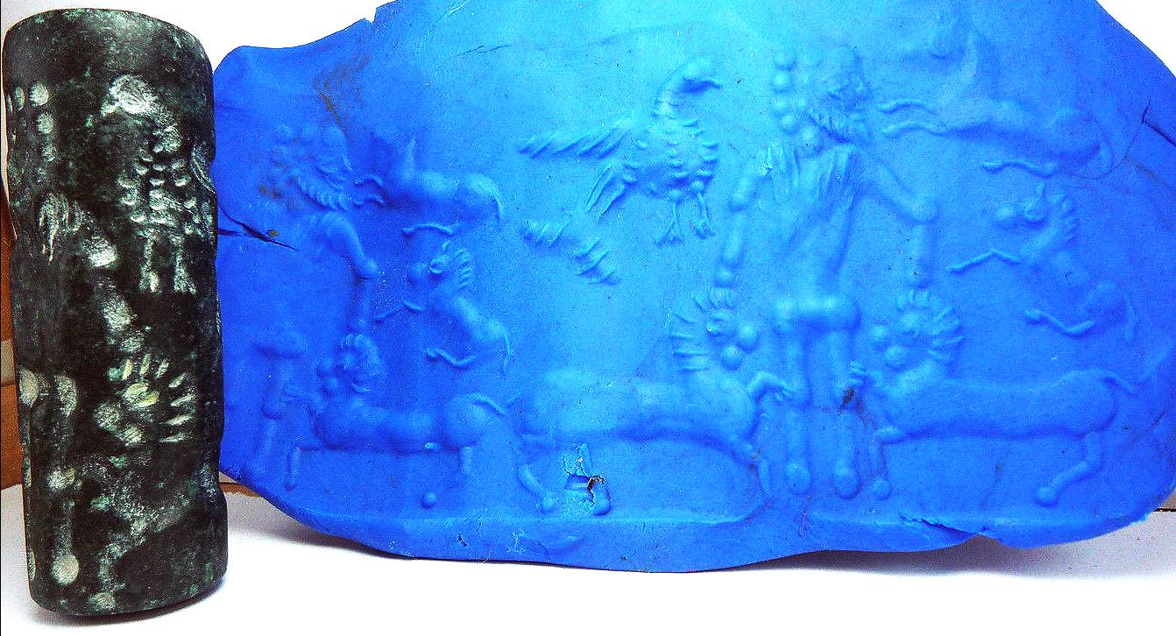

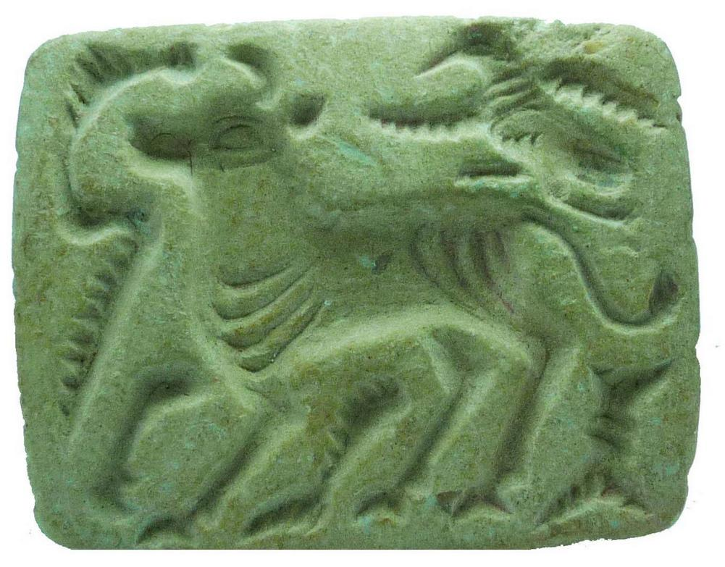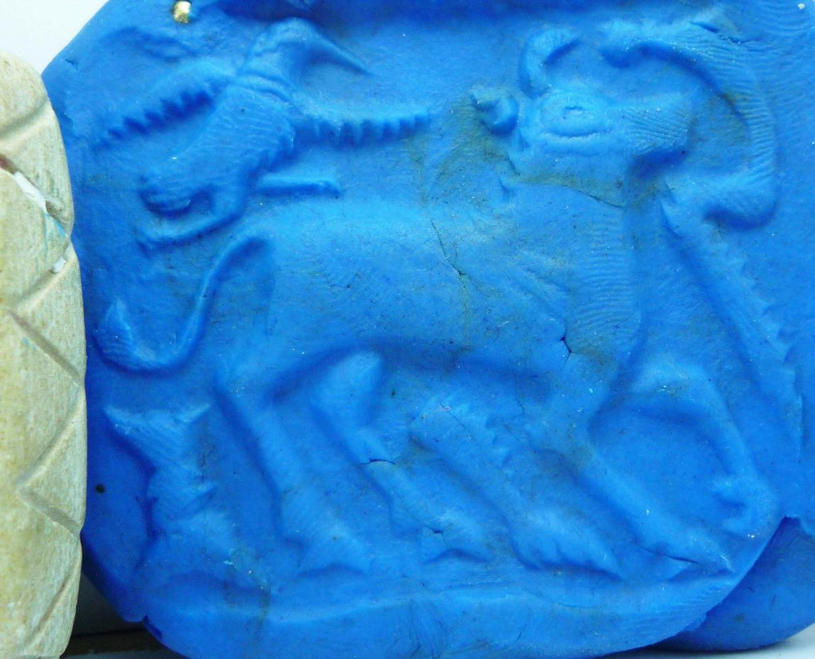

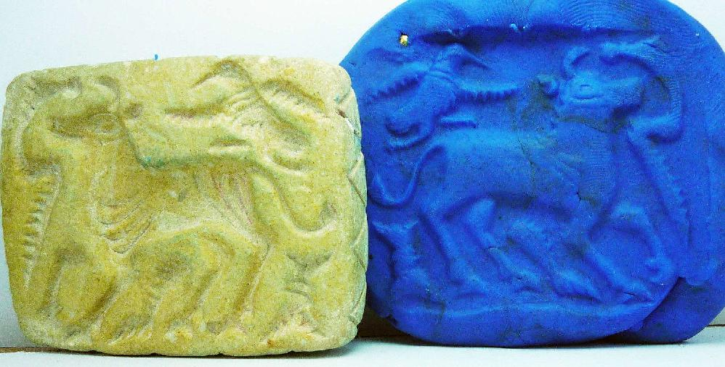

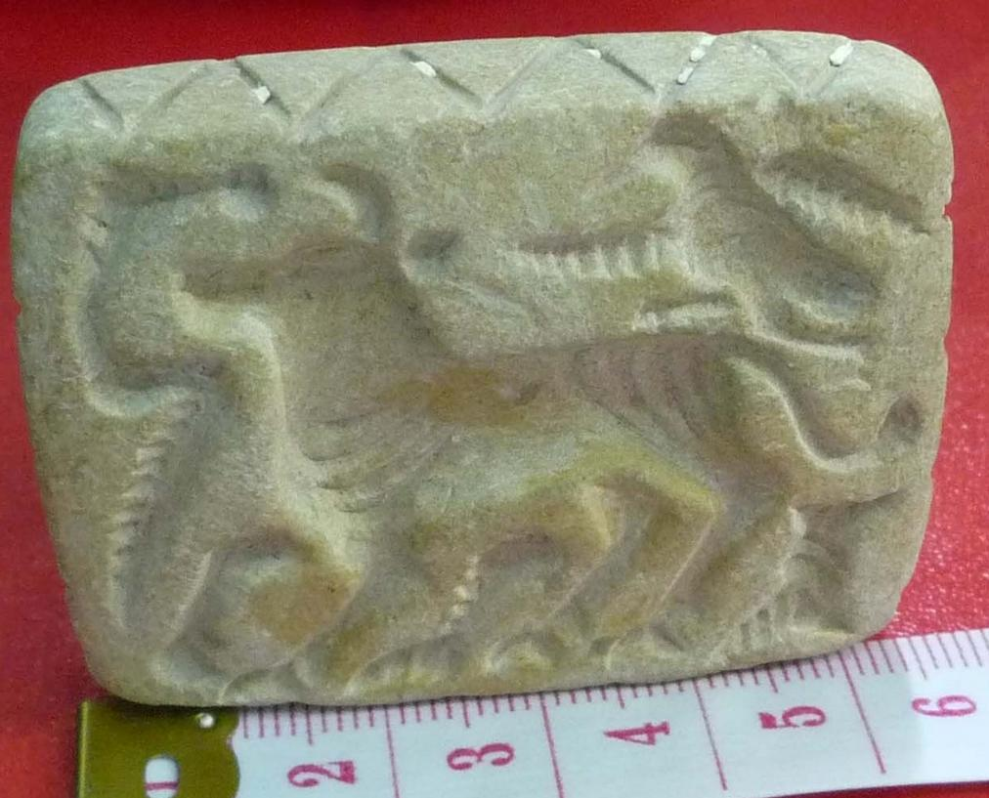

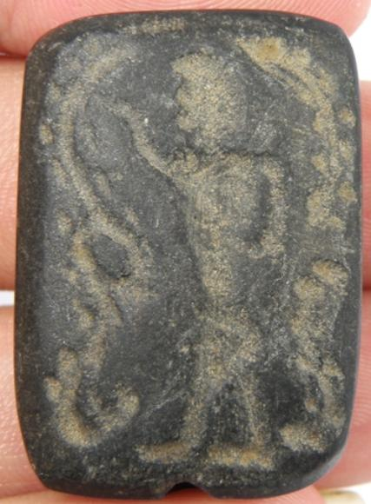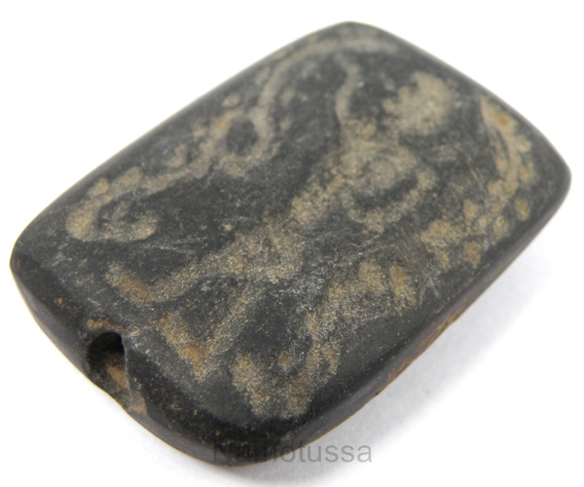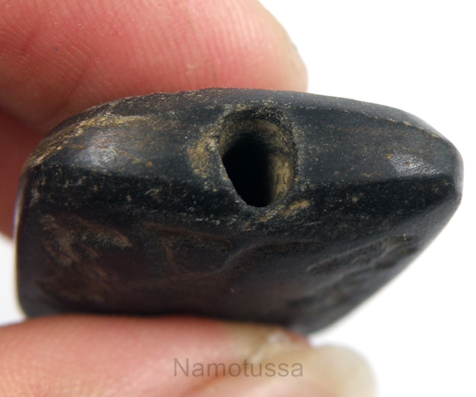

|  |  |  |
| --- | --- | --- |
| Beautiful Collection Stamp Bead | |  |
| Quantity PC(s) : | 1 | |
| Weight : | 14 g. | |
| Size : | 24 x 33 mm. | |
| Thickness : | 10 mm. | |
| Hole Size : | 3 mm. | |
| Shape : | Rectangle Shape | |
| Stone Type : | Black Stone | |