Dis-Eur-Spain-Levant-Paleo-Venus

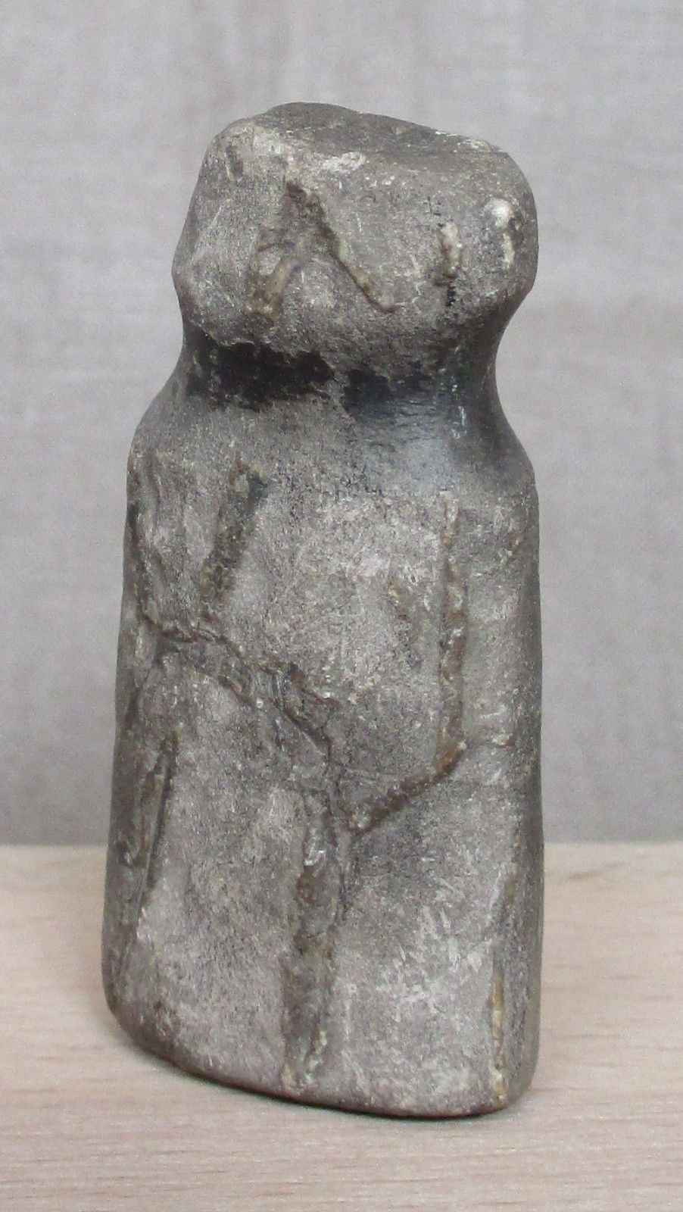 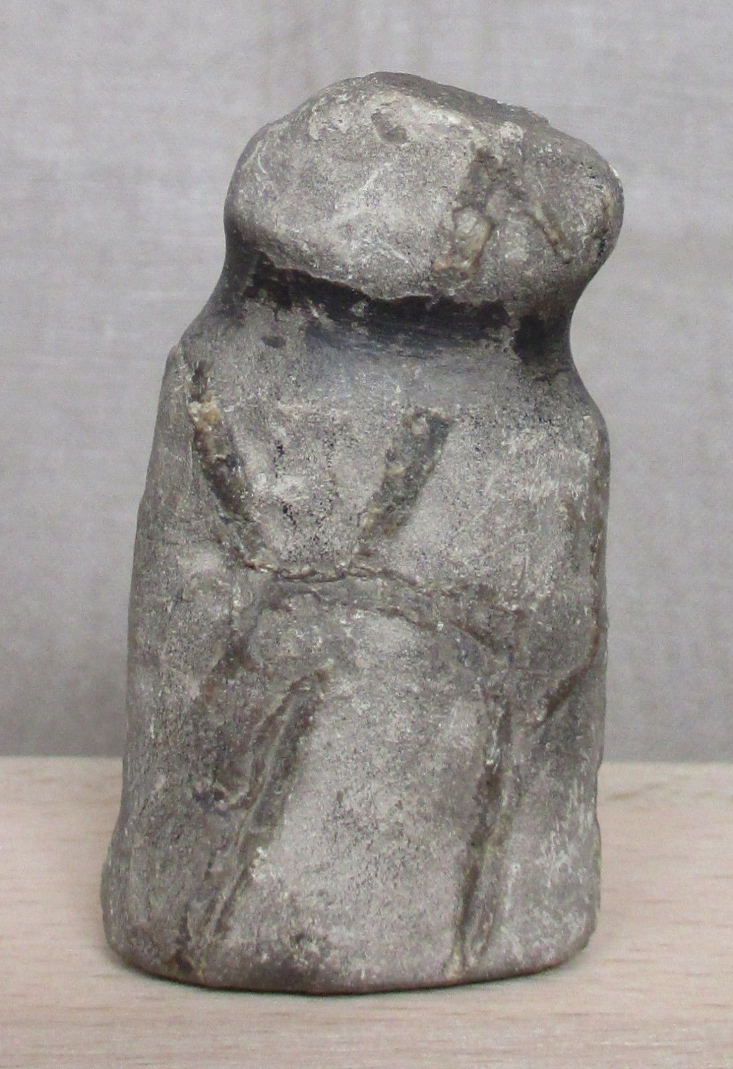 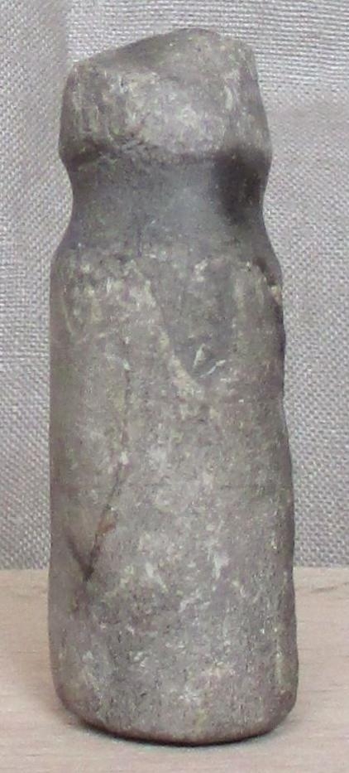 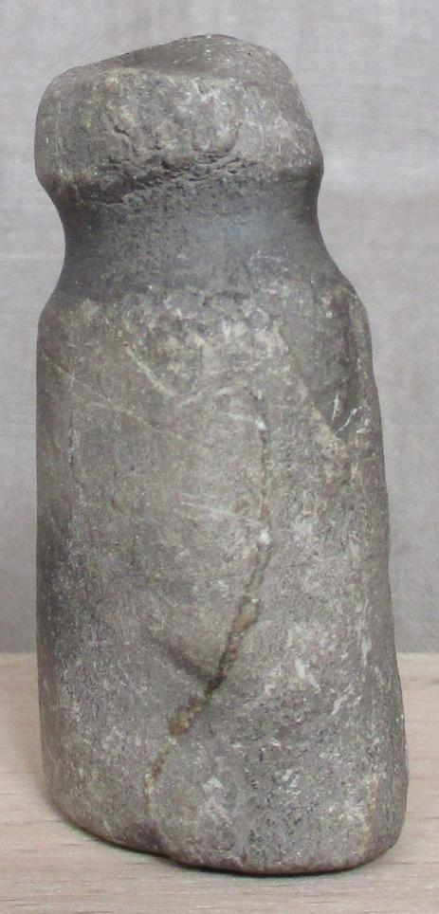 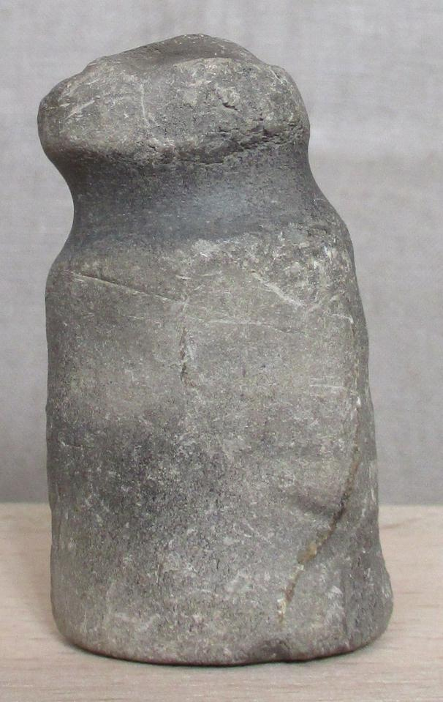

Fig. 1. Paleolithic Venus Figurine, Cantabria, Spain

Formal Label: Paleolithic Venus Figurine, Spain

Accession Number: A124

**LC Classification:** GN772.2.A1

Date or Time Horizon: ca 26,000-16,000 BP

Geographical Area: Cantabria, Spain

**Map:**

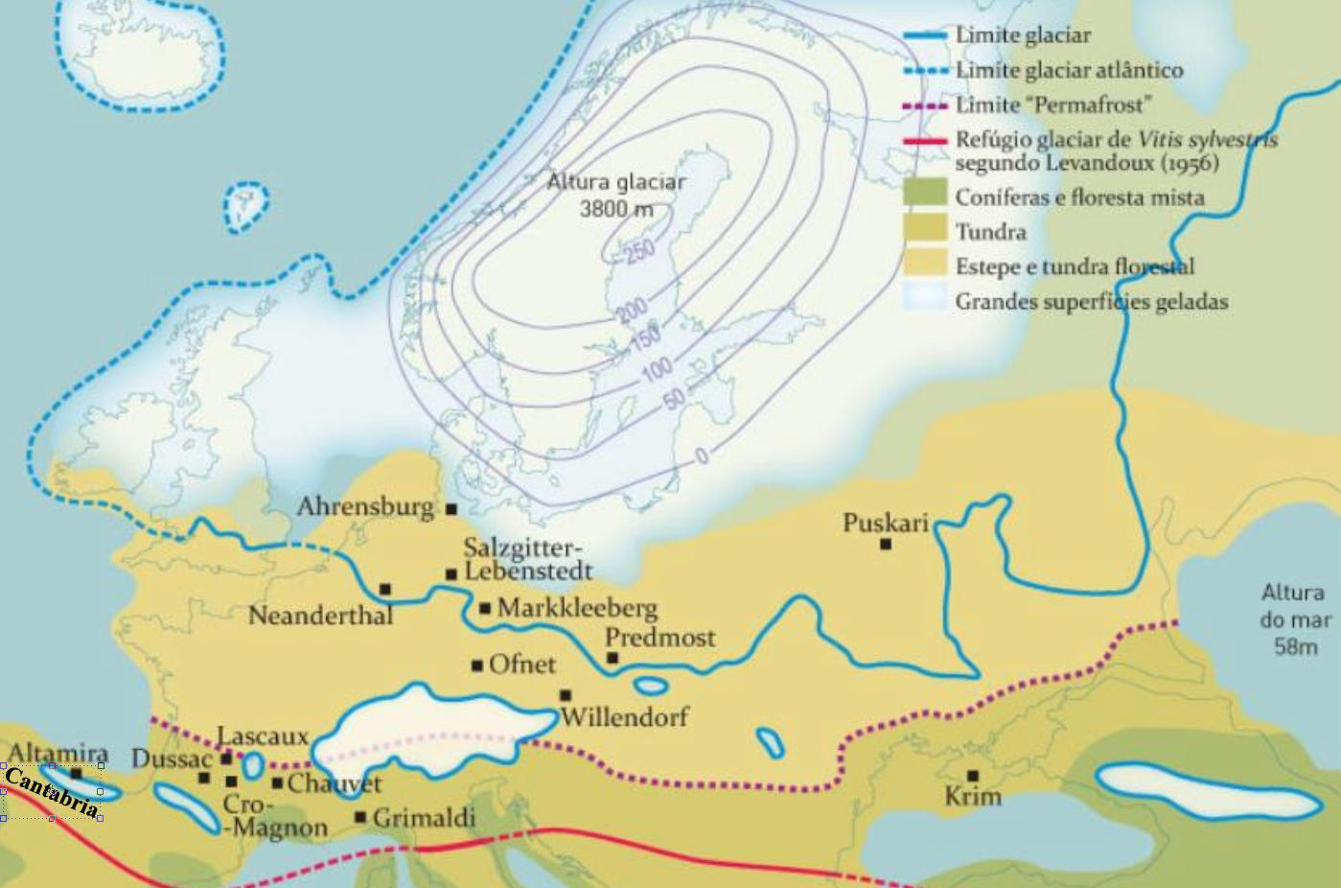

Fig. 2. Map showing location of Cantabria and Predmosti**́**within the landscape and vegetation in the Würm / Weichsel glaciation. From http://www.vinetowinecircle.com/wp-content/gallery/genetica-reflexoes/thumbs/thumbs\_fig02.jpg

Cultural Affiliation: Upper Paleolithic

Medium: limestone

Dimensions: 5.2 cm x 2.8 cm x 1.8 cm (2.05 in x 1.10 in x 0.71 in.)

Weight: 43 gms

Condition: Original

Provenance: inherited from a private archaeological collection from Cantabria, Spain.

**Discussion:**

The process of hominization of the Iberian Peninsula began about 4,000,000 years ago. *Homo erectus* was the leader of the diaspora from Africa towards the temperate zones across the Strait of Gibraltar from Africa ca. 1 ma. Initially, ancient remains were fewer in Morocco than in the Iberian Peninsula, but today ancient sites in Morocco are dated to 1.9 myBP, while in the Iberian Peninsula ancient sites are dated to 1.4 myBP. This suggests that the Strait of Gibraltar was used.

The present specimen from Cantabria of the Iberian peninsula is an example of this new environment and a stylistic tradition that connects it to specimens from the Předmostí site in Moravia (27,000-24,000 BP) and the Avdejevo site in Karelia, ca. 23,400 +/- 700 BP-11,950 +/- 310 BP Karelia.

The Předmostí site is a Late Pleistocene-Cro-Magnon archeological site accompanied by artifacts from the Gravetian culture in Central Europe dated to between 24,000 and 27,000 BP. It is located near [Přerov](https://en.wikipedia.org/wiki/Přerov) in the [country](https://en.wikipedia.org/wiki/Historical_country) [Moravia](https://en.wikipedia.org/wiki/Moravia) of what is today the [Czech Republic](https://en.wikipedia.org/wiki/Czech_Republic). The site was excavated between 1884 and 1930 but although many of the finds were destroyed in fire at [Mikulov castle](https://en.wikipedia.org/wiki/Mikulov_Castle) during World War II Jindřich Matiegka published the scientific findings (1934 and 1938) and casts were made of skulls from [Předmostí 3](https://en.wikipedia.org/wiki/Predmost_3) and Předmostí 4, and from endocrania from Předmostí 3, 4, 9 and 101, which are now in the collection of [Moravian Museum](https://en.wikipedia.org/wiki/Moravian_Museum) in [Brno](https://en.wikipedia.org/wiki/Brno). The site contains a living area with a burial ground and 20 burials, including 15 complete human interments, and five others either disturbed or secondary. From marks on the bones it has been suggested that cannibalism was practiced,[[](https://en.wikipedia.org/wiki/Předmostí_u_Přerova_(archeology)" \l "cite_note-1)

The Předmostí figurines were made of mammoth phalanges. This figurine from the Iberian peninsula is smaller by a factor of 4, but it still retains the general shape of the Moravian and Russian (Avdejevo) examples. It is made of limestone that can be worked with a simple friction bow. The neck area of the figurine is noticeably smoothened by a friction action under heat and therefore darkened. Of the P type

In attempting to differentiate possible behavioral traits between *Homo neanderthalensis* and *Homo sapiens sapiens* conflicting interpretations abound. An analysis of the information available on the Middle and Upper Paleolithic zooarchaeological studies of taphonomy in the Iberian Peninsula in the interpretation of the bone registry concludes that during this transition *there were hardly any significant subsistence changes between the two Hominins* (Yravedra-Sainz de los Terreros 2002). Since the taphonomic record is clear that behavioral traits of *Homo neanderthalensis* and *Homo sapiens sapiens* could not be differentiated, is it possible that the three sites of the Předmostí type of figurine, so different from all other “Venus” types, were made by *Homo neanderthalensis*? This would provide a wide expanse from the Iberian Levantine to Moravia (Předmostí) to Karelia (Avdejevo).

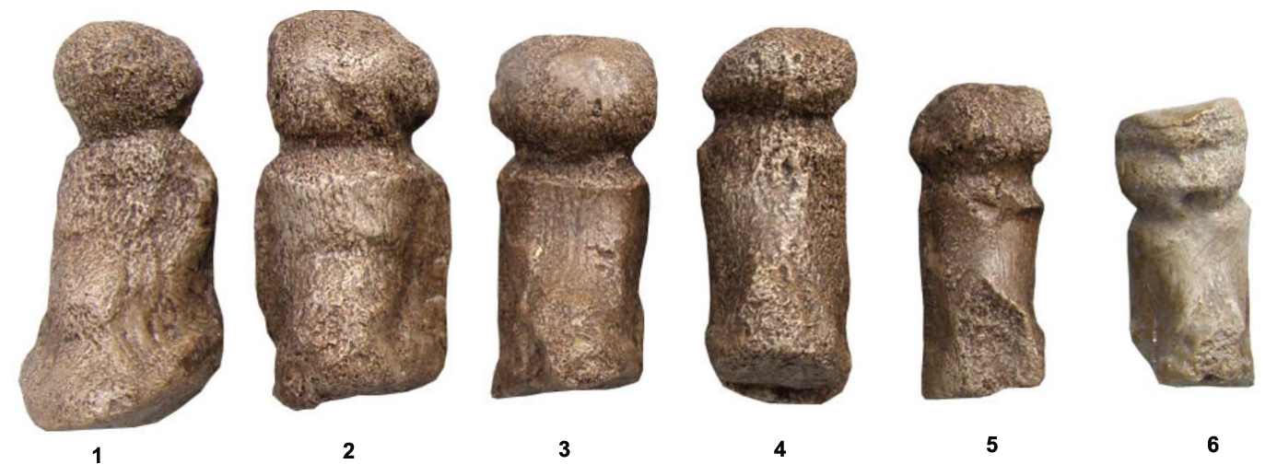A series of human figures carved from mammoth phalanges and then abraded around the neck area with a friction bow. 1-5 from Předmostí, Moravia, Czech Republic, a site of mammoth hunters, ca. 26,800 BP, Pavlovian culture. (Anthropos Institute, Brno, Czech Republic, accession inv. 11673). 6 is from Avdejevo, Karelia, ca. 23,400 +/- 700 BP=11,950 +/- 310 BP (Abramova, Grigorieva, Zaitseva 2001). Height of no. 1 is 14.5 cm (5.8 inches), height (Avdejevo) is 10.0 cm (4,0 inches).

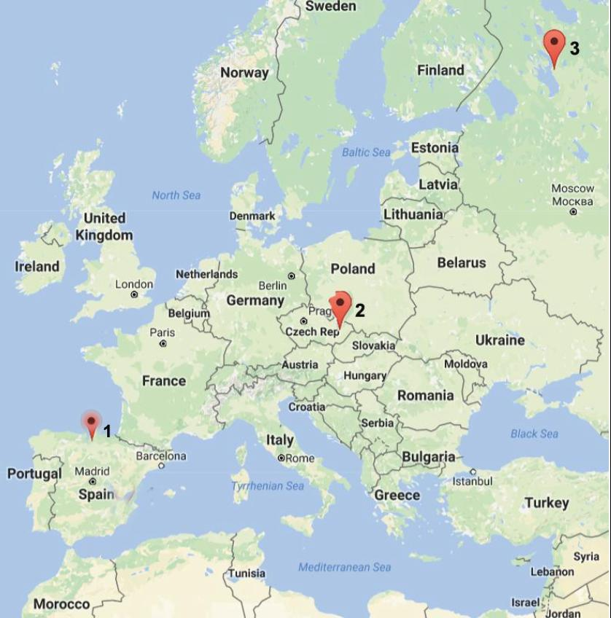

2. Map showing the three locations where the Předmostí type of figurines are found: 1. Iberia (Cantabria); 2. Moravia (Předmostí); 3. Karelia (Avdejevo). These sites suggest a northeast trajectory of of Cromagnon *Homo sapiens sapiens*, who hypothetically entered from the Strait of Gibraltar and spread into Spain and France and central Europe.

**References:**

### **Abramova, Z. A., G. V. Grigorieva, G. I. Zaitseva. 2001.** The age of upper Paleolithic sites in the middle Dnieper River basin of Eastern Europe.

### Absolon, K., Bohuslav Klíma. 1977. *Predmostí: ein Mammutjägerplatz in Mähren*. **Brno: Archeologický Ústav Ceskoslovenské Akademie Ved v. Brno.**

### Arias, P. and Ontañón, R. (2005). *La Materia del Lenguaje Prehistórico. El Arte Mueble Paleolítico de Cantabria en su Contexto*. Gobierno de Cantabria, Santander.

### **Barandiarán, Ignacio.** 2012. ***Prehistoria de la Península Ibérica*.** Barcelona : Ariel

# **de Bruxelles, Simon. June 15, 2012.** [**"Prehistoric cave art began 10,000 years earlier"**](http://www.thetimes.co.uk/tto/science/archaeology/article3445847.ece)**. The Times*.* Retrieved 18 Feb. 2017.**

Estévez, J. and Vila, A. 1999. *Piedra a Piedra. Historia de la construcción del Paleolítico en la Península Ibérica.* B.A.R. International Series 805. Oxford.

González Morales, M., Straus, L. G., and Mar´ın, A. B. (2005). Omóplato grabado en cabeza de cierva y posible bovino, El Mirón. In Arias, P., and Ontañón, R. (eds.), *La Materia del Lenguaje Prehistórico. Gobierno de Cantabria*. Santander, pp. 172–173.

Levadoux, L., 1956. *Les populations sauvages et cultivées des Vitis vinifera L* (Vol. 1). Institut national de la récherche agronomique.

Pericot, L. 1964. *La investigación del Paleolítico Superior en España*. Indice Histórico Español 10, nº 39, XII-XXXII. Barcelona: Universitat de Barcelona

Svoboda J.A. (2004). [*"The Gravettian on the Middle Danube"*](http://paleo.revues.org/index607.html). Paléo – Revue d'archéologie préhistorique. **19**: 203–220.

Villaverde, V. 1994. *Arte Paleolítico de la Cova del Parpalló. Estudio de la colección de plaquetas y cantos grabados y pintados*. Valencia: Diputación de Valencia

Yravedra-Sainz de los Terreros, José*.* 2002. Subsistencia en la transición del Paleolítico Medio al Paleolítico Superior de la Península Ibérica, *Trabajos de Prehistoria*, Vol 59, No 1 (2002)

Homo erectus ca. 1,3-,9 myr

Human remains recovered at European late Early

Pleistocene sites are currently ascribed to *Homo*

*antecessor* (Berm棈ez de Castro *et al.,* 1997), represented

by Atapuerca-TD6 sample, dated to 0.8

myr (Carbonell *et al.,* 1995), and Ceprano (Italy)

calotte, dated to 0.9 myr (Manzi *et al.,* 2001).

We find deposits such as Venta de Micena, in Granada, whose archaeological remains date back more than a million years. On the other hand we find the famous site of Atapuerca: In the Sima del Elefante have been found remains of a Homo Erectus jaw (discovered in 2007) 1.2 myBP, and a lithic industry (discovered in 2013) dating to 1.4 myBP. Homo erectus had very archaic physical characteristics, traits that have led the scientists to classify it as a variant of Europe. We know with certainty that these species practiced cannibalism (by cut marks and cartilage in the bones) for purely food reasons. Their displacement would be in accordance with the migratory movements of the herds of animals. Human occupation would be around 900,000 BP

The Lower Paleolithic 1,400,000 BP begin with the presence of the *choppers* or *Mode 1;* These would consist of worked songs, a simple stone with a cut to get a sharp edge and thus be able to break the bones and get the marrow. We also found the *tolos chopper,* which consist of songs worked on both faces. The hominids of this period are scavengers, and their simple lytic industry is destined to the best obtaining of the meat; They used the animals that had been hunted by other predators.

From 500,000 BP we already find the most long-lived lithic tool of humanity: the bifaz. A million and a half years will be in force. Its evolutionary process will tend to microliteration, but will remain the same tool. At this time the population of Portugal increases, the Miño basin is populated, as well as Asturias, Cantabria, La Rioja, Valle del Duero ... The bifaces created would then be large (weighing 4 kg), flint or quartzite ( Depending on the geographical area). As for the species in force we would find preneandertales and heidelbergensis. In the bones of the bones, for example, more than 1,300 bones of preneandertales have been found. Although initially dated to 600,000 BP the latest studies place it at 450,000 / 400,000. Cannibal practices have been found in this deposit. In addition to the large number of bones belonging to 33 individuals, a hyoid, a bone related to speech, has been recovered. This would be an important finding, since the use of language would be placed around the 400,000 BP (although probably it was previous). The earliest known evidence was an Israeli hyoid, dating to 60,000 BP

In this period, groups of hominids had a preference for river terraces, marine areas ... Avoiding caves and high mountains. These are tremendously mobile groups. They consume everything that falls into their hands, they are very little specialized hunter-gatherers. For hunting they use different places, such as holes, cliffs, marshes ... The consumption of the animal is not done in the same area of ​​the hunt, but in a somewhat secluded place, intended for it, where they remain until they finish with all the food. They hunted with stones, and from 400,000 with wooden spikes.

Already entering the Middle Paleolithic (130,000 / 128,000-40,000 / 27,000 BP) the protagonists would be the archaic Sapiens and the Neanderthal, which coexist. As for the climate, we are in the Würm glaciation, with a really hard cold. The points of greatest demographic concentration are on the Cantabrian coast. As for its industry, there is still the smaller bifaz, as well as the lithic industry manufactured on splinters. Catalonia will be another populated area, as well as the Mediterranean coast. Populations are concentrated in very specific places, which indicates that there would probably be more animals. They were essentially carnivores, living in caves due to the cold (from then on, the caves will be almost permanently occupied, where huge archaeological deposits accumulate, reaching 17 meters). We will not find outdoor deposits until the weather improves. The few that exist are located in strategic positions, of high visibility.

The groups move with the herds. As for hunting, slaughterhouses disappear, but not cliffs; Although they continue practicing the carrion. The game is generalized with pikes (with the edge hardened with fire). Some have been found in deposits such as Abric Romaní. Now the method of hunting is much more dangerous, closer to the animal. Most of the Neandertals found have broken bones and bruises. They also consumed fish, such as barbs, pikes or pike, in addition to a large amount of plant matter (tubers, roots ...).

For the first time we find burials, indicative of religious concerns. An example would be the three burials of the cave of the Sidrón (60,000-40,000 BP). The corpse was deposited in a lateral position, with legs shrunk, and then covered with dirt.

In conditions of famine they had cannibal behaviors. Many tribal communities are known to perform ritual meals where the tribal chief is consumed to acquire his qualities. This would not be the case, for the moment, of the Neanderthals. Prehistorians think that they are purely food reasons.

Human groups would comprise between 20-25 people, with ties of kinship. The lack of the sanguine renewal would be one of the reasons of its extinction, since would begin to appear congenital diseases. On the Cantabrian coast they had a lot of mix, due to the population density, but other areas were not so lucky, leading to their extinction. In the cave of the Sidrón have been found 700 bones, all with relations of kinship and different stages.

It is hypothesized that *Homo sapiens sapiens* crossed the Strait of Gibraltar and initiated the Upper Paleolithic world of Spain, where the weather conditions were tremendously harsh ca. 42,000 BP. In the Basque Country, in August, the maximum temperature would be around 5 degrees Celsius; the average annual temperature would be about -5 degrees Celsius. Yet, despite these climatic challenges we see a remarkable demographic increase at this time horizon and *Homo sapiens sapiens* groups are more often gathering, suggesting the initiation of a new social strategy. *Homo sapiens sapiens* developed an effective and specialized hunting strategy too at this time horizon that allowed greater distance of searching and greater precision resulting in a greater meat supply. This may be seen in the first maps carved on bone and ivory that could lead the hunters to the glacial margins where animals gathered (Marshack ).

At this time horizon the simple friction bow was introduced which made a series of jobs easier, especially starting fires. In a French cave a friction bow to ignite fire was discovered ( ). Burials were not very localized, but we know that the ritual practice was the individual burial, which suggests a magico-spiritual insight. It will be here the explosion of amulets and rock art takes place.

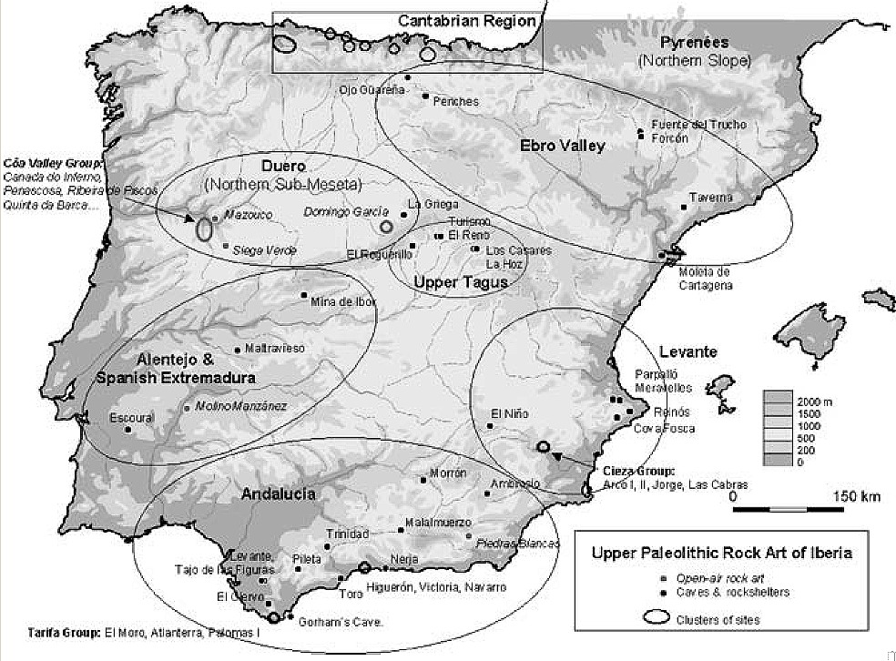

Fig. 1. Map showing the Upper Paleolithic Rock Art of Iberia. After C. Gonzalez Sainz in Bicho et al. 2007: 84).

The areas of population concentration were the Cantabrian coast where portable and parietal contexts, such as the long-famous striated engravings of ungulates (mainly red deer hinds) done on red deer scapulae and on the walls of El Castillo and Altamira, as first described by Breuil and Obermaier (1935), as well as on scapulae (from the Lower Magdalenian, ca. 15–16 kya) from several other sites in the province of Cantabria (plus an outlier site in eastern Asturias), now including well-dated examples from El Miron Cave (Gonzalez Morales et al., 2005;n.d.). The wealth of the Cantabrian record is due to a combination of factors: a relatively high human demographic density (especially in the Late Upper Paleolithic: Solutrean and Magdalenian) as permitted by the abundance and diversity of resources that could be exploited by hunter-gatherers in this circumscribed, high-relief region, plus excellent conditions for the preservation of information in the many caves of this karstic limestone-rich region which have been archeologically contextualized in an exhibit catalogue on Cantabrian portable art (Arias and Ontanon, 2005).

#### [Prehistoric Carved Stone Miniature Anthropomorphic Figure - 2,000 BC or earlier](http://www.ebay.com/itm/122203131101)

|  |  |
| --- | --- |
| Item price | $150.00 |
| Quantity | 1 |
| Item number | 122203131101 |
| Shipping service | Standard Shipping from outside US |

