A000-COINS-Greece-

|  |  |
| --- | --- |
| ORDER DATE  May 21, 2018 | ORDER TOTAL  US $4.99  Free shipping  **Order Rare Ancient Alexander III The Great Greek Coin 336-323 BC Silver Plated Drachm**[Return this item](https://www.ebay.com/rtn/Return/ReturnViewSelectedItem?transactionId=1726532958005&itemId=153020070061&_trksid=p2057872.m2749.l3185)[Leave feedback](http://feedback.ebay.com/ws/eBayISAPI.dll?LeaveFeedbackShow&useridto=uniqueitemsshop&transactID=1726532958005&item=153020070061&_trksid=p2057872.m2749.l2665)  [More actions](https://www.ebay.com/myb/PurchaseHistory) |

1 item sold by [uniqueitemsshop](http://www.ebay.com/usr/uniqueitemsshop?_trksid=p2057872.m2749.l2754" \o "uniqueitemsshop user ID, click for member’s profile)

|  |  |  |
| --- | --- | --- |
| [Rare Ancient Alexander III The Great Greek Coin  336-323 BC Silver Plated Drachm](https://www.ebay.com/itm/Rare-Ancient-Alexander-III-The-Great-Greek-Coin-336-323-BC-Silver-Plated-Drachm/153020070061?ssPageName=STRK%3AMEBIDX%3AIT&_trksid=p2057872.m2749.l2648)  [Rare Ancient Alexander III The Great Greek Coin 336-323 BC Silver Plated Drachm](https://www.ebay.com/itm/Rare-Ancient-Alexander-III-The-Great-Greek-Coin-336-323-BC-Silver-Plated-Drachm/153020070061?ssPageName=STRK%3AMEBIDX%3AIT&_trksid=p2057872.m2749.l2649)  ( 153020070061 )  Delivered on **Jun 08, 2018**  Tracking number: [**Tracking numberLB013459824SG**](javascript:;)  This item has been shipped.  [Add note](javascript:;) | ITEM PRICE:  US $4.99 |  |
| ORDER DATE  May 21, 2018 | ORDER TOTAL  US $7.99  Free shipping  **Order Gold Greek Mythology Athena and Owl COINS FREE SHIPPING**[Return this item](https://www.ebay.com/rtn/Return/ReturnViewSelectedItem?transactionId=1955631349002&itemId=123128662269&_trksid=p2057872.m2749.l3185)[Leave feedback](http://feedback.ebay.com/ws/eBayISAPI.dll?LeaveFeedbackShow&useridto=buystore4all&transactID=1955631349002&item=123128662269&_trksid=p2057872.m2749.l2665)  [More actions](https://www.ebay.com/myb/PurchaseHistory) | |

1 item sold by [buystore4all](http://www.ebay.com/usr/buystore4all?_trksid=p2057872.m2749.l2754)

|  |  |  |
| --- | --- | --- |
| [Gold Greek Mythology Athena and Owl COINS FREE SHIPPING](https://www.ebay.com/itm/Gold-Greek-Mythology-Athena-and-Owl-COINS-FREE-SHIPPING/123128662269?ssPageName=STRK%3AMEBIDX%3AIT&_trksid=p2057872.m2749.l2648)  [Gold Greek Mythology Athena and Owl COINS FREE SHIPPING](https://www.ebay.com/itm/Gold-Greek-Mythology-Athena-and-Owl-COINS-FREE-SHIPPING/123128662269?ssPageName=STRK%3AMEBIDX%3AIT&_trksid=p2057872.m2749.l2649)  ( 123128662269 )  Estimated delivery **Tue, Jun 12 - Mon, Jul 02**  Tracking number: [**Tracking numberLP00101263162963**](javascript:;)  This item has been shipped.  [Add note](javascript:;) | ITEM PRICE:  US $7.99 |  |
| ORDER DATE  May 21, 2018 | ORDER TOTAL  US $9.00  Free shipping  **Order Souvenir Ancient Greek Coin Gold Plate Education Gift**[Return this item](https://www.ebay.com/rtn/Return/ReturnViewSelectedItem?transactionId=2085553806012&itemId=222897320498&_trksid=p2057872.m2749.l3185)[Leave feedback](http://feedback.ebay.com/ws/eBayISAPI.dll?LeaveFeedbackShow&useridto=psychalopoulosluxurystore&transactID=2085553806012&item=222897320498&_trksid=p2057872.m2749.l2665)  [More actions](https://www.ebay.com/myb/PurchaseHistory) | |

1 item sold by [psychalopoulosluxurystore](http://www.ebay.com/usr/psychalopoulosluxurystore?_trksid=p2057872.m2749.l2754" \o "psychalopoulosluxurystore user ID, click for member’s profile)

|  |  |  |
| --- | --- | --- |
| [Souvenir Ancient Greek Coin Gold Plate Education Gift](https://www.ebay.com/itm/Souvenir-Ancient-Greek-Coin-Gold-Plate-Education-Gift/222897320498?ssPageName=STRK%3AMEBIDX%3AIT&_trksid=p2057872.m2749.l2648)  [Souvenir Ancient Greek Coin Gold Plate Education Gift](https://www.ebay.com/itm/Souvenir-Ancient-Greek-Coin-Gold-Plate-Education-Gift/222897320498?ssPageName=STRK%3AMEBIDX%3AIT&_trksid=p2057872.m2749.l2649)  ( 222897320498 )  Delivered on **May 29, 2018**  Tracking number: [**Tracking numberUC701616291CN**](javascript:;)  This item has been shipped.  [Add note](javascript:;) | ITEM PRICE:  US $9.00 |  |
| ORDER DATE | ORDER TOTAL  US $5.35  + US $0.00  shipping  **Order null**[View order details](http://payments.ebay.com/ws/eBayISAPI.dll?ViewPaymentStatus&transId=2085553668012&itemid=222979170842&_trksid=p2057872.m2749.l2673)[Resolve a problem](http://res.ebay.com/ws/eBayISAPI.dll?ResolveProblem&TransactionId=2085553668012&ItemNumber=222979170842&PageNum=3984&_trksid=p2057872.m2749.l2666)  [More actions](https://www.ebay.com/myb/PurchaseHistory) | |

1 item sold by [kalpavix.inc](http://www.ebay.com/usr/kalpavix.inc?_trksid=p2057872.m2749.l2754)

|  |  |  |
| --- | --- | --- |
| [https://ir.ebaystatic.com/cr/v/c1/stockimage1.jpg](https://www.ebay.com/itm/222979170842/222979170842?ssPageName=STRK%3AMEBIDX%3AIT&_trksid=p2057872.m2749.l2648)  ( 222979170842 )  Estimated delivery **Fri, Jun 08 - Fri, Jul 13**  We had to remove this listing from the site and you're not required to complete the transaction. If you've already sent payment, the sale should process as normal and you don't have anything to worry about. If you have any questions about delivery, please check tracking or contact your seller. If you run into any trouble along the way eBay is here to help. Please visit the [Resolution Center](http://res.ebay.com/ws/eBayISAPI.dll?ResolutionCenter&ck=222979170842) to help resolve any problems you may encounter.  This item has been shipped.  [Add note](javascript:;) | ITEM PRICE:  US $5.35 |  |
| ORDER DATE  May 21, 2018 | ORDER TOTAL  US $10.00  Free shipping  **Order Greek COINS FREE SHIPPING Irregular size,G(15)Rare Ancient Greek Coin -415 Tetradrachm**[View order details](http://payments.ebay.com/ws/eBayISAPI.dll?ViewPaymentStatus&transId=1669604082010&itemid=202316433331&_trksid=p2057872.m2749.l2673)[Contact seller](http://contact.ebay.com/ws/eBayISAPI.dll?ShowSellerFAQ&requested=luuhu_0&iid=202316433331&redirect=0&_trksid=p2057872.m2749.l2652)  [More actions](https://www.ebay.com/myb/PurchaseHistory) | |

2 items sold by [luuhu_0](http://www.ebay.com/usr/luuhu_0?_trksid=p2057872.m2749.l2754)

|  |  |  |
| --- | --- | --- |
| [Greek COINS FREE SHIPPING Irregular size](https://www.ebay.com/itm/Greek-COINS-FREE-SHIPPING-Irregular-size/202316433331?ssPageName=STRK%3AMEBIDX%3AIT&_trksid=p2057872.m2749.l2648)  [Greek COINS FREE SHIPPING Irregular size](https://www.ebay.com/itm/Greek-COINS-FREE-SHIPPING-Irregular-size/202316433331?ssPageName=STRK%3AMEBIDX%3AIT&_trksid=p2057872.m2749.l2649)  ( 202316433331 )  Delivered on **Jun 04, 2018**  Tracking number: [**Tracking numberLY199586459CN**](javascript:;)  This item has been shipped.  [Add note](javascript:;) | ITEM PRICE:  US $5.00 | **Item Greek COINS FREE SHIPPING Irregular size**[Return this item](https://www.ebay.com/rtn/Return/ReturnViewSelectedItem?transactionId=1669604082010&itemId=202316433331&_trksid=p2057872.m2749.l3185)[Leave feedback](http://feedback.ebay.com/ws/eBayISAPI.dll?LeaveFeedbackShow&useridto=luuhu_0&transactID=1669604082010&item=202316433331&_trksid=p2057872.m2749.l2665)  [More actions](https://www.ebay.com/myb/PurchaseHistory) |
| [G(15)Rare Ancient Greek Coin -415 Tetradrachm](https://www.ebay.com/itm/G-15-Rare-Ancient-Greek-Coin-415-Tetradrachm/202316443559?ssPageName=STRK%3AMEBIDX%3AIT&_trksid=p2057872.m2749.l2648)  [G(15)Rare Ancient Greek Coin -415 Tetradrachm](https://www.ebay.com/itm/G-15-Rare-Ancient-Greek-Coin-415-Tetradrachm/202316443559?ssPageName=STRK%3AMEBIDX%3AIT&_trksid=p2057872.m2749.l2649)  ( 202316443559 )  Delivered on **May 30, 2018**  Tracking number: [**Tracking numberUC701625007CN**](javascript:;)  This item has been shipped.  [Add note](javascript:;) | ITEM PRICE:  US $5.00 | **Item G(15)Rare Ancient Greek Coin -415 Tetradrachm**[Return this item](https://www.ebay.com/rtn/Return/ReturnViewSelectedItem?transactionId=1669604083010&itemId=202316443559&_trksid=p2057872.m2749.l3185)[Leave feedback](http://feedback.ebay.com/ws/eBayISAPI.dll?LeaveFeedbackShow&useridto=luuhu_0&transactID=1669604083010&item=202316443559&_trksid=p2057872.m2749.l2665)  [More actions](https://www.ebay.com/myb/PurchaseHistory) |
| ORDER DATE | ORDER TOTAL  US $5.56  + US $0.00  shipping  **Order null**[View order details](http://payments.ebay.com/ws/eBayISAPI.dll?ViewPaymentStatus&transId=1815111876001&itemid=113006076664&_trksid=p2057872.m2749.l2673)[Resolve a problem](http://res.ebay.com/ws/eBayISAPI.dll?ResolveProblem&TransactionId=1815111876001&ItemNumber=113006076664&PageNum=3984&_trksid=p2057872.m2749.l2666)  [More actions](https://www.ebay.com/myb/PurchaseHistory) | |

1 item sold by [store-replicas](http://www.ebay.com/usr/store-replicas?_trksid=p2057872.m2749.l2754)

|  |  |  |
| --- | --- | --- |
| [https://ir.ebaystatic.com/cr/v/c1/stockimage1.jpg](https://www.ebay.com/itm/113006076664/113006076664?ssPageName=STRK%3AMEBIDX%3AIT&_trksid=p2057872.m2749.l2648)  ( 113006076664 )  Estimated delivery **Sat, Jun 02 - Sat, Jun 16**  Tracking number: [**Tracking numberLY203201660CN**](javascript:;)  We had to remove this listing from the site and you're not required to complete the transaction. If you've already sent payment, the sale should process as normal and you don't have anything to worry about. If you have any questions about delivery, please check tracking or contact your seller. If you run into any trouble along the way eBay is here to help. Please visit the [Resolution Center](http://res.ebay.com/ws/eBayISAPI.dll?ResolutionCenter&ck=113006076664) to help resolve any problems you may encounter.  This item has been shipped.  [Add note](javascript:;) | ITEM PRICE:  US $5.56 |  |
| ORDER DATE  May 21, 2018 | ORDER TOTAL  US $19.07  Free shipping  **Order Alexander III the Great 336-323 BC Silver Drachm Ancient Greek COINS,323 BC Roman Ancient Greek Gold Stater COINS of King Philip II of Macedon,Greek Antique COINS FREE SHIPPING Irregular Size for Collections**[View order details](http://payments.ebay.com/ws/eBayISAPI.dll?ViewPaymentStatus&transId=1514185149009&itemid=192522520121&_trksid=p2057872.m2749.l2673)[Contact seller](http://contact.ebay.com/ws/eBayISAPI.dll?ShowSellerFAQ&requested=vejusshop17&iid=192522520121&redirect=0&_trksid=p2057872.m2749.l2652)  [More actions](https://www.ebay.com/myb/PurchaseHistory) | |

3 items sold by [vejusshop17](http://www.ebay.com/usr/vejusshop17?_trksid=p2057872.m2749.l2754)

|  |  |  |
| --- | --- | --- |
| [Alexander III the Great 336-323 BC Silver Drachm Ancient Greek COINS](https://www.ebay.com/itm/Alexander-III-the-Great-336-323-BC-Silver-Drachm-Ancient-Greek-COINS/192522520121?ssPageName=STRK%3AMEBIDX%3AIT&_trksid=p2057872.m2749.l2648)  [Alexander III the Great 336-323 BC Silver Drachm Ancient Greek COINS](https://www.ebay.com/itm/Alexander-III-the-Great-336-323-BC-Silver-Drachm-Ancient-Greek-COINS/192522520121?ssPageName=STRK%3AMEBIDX%3AIT&_trksid=p2057872.m2749.l2649)  ( 192522520121 )  Estimated delivery **Thu, Jun 07 - Thu, Jul 12**  Tracking number: [**Tracking numberLP00101238844054**](javascript:;)  This item has been shipped.  [Add note](javascript:;) | ITEM PRICE:  US $5.99 | **Item Alexander III the Great 336-323 BC Silver Drachm Ancient Greek COINS**[Return this item](https://www.ebay.com/rtn/Return/ReturnViewSelectedItem?transactionId=1514185149009&itemId=192522520121&_trksid=p2057872.m2749.l3185)[Leave feedback](http://feedback.ebay.com/ws/eBayISAPI.dll?LeaveFeedbackShow&useridto=vejusshop17&transactID=1514185149009&item=192522520121&_trksid=p2057872.m2749.l2665)  [More actions](https://www.ebay.com/myb/PurchaseHistory) |
| [323 BC Roman Ancient Greek Gold Stater COINS of King Philip II of Macedon](https://www.ebay.com/itm/323-BC-Roman-Ancient-Greek-Gold-Stater-COINS-of-King-Philip-II-of-Macedon/192523382128?ssPageName=STRK%3AMEBIDX%3AIT&_trksid=p2057872.m2749.l2648)  [323 BC Roman Ancient Greek Gold Stater COINS of King Philip II of Macedon](https://www.ebay.com/itm/323-BC-Roman-Ancient-Greek-Gold-Stater-COINS-of-King-Philip-II-of-Macedon/192523382128?ssPageName=STRK%3AMEBIDX%3AIT&_trksid=p2057872.m2749.l2649)  ( 192523382128 )  Estimated delivery **Thu, Jun 07 - Thu, Jul 12**  Tracking number: [**Tracking numberLP00098165055186**](javascript:;)  This item has been shipped.  [Add note](javascript:;) | ITEM PRICE:  US $7.29 | **Item 323 BC Roman Ancient Greek Gold Stater COINS of King Philip II of Macedon**[Return this item](https://www.ebay.com/rtn/Return/ReturnViewSelectedItem?transactionId=1514185146009&itemId=192523382128&_trksid=p2057872.m2749.l3185)[Leave feedback](http://feedback.ebay.com/ws/eBayISAPI.dll?LeaveFeedbackShow&useridto=vejusshop17&transactID=1514185146009&item=192523382128&_trksid=p2057872.m2749.l2665)  [More actions](https://www.ebay.com/myb/PurchaseHistory) |

|  |  |  |
| --- | --- | --- |
| [Greek Antique COINS FREE SHIPPING Irregular Size for Collections](https://www.ebay.com/itm/Greek-Antique-COINS-FREE-SHIPPING-Irregular-Size-for-Collections/192523957355?ssPageName=STRK%3AMEBIDX%3AIT&_trksid=p2057872.m2749.l2648)  [Greek Antique COINS FREE SHIPPING Irregular Size for Collections](https://www.ebay.com/itm/Greek-Antique-COINS-FREE-SHIPPING-Irregular-Size-for-Collections/192523957355?ssPageName=STRK%3AMEBIDX%3AIT&_trksid=p2057872.m2749.l2649)  ( 192523957355 )  Delivered on **Jun 09, 2018**  Tracking number: [**Tracking numberLY205829934CN**](javascript:;)  This item has been shipped.  [Add note](javascript:;) | ITEM PRICE:  US $5.79 | **Item Greek Antique COINS FREE SHIPPING Irregular Size for Collections**[Return this item](https://www.ebay.com/rtn/Return/ReturnViewSelectedItem?transactionId=1514185148009&itemId=192523957355&_trksid=p2057872.m2749.l3185)[Leave feedback](http://feedback.ebay.com/ws/eBayISAPI.dll?LeaveFeedbackShow&useridto=vejusshop17&transactID=1514185148009&item=192523957355&_trksid=p2057872.m2749.l2665)  [More actions](https://www.ebay.com/myb/PurchaseHistory) |
| ORDER DATE  May 21, 2018 | ORDER TOTAL  US $7.99  Free shipping  **Order Alexander III the Great 336-323 BC Drachm Ancient Greek COINS**[Return this item](https://www.ebay.com/rtn/Return/ReturnViewSelectedItem?transactionId=1514180472009&itemId=192523255660&_trksid=p2057872.m2749.l3185)[Leave feedback](http://feedback.ebay.com/ws/eBayISAPI.dll?LeaveFeedbackShow&useridto=vejusshop17&transactID=1514180472009&item=192523255660&_trksid=p2057872.m2749.l2665)  [More actions](https://www.ebay.com/myb/PurchaseHistory) | |

1 item sold by [vejusshop17](http://www.ebay.com/usr/vejusshop17?_trksid=p2057872.m2749.l2754)

|  |  |  |
| --- | --- | --- |
| [Alexander III the Great 336-323 BC Drachm Ancient Greek COINS](https://www.ebay.com/itm/Alexander-III-the-Great-336-323-BC-Drachm-Ancient-Greek-COINS/192523255660?ssPageName=STRK%3AMEBIDX%3AIT&_trksid=p2057872.m2749.l2648)  [Alexander III the Great 336-323 BC Drachm Ancient Greek COINS](https://www.ebay.com/itm/Alexander-III-the-Great-336-323-BC-Drachm-Ancient-Greek-COINS/192523255660?ssPageName=STRK%3AMEBIDX%3AIT&_trksid=p2057872.m2749.l2649)  ( 192523255660 )  Estimated delivery **Thu, Jun 07 - Thu, Jul 12**  Tracking number: [**Tracking numberLP00101238844054**](javascript:;)  This item has been shipped.  [Add note](javascript:;) | ITEM PRICE:  US $7.99 |  |
| ORDER DATE  May 21, 2018 | ORDER TOTAL  US $5.99  Free shipping  **Order Ancient Greek King Philip II Rare Silver Tetradrachm Of Macedon 323 BC Coin**[Return this item](https://www.ebay.com/rtn/Return/ReturnViewSelectedItem?transactionId=1726521641005&itemId=153023709396&_trksid=p2057872.m2749.l3185)[Leave feedback](http://feedback.ebay.com/ws/eBayISAPI.dll?LeaveFeedbackShow&useridto=uniqueitemsshop&transactID=1726521641005&item=153023709396&_trksid=p2057872.m2749.l2665)  [More actions](https://www.ebay.com/myb/PurchaseHistory) | |

1 item sold by [uniqueitemsshop](http://www.ebay.com/usr/uniqueitemsshop?_trksid=p2057872.m2749.l2754" \o "uniqueitemsshop user ID, click for member’s profile)

|  |  |  |
| --- | --- | --- |
| [Ancient Greek King Philip II Rare Silver Tetradrachm Of Macedon 323 BC Coin](https://www.ebay.com/itm/Ancient-Greek-King-Philip-II-Rare-Silver-Tetradrachm-Of-Macedon-323-BC-Coin/153023709396?ssPageName=STRK%3AMEBIDX%3AIT&_trksid=p2057872.m2749.l2648)  [Ancient Greek King Philip II Rare Silver Tetradrachm Of Macedon 323 BC Coin](https://www.ebay.com/itm/Ancient-Greek-King-Philip-II-Rare-Silver-Tetradrachm-Of-Macedon-323-BC-Coin/153023709396?ssPageName=STRK%3AMEBIDX%3AIT&_trksid=p2057872.m2749.l2649)  ( 153023709396 )  Estimated delivery **Mon, Jun 11 - Mon, Jul 16**  Tracking number: [**Tracking numberS000024674425**](javascript:;)  This item has been shipped.  [Add note](javascript:;) | ITEM PRICE:  US $5.99 |  |
| ORDER DATE  May 21, 2018 | ORDER TOTAL  US $111.44  Free shipping  **Order Silver-plated Greek Mythology COINS FREE SHIPPING,Greek Mythology Athena COINS Goddess of Wisdom,Greek Mythology Persephone COINS Goddess of the Underworld,Gold Greek Mythology Athena and Owl COINS FREE SHIPPING,High Quality Gorgona Thrace AR Tetradrachm Ancient Greek COINS,Thracer AR Stater Greek Ancient Silver COINS High-quality Unique Collections,Rare Unique Ancient Greek COINS -415 Tetradrachm Collections,Copper Casting Greek COINS 1840 Years Old FREE SHIPPING,Goddess of the Underworld Persephone Greek Mythology COINS,Greek Thrace Thasos AR Tetradrachm Silver COINS,323 BC Roman Ancient Greek Gold Stater COINS of King Philip II of Macedon,18490 and Earlier Years Copper Greek Ancient COINS FREE SHIPPING Irregular Size,Greek Antique COINS FREE SHIPPING Irregular Size for Collections,Prehistoric Greek Mythology COINS FREE SHIPPING Irregular Size,Ancient Greek COINS The Eagle and Coinage of Akragas,Irregular Greek Prehistoric COINS FREE SHIPPING,Pergamon Mysia Greek Ancient COINS Head of Herakles FREE SHIPPING,Crab of Akragas Greek Ancient COINS FREE SHIPPING**[View order details](http://payments.ebay.com/ws/eBayISAPI.dll?ViewPaymentStatus&transId=1514177450009&itemid=192522052399&_trksid=p2057872.m2749.l2673)[Contact seller](http://contact.ebay.com/ws/eBayISAPI.dll?ShowSellerFAQ&requested=vejusshop17&iid=192522052399&redirect=0&_trksid=p2057872.m2749.l2652)  [More actions](https://www.ebay.com/myb/PurchaseHistory) | |

18 items sold by [vejusshop17](http://www.ebay.com/usr/vejusshop17?_trksid=p2057872.m2749.l2754)

|  |  |  |
| --- | --- | --- |
| [Silver-plated Greek Mythology COINS FREE SHIPPING](https://www.ebay.com/itm/Silver-plated-Greek-Mythology-COINS-FREE-SHIPPING/192522052399?ssPageName=STRK%3AMEBIDX%3AIT&_trksid=p2057872.m2749.l2648)  [Silver-plated Greek Mythology COINS FREE SHIPPING](https://www.ebay.com/itm/Silver-plated-Greek-Mythology-COINS-FREE-SHIPPING/192522052399?ssPageName=STRK%3AMEBIDX%3AIT&_trksid=p2057872.m2749.l2649)  ( 192522052399 )  Estimated delivery **Thu, Jun 07 - Thu, Jul 12**  Tracking number: [**Tracking numberLY20582994CN**](javascript:;)  This item has been shipped.  [Add note](javascript:;) | ITEM PRICE:  US $6.47 | **Item Silver-plated Greek Mythology COINS FREE SHIPPING**[Return this item](https://www.ebay.com/rtn/Return/ReturnViewSelectedItem?transactionId=1514177450009&itemId=192522052399&_trksid=p2057872.m2749.l3185)[Leave feedback](http://feedback.ebay.com/ws/eBayISAPI.dll?LeaveFeedbackShow&useridto=vejusshop17&transactID=1514177450009&item=192522052399&_trksid=p2057872.m2749.l2665)  [More actions](https://www.ebay.com/myb/PurchaseHistory) |
| [Greek Mythology Athena COINS Goddess of Wisdom](https://www.ebay.com/itm/Greek-Mythology-Athena-COINS-Goddess-of-Wisdom/192522080587?ssPageName=STRK%3AMEBIDX%3AIT&_trksid=p2057872.m2749.l2648)  [Greek Mythology Athena COINS Goddess of Wisdom](https://www.ebay.com/itm/Greek-Mythology-Athena-COINS-Goddess-of-Wisdom/192522080587?ssPageName=STRK%3AMEBIDX%3AIT&_trksid=p2057872.m2749.l2649)  ( 192522080587 )  Estimated delivery **Thu, Jun 07 - Thu, Jul 12**  Tracking number: [**Tracking numberLY2058299348CN**](javascript:;)  This item has been shipped.  [Add note](javascript:;) | ITEM PRICE:  US $5.99 | **Item Greek Mythology Athena COINS Goddess of Wisdom**[Return this item](https://www.ebay.com/rtn/Return/ReturnViewSelectedItem?transactionId=1514177456009&itemId=192522080587&_trksid=p2057872.m2749.l3185)[Leave feedback](http://feedback.ebay.com/ws/eBayISAPI.dll?LeaveFeedbackShow&useridto=vejusshop17&transactID=1514177456009&item=192522080587&_trksid=p2057872.m2749.l2665)  [More actions](https://www.ebay.com/myb/PurchaseHistory) |

|  |  |  |
| --- | --- | --- |
| [Greek Mythology Persephone COINS Goddess of the Underworld](https://www.ebay.com/itm/Greek-Mythology-Persephone-COINS-Goddess-of-the-Underworld/192522501556?ssPageName=STRK%3AMEBIDX%3AIT&_trksid=p2057872.m2749.l2648)  [Greek Mythology Persephone COINS Goddess of the Underworld](https://www.ebay.com/itm/Greek-Mythology-Persephone-COINS-Goddess-of-the-Underworld/192522501556?ssPageName=STRK%3AMEBIDX%3AIT&_trksid=p2057872.m2749.l2649)  ( 192522501556 )  Estimated delivery **Thu, Jun 07 - Thu, Jul 12**  Tracking number: [**Tracking numberLY2039726012CN**](javascript:;)  This item has been shipped.  [Add note](javascript:;) | ITEM PRICE:  US $5.39 | **Item Greek Mythology Persephone COINS Goddess of the Underworld**[Return this item](https://www.ebay.com/rtn/Return/ReturnViewSelectedItem?transactionId=1514177460009&itemId=192522501556&_trksid=p2057872.m2749.l3185)[Leave feedback](http://feedback.ebay.com/ws/eBayISAPI.dll?LeaveFeedbackShow&useridto=vejusshop17&transactID=1514177460009&item=192522501556&_trksid=p2057872.m2749.l2665)  [More actions](https://www.ebay.com/myb/PurchaseHistory) |
| [Gold Greek Mythology Athena and Owl COINS FREE SHIPPING](https://www.ebay.com/itm/Gold-Greek-Mythology-Athena-and-Owl-COINS-FREE-SHIPPING/192522536687?ssPageName=STRK%3AMEBIDX%3AIT&_trksid=p2057872.m2749.l2648)  [Gold Greek Mythology Athena and Owl COINS FREE SHIPPING](https://www.ebay.com/itm/Gold-Greek-Mythology-Athena-and-Owl-COINS-FREE-SHIPPING/192522536687?ssPageName=STRK%3AMEBIDX%3AIT&_trksid=p2057872.m2749.l2649)  ( 192522536687 )  Estimated delivery **Thu, Jun 07 - Thu, Jul 12**  Tracking number: [**Tracking numberLP00098165055186**](javascript:;)  This item has been shipped.  [Add note](javascript:;) | ITEM PRICE:  US $8.99 | **Item Gold Greek Mythology Athena and Owl COINS FREE SHIPPING**[Return this item](https://www.ebay.com/rtn/Return/ReturnViewSelectedItem?transactionId=1514177457009&itemId=192522536687&_trksid=p2057872.m2749.l3185)[Leave feedback](http://feedback.ebay.com/ws/eBayISAPI.dll?LeaveFeedbackShow&useridto=vejusshop17&transactID=1514177457009&item=192522536687&_trksid=p2057872.m2749.l2665)  [More actions](https://www.ebay.com/myb/PurchaseHistory) |

|  |  |  |
| --- | --- | --- |
| [High Quality Gorgona Thrace AR Tetradrachm Ancient Greek COINS](https://www.ebay.com/itm/High-Quality-Gorgona-Thrace-AR-Tetradrachm-Ancient-Greek-COINS/192522545137?ssPageName=STRK%3AMEBIDX%3AIT&_trksid=p2057872.m2749.l2648)  [High Quality Gorgona Thrace AR Tetradrachm Ancient Greek COINS](https://www.ebay.com/itm/High-Quality-Gorgona-Thrace-AR-Tetradrachm-Ancient-Greek-COINS/192522545137?ssPageName=STRK%3AMEBIDX%3AIT&_trksid=p2057872.m2749.l2649)  ( 192522545137 )  Estimated delivery **Thu, Jun 07 - Thu, Jul 12**  Tracking number: [**Tracking numberLP001012388440**](javascript:;)  This item has been shipped.  [Add note](javascript:;) | ITEM PRICE:  US $6.71 | **Item High Quality Gorgona Thrace AR Tetradrachm Ancient Greek COINS**[Return this item](https://www.ebay.com/rtn/Return/ReturnViewSelectedItem?transactionId=1514177449009&itemId=192522545137&_trksid=p2057872.m2749.l3185)[Leave feedback](http://feedback.ebay.com/ws/eBayISAPI.dll?LeaveFeedbackShow&useridto=vejusshop17&transactID=1514177449009&item=192522545137&_trksid=p2057872.m2749.l2665)  [More actions](https://www.ebay.com/myb/PurchaseHistory) |
| [Thracer AR Stater Greek Ancient Silver COINS High-quality Unique Collections](https://www.ebay.com/itm/Thracer-AR-Stater-Greek-Ancient-Silver-COINS-High-quality-Unique-Collections/192522580077?ssPageName=STRK%3AMEBIDX%3AIT&_trksid=p2057872.m2749.l2648)  [Thracer AR Stater Greek Ancient Silver COINS High-quality Unique Collections](https://www.ebay.com/itm/Thracer-AR-Stater-Greek-Ancient-Silver-COINS-High-quality-Unique-Collections/192522580077?ssPageName=STRK%3AMEBIDX%3AIT&_trksid=p2057872.m2749.l2649)  ( 192522580077 )  Estimated delivery **Thu, Jun 07 - Thu, Jul 12**  Tracking number: [**Tracking numberLP0010123884405**](javascript:;)  This item has been shipped.  [Add note](javascript:;) | ITEM PRICE:  US $6.71 | **Item Thracer AR Stater Greek Ancient Silver COINS High-quality Unique Collections**[Return this item](https://www.ebay.com/rtn/Return/ReturnViewSelectedItem?transactionId=1514177455009&itemId=192522580077&_trksid=p2057872.m2749.l3185)[Leave feedback](http://feedback.ebay.com/ws/eBayISAPI.dll?LeaveFeedbackShow&useridto=vejusshop17&transactID=1514177455009&item=192522580077&_trksid=p2057872.m2749.l2665)  [More actions](https://www.ebay.com/myb/PurchaseHistory) |

|  |  |  |
| --- | --- | --- |
| [Rare Unique Ancient Greek COINS -415 Tetradrachm Collections](https://www.ebay.com/itm/Rare-Unique-Ancient-Greek-COINS-415-Tetradrachm-Collections/192523251263?ssPageName=STRK%3AMEBIDX%3AIT&_trksid=p2057872.m2749.l2648)  [Rare Unique Ancient Greek COINS -415 Tetradrachm Collections](https://www.ebay.com/itm/Rare-Unique-Ancient-Greek-COINS-415-Tetradrachm-Collections/192523251263?ssPageName=STRK%3AMEBIDX%3AIT&_trksid=p2057872.m2749.l2649)  ( 192523251263 )  Estimated delivery **Thu, Jun 07 - Thu, Jul 12**  Tracking number: [**Tracking numberLP00101238844054**](javascript:;)  This item has been shipped.  [Add note](javascript:;) | ITEM PRICE:  US $5.39 | **Item Rare Unique Ancient Greek COINS -415 Tetradrachm Collections**[Return this item](https://www.ebay.com/rtn/Return/ReturnViewSelectedItem?transactionId=1514177447009&itemId=192523251263&_trksid=p2057872.m2749.l3185)[Leave feedback](http://feedback.ebay.com/ws/eBayISAPI.dll?LeaveFeedbackShow&useridto=vejusshop17&transactID=1514177447009&item=192523251263&_trksid=p2057872.m2749.l2665)  [More actions](https://www.ebay.com/myb/PurchaseHistory) |
| [Copper Casting Greek COINS 1840 Years Old FREE SHIPPING](https://www.ebay.com/itm/Copper-Casting-Greek-COINS-1840-Years-Old-FREE-SHIPPING/192523271327?ssPageName=STRK%3AMEBIDX%3AIT&_trksid=p2057872.m2749.l2648)  [Copper Casting Greek COINS 1840 Years Old FREE SHIPPING](https://www.ebay.com/itm/Copper-Casting-Greek-COINS-1840-Years-Old-FREE-SHIPPING/192523271327?ssPageName=STRK%3AMEBIDX%3AIT&_trksid=p2057872.m2749.l2649)  ( 192523271327 )  Estimated delivery **Thu, Jun 07 - Thu, Jul 12**  Tracking number: [**Tracking numberLY2058289934CN**](javascript:;)  This item has been shipped.  [Add note](javascript:;) | ITEM PRICE:  US $6.99 | **Item Copper Casting Greek COINS 1840 Years Old FREE SHIPPING**[Return this item](https://www.ebay.com/rtn/Return/ReturnViewSelectedItem?transactionId=1514177452009&itemId=192523271327&_trksid=p2057872.m2749.l3185)[Leave feedback](http://feedback.ebay.com/ws/eBayISAPI.dll?LeaveFeedbackShow&useridto=vejusshop17&transactID=1514177452009&item=192523271327&_trksid=p2057872.m2749.l2665)  [More actions](https://www.ebay.com/myb/PurchaseHistory) |

|  |  |  |
| --- | --- | --- |
| [Goddess of the Underworld Persephone Greek Mythology COINS](https://www.ebay.com/itm/Goddess-of-the-Underworld-Persephone-Greek-Mythology-COINS/192523316629?ssPageName=STRK%3AMEBIDX%3AIT&_trksid=p2057872.m2749.l2648)  [Goddess of the Underworld Persephone Greek Mythology COINS](https://www.ebay.com/itm/Goddess-of-the-Underworld-Persephone-Greek-Mythology-COINS/192523316629?ssPageName=STRK%3AMEBIDX%3AIT&_trksid=p2057872.m2749.l2649)  ( 192523316629 )  Estimated delivery **Thu, Jun 07 - Thu, Jul 12**  Tracking number: [**Tracking numberLY205219934CN**](javascript:;)  This item has been shipped.  [Add note](javascript:;) | ITEM PRICE:  US $5.79 | **Item Goddess of the Underworld Persephone Greek Mythology COINS**[Return this item](https://www.ebay.com/rtn/Return/ReturnViewSelectedItem?transactionId=1514177448009&itemId=192523316629&_trksid=p2057872.m2749.l3185)[Leave feedback](http://feedback.ebay.com/ws/eBayISAPI.dll?LeaveFeedbackShow&useridto=vejusshop17&transactID=1514177448009&item=192523316629&_trksid=p2057872.m2749.l2665)  [More actions](https://www.ebay.com/myb/PurchaseHistory) |
| [Greek Thrace Thasos AR Tetradrachm Silver COINS](https://www.ebay.com/itm/Greek-Thrace-Thasos-AR-Tetradrachm-Silver-COINS/192523338367?ssPageName=STRK%3AMEBIDX%3AIT&_trksid=p2057872.m2749.l2648)  [Greek Thrace Thasos AR Tetradrachm Silver COINS](https://www.ebay.com/itm/Greek-Thrace-Thasos-AR-Tetradrachm-Silver-COINS/192523338367?ssPageName=STRK%3AMEBIDX%3AIT&_trksid=p2057872.m2749.l2649)  ( 192523338367 )  Estimated delivery **Thu, Jun 07 - Thu, Jul 12**  Tracking number: [**Tracking numberLP0009816505518**](javascript:;)  This item has been shipped.  [Add note](javascript:;) | ITEM PRICE:  US $5.59 | **Item Greek Thrace Thasos AR Tetradrachm Silver COINS**[Return this item](https://www.ebay.com/rtn/Return/ReturnViewSelectedItem?transactionId=1514177461009&itemId=192523338367&_trksid=p2057872.m2749.l3185)[Leave feedback](http://feedback.ebay.com/ws/eBayISAPI.dll?LeaveFeedbackShow&useridto=vejusshop17&transactID=1514177461009&item=192523338367&_trksid=p2057872.m2749.l2665)  [More actions](https://www.ebay.com/myb/PurchaseHistory) |

|  |  |  |
| --- | --- | --- |
| [323 BC Roman Ancient Greek Gold Stater COINS of King Philip II of Macedon](https://www.ebay.com/itm/323-BC-Roman-Ancient-Greek-Gold-Stater-COINS-of-King-Philip-II-of-Macedon/192523382128?ssPageName=STRK%3AMEBIDX%3AIT&_trksid=p2057872.m2749.l2648)  [323 BC Roman Ancient Greek Gold Stater COINS of King Philip II of Macedon](https://www.ebay.com/itm/323-BC-Roman-Ancient-Greek-Gold-Stater-COINS-of-King-Philip-II-of-Macedon/192523382128?ssPageName=STRK%3AMEBIDX%3AIT&_trksid=p2057872.m2749.l2649)  ( 192523382128 )  Estimated delivery **Thu, Jun 07 - Thu, Jul 12**  Tracking number: [**Tracking numberLP000981650551**](javascript:;)  This item has been shipped.  [Add note](javascript:;) | ITEM PRICE:  US $7.29 | **Item 323 BC Roman Ancient Greek Gold Stater COINS of King Philip II of Macedon**[Return this item](https://www.ebay.com/rtn/Return/ReturnViewSelectedItem?transactionId=1514177459009&itemId=192523382128&_trksid=p2057872.m2749.l3185)[Leave feedback](http://feedback.ebay.com/ws/eBayISAPI.dll?LeaveFeedbackShow&useridto=vejusshop17&transactID=1514177459009&item=192523382128&_trksid=p2057872.m2749.l2665)  [More actions](https://www.ebay.com/myb/PurchaseHistory) |
| [18490 and Earlier Years Copper Greek Ancient COINS FREE SHIPPING Irregular Size](https://www.ebay.com/itm/18490-and-Earlier-Years-Copper-Greek-Ancient-COINS-FREE-SHIPPING-Irregular-Size/192523608341?ssPageName=STRK%3AMEBIDX%3AIT&_trksid=p2057872.m2749.l2648)  [18490 and Earlier Years Copper Greek Ancient COINS FREE SHIPPING Irregular Size](https://www.ebay.com/itm/18490-and-Earlier-Years-Copper-Greek-Ancient-COINS-FREE-SHIPPING-Irregular-Size/192523608341?ssPageName=STRK%3AMEBIDX%3AIT&_trksid=p2057872.m2749.l2649)  ( 192523608341 )  Estimated delivery **Thu, Jun 07 - Thu, Jul 12**  Tracking number: [**Tracking numberUC7039666611CN**](javascript:;)  This item has been shipped.  [Add note](javascript:;) | ITEM PRICE:  US $5.79 | **Item 18490 and Earlier Years Copper Greek Ancient COINS FREE SHIPPING Irregular Size**[Return this item](https://www.ebay.com/rtn/Return/ReturnViewSelectedItem?transactionId=1514177462009&itemId=192523608341&_trksid=p2057872.m2749.l3185)[Leave feedback](http://feedback.ebay.com/ws/eBayISAPI.dll?LeaveFeedbackShow&useridto=vejusshop17&transactID=1514177462009&item=192523608341&_trksid=p2057872.m2749.l2665)  [More actions](https://www.ebay.com/myb/PurchaseHistory) |

|  |  |  |
| --- | --- | --- |
| [Greek Antique COINS FREE SHIPPING Irregular Size for Collections](https://www.ebay.com/itm/Greek-Antique-COINS-FREE-SHIPPING-Irregular-Size-for-Collections/192523957355?ssPageName=STRK%3AMEBIDX%3AIT&_trksid=p2057872.m2749.l2648)  [Greek Antique COINS FREE SHIPPING Irregular Size for Collections](https://www.ebay.com/itm/Greek-Antique-COINS-FREE-SHIPPING-Irregular-Size-for-Collections/192523957355?ssPageName=STRK%3AMEBIDX%3AIT&_trksid=p2057872.m2749.l2649)  ( 192523957355 )  Estimated delivery **Thu, Jun 07 - Thu, Jul 12**  Tracking number: [**Tracking numberLY2057829934CN**](javascript:;)  This item has been shipped.  [Add note](javascript:;) | ITEM PRICE:  US $5.79 | **Item Greek Antique COINS FREE SHIPPING Irregular Size for Collections**[Return this item](https://www.ebay.com/rtn/Return/ReturnViewSelectedItem?transactionId=1514177446009&itemId=192523957355&_trksid=p2057872.m2749.l3185)[Leave feedback](http://feedback.ebay.com/ws/eBayISAPI.dll?LeaveFeedbackShow&useridto=vejusshop17&transactID=1514177446009&item=192523957355&_trksid=p2057872.m2749.l2665)  [More actions](https://www.ebay.com/myb/PurchaseHistory) |
| [Prehistoric Greek Mythology COINS FREE SHIPPING Irregular Size](https://www.ebay.com/itm/Prehistoric-Greek-Mythology-COINS-FREE-SHIPPING-Irregular-Size/192524292601?ssPageName=STRK%3AMEBIDX%3AIT&_trksid=p2057872.m2749.l2648)  [Prehistoric Greek Mythology COINS FREE SHIPPING Irregular Size](https://www.ebay.com/itm/Prehistoric-Greek-Mythology-COINS-FREE-SHIPPING-Irregular-Size/192524292601?ssPageName=STRK%3AMEBIDX%3AIT&_trksid=p2057872.m2749.l2649)  ( 192524292601 )  Estimated delivery **Thu, Jun 07 - Thu, Jul 12**  Tracking number: [**Tracking numberUC703966661CN**](javascript:;)  This item has been shipped.  [Add note](javascript:;) | ITEM PRICE:  US $5.39 | **Item Prehistoric Greek Mythology COINS FREE SHIPPING Irregular Size**[Return this item](https://www.ebay.com/rtn/Return/ReturnViewSelectedItem?transactionId=1514177445009&itemId=192524292601&_trksid=p2057872.m2749.l3185)[Leave feedback](http://feedback.ebay.com/ws/eBayISAPI.dll?LeaveFeedbackShow&useridto=vejusshop17&transactID=1514177445009&item=192524292601&_trksid=p2057872.m2749.l2665)  [More actions](https://www.ebay.com/myb/PurchaseHistory) |

|  |  |  |
| --- | --- | --- |
| [Ancient Greek COINS The Eagle and Coinage of Akragas](https://www.ebay.com/itm/Ancient-Greek-COINS-The-Eagle-and-Coinage-of-Akragas/192524350242?ssPageName=STRK%3AMEBIDX%3AIT&_trksid=p2057872.m2749.l2648)  [Ancient Greek COINS The Eagle and Coinage of Akragas](https://www.ebay.com/itm/Ancient-Greek-COINS-The-Eagle-and-Coinage-of-Akragas/192524350242?ssPageName=STRK%3AMEBIDX%3AIT&_trksid=p2057872.m2749.l2649)  ( 192524350242 )  Delivered on **Jun 09, 2018**  Tracking number: [**Tracking numberLY203972601CN**](javascript:;)  This item has been shipped.  [Add note](javascript:;) | ITEM PRICE:  US $5.79 | **Item Ancient Greek COINS The Eagle and Coinage of Akragas**[Return this item](https://www.ebay.com/rtn/Return/ReturnViewSelectedItem?transactionId=1514177454009&itemId=192524350242&_trksid=p2057872.m2749.l3185)[Leave feedback](http://feedback.ebay.com/ws/eBayISAPI.dll?LeaveFeedbackShow&useridto=vejusshop17&transactID=1514177454009&item=192524350242&_trksid=p2057872.m2749.l2665)  [More actions](https://www.ebay.com/myb/PurchaseHistory) |
| [Irregular  Greek Prehistoric COINS FREE SHIPPING](https://www.ebay.com/itm/Irregular-Greek-Prehistoric-COINS-FREE-SHIPPING/192525190415?ssPageName=STRK%3AMEBIDX%3AIT&_trksid=p2057872.m2749.l2648)  [Irregular Greek Prehistoric COINS FREE SHIPPING](https://www.ebay.com/itm/Irregular-Greek-Prehistoric-COINS-FREE-SHIPPING/192525190415?ssPageName=STRK%3AMEBIDX%3AIT&_trksid=p2057872.m2749.l2649)  ( 192525190415 )  Delivered on **Jun 09, 2018**  Tracking number: [**Tracking numberLY205829934CN**](javascript:;)  This item has been shipped.  [Add note](javascript:;) | ITEM PRICE:  US $5.79 | **Item Irregular Greek Prehistoric COINS FREE SHIPPING**[Return this item](https://www.ebay.com/rtn/Return/ReturnViewSelectedItem?transactionId=1514177458009&itemId=192525190415&_trksid=p2057872.m2749.l3185)[Leave feedback](http://feedback.ebay.com/ws/eBayISAPI.dll?LeaveFeedbackShow&useridto=vejusshop17&transactID=1514177458009&item=192525190415&_trksid=p2057872.m2749.l2665)  [More actions](https://www.ebay.com/myb/PurchaseHistory) |

|  |  |  |
| --- | --- | --- |
| [Pergamon Mysia Greek Ancient COINS Head of Herakles FREE SHIPPING](https://www.ebay.com/itm/Pergamon-Mysia-Greek-Ancient-COINS-Head-of-Herakles-FREE-SHIPPING/192525196452?ssPageName=STRK%3AMEBIDX%3AIT&_trksid=p2057872.m2749.l2648)  [Pergamon Mysia Greek Ancient COINS Head of Herakles FREE SHIPPING](https://www.ebay.com/itm/Pergamon-Mysia-Greek-Ancient-COINS-Head-of-Herakles-FREE-SHIPPING/192525196452?ssPageName=STRK%3AMEBIDX%3AIT&_trksid=p2057872.m2749.l2649)  ( 192525196452 )  Estimated delivery **Thu, Jun 07 - Thu, Jul 12**  Tracking number: [**Tracking numberLY20397260CN**](javascript:;)  This item has been shipped.  [Add note](javascript:;) | ITEM PRICE:  US $5.79 | **Item Pergamon Mysia Greek Ancient COINS Head of Herakles FREE SHIPPING**[Return this item](https://www.ebay.com/rtn/Return/ReturnViewSelectedItem?transactionId=1514177453009&itemId=192525196452&_trksid=p2057872.m2749.l3185)[Leave feedback](http://feedback.ebay.com/ws/eBayISAPI.dll?LeaveFeedbackShow&useridto=vejusshop17&transactID=1514177453009&item=192525196452&_trksid=p2057872.m2749.l2665)  [More actions](https://www.ebay.com/myb/PurchaseHistory) |
| [Crab of Akragas Greek Ancient COINS FREE SHIPPING](https://www.ebay.com/itm/Crab-of-Akragas-Greek-Ancient-COINS-FREE-SHIPPING/192525947108?ssPageName=STRK%3AMEBIDX%3AIT&_trksid=p2057872.m2749.l2648)  [Crab of Akragas Greek Ancient COINS FREE SHIPPING](https://www.ebay.com/itm/Crab-of-Akragas-Greek-Ancient-COINS-FREE-SHIPPING/192525947108?ssPageName=STRK%3AMEBIDX%3AIT&_trksid=p2057872.m2749.l2649)  ( 192525947108 )  Estimated delivery **Thu, Jun 07 - Thu, Jul 12**  Tracking number: [**Tracking numberLY2058299334CN**](javascript:;)  This item has been shipped. | | |

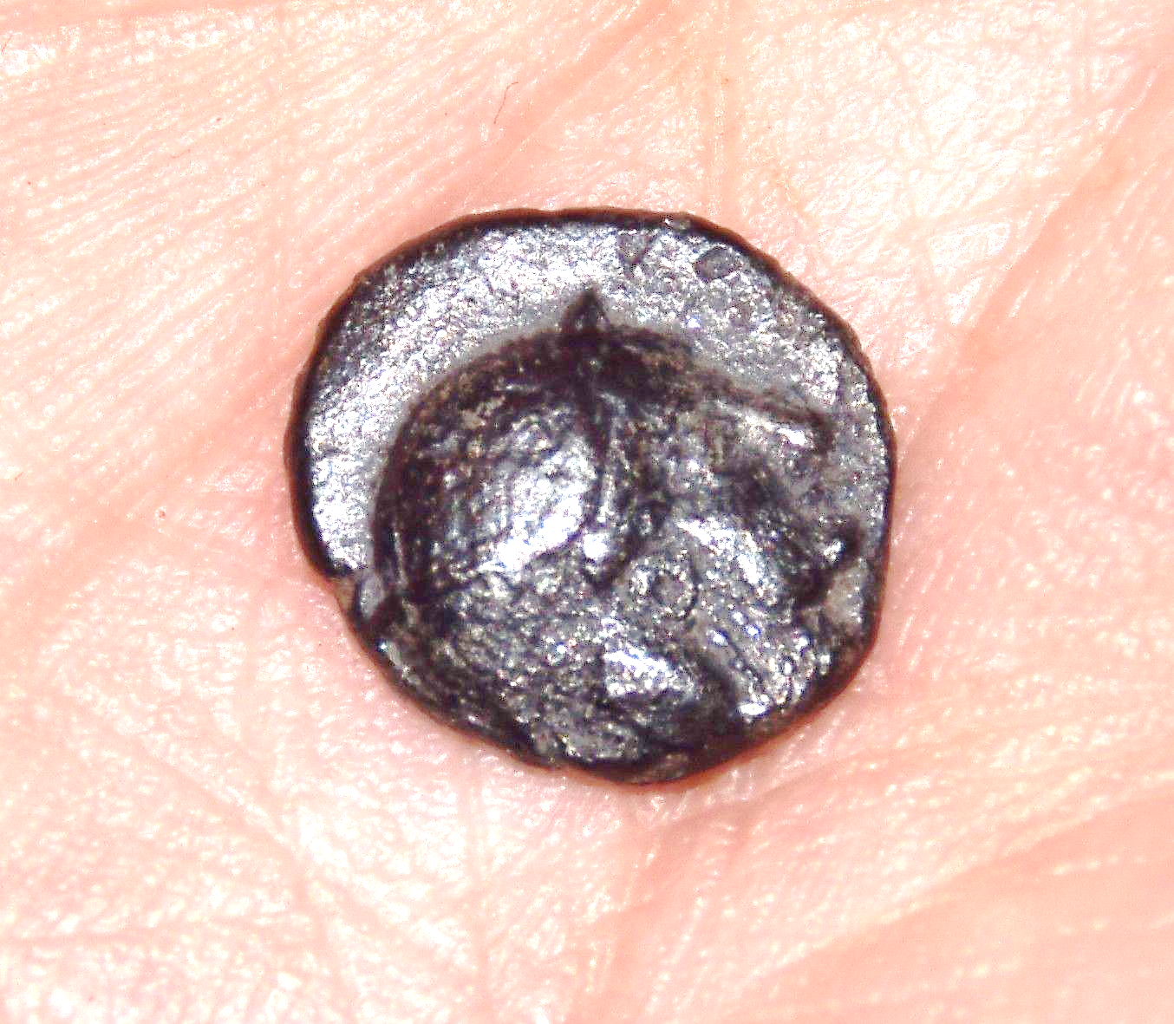

v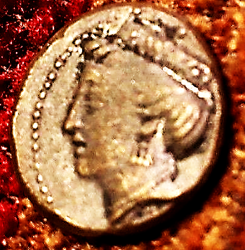 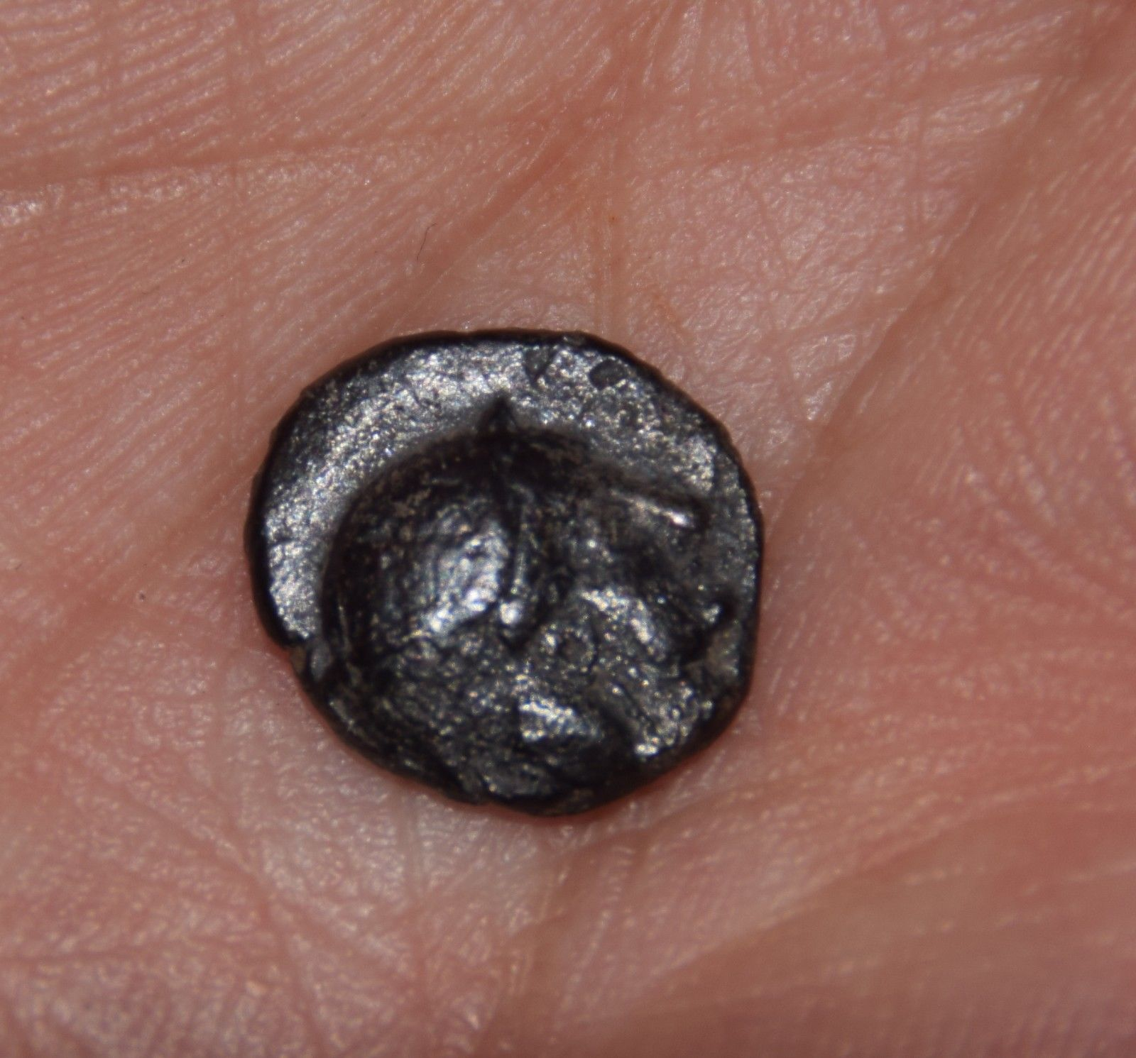

**Extremely Rare Thracian Silver Diobol Lampsakos - 1.16g**

|  |  |
| --- | --- |
| May 23, 2018 | ORDER TOTAL  US $15.99  Free shipping  **Order Ancient Greek Tetradrachm Silver Plated Attica ATHENS Owl Athena Eule Repro coin**[Return this item](https://www.ebay.com/rtn/Return/ReturnViewSelectedItem?transactionId=1994844945017&itemId=272693024561&_trksid=p2057872.m2749.l3185)[Leave feedback](http://feedback.ebay.com/ws/eBayISAPI.dll?LeaveFeedbackShow&useridto=masonicera&transactID=1994844945017&item=272693024561&_trksid=p2057872.m2749.l2665)  [More actions](https://www.ebay.com/myb/PurchaseHistory) |

1 item sold by [masonicera](http://www.ebay.com/usr/masonicera?_trksid=p2057872.m2749.l2754" \o "masonicera user ID, click for member’s profile)

|  |  |  |
| --- | --- | --- |
| [Ancient Greek Tetradrachm Silver Plated Attica ATHENS Owl Athena Eule Repro coin](https://www.ebay.com/itm/Ancient-Greek-Tetradrachm-Silver-Plated-Attica-ATHENS-Owl-Athena-Eule-Repro-coin/272693024561?ssPageName=STRK%3AMEBIDX%3AIT&_trksid=p2057872.m2749.l2648)  [Ancient Greek Tetradrachm Silver Plated Attica ATHENS Owl Athena Eule Repro coin](https://www.ebay.com/itm/Ancient-Greek-Tetradrachm-Silver-Plated-Attica-ATHENS-Owl-Athena-Eule-Repro-coin/272693024561?ssPageName=STRK%3AMEBIDX%3AIT&_trksid=p2057872.m2749.l2649)  ( 272693024561 )  Estimated delivery **Fri, Jun 01 - Wed, Jun 13**  This item has been shipped.  [Add note](javascript:;) | ITEM PRICE:  US $15.99 |  |
| ORDER DATE  May 23, 2018 | ORDER TOTAL  US $15.99  Free shipping  **Order REPRO ATTICA ATHENS SILVER PLATED TETRADRACHM COIN ATHENA OWL GIFT FREE SHIPPING**[Return this item](https://www.ebay.com/rtn/Return/ReturnViewSelectedItem?transactionId=848508632021&itemId=312109399353&_trksid=p2057872.m2749.l3185)[Leave feedback](http://feedback.ebay.com/ws/eBayISAPI.dll?LeaveFeedbackShow&useridto=2rooks&transactID=848508632021&item=312109399353&_trksid=p2057872.m2749.l2665)  [More actions](https://www.ebay.com/myb/PurchaseHistory) | |

1 item sold by [2rooks](http://www.ebay.com/usr/2rooks?_trksid=p2057872.m2749.l2754)

|  |  |  |
| --- | --- | --- |
| [REPRO ATTICA ATHENS SILVER PLATED TETRADRACHM COIN ATHENA OWL GIFT FREE SHIPPING](https://www.ebay.com/itm/REPRO-ATTICA-ATHENS-SILVER-PLATED-TETRADRACHM-COIN-ATHENA-OWL-GIFT-FREE-SHIPPING/312109399353?ssPageName=STRK%3AMEBIDX%3AIT&_trksid=p2057872.m2749.l2648)  [REPRO ATTICA ATHENS SILVER PLATED TETRADRACHM COIN ATHENA OWL GIFT FREE SHIPPING](https://www.ebay.com/itm/REPRO-ATTICA-ATHENS-SILVER-PLATED-TETRADRACHM-COIN-ATHENA-OWL-GIFT-FREE-SHIPPING/312109399353?ssPageName=STRK%3AMEBIDX%3AIT&_trksid=p2057872.m2749.l2649)  ( 312109399353 )  Estimated delivery **Fri, Jun 01 - Wed, Jun 13**  This item has been shipped.  [Add note](javascript:;) | ITEM PRICE:  US $15.99 |  |
| ORDER DATE  May 22, 2018 | ORDER TOTAL  US $28.50  + US $2.00  shipping  **Order Just in from Roma of UK Auction 45! Apollonia Pontika. 5th-4th c BC. AR Drachm**[Return this item](https://www.ebay.com/rtn/Return/ReturnViewSelectedItem?transactionId=0&itemId=123140320786&_trksid=p2057872.m2749.l3185)[Leave feedback](http://feedback.ebay.com/ws/eBayISAPI.dll?LeaveFeedbackShow&useridto=cody111111&transactID=0&item=123140320786&_trksid=p2057872.m2749.l2665)  [More actions](https://www.ebay.com/myb/PurchaseHistory) | |

1 item sold by [cody111111](http://www.ebay.com/usr/cody111111?_trksid=p2057872.m2749.l2754)

|  |
| --- |
| [Just in from Roma of UK Auction 45! Apollonia Pontika. 5th-4th c BC. AR Drachm](https://www.ebay.com/itm/Just-in-from-Roma-of-UK-Auction-45-Apollonia-Pontika-5th-4th-c-BC-AR-Drachm/123140320786?ssPageName=STRK%3AMEBIDX%3AIT&_trksid=p2057872.m2749.l2648)  [Just in from Roma of UK Auction 45! Apollonia Pontika. 5th-4th c BC. AR Drachm](https://www.ebay.com/itm/Just-in-from-Roma-of-UK-Auction-45-Apollonia-Pontika-5th-4th-c-BC-AR-Drachm/123140320786?ssPageName=STRK%3AMEBIDX%3AIT&_trksid=p2057872.m2749.l2649)  ( 123140320786 )  Delivered on **May 25, 2018**  Tracking number: [**Tracking number9400109699938494518756**](javascript:;)  This item has been shipped. |