A000-China-Tang-Yama-Bronze

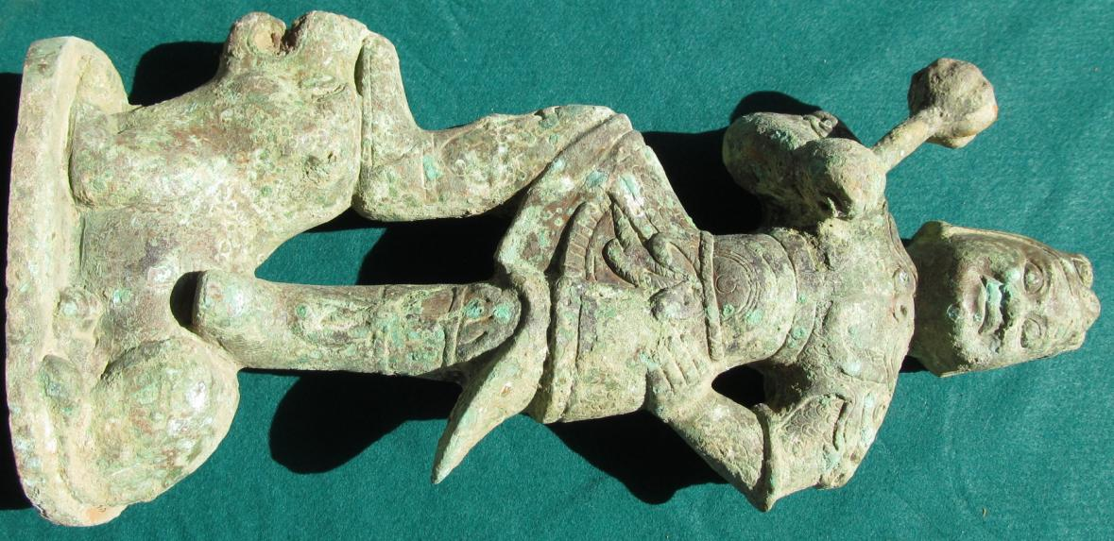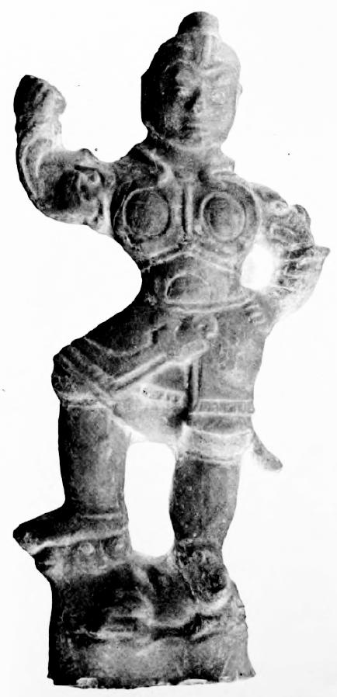

Fig. 1, left: Yama, bronze casting, T'ang dynasty, 8th century CE, possibly Shaanxi or Honan Province; fig. 2, right, stylistically similar T'ang dynasty (618-906 CE) clay figurine of Yama from Honan Province with only the mace missing, height 39 cm. in the Field Museum of Natural History, cat. no.117989 (Laufer 1914: 467).

Yama in Vedic mythology is the first ancestor, who is also worshipped as the god of the underworld and death. In Sanskrit Yama (यम) can be interpreted "twin" (Puhvel 1989: 285-286). In Buddhism, Yama is a *dharmapāla* or wrathful god, the judge of the dead and defender of the *dharma*. Though *dharmapālas* have a terrifying appearance and countenance, they are all bodhisattvas or buddhas, who embody compassion and only act in a wrathful way for the benefit of sentient beings.*Dharmapālas* preside over *naraka*, which literally means "[the underworld] of man" in Buddhism, the realm of the cycle of rebirth (see *Devadūta-sutta* ofthe Pāli Canon) which is not eternal but certainly protracted and may involve tortures and torments. In *naraka* the being that is brought there by the law of *karma* remains there until its negative *karma* has been expended.

Yama as a *dharmapāla* was developed by the esoteric teachings of Vajrayana Buddhism in India and were brought into China via the Silk Road by three great masters: [Śubhakarasimha](http://en.wikipedia.org/wiki/Subhakarasimha) (637－735), Vajrabodhi (671–741), and Amoghavajra (704–774) (Baruah 2008: 170). The travels of these masters suggest where the centers of esoteric Buddhism originated and where the bronze and ceramic Yama figurines were first envisioned in T'ang China. For instance, by AD 720 Vajrabodhi was ensconced in the Jianfu Temple at the Chinese capital, Chang'an (Xian in Shaanxi Province), accompanying him was his famous disciple, Amoghavajra (Goble 2012). Geoffrey Goble has suggested that Amoghavajra should be recognized as the most influential of the three who was able to gain rare T'ang court patronage of Buddhism by a non-Chinese monk among the ruling élite in the second half of the eighth century.

This bronze casting of Yama follows eighth century CE stylistic T'ang rules of replication of Yama's attributes of being both wrathful and compassionate. His facial expression conveys a positive attitude to the one being judged, supplemented by a tentativeness emphasized by his left arm akimbo suggesting a measure of detained compassion. However he wears the helmet of a tiger's skull, a powerful symbol of might and shamanic antiquity. Meanwhile his wrathful nature is suggested by his raised right hand menacing a mace which he is wielding with authority lest his detained compassion is not heeded.

His garb is that of a fully dressed T'ang warrior with high leathern boots cinched below the knee. His upper torso is clad in scale armor over a flaring kilt with a tightly fitting cuirass around his chest and a cord belt cinched at the waist with a large loop. He stands on the back of a recumbent tiger (?) to emphasize his power over a mighty beast with his right foot on its head and his left foot on its croup. This example illustrates the T'ang style of scale armor and represents one of the best examples of understanding its introduction and development.

SHAPE \* MERGEFORMAT 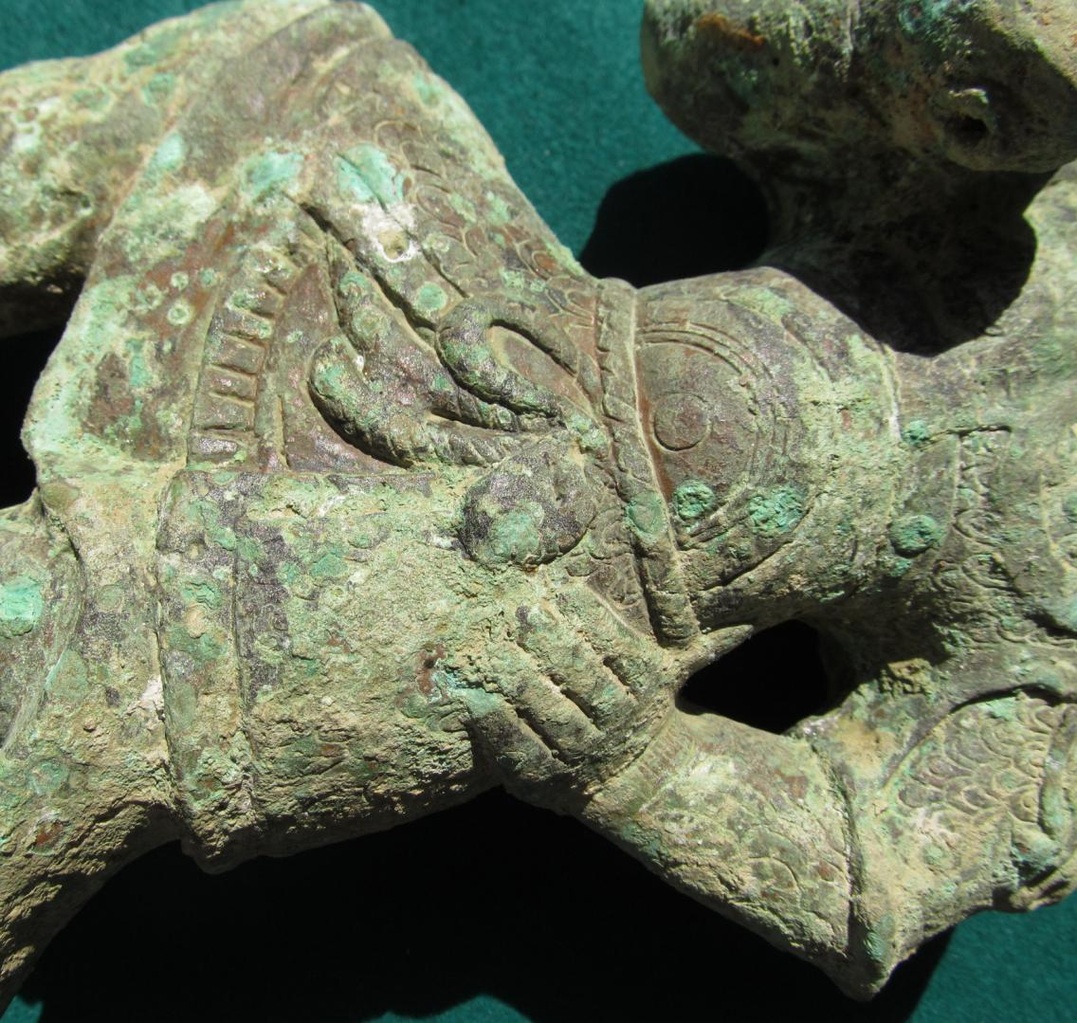

Fig. 3. detail of cuirass, scale armor construction, kilt, corded belt in a large loop at waist.

SHAPE \* MERGEFORMAT 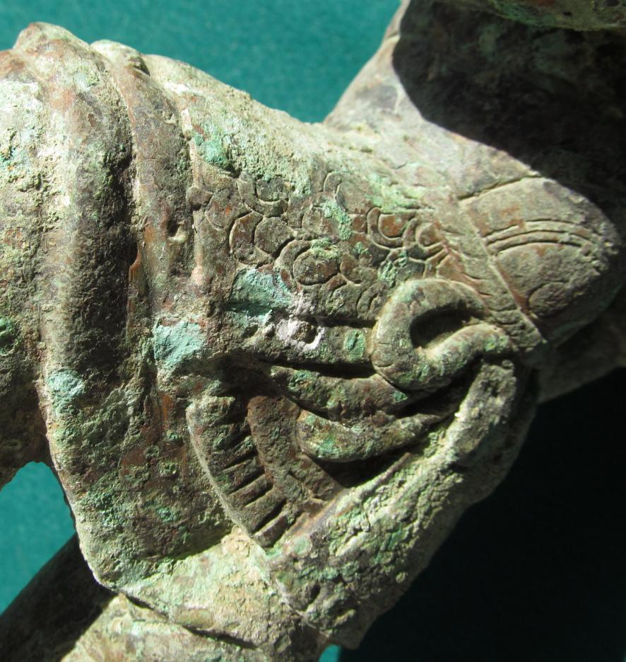

Fig. 4, detail of armor at waist.

SHAPE \* MERGEFORMAT 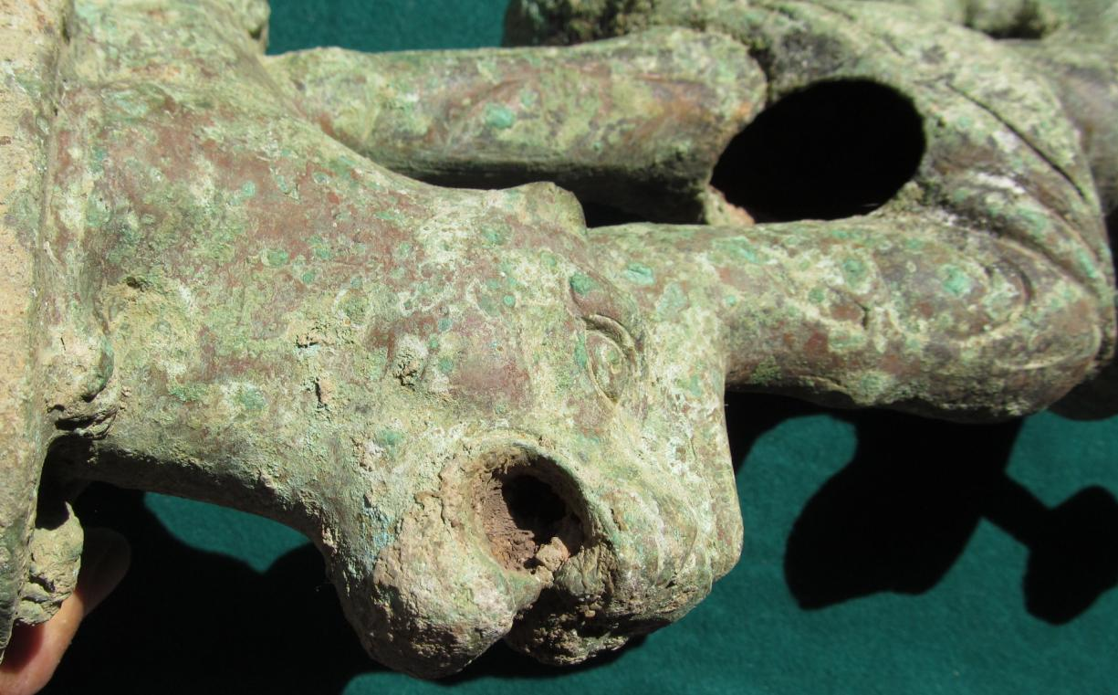

Fig. 5, detail of tiger's open maw.

SHAPE \* MERGEFORMAT 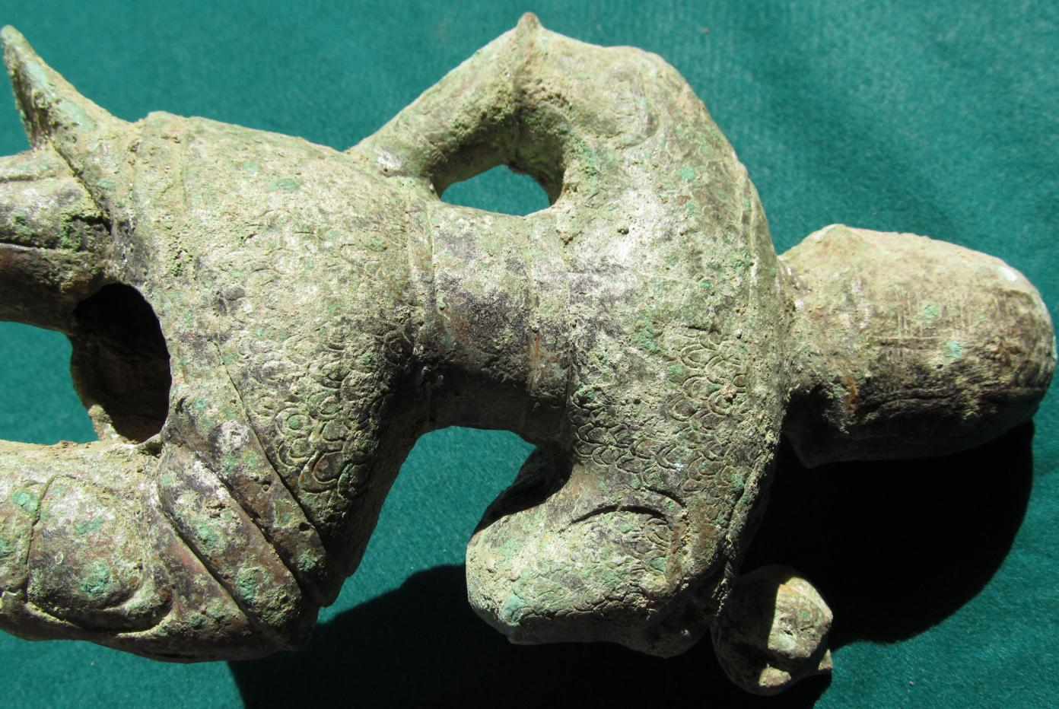

Fig. 6, detail of back showing scale armor construction for upper and lower body, leather belts holding upper body mail in place and elements of the helmet.

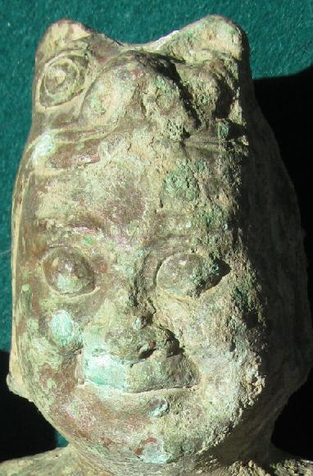

Fig. 7, bronze warrior showing his Caucasoid eyes, broad nose and oval face. His tiger (?) helmet is prominently displayed as a mark of his prowess.

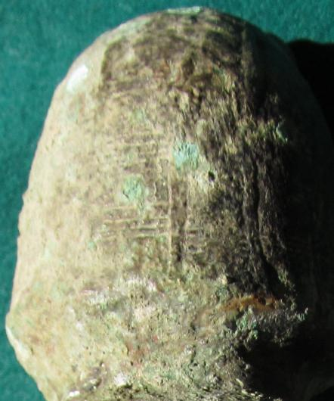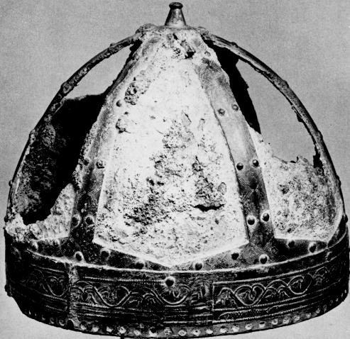

Fig. 8, left: rear view of detail of the helmet of the bronze warrior; fig. 9, right: a Frankish Barbarian chieftain's *spangenhelm* helmet, 6th cent CE, from Lyons, France.

The helmet of the bronze Yama figure has important parallels with Eastern Asiatic designs since its vertical bands that form its framework have their origin from the borders of Persia and were brought there by the Goths from the Black Sea in the 3rd century CE. This suggests the route of the Silk Road diffusion of the bronze figurine's stylistic attributes. The bronze helmet design is an earlier Eastern model that was brought eastward by Indo-Europeans into China. The horizontal bands were probably copper designed to hold a rigid shape. The flayed leopard head on the front of the bronze figure's helmet was probably a tribal emblem as the warrior was also posed on a recumbent tiger displaying his warrior's prowess.

A very similar T'ang dynasty (618-906 CE) clay figurine of Yama from Honan with only the mace missing, height 39 cm. is in the Field Museum of Natural History, cat. no.117989 (Laufer 1914: 467) is illustrated above, Fig. 2.

References:

Baruah, Bibbhuti. 2000. *Buddhist Sects and Sectarianism*. New Delhi : Sarup & Sons.

Goble, Geoffrey C. 2012. Chinese Esoteric Buddhism: Amoghavajra and the Ruling Elite. PhD diss. Indiana University.

Grancsay, Stephen V. 1949. A Barbarian Chieftain's Helmet , The Metropolitan Museum of Art Bulletin, New Series, Vol. 7, No. 10 (Jun., 1949), pp. 272-281

### Laufer, Berthold. 1914. Chinese Clay Figures, Part I, Prolegomena on the history of defensive armor, *Publications of the Field Museum of Natural History, Anthropological Series,* 13: 2.

### **Puhvel, Jaan (1989). *Comparative Mythology*. Baltimore and London: Johns Hopkins University Press.**