A000-ME-Assyria 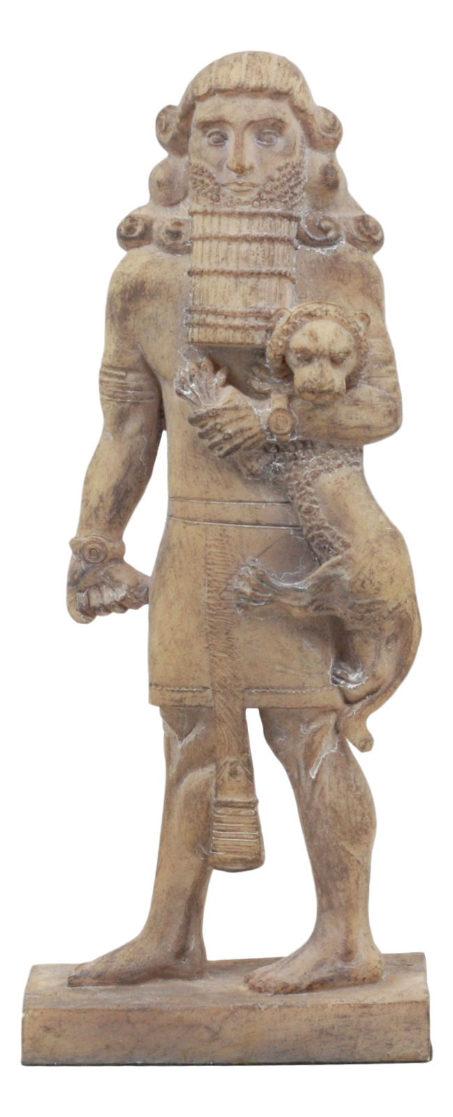

|  |  |
| --- | --- |
| ORDER DATE  May 14, 2018 | ORDER TOTAL  US $100.00  + US $40.00  shipping  **Order ASSYRIAN STYLE LIMESTONE TABLET WITH DRAWINGS ,CYLINDER SEAL,ANTIQUE STONE FRAGMENT WITH GRAFFITI,FERTILITY,GOD'S DRAWINGS FIGURE**[View order details](http://payments.ebay.com/ws/eBayISAPI.dll?ViewPaymentStatus&transId=0&itemid=273193955840&_trksid=p2057872.m2749.l2673)[Contact seller](http://contact.ebay.com/ws/eBayISAPI.dll?ShowSellerFAQ&requested=zaby78&iid=273193955840&redirect=0&_trksid=p2057872.m2749.l2652)  [More actions](https://www.ebay.com/myb/PurchaseHistory) |

2 items sold by [zaby78](http://www.ebay.com/usr/zaby78?_trksid=p2057872.m2749.l2754)

|  |  |  |  |
| --- | --- | --- | --- |
| [ASSYRIAN STYLE  LIMESTONE TABLET WITH DRAWINGS ,CYLINDER  SEAL](https://www.ebay.com/itm/ASSYRIAN-STYLE-LIMESTONE-TABLET-WITH-DRAWINGS-CYLINDER-SEAL/273193955840?ssPageName=STRK%3AMEBIDX%3AIT&_trksid=p2057872.m2749.l2648)  [ASSYRIAN STYLE LIMESTONE TABLET WITH DRAWINGS ,CYLINDER SEAL](https://www.ebay.com/itm/ASSYRIAN-STYLE-LIMESTONE-TABLET-WITH-DRAWINGS-CYLINDER-SEAL/273193955840?ssPageName=STRK%3AMEBIDX%3AIT&_trksid=p2057872.m2749.l2649)  ( 273193955840 )  Estimated delivery **Wed, May 16 - Wed, May 30**  Tracking number: [**Tracking number007350333608**](javascript:;)  ssyrian Winged Human Headed Bull Lamassu Replica Statue 8.5H  **Assyrian Bull Statue** recreates one of the famous Lamassu statues originally done on a colossal scale that were symbols of ancient rulers in the Assyrian empire. Animal beasts with human heads. Sadly, many have been either partially or fully destroyed by the extremists in modern day Iraq.  **Assyrian Winged Bull Lamassu Statue** is made from bonded stone, antique grey wash finish, and measures 8.5 in H x 7.25 in W x 3 in D each including brown base. Weighs 3.4 lbs.  Assyrian-Winged-Bull-Lamassu-Replica-Statue-8-5H-T87650  This item has been shipped.  [Add note](javascript:;) | ITEM PRICE:  US $44.00 | | **Item ASSYRIAN STYLE LIMESTONE TABLET WITH DRAWINGS ,CYLINDER SEAL**[Return this item](https://www.ebay.com/rtn/Return/ReturnViewSelectedItem?transactionId=0&itemId=273193955840&_trksid=p2057872.m2749.l3185)[Leave feedback](http://feedback.ebay.com/ws/eBayISAPI.dll?LeaveFeedbackShow&useridto=zaby78&transactID=0&item=273193955840&_trksid=p2057872.m2749.l2665)  [More actions](https://www.ebay.com/myb/PurchaseHistory) |
| [ANTIQUE STONE FRAGMENT WITH GRAFFITI,FERTILITY,GOD'S DRAWINGS FIGURE](https://www.ebay.com/itm/ANTIQUE-STONE-FRAGMENT-WITH-GRAFFITI-FERTILITY-GODS-DRAWINGS-FIGURE/273194063966?ssPageName=STRK%3AMEBIDX%3AIT&_trksid=p2057872.m2749.l2648)  [ANTIQUE STONE FRAGMENT WITH GRAFFITI,FERTILITY,GOD'S DRAWINGS FIGURE](https://www.ebay.com/itm/ANTIQUE-STONE-FRAGMENT-WITH-GRAFFITI-FERTILITY-GODS-DRAWINGS-FIGURE/273194063966?ssPageName=STRK%3AMEBIDX%3AIT&_trksid=p2057872.m2749.l2649)  ( 273194063966 )  Estimated delivery **Wed, May 16 - Wed, May 30**  Tracking number: [**Tracking number007350333608**](javascript:;)  This item has been shipped.  [Add note](javascript:;) | | ITEM PRICE:  US $56.00 | |

|  |  |
| --- | --- |
| ORDER DATE  May 14, 2018 | ORDER TOTAL  US $100.00  + US $40.00  shipping  **Order ASSYRIAN STYLE LIMESTONE TABLET WITH DRAWINGS ,CYLINDER SEAL,ANTIQUE STONE FRAGMENT WITH GRAFFITI,FERTILITY,GOD'S DRAWINGS FIGURE**[View order details](http://payments.ebay.com/ws/eBayISAPI.dll?ViewPaymentStatus&transId=0&itemid=273193955840&_trksid=p2057872.m2749.l2673)[Contact seller](http://contact.ebay.com/ws/eBayISAPI.dll?ShowSellerFAQ&requested=zaby78&iid=273193955840&redirect=0&_trksid=p2057872.m2749.l2652)  [More actions](https://www.ebay.com/myb/PurchaseHistory) |

2 items sold by [zaby78](http://www.ebay.com/usr/zaby78?_trksid=p2057872.m2749.l2754)

|  |  |  |  |
| --- | --- | --- | --- |
| [ASSYRIAN STYLE  LIMESTONE TABLET WITH DRAWINGS ,CYLINDER  SEAL](https://www.ebay.com/itm/ASSYRIAN-STYLE-LIMESTONE-TABLET-WITH-DRAWINGS-CYLINDER-SEAL/273193955840?ssPageName=STRK%3AMEBIDX%3AIT&_trksid=p2057872.m2749.l2648)  [ASSYRIAN STYLE LIMESTONE TABLET WITH DRAWINGS ,CYLINDER SEAL](https://www.ebay.com/itm/ASSYRIAN-STYLE-LIMESTONE-TABLET-WITH-DRAWINGS-CYLINDER-SEAL/273193955840?ssPageName=STRK%3AMEBIDX%3AIT&_trksid=p2057872.m2749.l2649)  ( 273193955840 )  Estimated delivery **Wed, May 16 - Wed, May 30**  Tracking number: [**Tracking number007350333608**](javascript:;)  This item has been shipped.  [Add note](javascript:;) | ITEM PRICE:  US $44.00 | | **Item ASSYRIAN STYLE LIMESTONE TABLET WITH DRAWINGS ,CYLINDER SEAL**[Return this item](https://www.ebay.com/rtn/Return/ReturnViewSelectedItem?transactionId=0&itemId=273193955840&_trksid=p2057872.m2749.l3185)[Leave feedback](http://feedback.ebay.com/ws/eBayISAPI.dll?LeaveFeedbackShow&useridto=zaby78&transactID=0&item=273193955840&_trksid=p2057872.m2749.l2665)  [More actions](https://www.ebay.com/myb/PurchaseHistory) |
| [ANTIQUE STONE FRAGMENT WITH GRAFFITI,FERTILITY,GOD'S DRAWINGS FIGURE](https://www.ebay.com/itm/ANTIQUE-STONE-FRAGMENT-WITH-GRAFFITI-FERTILITY-GODS-DRAWINGS-FIGURE/273194063966?ssPageName=STRK%3AMEBIDX%3AIT&_trksid=p2057872.m2749.l2648)  [ANTIQUE STONE FRAGMENT WITH GRAFFITI,FERTILITY,GOD'S DRAWINGS FIGURE](https://www.ebay.com/itm/ANTIQUE-STONE-FRAGMENT-WITH-GRAFFITI-FERTILITY-GODS-DRAWINGS-FIGURE/273194063966?ssPageName=STRK%3AMEBIDX%3AIT&_trksid=p2057872.m2749.l2649)  ( 273194063966 )  Estimated delivery **Wed, May 16 - Wed, May 30**  Tracking number: [**Tracking number007350333608**](javascript:;)  This item has been shipped.  [Add note](javascript:;) | | ITEM PRICE:  US $56.00 | |