A000-Xian-Byzantine

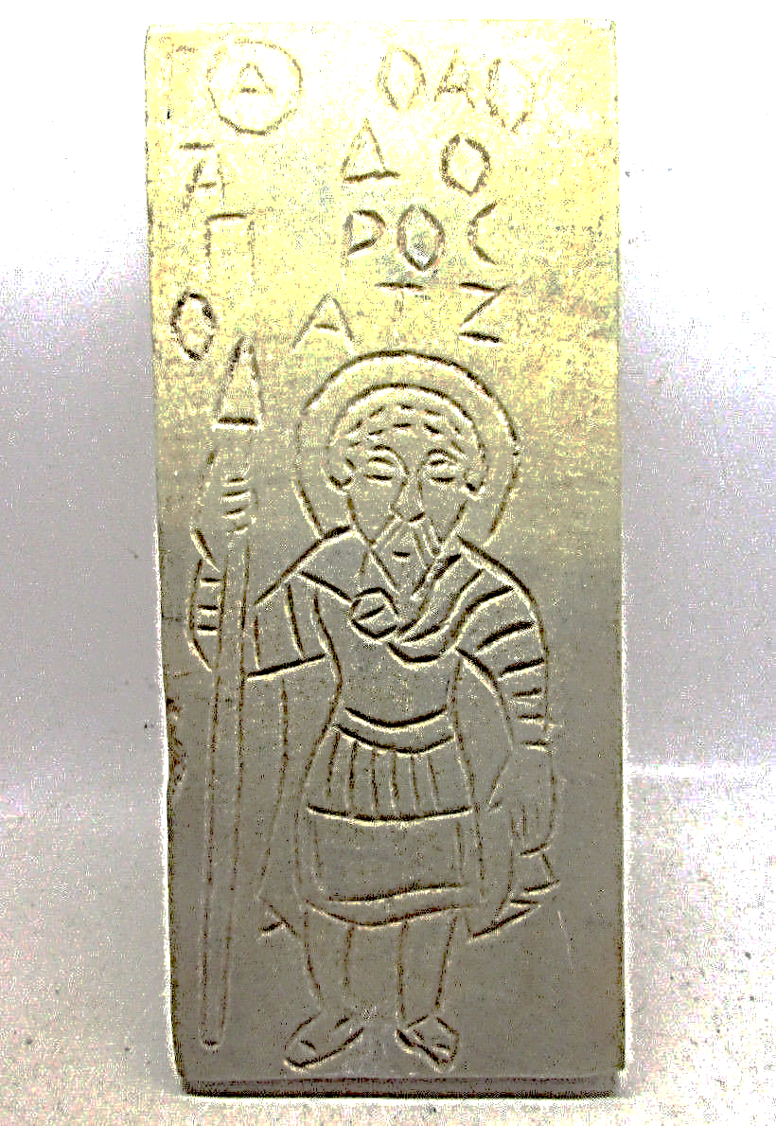

CIRCA 600-1000 CE BYZANTINE ERA HAND CRAFTED STONE PANEL WITH SAINT & INSCRIPTION