A000-Xian-Roman­­­­­

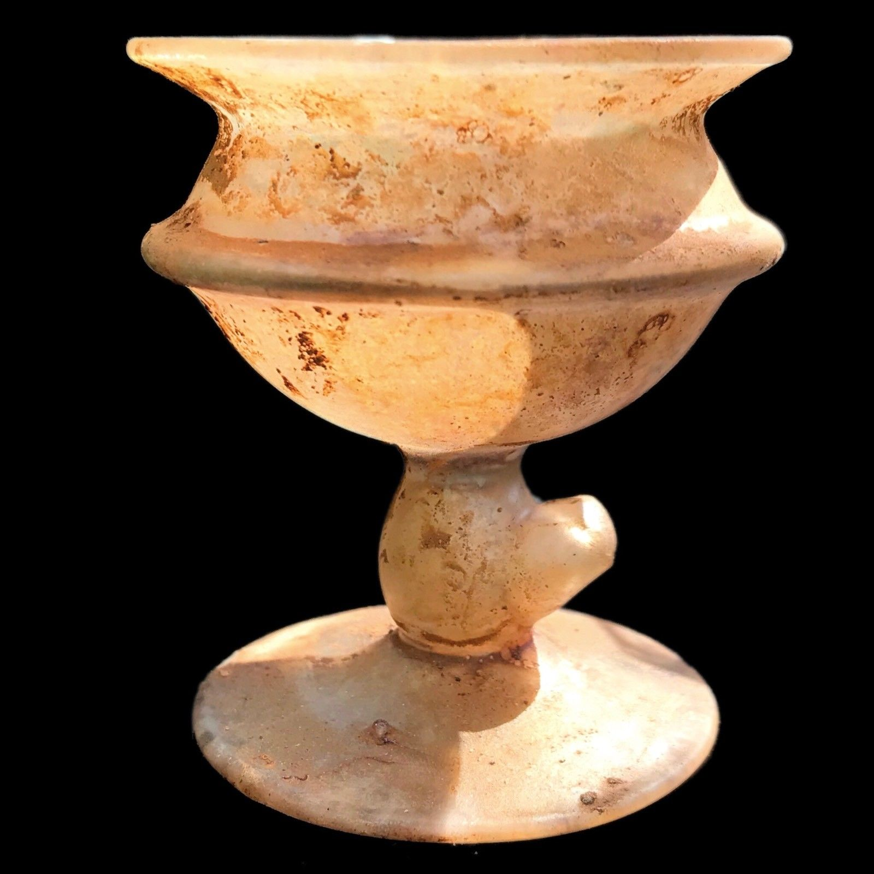

# VERY RARE HUGE ANCIENT ROMAN GLASS CHALICE 1ST CENTURY A.D.

|  |  |  |
| --- | --- | --- |
| [ANCIENT ROMAN PERIOD DECORATED RELIQUARY CROSS  2nd-3rd Cent AD (1)](https://www.ebay.com/itm/ANCIENT-ROMAN-PERIOD-DECORATED-RELIQUARY-CROSS-2nd-3rd-Cent-AD-1/253608245878?ssPageName=STRK%3AMEBIDX%3AIT&_trksid=p2057872.m2749.l2648)  [ANCIENT ROMAN PERIOD DECORATED RELIQUARY CROSS 2nd-3rd Cent AD (1)](https://www.ebay.com/itm/ANCIENT-ROMAN-PERIOD-DECORATED-RELIQUARY-CROSS-2nd-3rd-Cent-AD-1/253608245878?ssPageName=STRK%3AMEBIDX%3AIT&_trksid=p2057872.m2749.l2649)  ( 253608245878 )  Estimated delivery **Tue, May 22 - Tue, Jun 05**  This item has been shipped.  [Add note](javascript:;) | ITEM PRICE:  US $15.37 | **Item ANCIENT ROMAN PERIOD DECORATED RELIQUARY CROSS 2nd-3rd Cent AD (1)**[Return this item](https://www.ebay.com/rtn/Return/ReturnViewSelectedItem?transactionId=0&itemId=253608245878&_trksid=p2057872.m2749.l3185)[Leave feedback](http://feedback.ebay.com/ws/eBayISAPI.dll?LeaveFeedbackShow&useridto=egdirdlewendy&transactID=0&item=253608245878&_trksid=p2057872.m2749.l2665)  [More actions](https://www.ebay.com/myb/PurchaseHistory) |
| ORDER DATE  May 12, 2018 | ORDER TOTAL  US $60.15  + US $14.69  shipping  **Order roman silver ring depicting a fish on the bezel**[Return this item](https://www.ebay.com/rtn/Return/ReturnViewSelectedItem?transactionId=1706413313006&itemId=162930918140&_trksid=p2057872.m2749.l3185)[Leave feedback](http://feedback.ebay.com/ws/eBayISAPI.dll?LeaveFeedbackShow&useridto=romantiquity&transactID=1706413313006&item=162930918140&_trksid=p2057872.m2749.l2665)  [More actions](https://www.ebay.com/myb/PurchaseHistory) | |

1 item sold by [romantiquity](http://www.ebay.com/usr/romantiquity?_trksid=p2057872.m2749.l2754" \o "romantiquity user ID, click for member’s profile)

|  |  |
| --- | --- |
| [roman silver  ring depicting a fish on the bezel](https://www.ebay.com/itm/roman-silver-ring-depicting-a-fish-on-the-bezel/162930918140?ssPageName=STRK%3AMEBIDX%3AIT&_trksid=p2057872.m2749.l2648)  [roman silver ring depicting a fish on the bezel](https://www.ebay.com/itm/roman-silver-ring-depicting-a-fish-on-the-bezel/162930918140?ssPageName=STRK%3AMEBIDX%3AIT&_trksid=p2057872.m2749.l2649)  ( 162930918140 )  Delivered on **May 21, 2018**  Tracking number: [**Tracking numberRN146321485GB**](javascript:;)  This item has been shipped.  [Add note](javascript:;) | ITEM PRICE: |

|  |  |  |
| --- | --- | --- |
| [ANCIENT ROMAN PERIOD DECORATED RELIQUARY CROSS  2nd-3rd Cent AD (1)](https://www.ebay.com/itm/ANCIENT-ROMAN-PERIOD-DECORATED-RELIQUARY-CROSS-2nd-3rd-Cent-AD-1/253608245878?ssPageName=STRK%3AMEBIDX%3AIT&_trksid=p2057872.m2749.l2648)  [ANCIENT ROMAN PERIOD DECORATED RELIQUARY CROSS 2nd-3rd Cent AD (1)](https://www.ebay.com/itm/ANCIENT-ROMAN-PERIOD-DECORATED-RELIQUARY-CROSS-2nd-3rd-Cent-AD-1/253608245878?ssPageName=STRK%3AMEBIDX%3AIT&_trksid=p2057872.m2749.l2649)  ( 253608245878 )  Estimated delivery **Tue, May 22 - Tue, Jun 05**  This item has been shipped.  [Add note](javascript:;) | ITEM PRICE:  US $15.37 | **Item ANCIENT ROMAN PERIOD DECORATED RELIQUARY CROSS 2nd-3rd Cent AD (1)**[Return this item](https://www.ebay.com/rtn/Return/ReturnViewSelectedItem?transactionId=0&itemId=253608245878&_trksid=p2057872.m2749.l3185)[Leave feedback](http://feedback.ebay.com/ws/eBayISAPI.dll?LeaveFeedbackShow&useridto=egdirdlewendy&transactID=0&item=253608245878&_trksid=p2057872.m2749.l2665)  [More actions](https://www.ebay.com/myb/PurchaseHistory) |
| ORDER DATE  May 12, 2018 | ORDER TOTAL  US $60.15  + US $14.69  shipping  **Order roman silver ring depicting a fish on the bezel**[Return this item](https://www.ebay.com/rtn/Return/ReturnViewSelectedItem?transactionId=1706413313006&itemId=162930918140&_trksid=p2057872.m2749.l3185)[Leave feedback](http://feedback.ebay.com/ws/eBayISAPI.dll?LeaveFeedbackShow&useridto=romantiquity&transactID=1706413313006&item=162930918140&_trksid=p2057872.m2749.l2665)  [More actions](https://www.ebay.com/myb/PurchaseHistory) | |

1 item sold by [romantiquity](http://www.ebay.com/usr/romantiquity?_trksid=p2057872.m2749.l2754" \o "romantiquity user ID, click for member’s profile)

|  |  |
| --- | --- |
| [roman silver  ring depicting a fish on the bezel](https://www.ebay.com/itm/roman-silver-ring-depicting-a-fish-on-the-bezel/162930918140?ssPageName=STRK%3AMEBIDX%3AIT&_trksid=p2057872.m2749.l2648)  [roman silver ring depicting a fish on the bezel](https://www.ebay.com/itm/roman-silver-ring-depicting-a-fish-on-the-bezel/162930918140?ssPageName=STRK%3AMEBIDX%3AIT&_trksid=p2057872.m2749.l2649)  ( 162930918140 )  Delivered on **May 21, 2018**  Tracking number: [**Tracking numberRN146321485GB**](javascript:;)  This item has been shipped.  [Add note](javascript:;) | ITEM PRICE: |

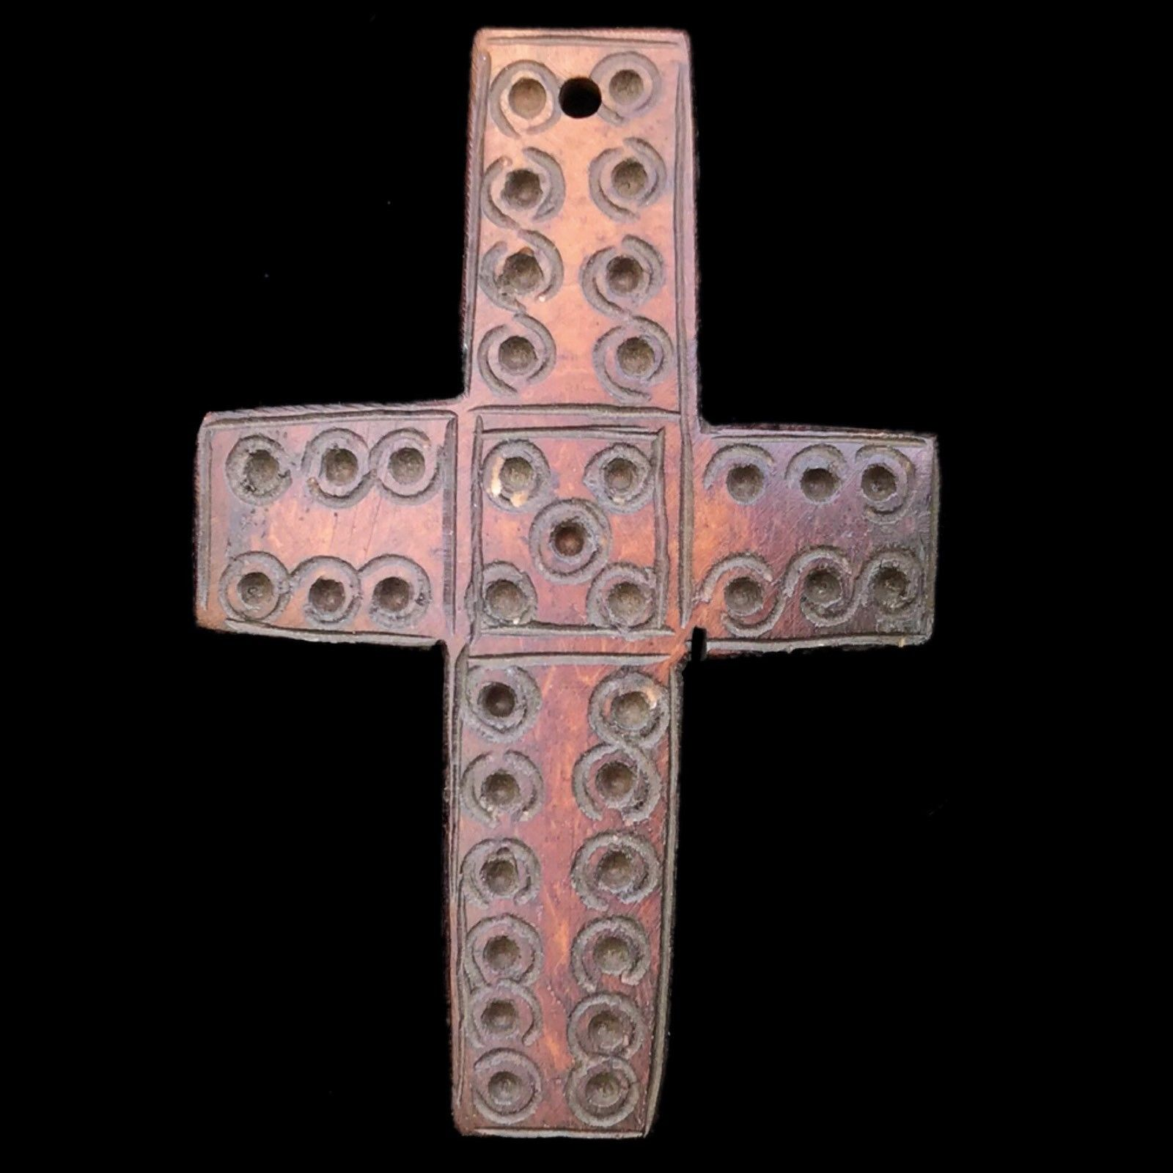

Ancient Roman Decorative Reliquary Cross, These Crosses Were Composed of The Ankle and Leg Bones From The Common Sheep. This Roman Cross Has NOT Been Made From Any Endangered Animal. This Item Has Come From a Private 1970s Collection. Circa 1st - 4th Century AD

a Very High Quality Very Large Roman Chalice Vessel, Dating From Around the 1st Century. This Piece is in Perfect Condition with No Repairs or Damage and also Uncleaned. Pleas Do Not Clean as this Could Damage Item. This Item Has Come From a Private 1980s London Collection. This Chalice Has a Small Break to the Bottom Shown in Picture

Height: 6 cm

Weight: 28 grams

Height: 4.8 cm

Weight: 7 grams

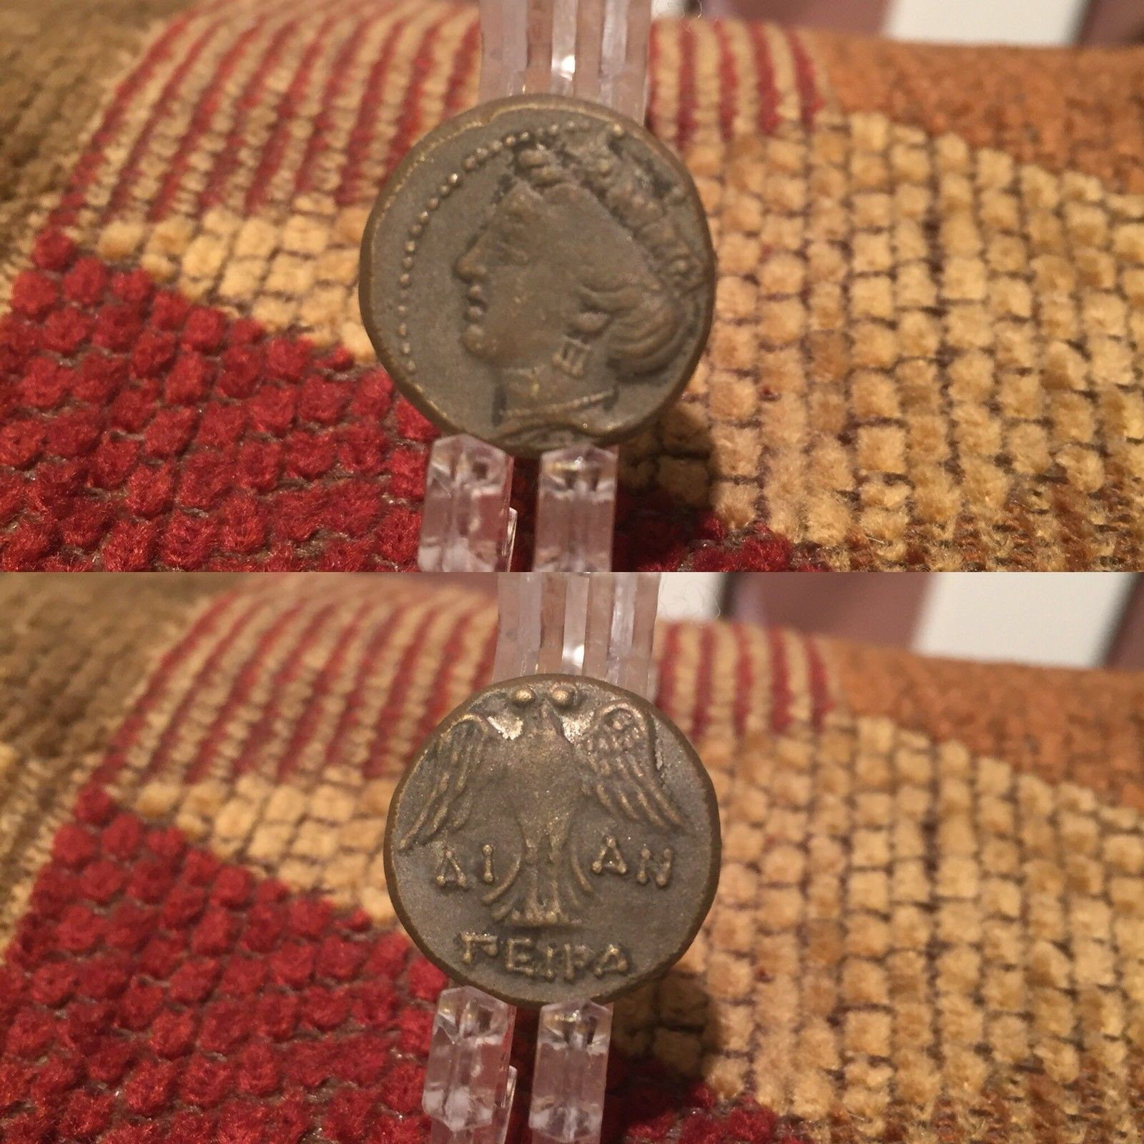

|  |  |
| --- | --- |
| May 12, 2018 | ORDER TOTAL  US $114.96  + US $16.04  shipping  **Order ANCIENT ROMAN PERIOD DECORATED RELIQUARY CROSS SEAL 2nd-3rd Cent AD,ANCIENT ROMAN PERIOD DECORATED RELIQUARY CROSS 2nd-3rd Cent AD (2)**[View order details](http://payments.ebay.com/ws/eBayISAPI.dll?ViewPaymentStatus&transId=0&itemid=253608508228&_trksid=p2057872.m2749.l2673)[Contact seller](http://contact.ebay.com/ws/eBayISAPI.dll?ShowSellerFAQ&requested=egdirdlewendy&iid=253608508228&redirect=0&_trksid=p2057872.m2749.l2652)  [More actions](https://www.ebay.com/myb/PurchaseHistory) |

2 items sold by [egdirdlewendy](http://www.ebay.com/usr/egdirdlewendy?_trksid=p2057872.m2749.l2754" \o "egdirdlewendy user ID, click for member’s profile)

|  |  |
| --- | --- |
| [ANCIENT ROMAN PERIOD DECORATED RELIQUARY CROSS SEAL 2nd-3rd Cent AD](https://www.ebay.com/itm/ANCIENT-ROMAN-PERIOD-DECORATED-RELIQUARY-CROSS-SEAL-2nd-3rd-Cent-AD/253608508228?ssPageName=STRK%3AMEBIDX%3AIT&_trksid=p2057872.m2749.l2648)  [ANCIENT ROMAN PERIOD DECORATED RELIQUARY CROSS SEAL 2nd-3rd Cent AD](https://www.ebay.com/itm/ANCIENT-ROMAN-PERIOD-DECORATED-RELIQUARY-CROSS-SEAL-2nd-3rd-Cent-AD/253608508228?ssPageName=STRK%3AMEBIDX%3AIT&_trksid=p2057872.m2749.l2649)  ( 253608508228 )  Delivered on **May 26, 2018**  Tracking number: [**Tracking numberLB847792539GB**](javascript:;)  This item has been shipped.  [Add note](javascript:;) | ITEM PRICE: |