POINTS-US-MO-Matanzas-Side-notched

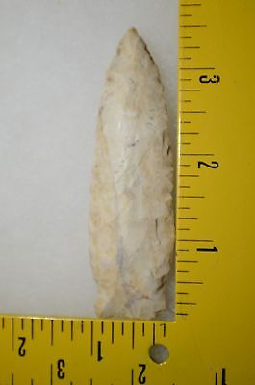

#### [Matanzas Missouri Arrowhead Authentic Indian Artifact](http://www.ebay.com/itm/321865749253)