BASKET-US-AZ-Pima-Geometric
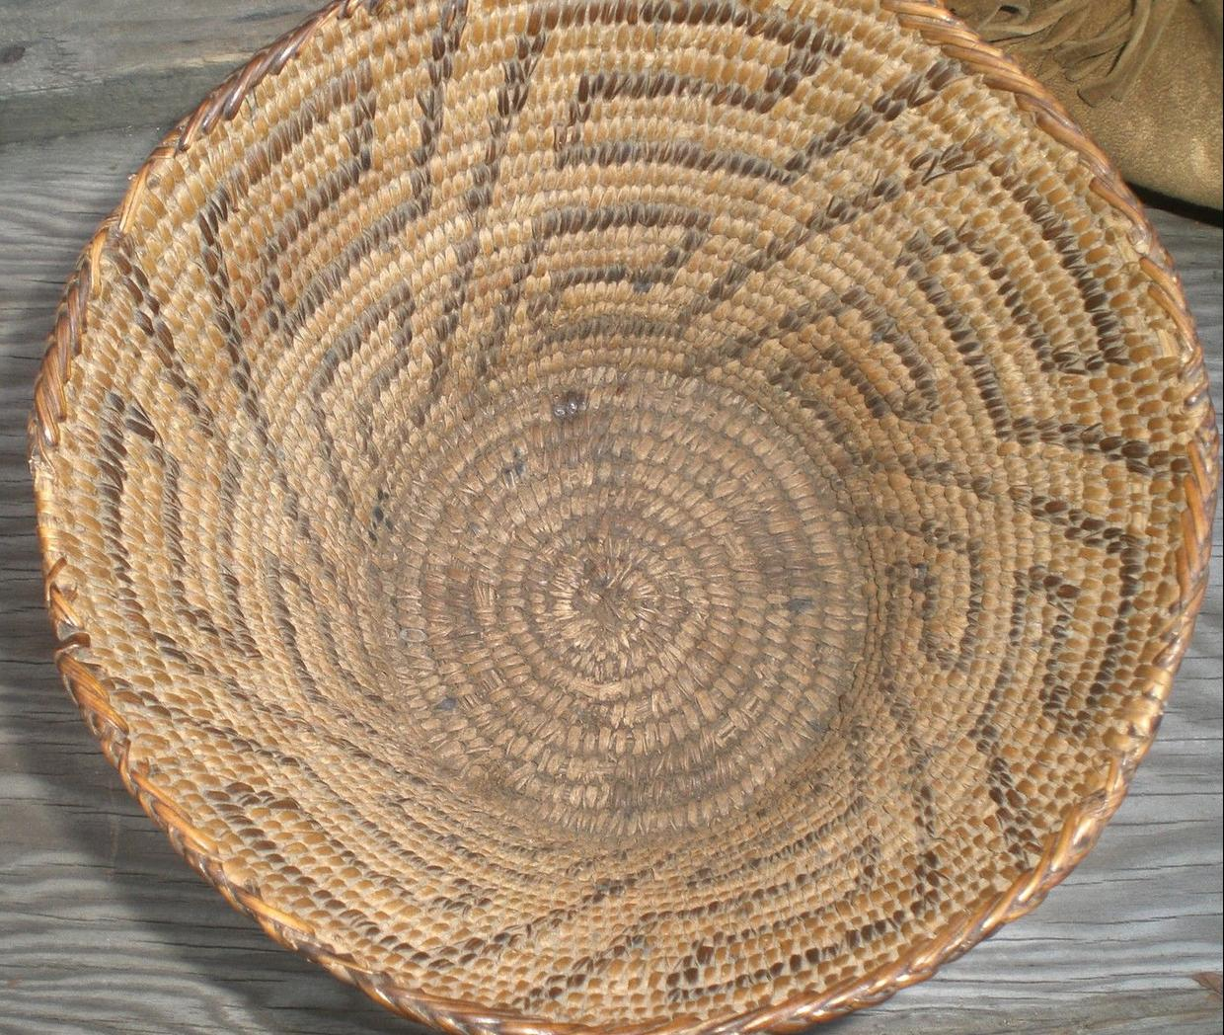
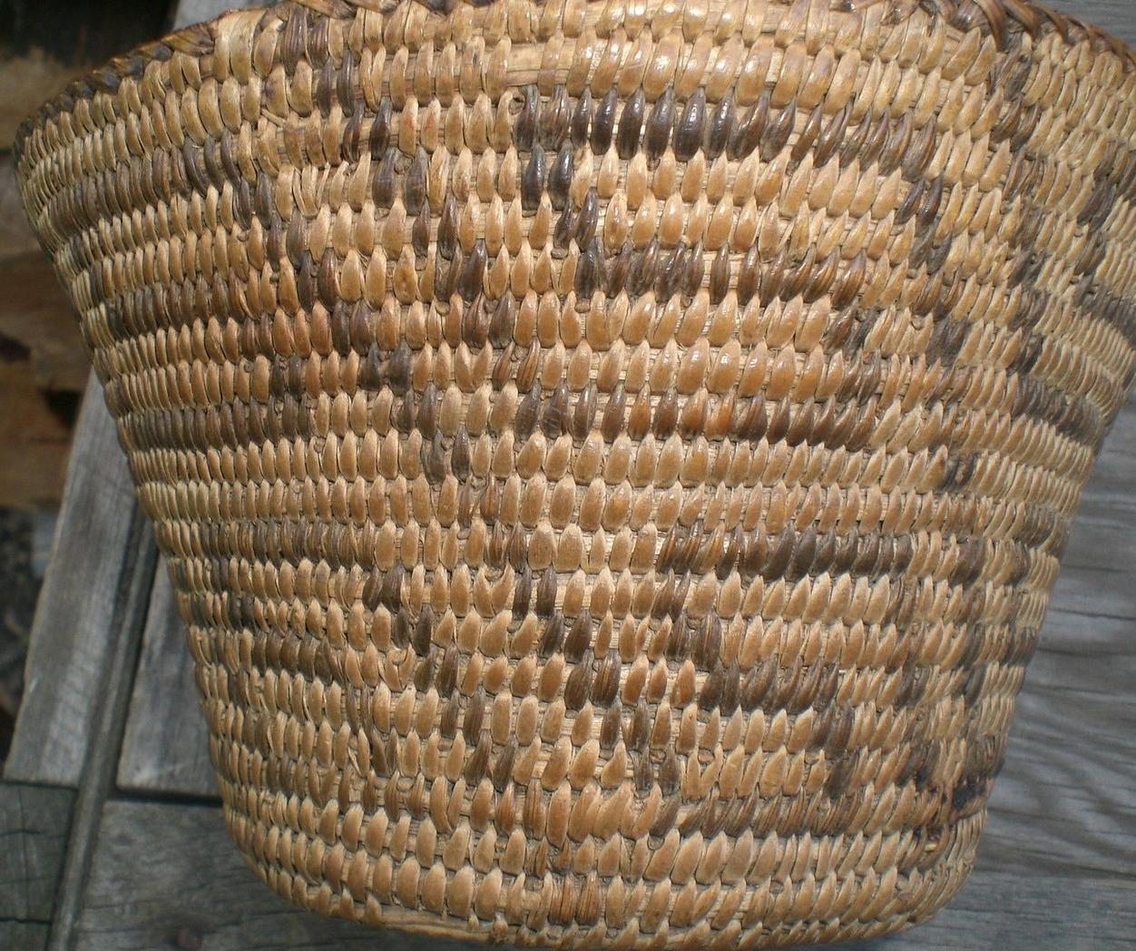
Sold by bobbyhal ( 1466 )

Delivery package 1 of 1
Estimated delivery Tuesday, Oct 13, 2015 - Friday, Oct 16, 2015
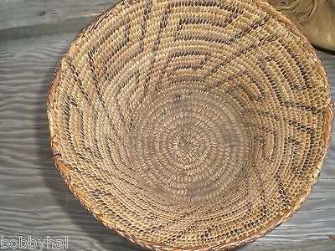

2 BEAUTIFUL NATIVE AMERICAN INDIAN ITEMS BEADED PURSE ANTIQUE BERRY BASKET OLD
Item price | $153.50
Quantity | 1
Item number | 371451629374
Shipping service | Expedited Shipping

