Dis-Paleo-Mastodon-Mammut americanum-Molar

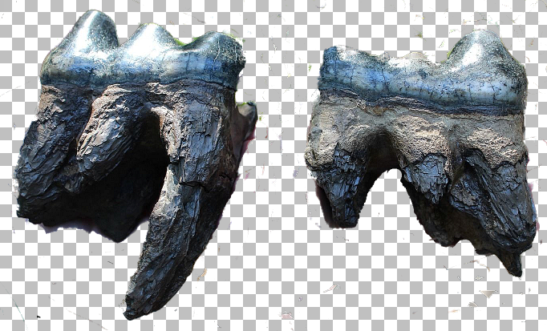

**Fig. 1: left, tooth no. 1; right, tooth no. 2.**

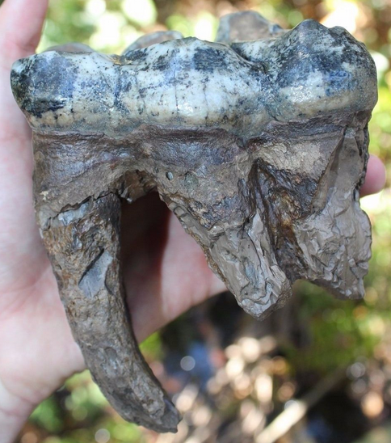 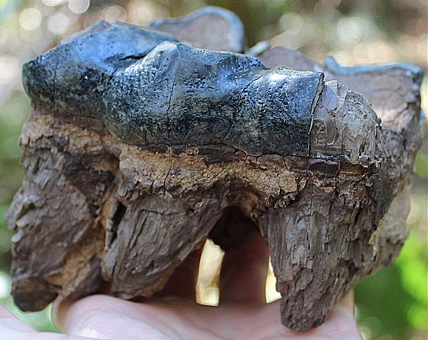 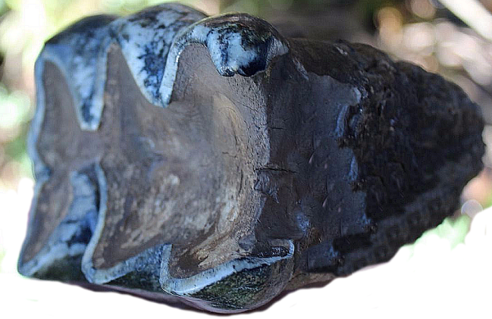

Fig. 2: tooth no 1; Fig. 3: tooth no 2. Fig. 4, tooth no. 2.

**Accession Number:**

**LC Classification:** QE882

**Date or Time Horizon:** 50,000 BP

**Geographical Area:** Withlacoochee River gravel bars, Florida

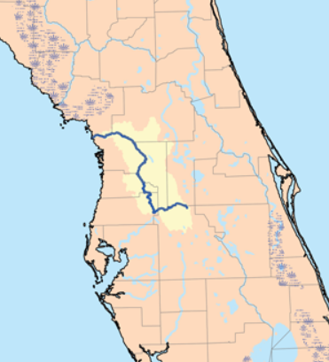

**Map of the** Withlacoochee River, Florida

**Cultural Affiliation:**

**Medium:** Two fossilized mastodon molars with attached roots

**Dimensions:** **Size tooth #1:** 5.7" by 4.4" by 3.5" (Chewing surface is 4.4")

**Size tooth #2:** 4.2" by 4.2" by 3.5" (Chewing surface is 4.2")

**Weight:**

**Provenance:** Jonathan Valentine, 9951 E Fowler Avenue, Thonotosasaj, FL, ca. 2014

**Condition:** Excellent, only repair being a small section of root which was reattached to the largest molar.

**Discussion:** This is a fossil specimen of the extinct Mastodon, *Mammut americanum,* found in the gravel bars of the Withlacoochee River, Florida.The Withlacoochee River, Florida, originates in central Florida's Green Swamp, a plateau above surrounding areas contains 560,000 acres of wetlands, flatlands and low ridges that are bounded by prominent sandy ridgelines. Rainwater drains across the surface to create the headwaters of four major rivers: the Withlacoochee, the Ocklawaha, the Hillsborough and the Peace. In the Late Pliocene and Pleistocene this area was covered with a lush undergrowth and a shallow sinkhole with vegetation attracted the animals that then became trapped, and these teeth are the result of such an accident.

**References:**

Green, Jeremy. 2003. Reconstructing the dietary habits of Florida Mastodons via low-magnification stereomicroscopy, *Journal of Vertebrate Paleontology*, 23:57A-57A

Lister, Adrian. 1994. New York: Macmillan Pub. Co.: Maxwell Macmillan International.