Fossils-US-Foraminifera

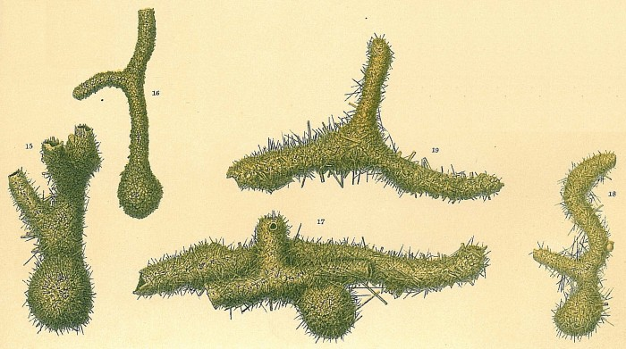

Saccorhiza ramosa

Description Saccorhiza ramosa sensu Jones, R.W. 1994. The Challenger Foraminifera. Image source: Brady, H.B. (1884) Pl. 23 Author [Cedhagen, Tomas](http://www.marinespecies.org/imis.php?module=person&persid=23743) JPG file - 2.94 MB - 2 149 x 1 203 pixels[more](http://www.marinespecies.org/photogallery.php?album=772&pic=35162) added on 2010-12-04273 viewsWoRMS taxa [*Saccorhiza ramosa* (Brady, 1879)](http://www.marinespecies.org/aphia.php?p=taxdetails&id=113974)Checked: verified by a taxonomic editorchecked Hayward, Bruce 2013-05-03

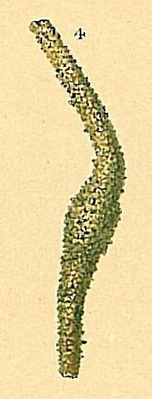

Rhabdammina neglecta

Description Rhabdammina neglecta sensu Jones, R.W. 1994. The Challenger Foraminifera. Image source: Brady, H.B. (1884) Pl. 22 Author [Cedhagen, Tomas](http://www.marinespecies.org/imis.php?module=person&persid=23743) JPG file - 111.44 kB - 202 x 530 pixels[more](http://www.marinespecies.org/photogallery.php?album=772&pic=35161) added on 2010-12-04104 viewsWoRMS taxa [*Rhabdammina neglecta* Gooday, 1986](http://www.marinespecies.org/aphia.php?p=taxdetails&id=113904)Checked: verified by a taxonomic editorchecked Hayward, Bruce 2013-05-03

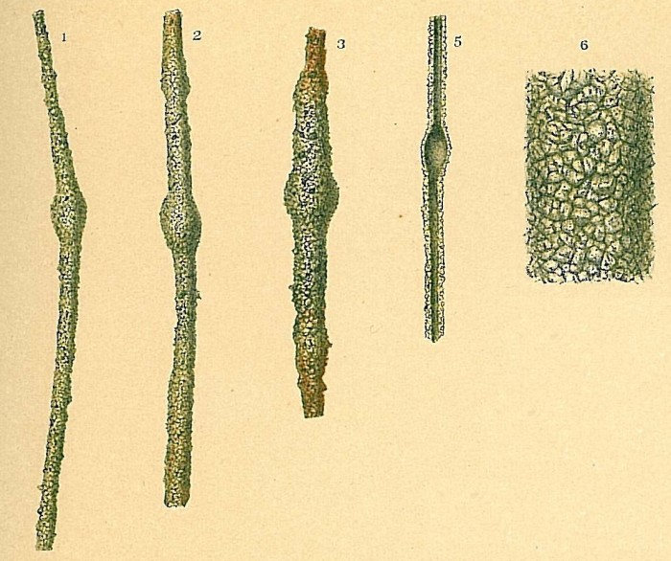

Rhabdammina linearis

Description Rhabdammina linearis sensu Jones, R.W. 1994. The Challenger Foraminifera. Image source: Brady, H.B. (1884) Pl. 22 Author [Cedhagen, Tomas](http://www.marinespecies.org/imis.php?module=person&persid=23743) JPG file - 991.19 kB - 1 106 x 926 pixels[more](http://www.marinespecies.org/photogallery.php?album=772&pic=35159) added on 2010-12-04208 viewsWoRMS taxa [*Rhabdammina linearis* Brady, 1879](http://www.marinespecies.org/aphia.php?p=taxdetails&id=113902)Checked: verified by a taxonomic editorchecked Hayward, Bruce 2013-05-03

[WoRMS Photogallery](http://www.marinespecies.org/photogallery.php) » [Foraminifera](http://www.marinespecies.org/photogallery.php?album=772)

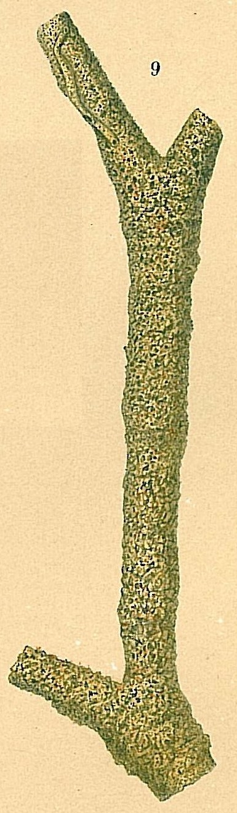

Rhabdammina major

Description Rhabdammina major sensu Jones, R.W. 1994. The Challenger Foraminifera. Image source: Brady, H.B. (1884) Pl. 21 Author [Cedhagen, Tomas](http://www.marinespecies.org/imis.php?module=person&persid=23743) JPG file - 532.23 kB - 385 x 1 317 pixels[more](http://www.marinespecies.org/photogallery.php?album=772&pic=35160) added on 2010-12-04104 viewsWoRMS taxa [*Rhabdammina major* Folin, 1887](http://www.marinespecies.org/aphia.php?p=taxdetails&id=113903)Checked: verified by a taxonomic editorchecked Hayward, Bruce 2013-05-03

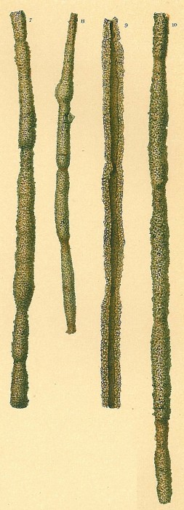

Rhabdammina discreta

Description Rhabdammina discreta sensu Jones, R.W. 1994. The Challenger Foraminifera. Image source: Brady, H.B. (1884) Pl. 22 Author [Cedhagen, Tomas](http://www.marinespecies.org/imis.php?module=person&persid=23743) JPG file - 1.92 MB - 799 x 2 205 pixels[more](http://www.marinespecies.org/photogallery.php?album=772&pic=35158) added on 2010-12-04276 viewsWoRMS taxa [*Rhabdammina discreta* Brady, 1881](http://www.marinespecies.org/aphia.php?p=taxdetails&id=113900)Checked: verified by a taxonomic editorchecked Hayward, Bruce 2013-05-03

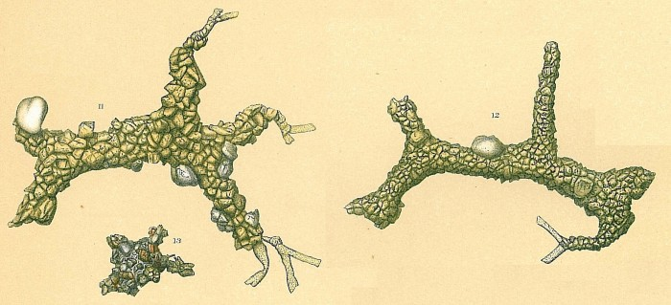

Rhabdammina cornuta

Description Rhabdammina cornuta sensu Jones, R.W. 1994. The Challenger Foraminifera. Image source: Brady, H.B. (1884) Pl. 22 Author [Cedhagen, Tomas](http://www.marinespecies.org/imis.php?module=person&persid=23743) JPG file - 1.97 MB - 2 077 x 949 pixels[more](http://www.marinespecies.org/photogallery.php?album=772&pic=35157) added on 2010-12-04159 viewsWoRMS taxa [*Rhabdammina cornuta* (Brady, 1879)](http://www.marinespecies.org/aphia.php?p=taxdetails&id=113899) accepted as [*Astrorhizoides cornuta* (Brady, 1879)](http://www.marinespecies.org/aphia.php?p=taxdetails&id=746099)Checked: verified by a taxonomic editorchecked Hayward, Bruce 2013-04-26

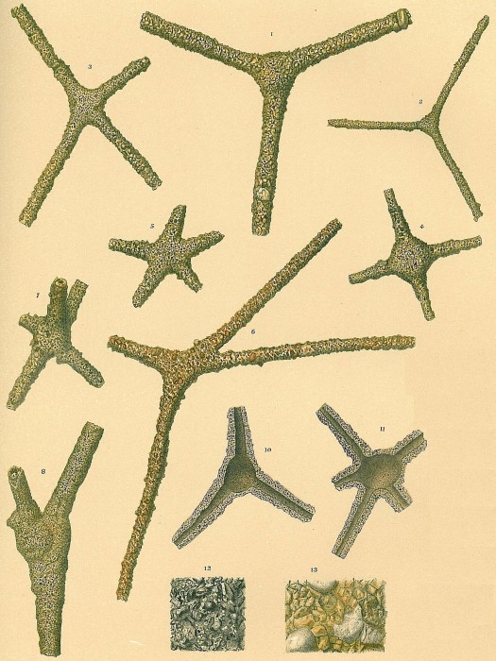

Rhabdammina abyssorum

Description Rhabdammina abyssorum sensu Jones, R.W. 1994. The Challenger Foraminifera. Image source: Brady, H.B. (1884) Pl. 21 Author [Cedhagen, Tomas](http://www.marinespecies.org/imis.php?module=person&persid=23743) JPG file - 5.98 MB - 2 140 x 2 852 pixels[more](http://www.marinespecies.org/photogallery.php?album=772&pic=35156) added on 2010-12-04246 viewsWoRMS taxa [*Rhabdammina abyssorum* Sars, 1869](http://www.marinespecies.org/aphia.php?p=taxdetails&id=113898)Checked: verified by a taxonomic editorchecked Hayward, Bruce 2013-02-25

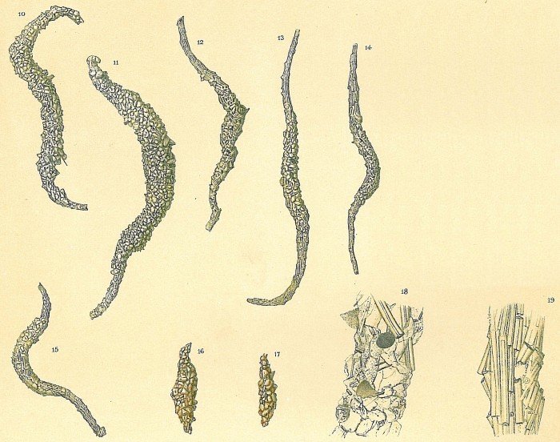

Marsipella elongata

Description Marsipella elongata sensu Jones, R.W. 1994. The Challenger Foraminifera. Image source: Brady, H.B. (1884) Pl. 24 Author [Cedhagen, Tomas](http://www.marinespecies.org/imis.php?module=person&persid=23743) JPG file - 3.50 MB - 2 151 x 1 698 pixels[more](http://www.marinespecies.org/photogallery.php?album=772&pic=35155) added on 2010-12-04173 viewsWoRMS taxa [*Marsipella elongata* Norman, 1878](http://www.marinespecies.org/aphia.php?p=taxdetails&id=113885)Checked: verified by a taxonomic editorchecked Hayward, Bruce 2013-04-26