AM000-Asia-China-Hn-TLV-Square

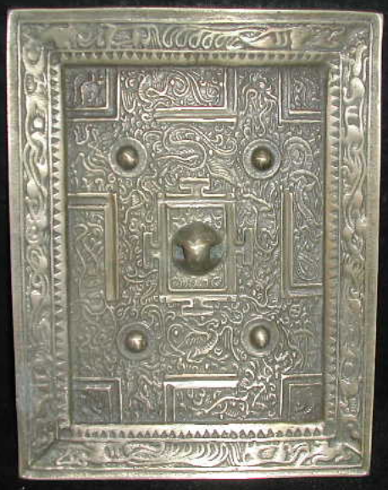

length: 17.00cm  
Width: 13.00cm   
Thickness:1.00cm  
Weight: 0.8 kg

