Eur-Phoenicia-Ship

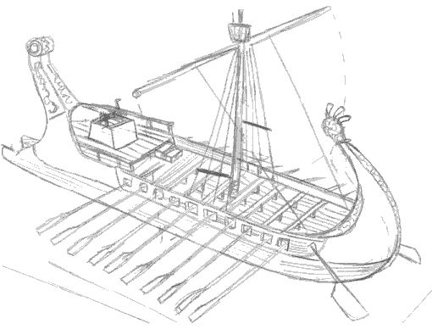

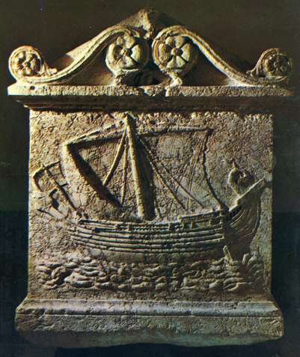

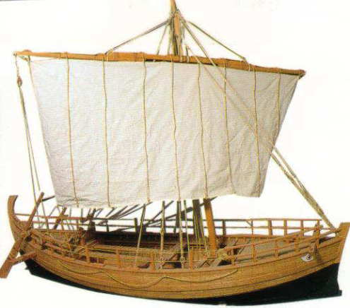  
Kyrenia Model Under Sail

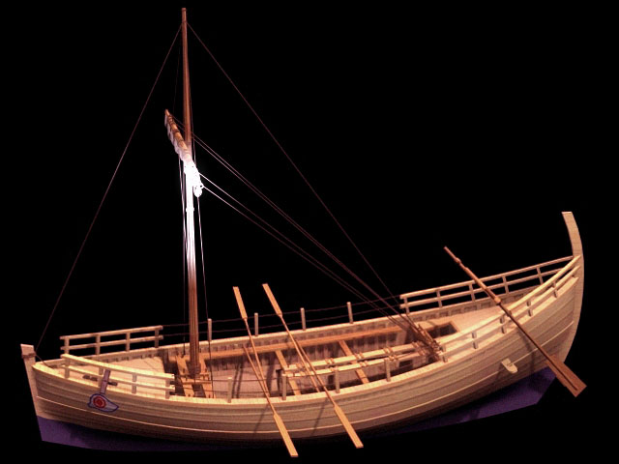  
Kyrenia Model

The Ancient Greeks, especially the Athenians, exported olive oil, wine, and beautiful painted pottery to many different parts of the Mediterranean. They used these goods to trade for many different imports. This is a picture of a typical Greek merchant ship used to transport goods around the Mediterranean. Recent oceanographic archeological finds are shedding more light on the actual contents of their cargo’s and the construction techniques used in the merchant ships of antiquity. It is evident from art history that the Iconography and its varied sources that the general design of these merchant vessels remained consistent and changed little over an extended period of time .

|  |  |
| --- | --- |
| http://www.artsales.com/ARTistory/Ancient_Ships/images/Corbita_Boat.jpg | Image from [Attic Pottery ancient Greek art of 540 BCE](http://www.perseus.tufts.edu/cgi-bin/image?lookup=1990.14.0124) |

[See Trading Vessel Image from Greek Attic Pottery](http://www.perseus.tufts.edu/cgi-bin/image?lookup=1990.14.0122)

|  |  |
| --- | --- |
| The configuration of merchant vessels changed little in form and function over time the bucket boat was the norm throughout the Mediterranean | http://www.artsales.com/ARTistory/Ancient_Ships/images/Mercha32.jpg |

|  |  |
| --- | --- |
| http://www.artsales.com/ARTistory/Ancient_Ships/images/Mercha33.jpg | **Model of a Roman merchant ship,  of the Corbita type From the Museum of the Ephebe. See wall panel illustration above**    [Compare to image from this ancient Greek art Attic Po](http://www.perseus.tufts.edu/cgi-bin/image?lookup=1990.14.0122) |

**London B 436 (Vase)**

Top of Form



Bottom of Form

Top of Form

("Agamemnon", "Hom. Od. 9.1", "denarius")

[All Search Options](http://www.perseus.tufts.edu/hopper/search) [[view abbreviations](javascript:abbrev_help())]

Bottom of Form

[Home](http://www.perseus.tufts.edu/hopper/home) [Collections/Texts](http://www.perseus.tufts.edu/hopper/collections) [Perseus Catalog](http://catalog.perseus.org) [Research](http://www.perseus.tufts.edu/hopper/research) [Grants](http://www.perseus.tufts.edu/hopper/grants) [Open Source](http://www.perseus.tufts.edu/hopper/opensource) [About](http://www.perseus.tufts.edu/hopper/about) [Help](http://www.perseus.tufts.edu/hopper/help)

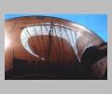

[Image access restricted](http://www.perseus.tufts.edu/hopper/help/copyright.jsp#images)  
Side B: war ship

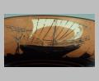

[Image access restricted](http://www.perseus.tufts.edu/hopper/help/copyright.jsp#images)  
Side B: merchant ship

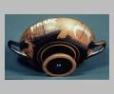

[Image access restricted](http://www.perseus.tufts.edu/hopper/help/copyright.jsp#images)  
Side A: oblique from below

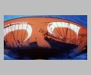

[Image access restricted](http://www.perseus.tufts.edu/hopper/help/copyright.jsp#images)  
Side B: merchant and war ships

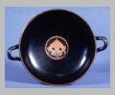

[Image access restricted](http://www.perseus.tufts.edu/hopper/help/copyright.jsp#images)  
Interior: view from above

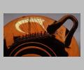

[Image access restricted](http://www.perseus.tufts.edu/hopper/help/copyright.jsp#images)  
Side A: warship

Top of Form

Bottom of Form

|  |  |
| --- | --- |
| [Permalink](http://data.perseus.org/artifacts/vase/London+B+436) | |
| **Collection:** | [London, British Museum](http://www.perseus.tufts.edu/hopper/artifactBrowser?object=Vase&field=Collection&value=London%2C+British+Museum) |
| **Summary:** | Side A: Merchant vessel and war ship sailing towards each other. Side B: Similar to Side A. Int.: Gorgoneion. |
| **Ware:** | [Attic Black Figure](http://www.perseus.tufts.edu/hopper/artifactBrowser?object=Vase&field=Ware&value=Attic+Black+Figure) |
| **Context:** | From [Vulci](http://www.perseus.tufts.edu/hopper/artifactBrowser?object=Vase&field=Context&value=Vulci) |
| **Date:** | ca. 540 BC - ca. 500 BC |
| **Dimensions:** | H. 0.084 m., D. 0.276 m. |
| **Shape:** | [Kylix](http://www.perseus.tufts.edu/hopper/artifactBrowser?object=Vase&field=Shape&value=Kylix) |
| **Beazley Number:** | 479 |
| **Region:** | [Etruria](http://www.perseus.tufts.edu/hopper/artifactBrowser?object=Vase&field=Region&value=Etruria) |
| **Period:** | [Archaic](http://www.perseus.tufts.edu/hopper/artifactBrowser?object=Vase&field=Period&value=Archaic) |

**Decoration Description:**

Side A: A merchant vessel is facing right, approached by a war ship. The merchant vessel is rigged with a mast and sail, and it has an apotropaic eye painted on its bow. At the stern is a landing-ladder, and a steersman with the steering oars. Along the sides are lattice-work bulwarks. The sails are furled. Sailing towards it is a war ship with mast and sail. Its prow is in the form of a boar's head, and it has a high fore-deck, steering oars and a landing ladder at the stern. The bulwarks are the same as the merchant ship's. Eight figures can be seen rowing the upper set of oars (there are at least as many people on the lower deck) and the sail is fully extended, giving the impression that the boat is moving "full steam ahead."

Side B: A similar design as Side A. The merchant vessel has unfurled sails in this scene, while the people in the war ship are standing up; one is holding onto the end of a sail, and the other two are hauling on ropes. The war ship is towing a smaller boat, to the right, which has an apotropaic eye painted on the prow. The surface of the sea is indicated with a wavy line.

Interior: A Gorgoneion is depicted, with curly hair, a protruding tongue, and tusks.

This was originally interpreted as a boat race scene (Harrison, 29), but it is more likely that it depicts a pirate ship overtaking a merchant vessel. Side A is the first part of the story, where the pirate ship races toward the unsuspecting boat, using all of its oarsmen and sails. On Side B, it has reached its prey; the pirates have leapt up from their oars and are pulling down the sails as they prepare to board the merchant vessel. The latter, realizing too late what is happening, is attempting to escape under sail (Casson 1971, 128).

**Collection History:**

From the Blacas Collection

**Sources Used:**

Walters 1893, 229, n. B436; Boardman 1974, fig. 180; Morrison & Coates 1986, 35, fig. 26; Casson 1971, 128; Morrison & Williams 1968, 109, Arch. 85; J. Harrison "Odysseus and the Sirens—Dionysiac Boat Races—a Cylix by Nikosthenes," JHS VI (1885) 29

**Other Bibliography:**

O. Höckmann, Antike Seefahrt (Munich 1985) 55, fig. 43; E. Afsmann "Nautisch-archäologische Untersuchungen," JdI VII (1892) 53; R. Williams "Notes on Supplementary Plates LXXXV-LXXXVIII," Greece and Rome XVIII (1949) 144, pl. LXXXVIII, 4c; L. Casson "Hemiolia and Triemiolia" JHS LXXVIII (1958) 14-16, pl. V, VI; R. Williams "Early Greek Ships of Two Levels," JHS LXXVIII (1958) 127, pl. XIVe