US-MONTANA-BEAR_CANYON-2002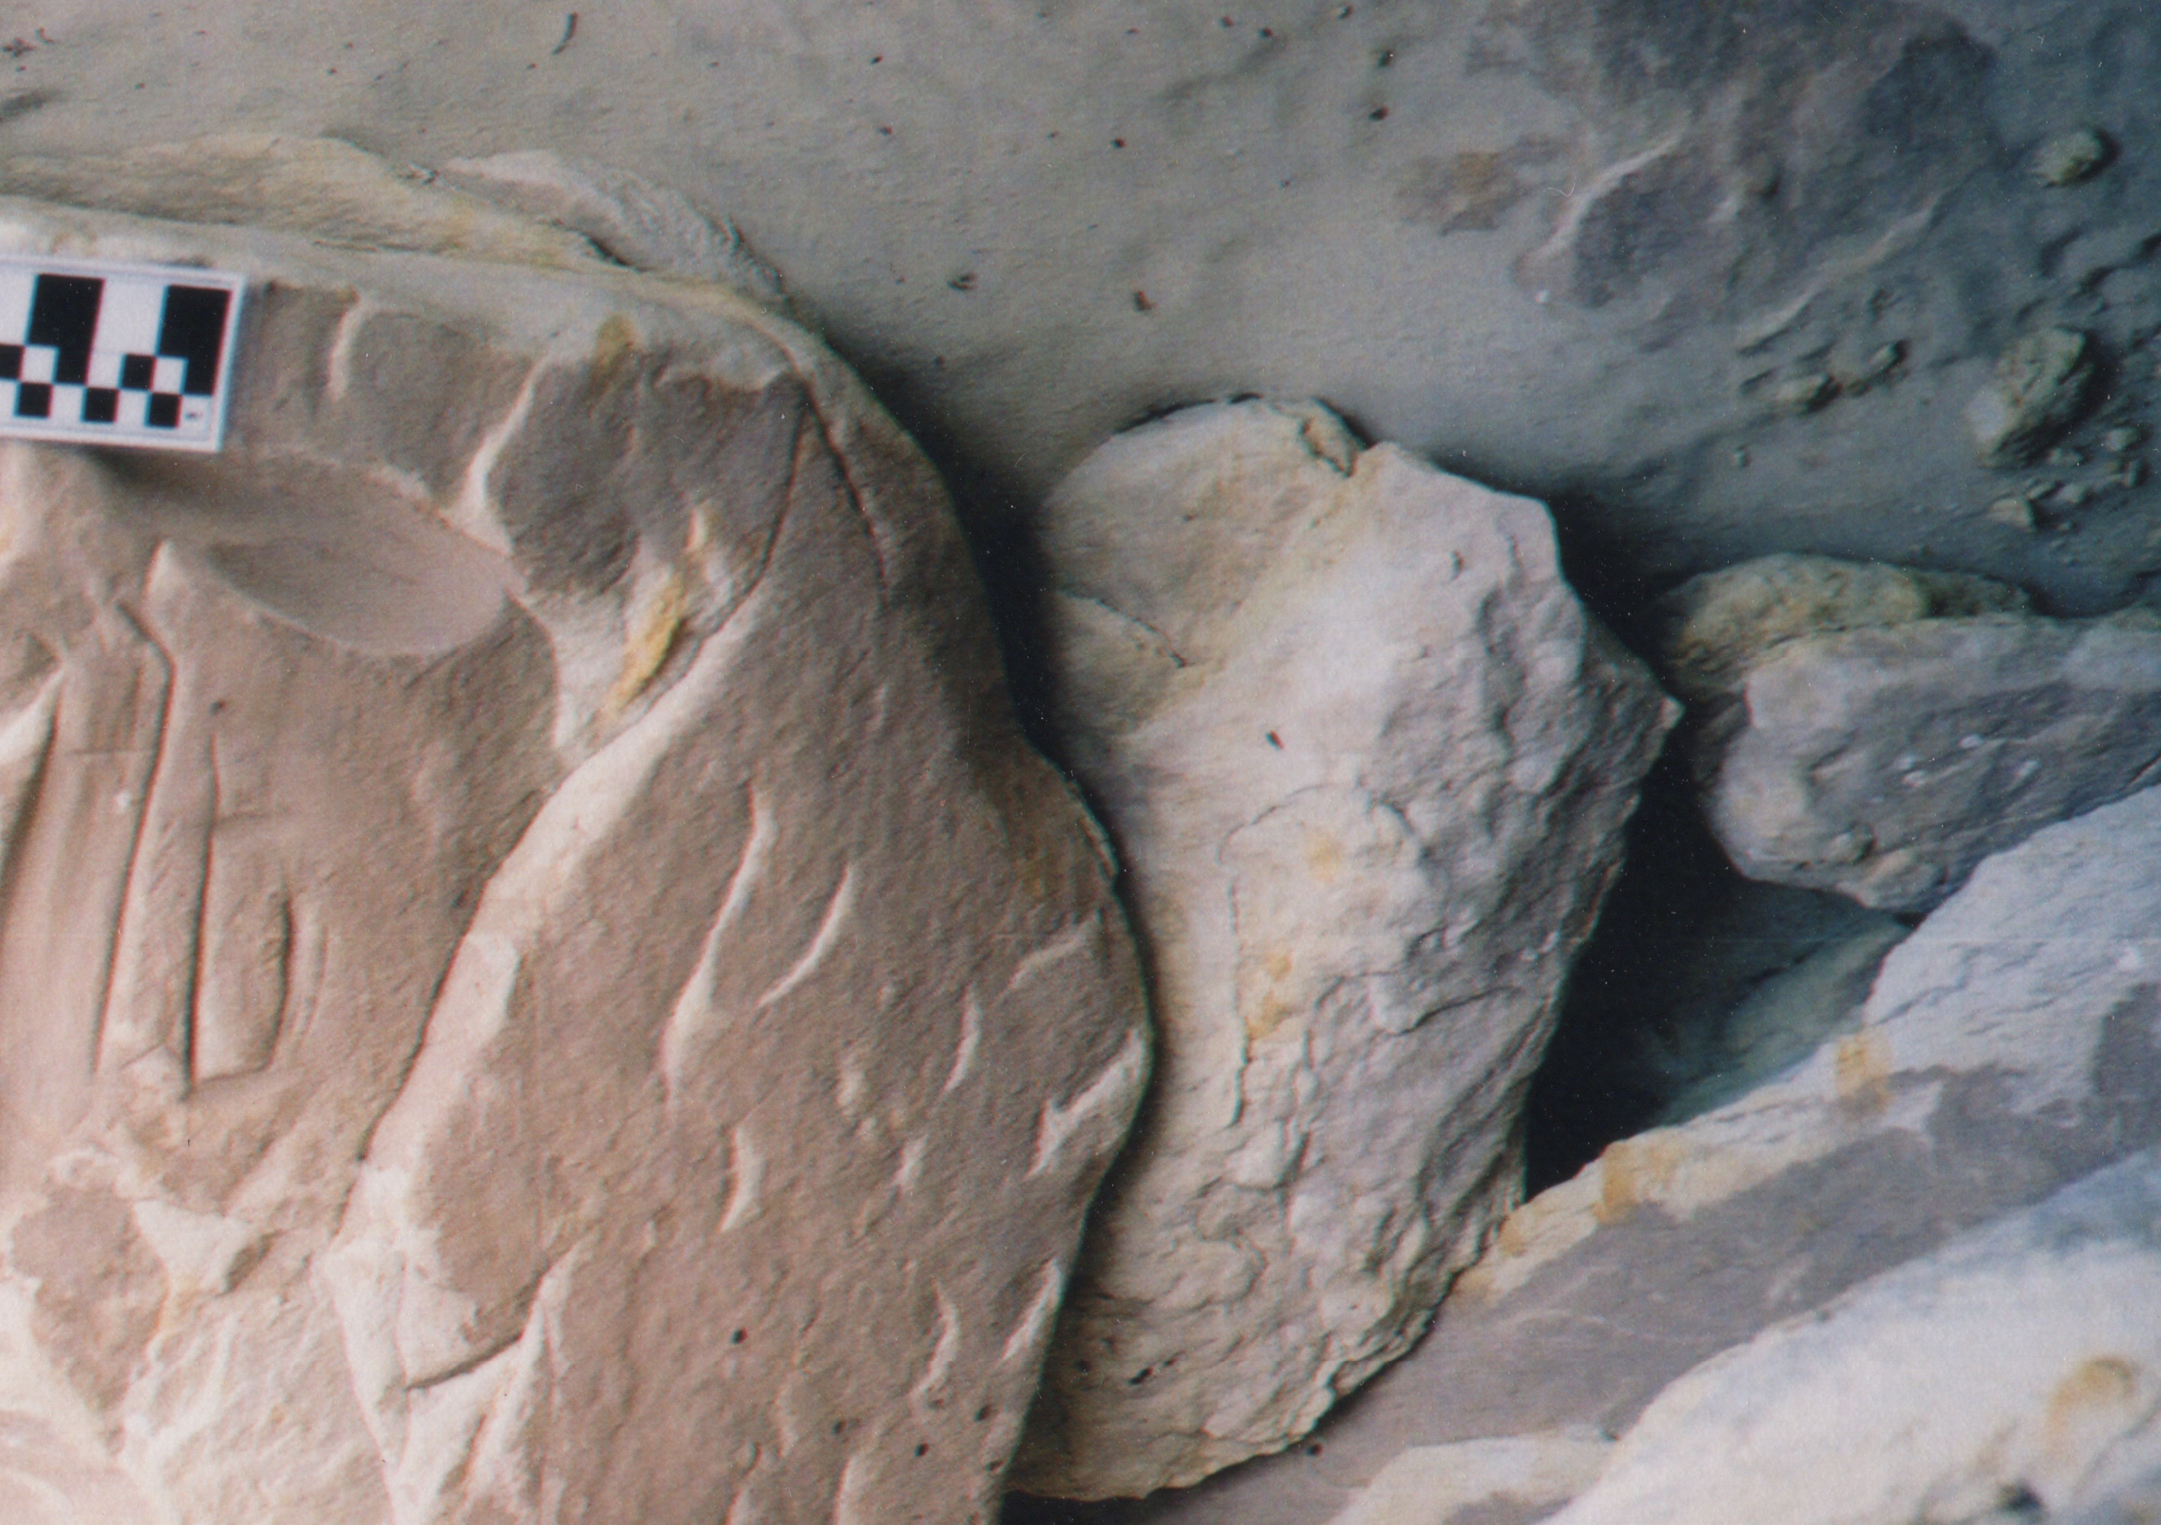

**Formal Name**: MONTANA-BEAR_CANYON-2002

**Accession no:** US

**Display Description**:

**Cultural Affiliation**:

**Time Horizon**:

**Geographical Location**:

**Map**:

**GPS**:

**Medium**:

**Dimensions**:

**Date Photographed**:

**Discussion**:

**References**: