RA12.6-US-UT-High_Cave-10-16-03

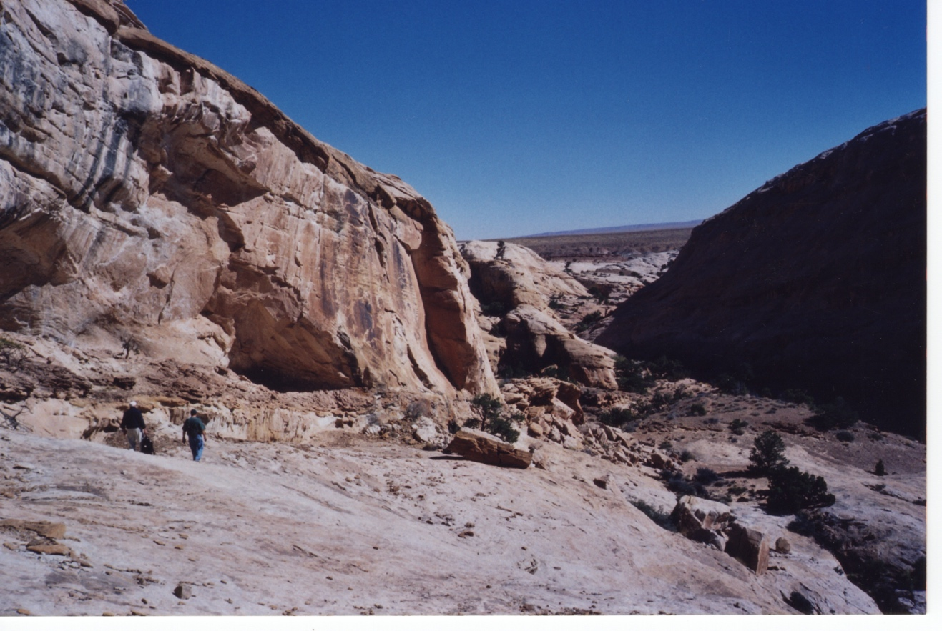

**Formal Name**: US-UT-High_Cave-10-16-03

**Accession no:** RA12.6

**Display Description**:

**Cultural Affiliation**:

**Time Horizon**:

**Geographical Location**:

**Map**:

**GPS**:

**Medium**:

**Dimensions**:

**Date Photographed**:

**Discussion**:

**References**: