# **OBJECTIVE QUESTIONS**

## Are there any tables with duplicate or missing null values? If so, how would you handle them?

Ans. 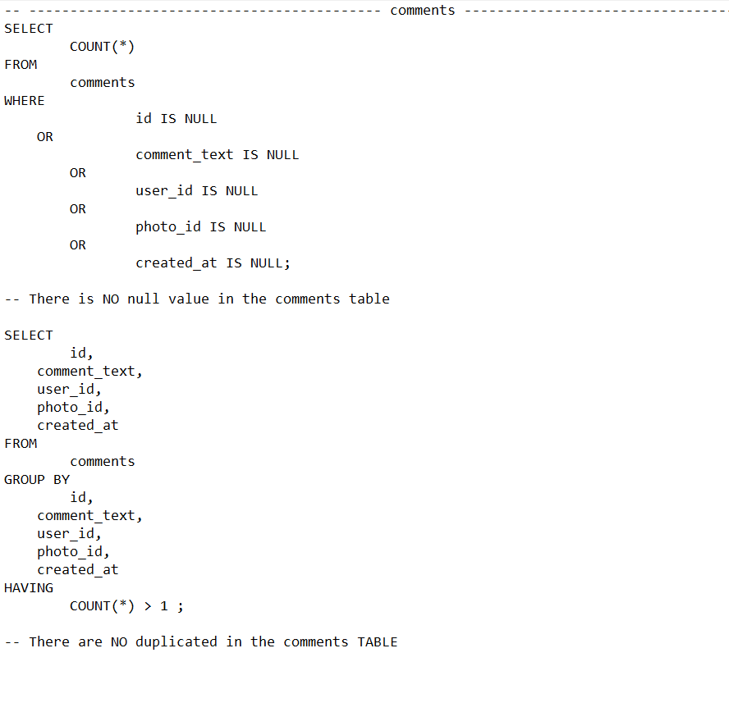

We can identify duplicates and null values in other tables by creating these kinds of queries.There are no duplicates or null values in any of the tables, according to the results.

## What is the distribution of user activity levels (e.g., number of posts, likes, comments) across the user base?

Ans.

* QUERIES

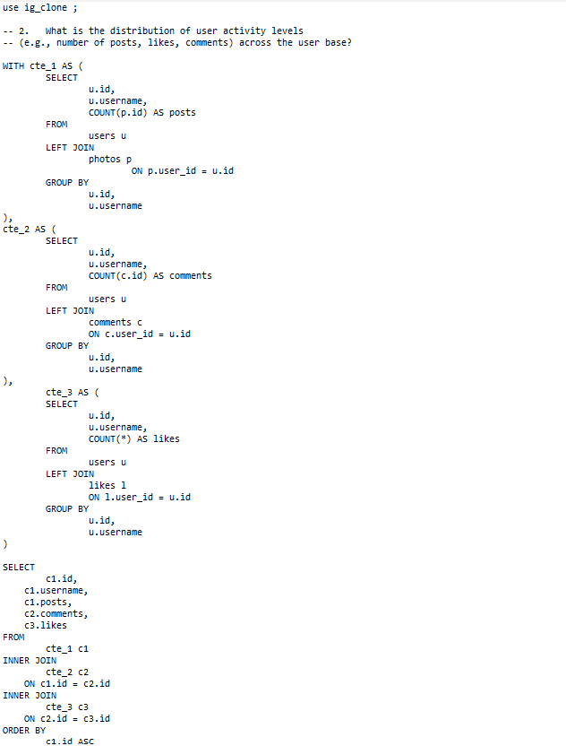

* RESULT

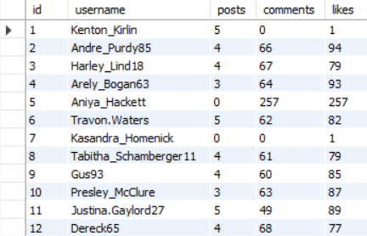

## 3. Calculate the average number of tags per post (photo_tags and photos tables).

Ans .

* QUERIES

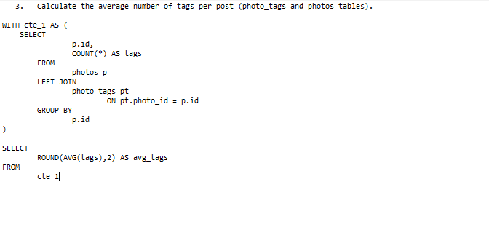

* RESULT

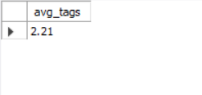

## Identify the top users with the highest engagement rates (likes, comments) on their posts and rank them.

Ans.

* QUERY

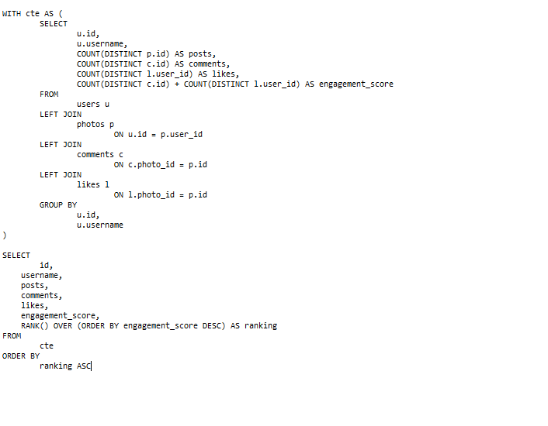

* RESULT

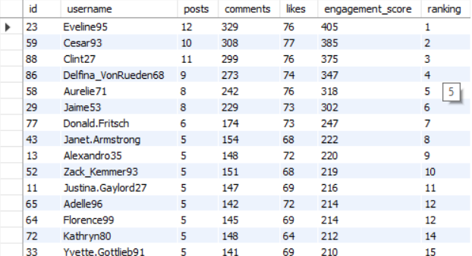

## Which users have the highest number of followers and followings?

Ans.

* Query

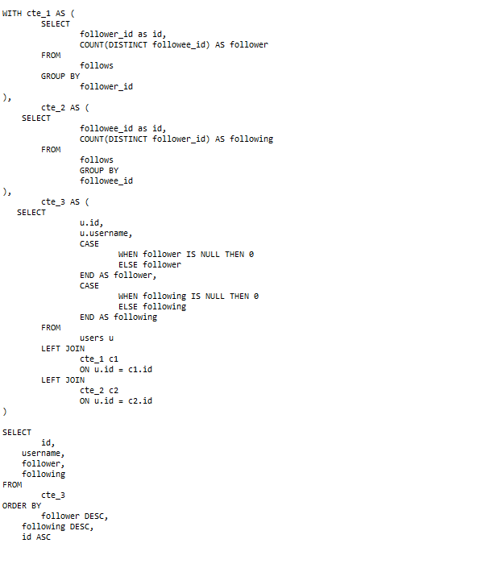

* RESULT

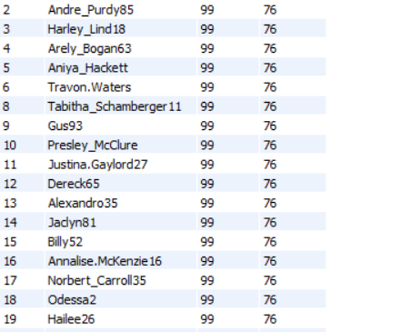

## Calculate the average engagement rate (likes, comments) per post for each user.

Ans.

* Query

## 

* RESULT

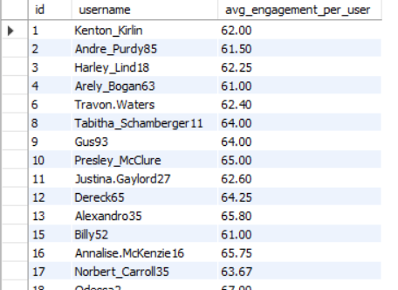

## Get the list of users who have never liked any post (users and likes tables)

Ans.

* QUERY

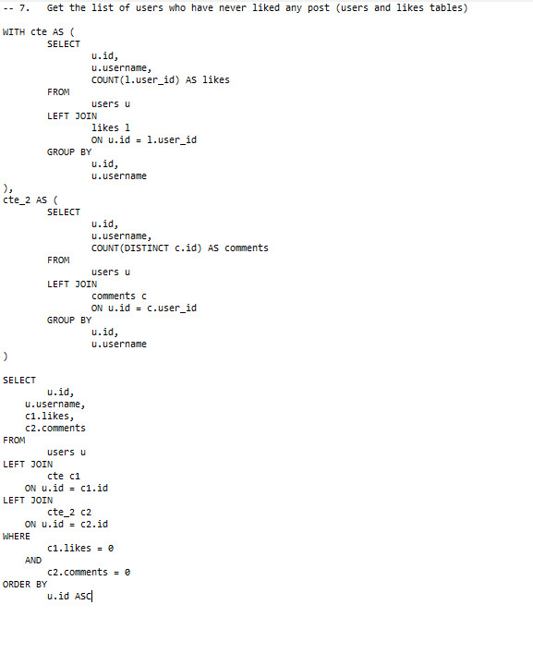

* RESULT

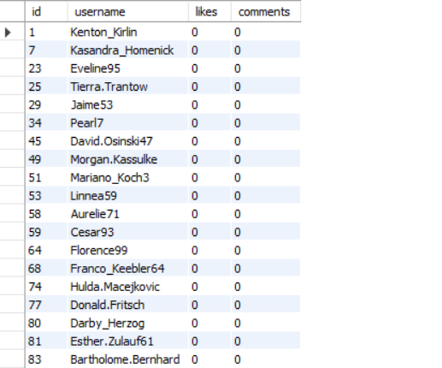

## How can you leverage user-generated content (posts, hashtags, photo tags) to create more personalized and engaging ad campaigns?

Ans. All of the tags used in recent postings are grouped together in this query. provides a compiled collection of tags from recent posts for segmentation and customized ad targeting. By utilizing these strategies, we can employ user-generated content (UGC) to better match advertisements with user interests, boosting relevance and engagement.

* QUERY

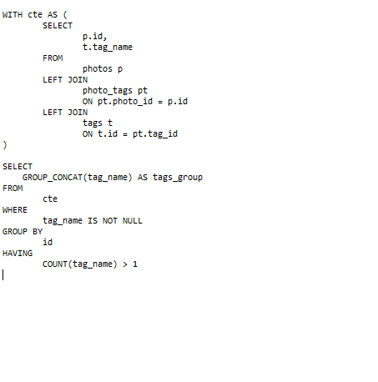

* RESULT

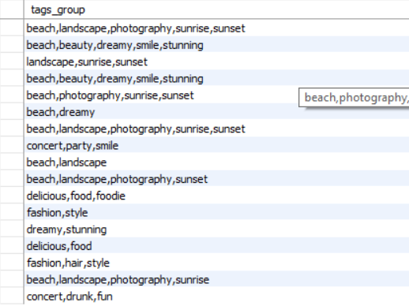

## Are there any correlations between user activity levels and specific content types (e.g., photos, videos, reels)? How can this information guide content creation and curation strategies?

Ans.

* Analyze Engagement per Content Type

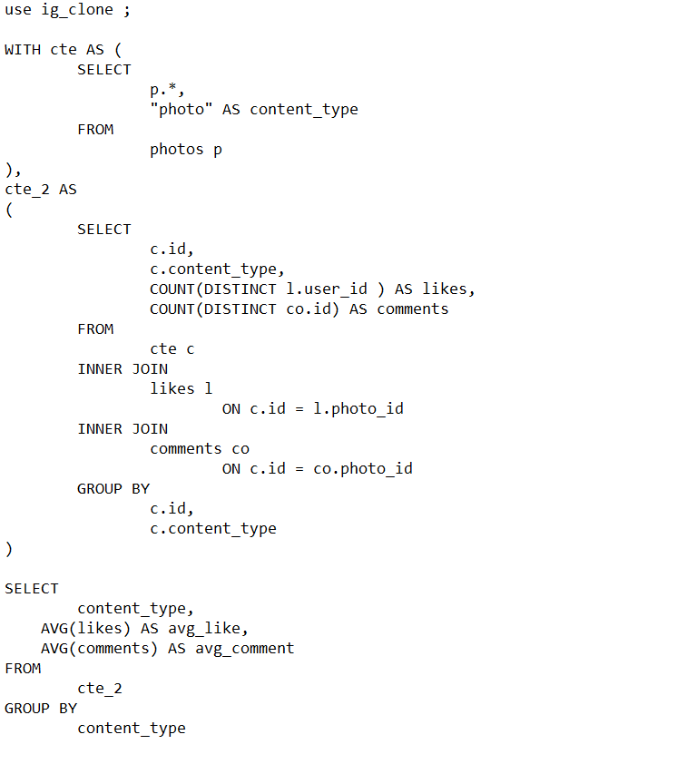

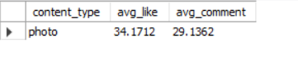

* Identify Correlations and Patterns :

Once you have average engagement rates per content type, you can look for correlations:

* + **Identify High-Engagement Content Types**: If videos or reels have higher average views and shares, they may be more engaging for the audience.
  + **Compare Content Type Popularity**: Examine if certain types drive more likes or comments than others, showing preferences.
* Segment Audience Based on Engagement Behavior:

Segment users based on their engagement with content types. For instance:

* + **Video-Engaged Users**: Targeted with video-heavy campaigns.
  + **Photo-Engaged Users**: Encouraged to engage with interactive photos, like carousels.
* Guiding Content Creation and Strategy:
  + **Content Optimization**: Focus resources on high-engagement content types for better reach.
  + **Curated Campaigns**: Tailor content campaigns to user preferences (e.g., more reels if reels see higher engagement).
  + **Ad Targeting**: Create ads around the preferred content types to improve relevancy and ad performance.

This approach ensures content aligns with user interests, leading to more effective engagement strategies and user satisfaction.

## Calculate the total number of likes, comments, and photo tags for each user.

Ans.

* QUERY

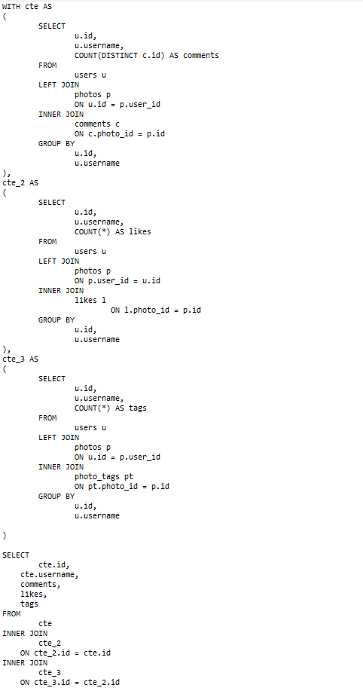

* RESULT

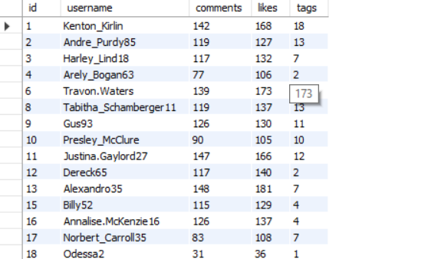

## 11. Rank users based on their total engagement (likes, comments, shares) over a month.

Ans.

* QUERY

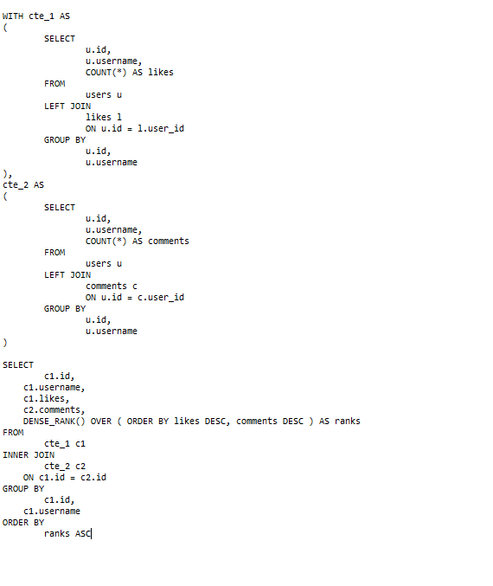

* RESULT

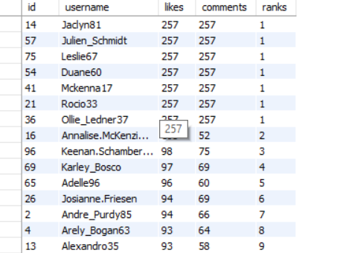

## Retrieve the hashtags that have been used in posts with the highest average number of likes. Use a CTE to calculate the average likes for each hashtag first.

Ans.

* Query

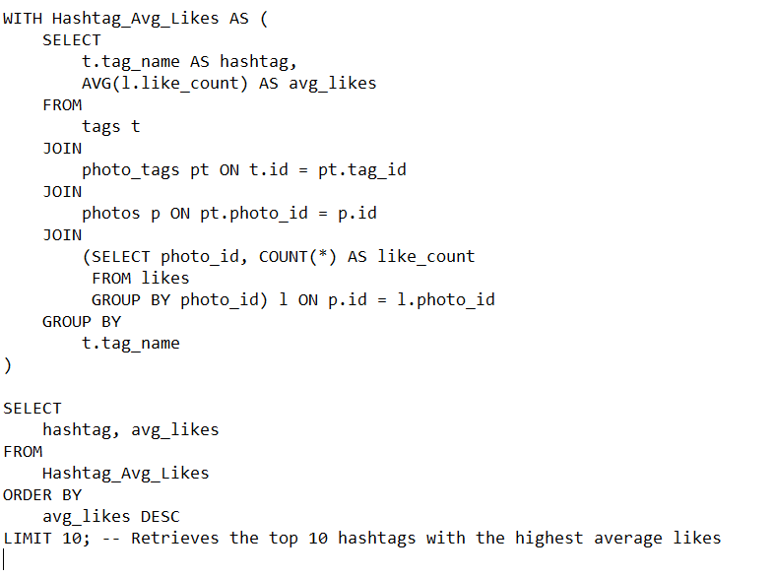

* RESULT

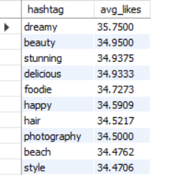

## Retrieve the users who have started following someone after being followed by that person

Ans.

* QUERY

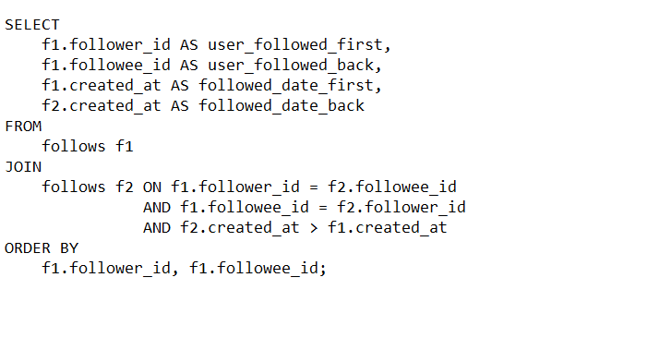

* RESULT

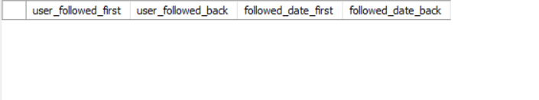

* BRIEF :

The result is emplty because the column created_at accepts the current date_time and when we made the bulk insertion the timespam remain same throughout the column due to which it became hard to distinguish between the before and after transaction because of that when we put the where clause to check created_at before and after there are no such entries.