# **SUBJECTIVE QUESTIONS**

## **1. Based on user engagement and activity levels, which users would you consider the most loyal or valuable? How would you reward or incentivize these users?**

Ans.

* QUERY

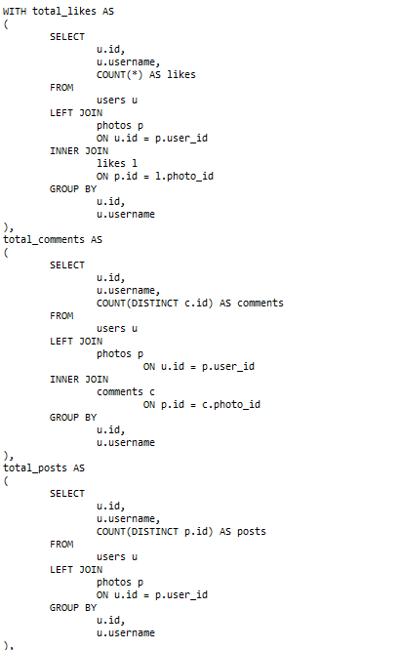

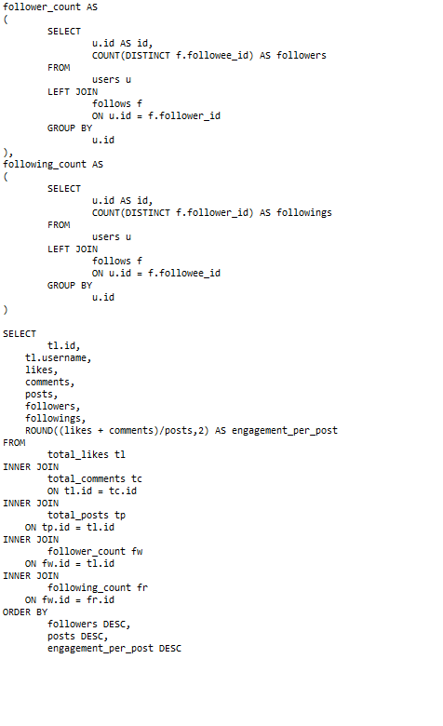

* RESULT

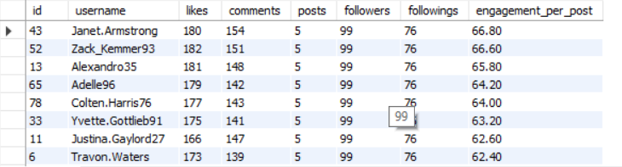

* EXPLAINATION :

The people with a large following, high engagement per post, and a high volume of posts on Instagram play a significant role in attracting new audiences to the application. Their substantial follower base and frequent, engaging content create visibility, drawing attention to their profiles. This visibility, combined with their active audience interactions, makes their profiles effective channels for attracting new users to the application, as their content resonates with and engages a wider audience. By sharing interesting or relatable content, they build trust and encourage others to explore the app, contributing to user growth and increasing the app's reach through organic influence.

* Rewarding or Incentivizing Loyal Users

• **Exclusive Content or Features**: Provide loyal users with early access to new features or exclusive content.

• **Gamification**: Implement badges, levels, or rewards for reaching certain engagement milestones.

• **Personalized Discounts or Offers**: Offer personalized deals or incentives based on user preferences and engagement patterns.

• **User Recognition**: Showcase top users on leaderboards or in community highlights, boosting their visibility and sense of contribution.

• **Incentive Programs**: Offer incentives like free subscriptions, digital goods, or loyalty points redeemable for rewards.

## **For inactive users, what strategies would you recommend to re-engage them and encourage them to start posting or engaging again?**

Ans.

* QUERY

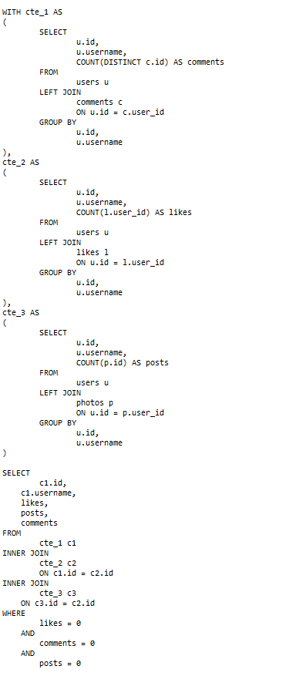

* RESULT

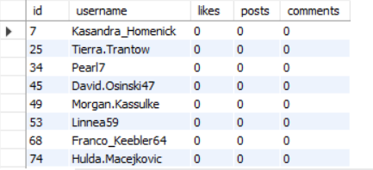

Many people are considered inactive users since they never like, comment on, or post anything of any type.

* Strategies to regain users
* **Targeted Emails or Push Notifications**: Send personalized messages highlighting new features, updates, or content they may have missed.
* **Friendly Competitions**: Host friendly leaderboards where users can compete based on interactions or content quality to re-engage those with a competitive spirit.
* **Highlight New and Exclusive Content**: Let inactive users know about exciting new content, such as videos, articles, or trending posts, that might appeal to their interests.
* **Early Access or Premium Trials**: Offer a limited-time trial of premium features or exclusive content to bring users back to the platform.
* **Personalized Recommendations**: Showcase relevant or trending posts, groups, or discussions based on the user’s past activity.
* **Peer Recommendations**: Show users content or posts that their friends or people they follow have recently engaged with.
* **Celebrate Milestones and Anniversaries**: Send notifications celebrating their membership anniversary or “welcome back” messages that recognize their return.

## **Which hashtags or content topics have the highest engagement rates? How can this information guide content strategy and ad campaigns?**

Ans.

* QUERY

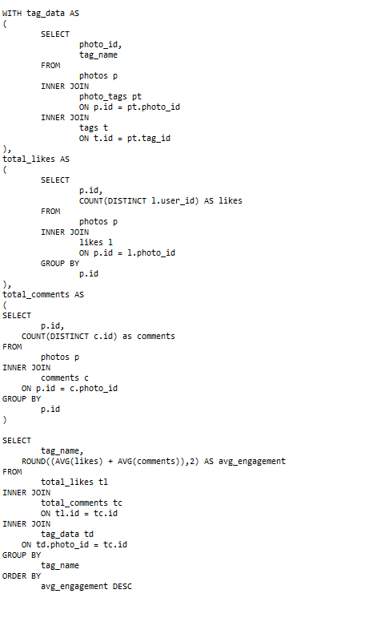

* OUTPUT

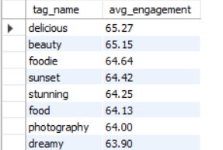

### Content Strategy and Ad Campaigns

* + **Content Strategy**:
    - **Focus on High-Engagement Topics**: Create more content around hashtags/topics with the highest engagement to increase visibility and interactions.
    - • **Diversify Content Formats**: Experiment with the format (video, image, reel) for these top topics to explore what resonates most.
    - • **Community-Building**: Use these popular hashtags to form user groups, challenges, or events, boosting user interaction around these themes.
  + **Ad Campaigns**:
    - **Targeted Ad Themes**: Center ads around trending high-engagement topics to capture user attention, as they’ve already shown interest in these areas.
    - **Influencer Collaborations**: Partner with influencers who align with high-engagement hashtags or topics, amplifying reach to an interested audience.
    - **Personalized Ads**: Show ads featuring high-engagement topics to users who have interacted with related content, maximizing relevance and conversion potential.
* By leveraging popular hashtags and content topics, you can better align both organic content and paid promotions to match audience interests, driving higher engagement and fostering a more active community.

## **Are there any patterns or trends in user engagement based on demographics (age, location, gender) or posting times? How can these insights inform targeted marketing campaigns?**

Ans.

* **Analyzing Demographic Engagement Patterns**
* **Age, Location, and Gender Analysis**: Using historical engagement data, examine how users of different age groups, locations, and genders interact with content.
* **Engagement Metrics**: Measure likes, comments, shares, and views for each demographic category to identify the highest engagement levels.
* **Analyzing Engagement Patterns by Posting Time**
* **Engagement by Time of Day**: Segment engagement metrics by posting times (morning, afternoon, evening, night) to identify optimal times for user interaction.
* **Day of the Week Patterns**: Track variations in engagement across weekdays and weekends to tailor post timing.

**Example SQL for Posting Time**

* + - **QUERY**

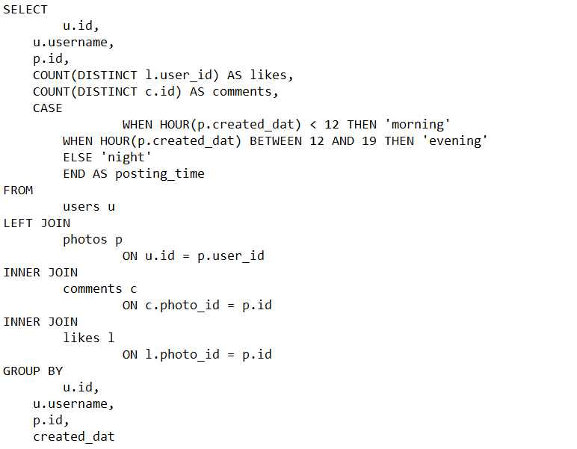

* + - OUTPUT

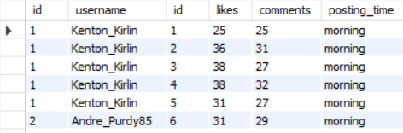

* **Utilizing Insights for Targeted Marketing Campaigns**
  + **Personalized Ad Targeting by Demographics**:
    - **Age-Based Content**: Design age-specific content (e.g., visually engaging for younger audiences, informational for older groups) to match engagement patterns.
    - **Location-Based Ads**: Run geographically tailored ads during high-engagement hours in each region for maximum visibility.
    - **Gender-Specific Promotions**: If one gender shows higher engagement in certain topics, target ad campaigns around those interests accordingly.
  + **Optimized Posting Times for Campaigns**:
    - **Time-Sensitive Content Delivery**: Schedule posts and ads for peak engagement hours identified from the analysis, ensuring higher visibility and interaction.
    - **Day-Parted Ads**: Use high-engagement windows, such as mornings or evenings, for specific time-sensitive promotions or limited-time offers.
  + **Strategic Use of High-Engagement Content Types**:
    - **Match Content Types with Demographic Preferences**: If specific demographics prefer certain types of content (e.g., videos for younger users), incorporate these formats in ads and organic posts.
    - **Event-Based Campaigns**: Launch campaigns tied to high-activity days, such as weekends or special holidays, to take advantage of heightened engagement.
* By leveraging demographic engagement insights, brands can ensure that their content reaches the right audience at the right time, maximizing engagement and improving the ROI of targeted marketing campaigns.

## **Based on follower counts and engagement rates, which users would be ideal candidates for influencer marketing campaigns? How would you approach and collaborate with these influencers?**

Ans.

* **Identify Potential Influencers**
* **High Follower Counts**: Select users with a significant number of followers, as this indicates a larger reach.
* **High Engagement Rates**: Choose users whose followers frequently like, comment, and share their content, which signals active audience involvement.

**SQL Query Example**: Assuming tables like follows for follower count, likes, and comments for engagement rate:

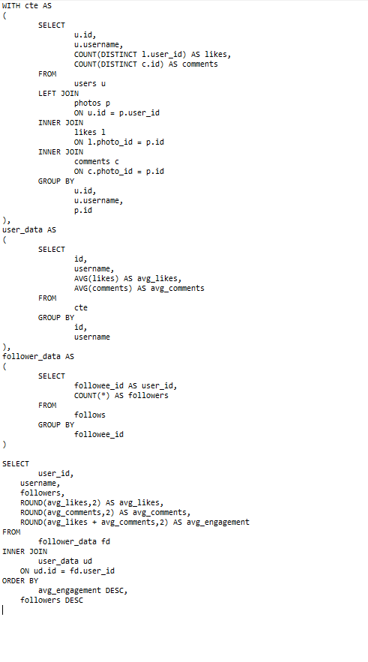

* + OUTPUT

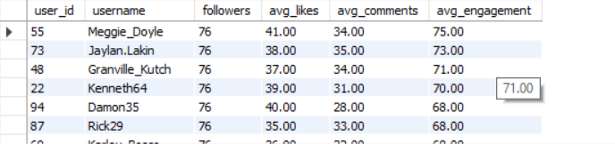

* **Analyzing & Selecting Candidates for Influencer Marketing**
* **Top-Performing Users**: Use the query results to pinpoint users with high follower counts and high engagement rates.
* **Content Quality Check**: Review these users' content for brand fit, consistency, and tone alignment to ensure they resonate with your brand’s identity.
* **Approaching Influencers for Collaboration**
* **Personalized Outreach**: Send personalized messages to each selected influencer, explaining why they align with your brand’s values and target audience.
* **Clear Value Proposition**: Share the benefits of collaboration, like exposure to a new audience, cross-promotional opportunities, or product incentives.
* **Flexible Collaboration Options**: Offer a range of partnership ideas, from product sponsorships and discount codes to content creation opportunities, allowing influencers to choose how they wish to engage.
* **Structuring Collaborations**
* **Content Guidelines**: Provide clear but flexible guidelines to help them create authentic, brand-aligned content.
* **Engagement Metrics Tracking**: Use data to monitor the success of each campaign, tracking metrics like reach, impressions, and engagement generated by each influencer's posts.
* **Long-Term Relationships**: For high-performing influencers, establish ongoing collaborations to create consistent brand awareness and deeper audience engagement.

## **Based on user behavior and engagement data, how would you segment the user base for targeted marketing campaigns or personalized recommendations?**

Ans.

* **Highly Engaged Users**
* **Description**: These users demonstrate the highest level of activity and engagement, often interacting frequently through likes, comments, shares, and possibly generating content themselves.
* **Characteristics**: Consistent interaction, high follower count, and positive influence on other users’ engagement.
* **Strategy**: Reward these users to sustain loyalty and incentivize further engagement. Examples include exclusive access to new features, personalized recommendations, or early access to content. This group can also be considered for influencer programs or brand advocacy.
* **Moderately Engaged Users**
* **Description**: Users in this group interact regularly but not as intensely as the highly engaged. They contribute meaningfully and often consume and share content, though less frequently.
* **Characteristics**: Moderate frequency of engagement, potential for growth into high engagement with incentives.
* **Strategy**: Encourage further engagement through targeted campaigns, like content that aligns with their interests or limited-time offers. This segment may benefit from reminder notifications, content tailored to their interests, and personalized recommendations to enhance involvement.
* **Casual Users**
* **Description**: These users engage sporadically and may primarily consume content without frequent interactions. They might still be interested but lack the motivation to engage more often.
* **Characteristics**: Low engagement, possibly new or infrequent users, often consume content without consistent interaction.
* **Strategy**: Re-engage with occasional prompts, content recommendations, or notifications about trending topics to draw them back. For this group, personalized outreach, special offers, and content suggestions that are low-effort to engage with can help re-spark interest.

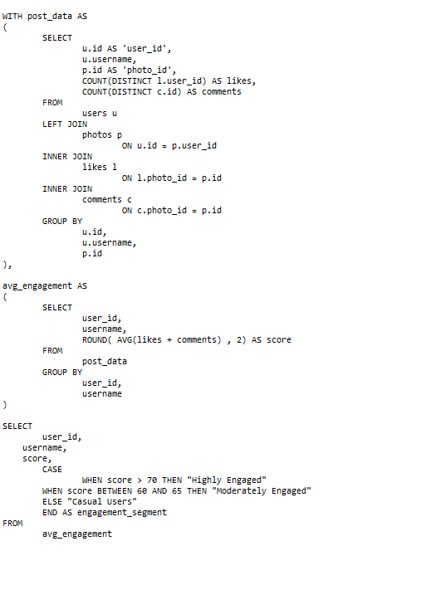

* + OUTPUT

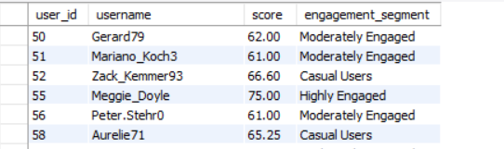

* **Implementing Targeted Campaigns**

Using these segments, you can then:

* **Personalize Content**: Recommend posts, products, or content that match user preferences.
* **Design Tailored Offers**: Customize promotions based on user segment and activity level.
* **Optimize Communication Channels**: For example, email campaigns for inactive users, in-app notifications for loyal users, or targeted ads for casual users.
* **Analyzing and Iterating**

Regularly monitor the performance of each segment’s campaign and adjust strategies as users shift between segments or new engagement trends emerge. This dynamic approach ensures your marketing remains relevant and effective over time.

## **If data on ad campaigns (impressions, clicks, conversions) is available, how would you measure their effectiveness and optimize future campaigns?**

Ans.

To measure the effectiveness of ad campaigns and optimize future ones, you can focus on several key performance indicators (KPIs) and strategies that analyze how well each campaign performs relative to its goals:

**1. Calculate Key Metrics**

* **Impressions**: The number of times the ad is shown.
* **Click-Through Rate (CTR)**: CTR=ClicksImpressions×100\text{CTR} = \frac{\text{Clicks}}{\text{Impressions}} \times 100CTR=ImpressionsClicks​×100 — a higher CTR indicates that the ad is relevant and engaging.
* **Conversion Rate (CVR)**: CVR=ConversionsClicks×100\text{CVR} = \frac{\text{Conversions}}{\text{Clicks}} \times 100CVR=ClicksConversions​×100 — this shows the ad’s ability to lead users to take a desired action (e.g., purchase, signup).
* **Cost Per Click (CPC)**: CPC=Total CostClicks\text{CPC} = \frac{\text{Total Cost}}{\text{Clicks}}CPC=ClicksTotal Cost​ — helps to assess budget efficiency by analyzing the cost-effectiveness of each click.
* **Cost Per Conversion (CPA)**: CPA=Total CostConversions\text{CPA} = \frac{\text{Total Cost}}{\text{Conversions}}CPA=ConversionsTotal Cost​ — useful for understanding the cost of acquiring a customer or lead.
* **Return on Ad Spend (ROAS)**: ROAS=RevenueTotal Cost\text{ROAS} = \frac{\text{Revenue}}{\text{Total Cost}}ROAS=Total CostRevenue​ — a key measure for profitability and determining the return on advertising investments.

**2. Set Benchmarks and Compare**

* **Benchmarking**: Use historical data or industry averages to set benchmarks for CTR, CVR, CPA, and ROAS, allowing you to quickly assess if the campaign is performing above or below expectations.
* **Comparative Analysis**: Compare campaigns to see which ads, platforms, or audience segments yield the best results. Analyzing differences helps understand where to allocate more resources.

**3. Analyze Audience Segmentation and Targeting**

* Identify which demographic segments (age, gender, location) engage and convert most effectively. This can inform audience targeting and retargeting strategies in future campaigns.
* Use **A/B testing** within campaigns to identify which creatives, formats, or targeting methods drive better engagement and conversions.

**4. Evaluate Conversion Attribution**

* Analyze attribution paths to understand the journey users take before converting (e.g., from click to purchase).
* For multi-channel campaigns, evaluate cross-channel attribution to understand how each channel (e.g., social, email, search ads) contributes to conversions and adjust budget allocation accordingly.

**5. Optimize Ad Creative and Content**

* Based on CTR and engagement, identify the types of creatives (e.g., video vs. image, carousel ads) and messaging that resonate best with users.
* Track performance by content type and continuously update ads to maintain relevance and user interest.

**6. Monitor Frequency and Audience Saturation**

* Track ad frequency (the number of times a single user sees the ad) to avoid oversaturation, which can lead to user fatigue. Limit the frequency if CTR or engagement drops over time.
* Implement retargeting strategies for users who engage with the ad but don’t convert, ensuring they’re reached with fresh messaging or offers.

**7. Use Conversion Rate Optimization (CRO) Techniques**

* For ads with high clicks but low conversion rates, analyze the landing page experience, speed, and messaging consistency.
* Optimize landing pages for better load times, mobile-friendliness, and alignment with the ad content to improve conversion rates.

**8. Conduct Post-Campaign Analysis and Apply Learnings**

* Review KPIs and user feedback to gather insights about what worked and what didn’t.
* Identify lessons learned and apply them to future campaigns. Document successful strategies, optimal targeting segments, and effective ad formats for future reference.

Regular monitoring and fine-tuning based on these insights can significantly improve campaign effectiveness and return on investment in the long term.

## **How can you use user activity data to identify potential brand ambassadors or advocates who could help promote Instagram's initiatives or events?**

Ans.

User activity data provides valuable insights for identifying potential brand ambassadors or advocates who can help promote Instagram’s initiatives or events. Here’s how to leverage this data effectively:

**1. Analyze High Engagement Rates**

* Identify users with consistently high engagement rates on their posts (likes, comments, shares), as they show a strong connection with their followers.
* Look for users whose engagement is above the platform’s average, especially in key demographics relevant to Instagram’s initiatives or events.

**2. Track Consistent and Frequent Posting Activity**

* Find users who post regularly and maintain high engagement. Consistency indicates an invested interest in the platform, and frequent posters are likely to be highly visible and influential.
* Track metrics like **daily active users (DAU)** and **monthly active users (MAU)** to determine who uses the app most and stays engaged over time.

**3. Identify Users with a Strong Follower Growth Trend**

* Look for users whose follower counts are steadily increasing, suggesting they have a growing influence and are attracting a wider audience.
* Follower growth trends show users with expanding reach, which can amplify Instagram’s brand initiatives to new audiences.

**4. Evaluate Content Relevance and Alignment with Brand Values**

* Filter users whose content aligns with Instagram’s brand values, such as creativity, community connection, and authenticity.
* Track hashtags, themes, and types of content shared by users to find those naturally advocating similar values, which makes them likely to promote initiatives authentically.

**5. Analyze Positive Mentions of Instagram or its Features**

* Use text analysis on posts, comments, and stories to detect positive mentions of Instagram, its features, or initiatives (e.g., Reels, IGTV).
* Look for users who are enthusiastic about new features or actively engage with Instagram campaigns, as they may already serve as unofficial brand advocates.

**6. Track Influential Micro-Influencers in Specific Niches**

* Identify users with smaller but highly engaged audiences, often known as micro-influencers, within niches that match Instagram’s target demographics.
* Micro-influencers are often perceived as more relatable and trustworthy, making them effective ambassadors.

**7. Observe Cross-Platform Presence**

* If possible, monitor users who also engage in other social media platforms (e.g., Twitter, YouTube, TikTok) and advocate for Instagram there.
* Users with a multi-platform presence can cross-promote Instagram’s events and reach a broader, diverse audience.

**8. Evaluate Engagement Beyond Personal Content**

* Look for users who engage with Instagram’s official account through likes, comments, and shares. Their willingness to engage with Instagram’s posts shows they are already invested in the brand.
* Also, track participation in Instagram-sponsored events or contests as this indicates an interest in collaborating with Instagram’s initiatives.

**Approach to Collaborate with Brand Ambassadors**

1. **Reach Out with Personal Messaging**: Connect personally and explain why their profile aligns with Instagram’s brand. Highlight how their influence can make a difference.
2. **Offer Exclusive Opportunities**: Provide early access to new features, invitations to Instagram events, and exclusive collaborations to increase their engagement and advocacy.
3. **Incentivize with Perks and Recognition**: Provide perks such as free subscriptions, content boosting, or official “Instagram Ambassador” badges to reinforce their status and dedication.

## **How would you approach this problem, if the objective and subjective questions weren't given?**

Ans.

**1. Define the Problem Scope**

* **Identify Key Goals**: Clarify what specific outcomes you want to achieve (e.g., increasing user engagement, identifying potential influencers, improving marketing strategies).
* **Gather Context**: Understand the broader context in which this problem exists (e.g., the industry, competitive landscape, and current marketing trends).

**2. Data Collection and Preparation**

* **Identify Relevant Data Sources**: Look for available data on user interactions, engagement metrics, demographics, campaign performance, etc.
* **Data Cleaning**: Ensure the data is clean and structured for analysis, dealing with missing values and inconsistencies.

**3. Exploratory Data Analysis (EDA)**

* **Descriptive Statistics**: Analyze basic statistics (means, medians, distributions) of key engagement metrics (likes, comments, shares).
* **Data Visualization**: Use graphs and charts (e.g., histograms, scatter plots) to identify patterns, trends, and outliers in user behavior.
* **Segmentation Analysis**: Group users based on demographics, activity levels, and engagement metrics to uncover unique segments.

**4. Identify Engagement Patterns**

* **Correlate Engagement Metrics**: Explore relationships between various engagement metrics (e.g., do users with more followers also receive more likes?).
* **Trend Analysis**: Identify trends over time in user engagement and behavior, examining seasonal effects or reactions to specific campaigns.

**5. User Segmentation**

* **Develop Segmentation Criteria**: Based on the analysis, create segments (e.g., highly engaged, occasional users, influencers) using clustering techniques or rule-based criteria.
* **Behavioral Profiles**: Define profiles for each segment, highlighting their characteristics, preferences, and engagement behaviors.

**6. Hypothesis Generation**

* **Formulate Hypotheses**: Generate hypotheses regarding user behavior based on insights derived from EDA (e.g., "Users who engage with hashtags have higher engagement rates than those who do not").

**7. Testing and Validation**

* **A/B Testing**: If applicable, design A/B tests to validate hypotheses or explore new strategies (e.g., test different types of content).
* **Statistical Analysis**: Use statistical methods to evaluate the significance of findings and validate patterns observed during EDA.

**8. Strategic Recommendations**

* **Actionable Insights**: Based on the analysis and validation, outline clear, actionable strategies tailored to the identified segments.
* **Campaign Strategies**: Develop marketing and engagement campaigns that target specific segments based on their behavior and preferences.

**9. Continuous Monitoring and Feedback**

* **Implement Tracking Mechanisms**: Set up metrics and KPIs to track the performance of implemented strategies over time.
* **Iterate and Adapt**: Be prepared to iterate on strategies based on ongoing performance data and feedback.

**10. Communication of Findings**

* **Reporting**: Prepare a clear report summarizing key insights, strategies, and recommendations to stakeholders.
* **Visual Presentations**: Use data visualizations to effectively communicate findings and engage stakeholders in discussions about the next steps.

## **10. Assuming there's a "User_Interactions" table tracking user engagements, how can you update the "Engagement_Type" column to change all instances of "Like" to "Heart" to align with Instagram's terminology?**

Ans.

To update the Engagement_Type column in the User_Interactions table and change all instances of "Like" to "Heart," you can use the SQL UPDATE statement. Here’s how you would write the query:

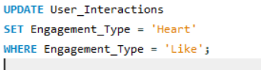

**Explanation:**

* **UPDATE User_Interactions**: Specifies the table you want to update.
* **SET Engagement_Type = 'Heart'**: Sets the Engagement_Type column to "Heart" for the rows that meet the condition.
* **WHERE Engagement_Type = 'Like'**: This condition ensures that only rows where the Engagement_Type is currently "Like" will be updated.

**Steps to Execute:**

1. **Backup Data**: Before performing updates, it's always a good practice to back up the table or database to prevent data loss.
2. **Run the Query**: Execute the SQL query in your database management system.
3. **Verify the Update**: After running the query, check a sample of records in the User_Interactions table to confirm that the changes have been made as expected.

**Example of Verification Query:**

You can run the following query to verify the update:

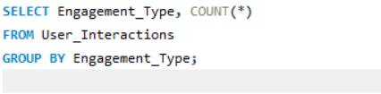

This will give you a count of how many times each engagement type appears, allowing you to see if "Like" has been replaced by "Heart."

* **OUTPUT**

